**Burundi**

**School construction for Basic Education**

**In the context of the Education and Training Sector Plan /**

**Plan Sectoriel de Développement de l'Education et la Formation (PSDEF)**

**Constraints and opportunities - Challenges and options for future**

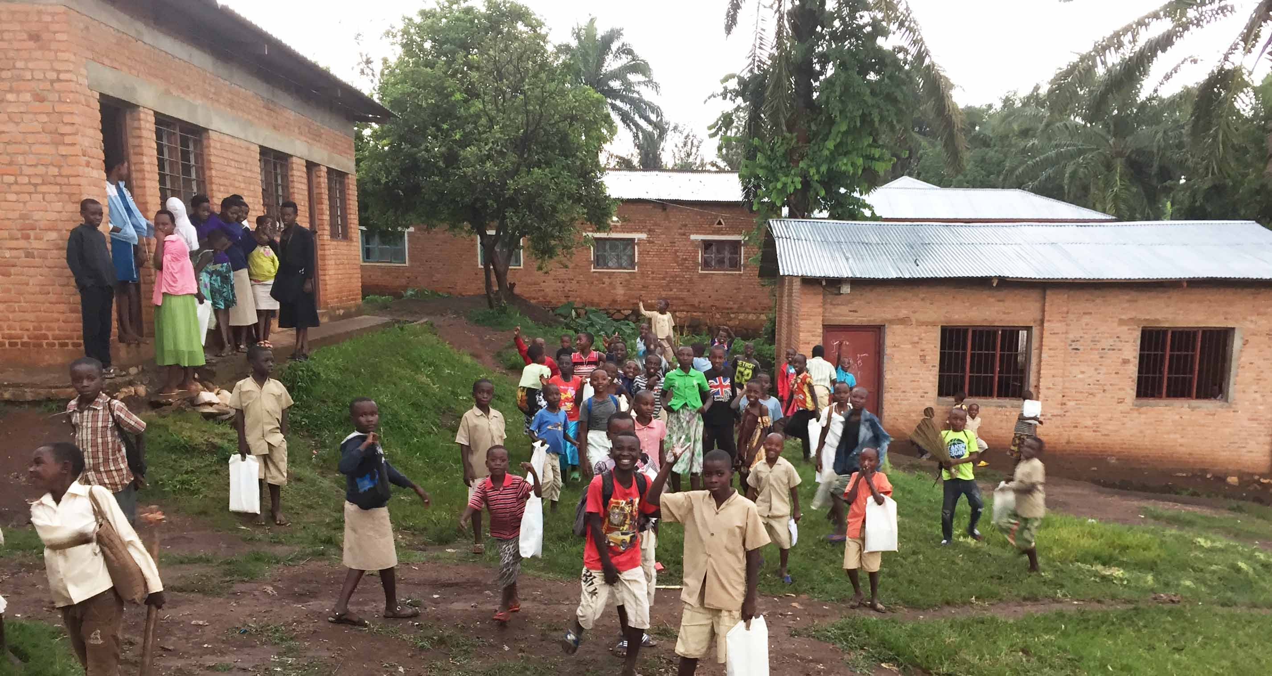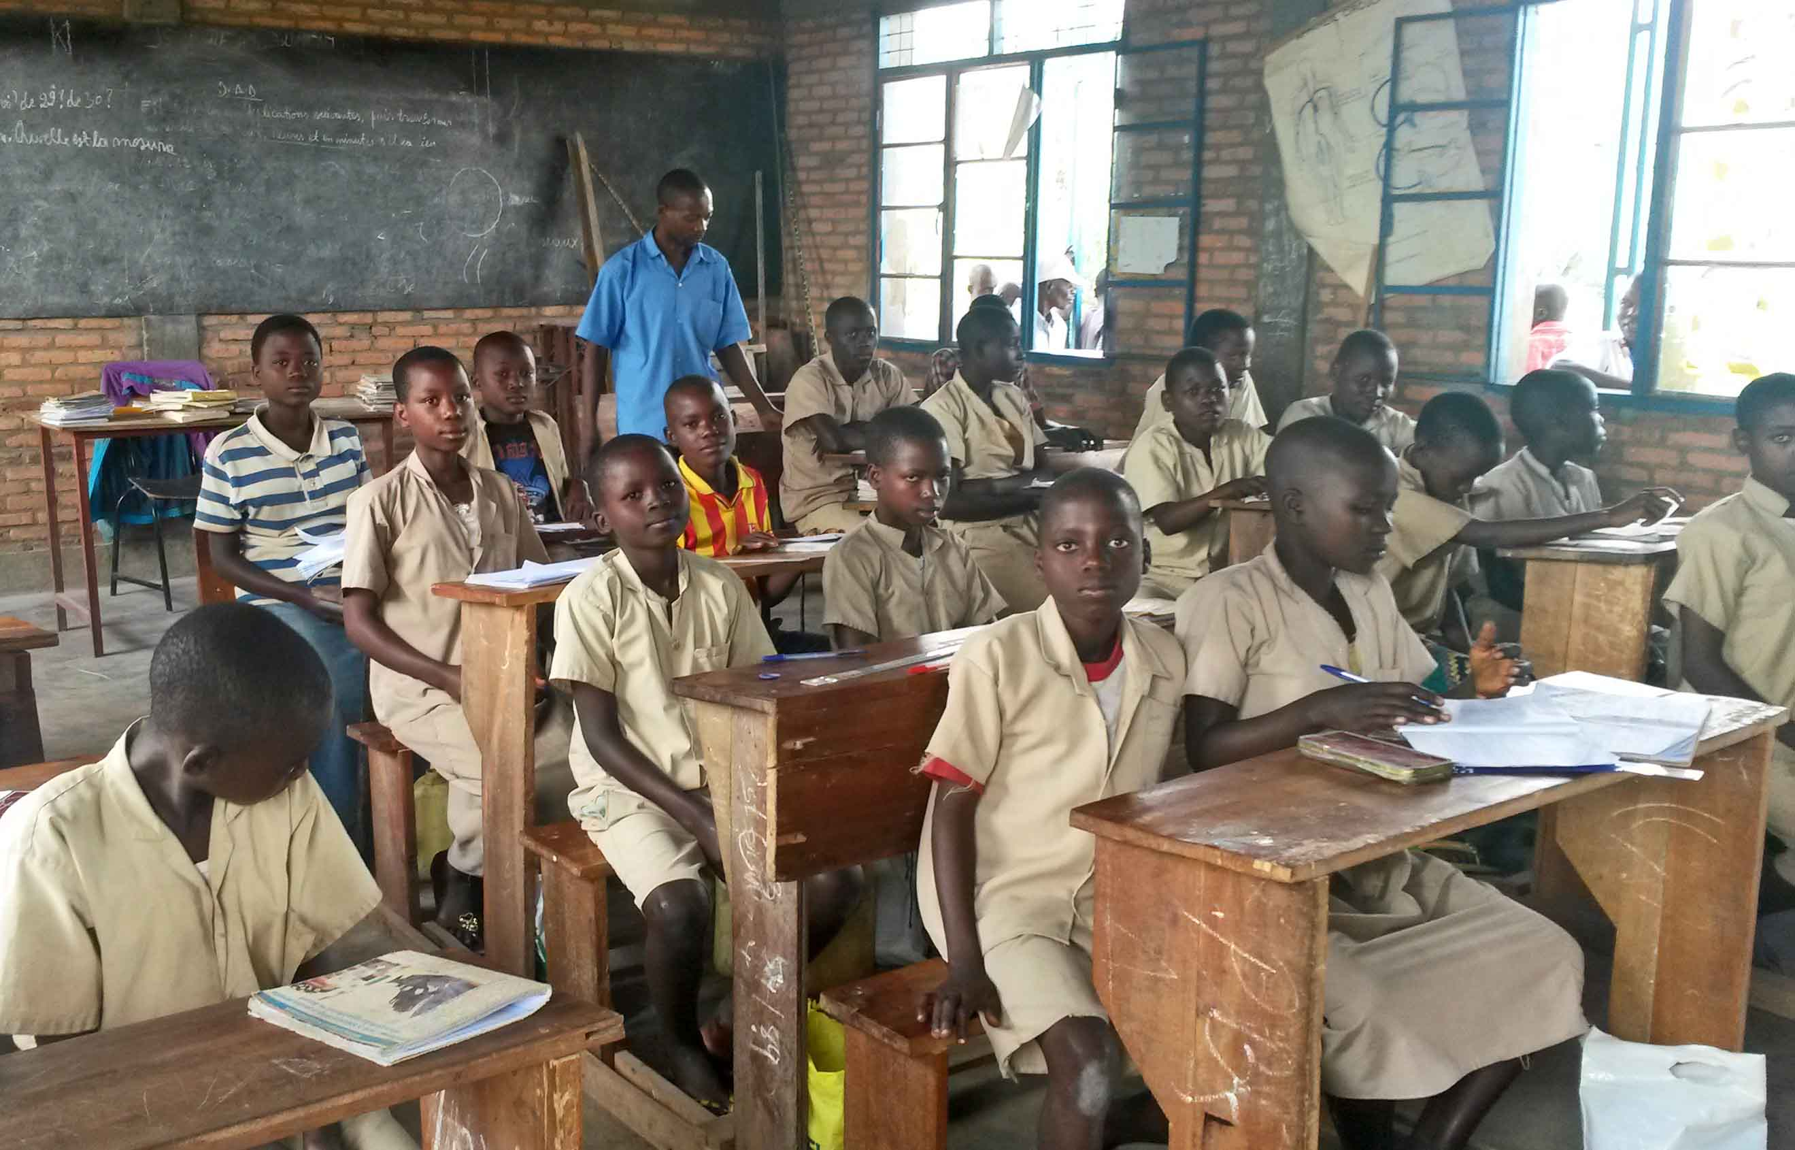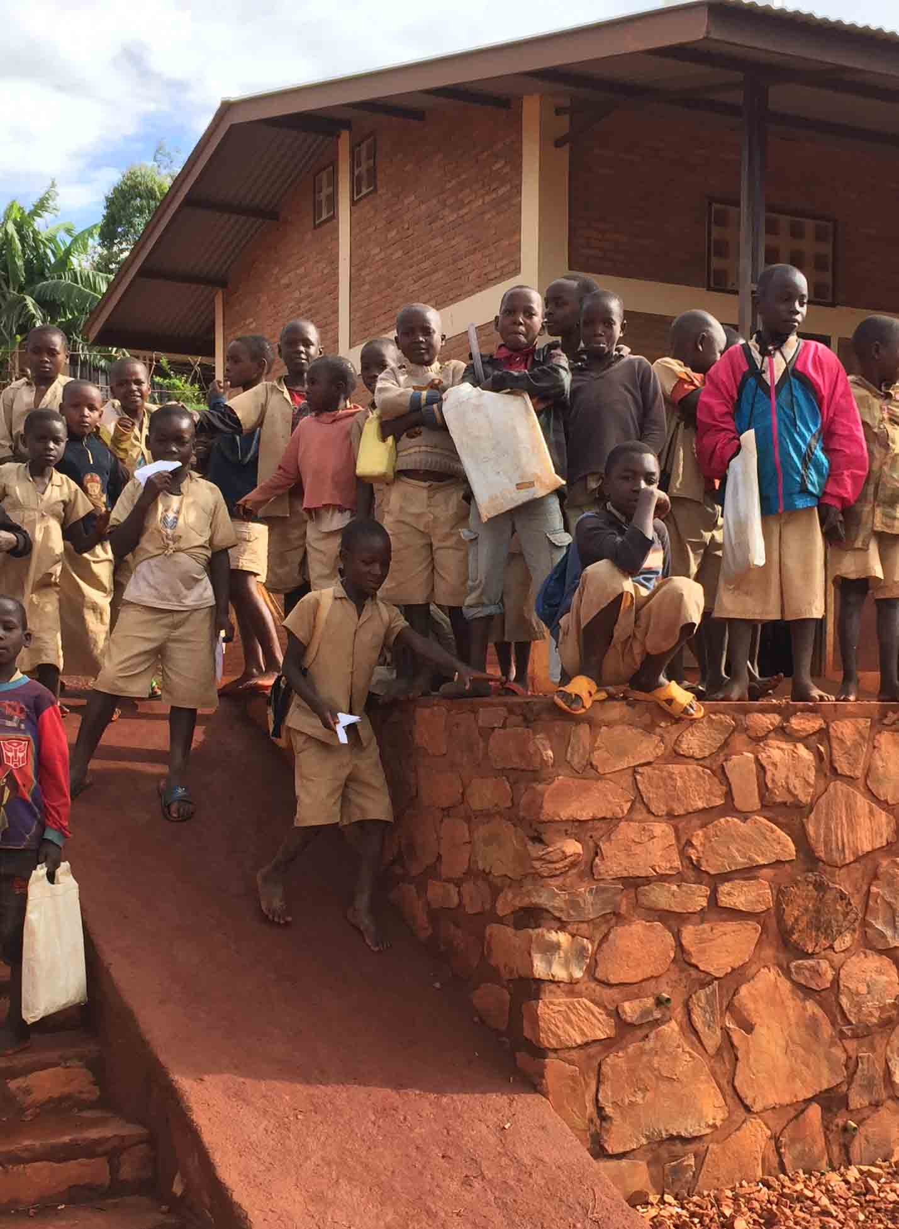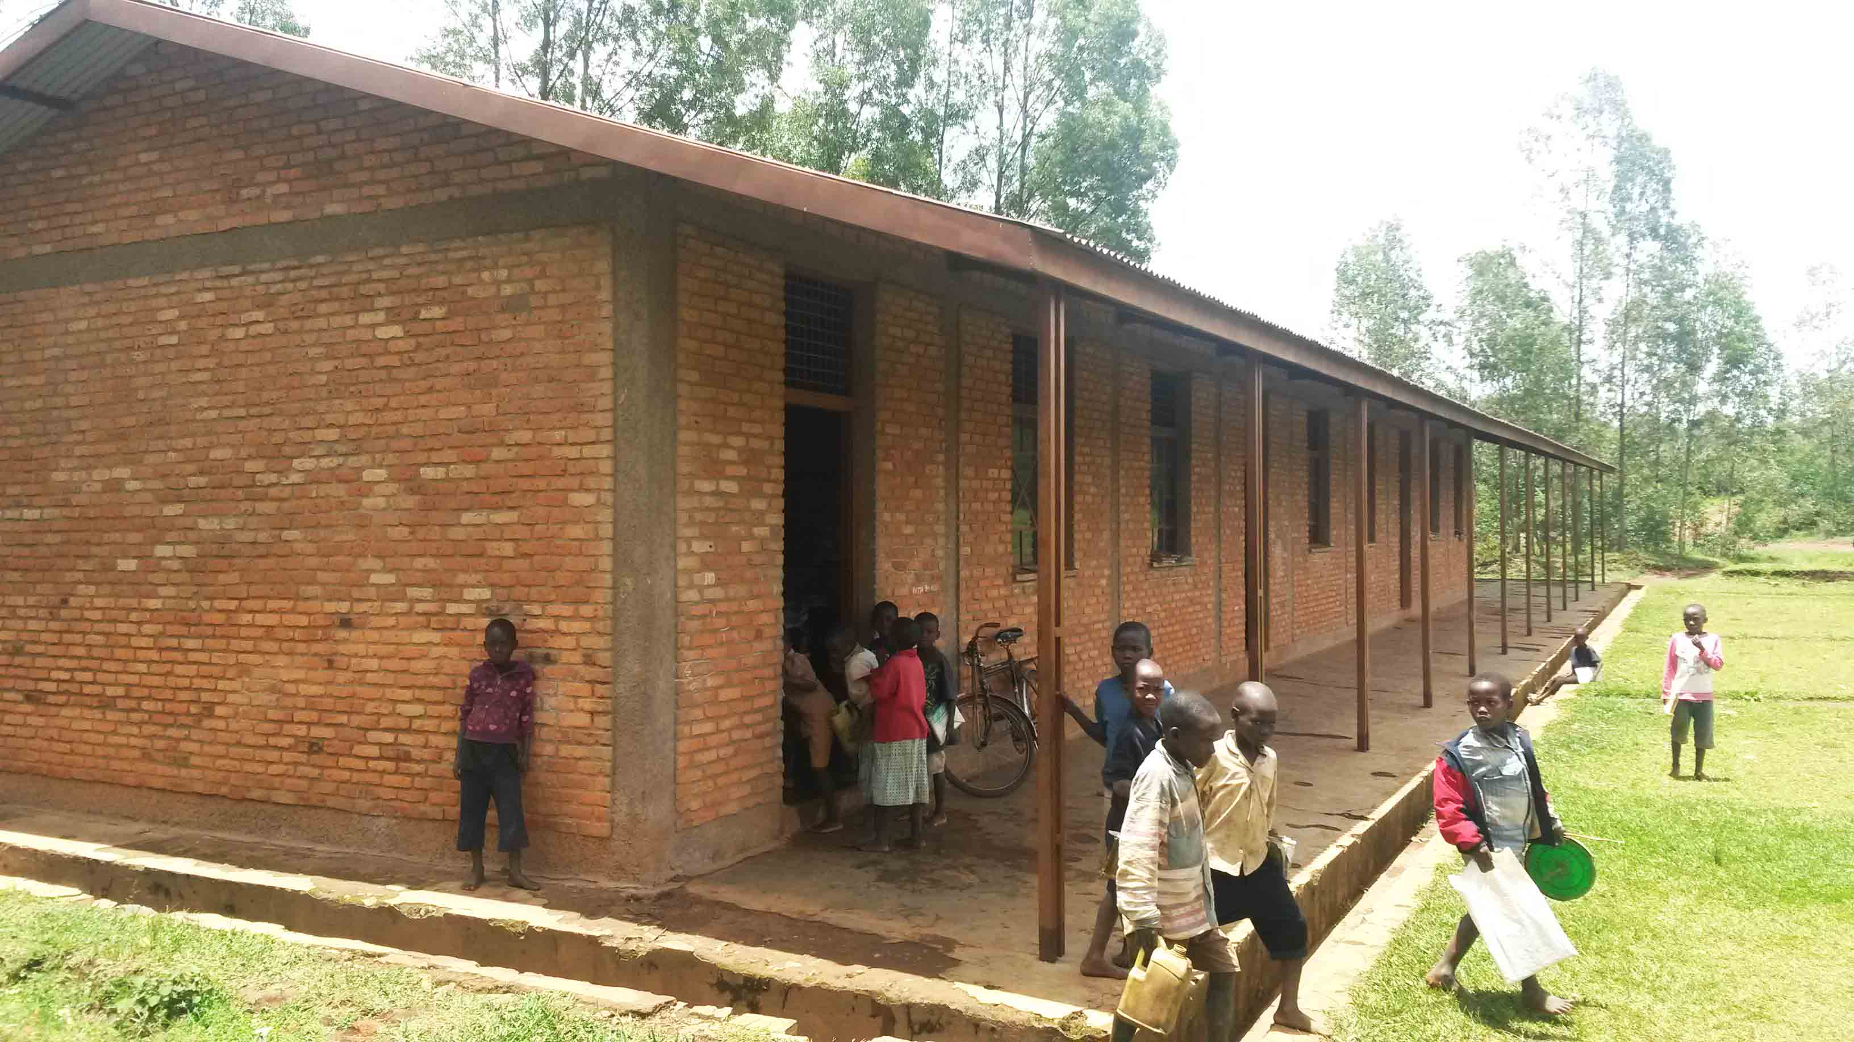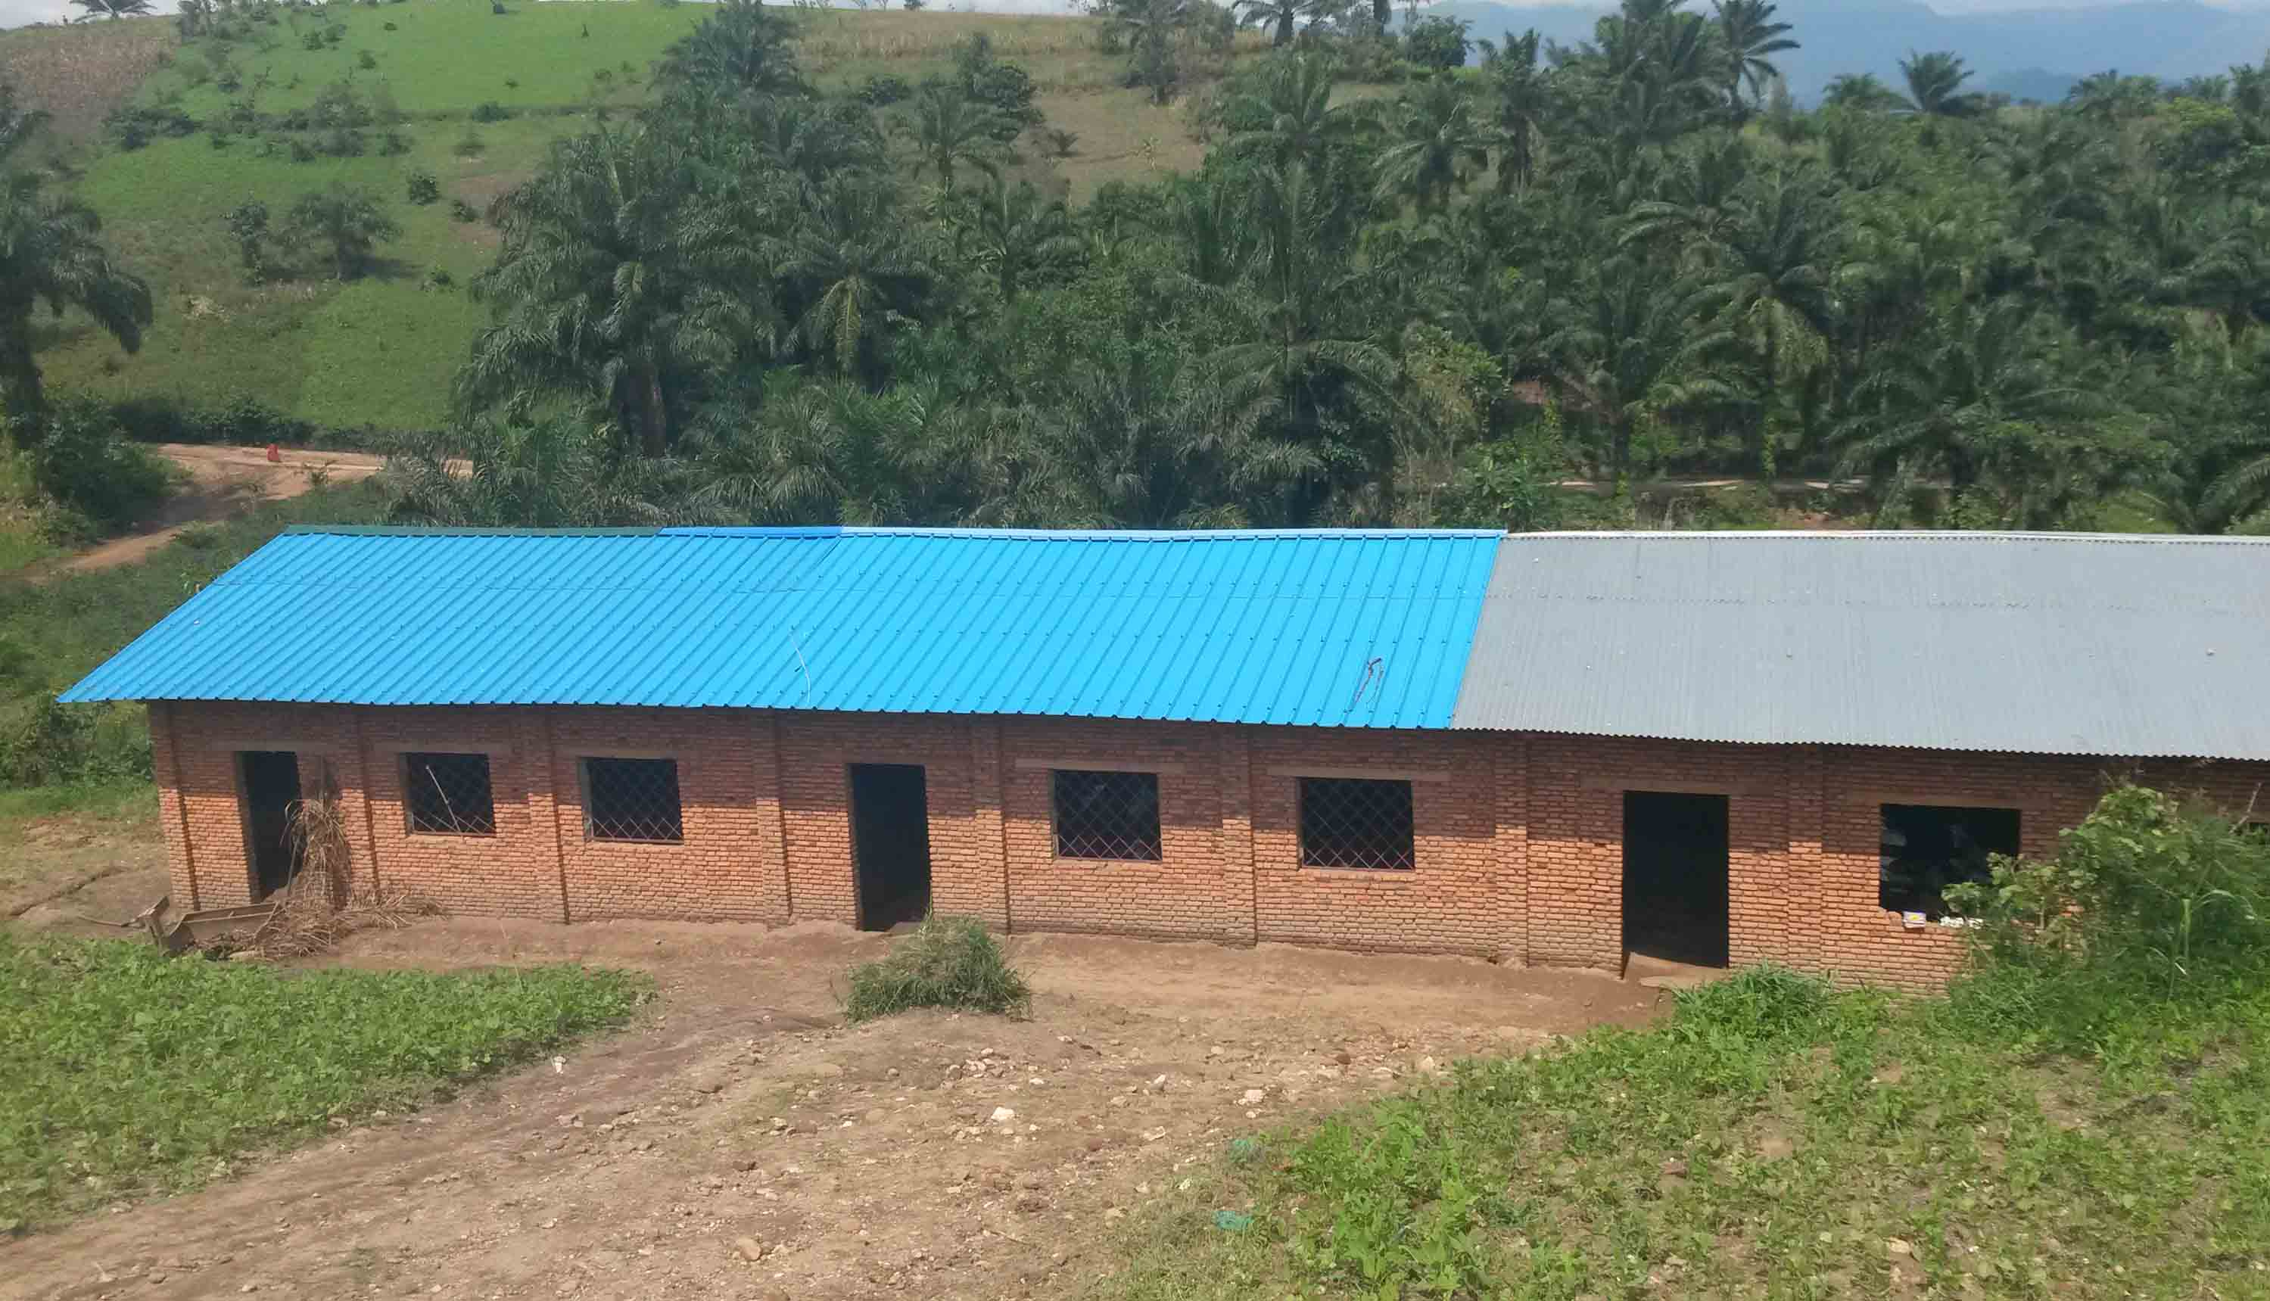

**EcoFo Giko**

**EcoFo Bubanza-II**

**EcoFo Rutegama**

**EcoFo Kyange**

**Serge Theunynck et Hervé Rabakoson**

**The World Bank**

**Mai 2017**

**Contents**

**Introduction** 3

**I. Status of the School Infrastructure Network 4**

Growth of the School Network 4

Occupancy rates of classrooms 6

Distance to school 7

Problematic of the Burundian school network

Status of facilities and hygiene in schools 8

**II. School construction needs analysis 9**

**III. The role of decentralization in school construction 11**

**IV. The Education and Training Sector Development Plan [Plan Sectoriel de l'Education et la Formation]**

**2012-2020 (PSDEF) as regards school construction 12**

**IV-A. The context before the PSDEF (before 2012) 12**

A1. School constructions with domestic resources 12

A2. School constructions with external resources 13

**IV-B. The Education and Training Sector Development Plan (PSDEF) 15**

**IV-C. School constructions under PSDEF (2013-2017) 16**

C1. Construction on domestic resources 16

- Community-based approaches 16

- A new communal approach: FONIC 18

C2. School construction financed by donor support 20

- The Common Fund for Education Fonds Commun pour l'Education (FCE) 20

- Delegation of Contract Management (MOD) to l'ABUTIP 21

- Contract Management Delegation (MOD) to UNICEF 23

- Direct contract management by communes (MOC) during PSDEF 24

**IV-D. The Performance-Based Financing pilot (PBF) 25**

**V. Comparative analysis of unit costs during PSDEF 27**

**VI. Options for the future 28**

Option 1: Delegation of contract management to communities 28

Option 2: Align communal financing channels 30

Option 3: Incorporating a formal construction component into the PBF 31

Option 4: Develop a National Scholl Construction Strategy 31

Option 5: Preparing a school construction program 33

**VII. Two environmental and social issues 35**

Seismic risk 35

Use of fired bricks 36

**References 37**

**Annex 1 40**

**Notes 41**

**Introduction**

**Context of this study on school construction.**

The present school construction study is done in the context of a World Bank's broader study performed in the context of Bank's reengagement in the Education Sector in Burundi, which has 3 components : (i) a review of the implementation status of the Education and Training Development Sector Plan (ETDSP) [Plan Sectoriel de Development de l'Education et la Formation (PDEF)] as regards basic education [École Fondamentale] ; (ii) a review of the school construction programs for basic education with a special attention on community-based approaches; and (iii) a feasibility study of a potential scale up of the Performance Based Financing (PBF) pilot. The present study the second one in this list.

**Objective of the Study**

The objective of the study is to: (i) review the current status of implementation of the school construction component of Burundi’s Education Sector Plan, the PSDEF, (ii) analyze school infrastructure needs and consider the extent of the challenge (iii) take stock of activities of the various school building donors, partners, and organizations, (iv) analyze the situation regarding decentralization in relation to school buildings and the potential in this context of the impressive community dynamics observed in the country and (v) identify opportunities which could help determine the form and content of a larger scale school building program. It is also to (vi) examine the extent to which the Performance Based Funding (PBF) pilot approach in the province of Bubanza and (vii) a Disbursement-linked Indicator Approach (DLI) approach would be appropriate for a school construction program.

**The mission**

Le school construction study was performed during a World Bank mission in Burundi on February 13-24, 2017 by: MM. Serge Theunynck, school construction and community-driven development and Hervé Rabakoson, engineer, under the lead of Mr. Simon Thacker, senior education specialist, head of mission; in liaison with the experts in charge of the other studies including Mr. Maurice Mazunya, university teacher and xxxx; and with support of Mrs. Sandrine Nininahaswe, program assistant. The study team was received in audience by her excellency Mrs. Dr. Janvière Ndirahisha, Education Minister [*Ministre de education, de l'Enseignement Supérieur et de la Recherche Scientifique (MEESRS*)], and by Mr./Dr. Léopold Habyarimana, Permanent Secretary in the MEESRS. The mission worked closely with Mrs. Malysie Hatungimana, Director of Basic Education, and Mr. Jérome Nyabemda, Director of the *Bureau des Infrastructures Scolaires, des Equipements et de la Maintenance* (BISEM) and his team, in the MEERS. The mission was received by the *Conseiller Principal Chargé de Missions* in the Republic Presidency office. Working sessions were held with the General Director of *Fonds National d'Investissement Communal (FONIC)*, Mrs. General Director of the *Agence Burundaise pour la Réalisation des Travaux d’Intérêt Public (ABUTIP)*, and experts of the international NGO Cordaid and the national NGO *Association de Développement pour l'Intérêt Social* (ADIS). The mission participated in an information/coordination meeting with the international partners (PTF) that support the Education sector, chaired by UNICEF with participation of PAM, CTB (complete list). Working sessions were held with UNICEF the Embassy of the Belgium Kingdom. Working sessions on field trips were also held with the Governor and the Education Provincial Directorate [*Direction Provinciale de l'Éducation (DPE*)] in Bubanza province, and the [*Directions Communales de l'Éducation (DCE)*] de Shombo et de Gitega. The mission visited the basic schools [Écoles Fondamentales (ECOFO)] of Notre Dame de la Paix et Bubanza II (Commune de Bubanza), Kiange (commune de Shombo), and Rutegama (Commune de Gitega).

**I**. **Status of the School Infrastructure Network**.

**Methodological note**. The structure of the pre-university education system in Burundi changed in 2012-2013. It went from 13 years divided into 6-4-3 years for primary, lower secondary, and higher secondary to a new structure with 9 years of Basic Education (*École Fondamentale*) and 3 years for Post-Basic Education. Basic education is organized into 4 cycles: I-II-III-IV, 2-2-2-3 years, with the first three cycles corresponding to the former primary school, and the fourth cycle to the former lower secondary. In the statistical yearbook 2014-2015, the data for Basic Education only goes to the 8th year because the reform only goes to that level after 2 years of existence.

**Growth of the School Network**

* 1. **The total number basic schools [*École Fondamentale*] (public and private) offering the first 8 levels of education is 4,035 in 2014/15**, of which 3,889 (96%) are public and 4% private. Out of the total of 4,035 schools, 736, or 18%, are recorded in the statistical yearbook as having a double-shift organization (p.70) [1]. However, it is possible that this percentage represents only the schools that are *fully* operating in double-shift, since according to the 2007 ECSR, 87% of sample of public primary schools analyzed in this study were operating in double-shift, at least partially. In 2014/2015, out of the total number of basic public schools, 2,727 schools or 70% offer primary education only, as shown in Table 1 below (the table stops at the 8th year because the reform introducing the 9-year basic education is then only 2 years old).

**Table 1. Number of public basic schools [*Ecole fondamentale -EF*] by higher level (year) reached by the school in 2014/2015 [2]**



Source: MEESRS. Data from the School Statistical Yearbook [*Annuaire statistique scolaire*] 2014/2015, p. 64

1. **The availability of *Écoles fondamentales* drops at the end of the 6th year.** There are less than half the number of schools offering the 7th and 8th year of schooling as there are schools offering the first 6 levels. This suggests that the distance between schools and dwellings increases significantly between the third and the fourth cycle of basic education. It is likely that the increase in distance may be one of the factors that explains drop-out by pupils at the end of the 6th year.
2. **Over the past 4 years (from 2012/2013 to 2016/2017), the total number of schools offering primary education has increased from 3,774 to 4,135 schools, an increase of 351 schools in 4 years or 88 schools per year, which is a considerable pace.** Yet this recent rhythm seems much lower than in previous years. Unfortunately, an analysis on a longer period is made difficult because the available the data for 2016/2017 does not disaggregate public and private schools, and data available for 2005/06 provides only the number of public primary schools (2,132). To circumvent this difficulty, a reasonable assumption is to apply for 2016/2017 the ratio of public schools out of total schools of 2012/2013 that is 97%. This gives a number of public primary schools of 4,016 in 2016/2017 that can now be compared to the number of 2,232 public schools in 2005/06. Based on this assumption, the number of public primary schools would have increased by 1,884 schools over the past 11 years, i.e. an average annual school-building rate of 171 per year that is almost twice the rate observed over the past 4 years. This also suggests that land acquisition problems for new schools have been well mastered in the past**.**

**Table 2. Evolution of the number of public school between 2005/06 and 206/17**



Sources: MEBSEMFPA. Data from Education Statistical Yearbook 2012/2013; MEESRS. Data from Education Statistical Yearbook 2014/2015; and "*Données de la rentrée scolaire* 2016/2017"

1. **The average annual rate of increase in the number of primary public classrooms (Level 1-6) was 458 rooms per year between 2012/2013 and 2014/15**, **a substantial decrease of the increase rate compared with the previous period**. Indeed, the number of classrooms of public primary education has only increased from 27,219 rooms in 2012-2013 to 28,134 rooms in 2014/2015, an increase of 915 rooms in 2 years. The comparison with the number of primary public classrooms in 2005/2006 shows that over the next 9 years the number of primary classrooms increased by 12,962 rooms, with an average annual growth of 1,440 classrooms during this period.

**Table 3. Evolution of the number of public primary classrooms from 2005 to 2014**



Sources: MEBSEMFPA. Data from Education Statistical Yearbook 2012/2013; MEESRS. Data from Education Statistical Yearbook 2014/2015; and "*Données de la rentrée scolaire* 2016/2017"

1. **About one-third (32%) of the classrooms and almost half (48%) of the 2014/2015 classes [teaching groups or *Groupes pédagogiques*] operate in double-shifts.** The number of teaching groups at the level of the *Ecole Fondamentale* (40,245) exceeds that of classrooms by 32% (30,421). The difference between the two numbers (40,245 – 30,421 = 9,824) represents the number of teaching groups that have no classroom, and therefore have to share one with another group. This number (9,824) represents the number of classrooms that accommodate successively two teaching groups in the same day. In other words, 32% of the classrooms operate un double-shifts. As regards the number of teaching groups that operate in double-shift with another group, it is 9.824 x 2 = 19,648, or almost half (49%) of the total number of the teaching groups. However, this situation affects only the first 6 years of education and virtually never reaches into years 7 and 8 where the ratio of groups to classrooms is nearly equal to 1.[3] In contrast, this ratio increases steadily as one descends from the 6th to the 1st year. Otherwise, the fact that the 32% classrooms that operate in double shift are located in 18% of the schools recorded to operate in double-shift suggests that double-shift classrooms tend to be concentrated in larger schools --these practicing double-shift have in average 13 classrooms/school compared to a national average of 6 classrooms/school (2014/2015).

**Table 4. Classrooms versus classes or groups of students in public schools by level**



Source: data from Education Statistical Yearbook 2014/2015, p. 7

1. **Over the past two years (2014/2015 to 2016/2017), the total number of cycles I, II and III (years 1-6) classrooms would have decreased significantly by 4%, from 29,146 to 28,017 rooms while the number of rooms in double-shifts would have increased by 18%.** This analysis is based on data from the Statistical Yearbook 2014/2015 and the Municipal Statistical Data from the school year 2016-2017 for cycles I, II and III. According to these latest data, the number of rooms for the first 3 cycles (first 6 year) has registered a significant decline of more than 1,100 classrooms over the past two years. It would be important to verify these data because they are inconsistent with the fact that at the same time, 915 FCE-funded classrooms and at least 302 FONIC-funded classrooms were built during these years, (see Fig 3, para. 4.10), without counting more than 1,600 rooms estimated by the authorities to have been constructed through the "community works" (see para.4.8). If these data are verified, this could mean that very many classrooms in the first three cycles are actually used for Cycle IV and secondary, and that others, built of unsustainable materials, were carried away by severe weather[4], as the mission also observed in two of the schools visited. In any case, the importance of the decline in the number of classrooms calls for a more detailed examination of this issue.

**Table 5. Evolution of the number of classrooms and double-shifts between 2014/15 and 2016/17**



Sources: (a) Statistics 2014-2015, p. 7 et 77; (b) special query 2016-2017; (c) number private TG in 2014-2015: authors' assumption: 1 TG = 1 clrm.

**Occupancy rates of classrooms**

1. **Classrooms are overloaded...** The average national pupil/classroom and pupil/teaching group ratios are respectively 71 and 54 as shown in Table 6. The average figure of 54 pupils per teaching group shows that classes are overloaded even after classes were organized in double-shifts (two groups in a single classroom, successively each day), which, as we have seen, involves almost half of the teaching groups. Despite the massive use of double-shift, the average size of the pedagogical groups are above the maximum standard of 50 students per class around which the construction programs are designed - as can be seen in the FCE-funded master plans. In addition, an average of 54 pupils / teaching group masks local disparities: if there are educational groups with a size of less than 54, there is also a correspondingly larger group of pedagogical groups (next para.).

**Table 6: Classrooms and Teaching Groups by Year of Instruction, and Ratios, National Averages**

Source: data from Statistics 2014-2015, p. 77 et p. 94

1. **...And classrooms in Bujumbura are extremely overburdened.** In the province of *Bujumbura-Mairie*, the ratios are extremely elevated. The group-to-classroom ratio rises to 1.6, and 74% of the Teaching Groups operate in double shifts - sharing the same classroom with another group. However, the practice of double-shift does not affect the years 7 and 8. In the lower classes, it is practiced by 80% of the teaching groups, and this rate rises to 85%, 90% and 86% in the Years 1, 2 and 3. Despite the division of the pupils' groups by double-shift, the rooms remain overloaded in proportions far above the national average. For the years 1, 2, 3 and 4, the average size of the educational groups is 80, 75, 71 and 69, which is well above the maximum of 60 pupils beyond which pedagogical specialists estimate that crowding does affect student outcomes. This is verified in Burundi where the *Concours National* of 2013 and the PASEC 2014 show that the results of students' learning are not different when the class size is between 40 and 60 students but is detrimentally affected above 60 (ECSR 2016, p.77).[5]

**Tableau 7: Classrooms and Teaching Groups by Year of Instruction, and Ratios, National Averages**

****Source: data from Education Statistics Yearbook 2014-2015, p. 77 et p. 81

**Distance to school**

1. **Primary schools are still too far from children**. Despite the sharp increase in the number of public primary schools between 2005 and 2014, they are still too far from children. In 2007, reducing the distance that children walk to school was recognized by the ECSR as necessary to increase access to education and reduce drop-outs. According to the 2002 QUID survey[6], 42% of rural children lived more than 2 km (equivalent to 30 minutes) from school. The 2006 QUIBB survey found that 56% of rural children were living more than 30 minutes from a school[7]; and half of the parents felt that their children aged 7-9 were too young to attend school --which is a reflection of this same fact. Figure1 shows the position of rural children in Burundi compared to other African countries, based on the 2 km distance threshold used in many African countries as a maximum distance. In Burundi, the Ministry has more recent data but uses the 3 km threshold. In 2012/2013, one quarter (24%) of primary school students walked more than 3 km, and 5% of students walked more than 5 km. In 5 provinces, there are 30% and more to walk more than 3 km. The 2016 ECSR does not provide distance data, but indicates that by 2013, the proportion of parents who feel their children are too young to go to school is 45%. It also indicates that in 2014, only 13% of children started school at the required age of 6 years, 58% came in one year late, and 29% were delayed by 2 years or more. The problem of distance has taken on a new dimension in 2012/2013 as the age of access to the Fundamental School [*Ecole Fondamentale*] has been lowered from 7 to 6 years old.

**Fig. 1. Percentage of rural primary school-age children living at more than 1/2 h or 2 km from the nearest school**



Source: ASCQE 2.1.

**Burundi**

1. **Distance to school is a factor in non-schooling.** The 2016 ECSR estimates that access to school is not universal: despite an admission rate of more than 100% and a gross enrollment ratio (GER) of 135 in 2013, almost 23% of children of 6-14 years of age who should attend *école fondamentale* are nevertheless out of school. In addition to other factors such as instability and lack of space, distance to school contributes negatively to access, but it also affects student retention.

**Fig. 2. Size of primary schools in Africa**

**(**Number of pupils per school)



Source: ASQUE 2.2

1. **Are schools too big?** There is, of course, a relationship between the size of schools and the distances that students have to travel to get there: larger schools often have a larger catchment area. Burundian primary schools averaged 7.1 classrooms and 510 pupils in 2005, and these ratios increased to 7.4 classrooms and 540 pupils per primary school in 2012/2013, despite the sharp increase in the number of schools. Figure 2 shows the position of Burundi compared to other African countries as regards school size. In Burundi, school size is certainly much lower than in Rwanda (885), but higher than in other neighboring countries: Tanzania (518), Kenya (385) and Uganda (274). Moreover, it is well established that beyond 200 - 250 pupils there is no economy of scale that can be generated by the increase in the size of the school.[8]

**Problematic of the Burundian school network.**

1. **Strategic planning choices.** The distance from school to students’ homes and the size of schools - which are the two sides of the same question - are at the heart of the problem of the future evolution of the school network. The question is also to solve two major problems mentioned above, namely: (a) decongestion of classes to allow for interactive pedagogy; and (b) the gradual elimination of double shifts to return to normal daily teaching time. In order to solve these problems, it is necessary to construct classrooms: there are three options: 1) to build them in existing schools, but this does not reduce the problem of distance between schools and dwellings; 2) build new schools, which reduces the problem of distance but raises the problem of finding the necessary lands, and 3) a judicious combination of the two.

**The status of facilities and hygiene in schools**

1. **A large number of primary schools are in poor condition**. In 2005-06, it was estimated that only 40 per cent of Burundi's 15,000 classrooms were constructed of durable or semi-durable materials with adequate roofing, i.e. 9,000 classrooms of non-durable materials such as adobe bricks. According to the ECSR 2012, only a little more than a third of the schools have all their rooms in good condition, and the rest is a mix of good and poor condition. According to a preparatory study for the PSDEF in 2012, it appeared that the classrooms constructed by the FONIC had many construction defects. The constructions made in the context of the "community works" are of low quality and poor durability. It is reasonable to think that the number of 9,000 classrooms in poor state has increased since 2005.
2. **Hygiene in schools requires significant improvement.** In 2005-06, it was estimated that drinking water was virtually non-existent in schools. Nine years later, in 2014/15, nearly half of schools (1,707 out of 3,889) have access to safe drinking water. This progression is impressive, although the situation is still far from satisfactory. For instance, less than half of the schools with drinking water (742 schools) had handwashing facilities. At the sanitary level, 3,889 schools in 2014/15 had 30,072 latrines for 2,166 million pupils, A ratio of 1 latrine for 72 students, slightly less for girls: 1 latrine for 75 girls. However, of this number, only 22,603 ​​latrines are in good condition which changes the ratio to 96 pupils per latrine. These ratios are very far from the standards recommended by UNICEF and WHO that recommend one latrine for 25 girls and a latrine plus a urinal for 50 boys. Statistics do not provide information on the availability of separate sanitary facilities for teachers.

**II. School construction needs analysis**

1. **The assessment of total classroom needs comprises seven distinct elements:**

* Additional classrooms needed to enroll school-aged children who are still out of school.
* The rooms to be added so that the average size of a teaching group evolves towards the goal of 50 pupils, which is the objective for good quality of education;
* Rooms that are needed to reduce the number of double-shifting classes to 20% (two teaching groups per day in the same classroom);
* The need to replace non-standard and unsustainable classrooms;
* The reconstruction needs of the classrooms destroyed during the events of 2015 and
* Rooms needed to cope with future population growth, for example, during with 5 years.

1. **A bout 11,000 classrooms would be built if all out-of-school children of school age 6-14 would be enrolled.** According to the ECSR 2016, 23% of children of basic age in 2013, (557,000 out of 2.42 million), are not in school. Using the ratio of 50 pupils per classroom which is currently used in the standard plans, it would be necessary to build 11,140 classrooms to accommodate them if they should have been in schools. However, this number is an absolute upper bound because the causes for non-attendance are not only related to lack of supply but also to demand-related issues. In addition, other options may be considered to reduce this number such as a more intense use of double-shift or alternative methods of education.
2. **At least 2,250 additional classrooms are required in order to move the size of teaching groups [*groupes pédagogiques*]** **to an average of 50 students.** Indeed, the 39,511 teaching groups (in 2014-15) have an average of 53.8 pupils. In order to have an average of 50 pupils, they should be divided into 42,500 teaching groups (2,166 million pupils / 50). That is to say that it would be necessary to create 2,250 additional teaching groups, hence to build 2,250 additional classrooms. This, without changing the current rate of rooms in double shift.
3. **Approximately 9,200 additional classrooms are required to reduce double-shift instruction --an objective of the PSDEF.** The plan aims to decrease the percentage of double-shifts from 57% in 2010-11 to 20% in 2020. In 2014-15, statistics show that 58% of teaching groups (TG) shared a single classroom with another teaching group. In fact, there are 39,511 teaching groups, while there are only 28,011 classrooms, which means that 11,500 TGs do not have a classroom and therefore have to share one with another TG. As a result, 23,000 TGs operate in double shifts, out of a total of 39,511, or 58%. For this rate to fall to 0% it would be necessary to build 11,500 additional rooms; and to fall to 20%, it would be necessary to build 4/5 of 11,500 rooms, or 9,200 rooms. The other option to cope with the demographic increase is, in the short run, to continue expanding the double-shifting system, and in the long run, to keep the girls in middle and secondary schools.
4. **Approximately 9,000 classrooms of unsustainable materials should be rebuilt.** Classrooms made of unsustainable materials do not allow for a secure teaching environment. They cannot be used when it rains, reducing the number of hours taught each year. In addition, many of these classrooms are destroyed every year during the heavy rainfall. This was the case of two rooms destroyed by floods in the school of Kigondeka (Bubanza commune) visited by the mission. In 2005-06, it was estimated that only 40% of Burundi's 15,000 classrooms were constructed of durable or semi-durable materials with adequate roofing, or 9,000 classrooms of non-durable materials. It is reasonable to think that this order of magnitude is still current in 2017.
5. **Classrooms were damaged during the events of 2015 during their occupations of military or police forces**. A number are probably to be reconstructed, but there is no data available on this point[9].
6. **At least 5,500 additional classrooms should be built from 2015 to 2020 to deal with population growth alone.** Estimates of the population growth rate are different depending on the sources. On the basis of 3.28% / year (World Bank Indicators), the annual growth in the number of children of basic school age, estimated at 2.42 million in 2013, is over 55,200 children per year, which represents a little over 1,100 classrooms per year. In other words, from 2015 to 2020, the need for classrooms grew by 5,500 classrooms.
7. **In total, an estimated nearly 38,000 classrooms would have to be built if all the above-listed need would be addressed.** This estimate shows an absolute upper bound that does not take into account the demand-related issue, nor possible pedagogic alternatives, as earlier mentioned for the estimation of classrooms related to out-of-school children (11,000) that comes on top. Second, comes the need for classrooms to reduce double-shifts to 20% according to PSEDF objective (9,200), and almost in equal proportion (9,000), classrooms of non-durable materials that need to be reconstructed. The need for classrooms to cope with population growth for the next 5 years (5,500) comes in 4th place in the list. In any case, the objective of this paragraph is to draw attention on the fact that the satisfaction of all these needs requires the construction of a number of classrooms whose scale is far above the quantitative objectives of the PSDEF and that of the support programs that are available to it.

**Fig. 3. Assessment of the number of classrooms that needs to be built (2015)**



Source: authors' calculations

1. **On the basis of current CFE unit costs, the corresponding amount to finance all of the above-listed requirements would be about US$ 760 million or 570 million (at the official rate of US $ 1700/US$) depending on whether double shifting is covered or not**. For this calculation, the unit cost used for a "classroom equivalent" includes the classroom, its furniture, the prorated sanitary facilities that accompanies it, plus the cost of site supervision. It is taken from the average costs of the CFE-financed MOC program that committed BIF 23 billion for the construction of 657 classrooms, at a unit cost of BIF 35 million per "classroom equivalent". Table 8 below further shows that the total amount would be BIF 517 or 389 million if the exchange rate on the informal market is used for the calculation. In any case, the purpose of this paragraph is to highlight the importance of the amounts to be considered in order to meet all needs.

**Table 8. Estimation of the scale of financing needs to face all needs**

Source. Authors' calculation.

1. **The magnitude of the estimated needs of the above-list shows the importance of prioritizing them**. It is unlikely that the above-mentioned amounts would be mobilized in the immediate future. In this context, what priority should be given to out-of-school children and to the question of distance home-to-schools? Is it so urgent to reduce the practice of double-flow? Given their magnitude, is it reasonable to consider the reduction of double-shift? Would it not be preferable to increase its expansion? In this case, the priority may be placed on the limitation of the size of teaching groups, which has a strong impact on the quality of education and students learnings, and to place a stronger priority on a further reduction of teaching-group-size in the first levels. How urgent is the reconstruction of classrooms of non-durable materials that are likely to be washed away by rain and/or strong winds? What priority should be given to expanding basic education infrastructure to meet population growth? Perhaps would it be better to give priority to the type of school infrastructure that help keeping girls in middle and secondary schools - including hygiene arrangements -- as it is well established that this plays a key role for the demographic transition. These questions of priority may be addressed in the process of developing a School Construction Strategy as mentioned in Chapter VI (option 4)
2. **The question of the availability of school land arises acutely** because of demography, i.e. the high population density in Burundi (400 inhabitants / km2), the very high rate of rural population (estimated at 88% in 2016), and the high degree of population growth (above 3%). In this context of tension on land, is it possible to build new schools, according to which practical modality ? This issue would also be adressed during the preparation of a School Construction Strategy.

**III. The role of decentralization in school construction**

1. **The 2010 law establishes communal decentralization.** The municipality [in French ‘commune’] is now at the heart of local development in Burundi. It is headed by the Administrator and is responsible for the Communal Plan for Community Development (CPCD) after consultation with the Communal Development Committee (CDC). In the 2010 law, the details of the transfer of competencies are not specified, nor the practical arrangements for the exercise of transferred powers. Highlights of the 2010 act are summarized in Box 1.

**Box 1. Municipal law of 2010. Extracts.** The municipality is responsible for managing the local interests of the population of its jurisdiction. It ensures public services that meet the needs of this population and are not, by their nature, their importance or by the determination of the law, the direct responsibility of the State. The State may delegate to it the management or the execution, at the local level, of some of the missions that fall to it. In this case, it provides the necessary human, material and financial resources (Art. 5). The municipal council votes the budget, sets the community development program, supervises its implementation and ensures its evaluation (Art. 13). The commune is administered by the Municipal Council and the Communal Administrator (Art. 8) elected by the council (Art. 11). The Communal Administrator directs and supervises all communal services and coordinates all socio-economic development activities (Article 25). In his commune, the Communal Administrator represents the State (Article 26). It receives a salary from the State and other benefits determined by the Municipal Council from the budget of the municipality (Art. 29). He directs and administers the commune; he prepares the community development section and monitors its implementation (Article 30). The "Hill" [in French "Colline"] or the Neighborhood [in French "Quartier"] is administered by the Council of Hill or Neighborhood and the Head of Hill or Neighborhood (Article 34) who is the animator of social peace and development in his constituency (Article 37). The Community Development Committee set up by the Communal Council on the basis of a proposal by the Communal Administrator is an advisory body composed of persons engaged in community development (Article 38). The Communal Administrator transmits to the Municipal Council a semi-annual report on the state of progress of the communal plan for community development -CPCD (Article 39). The Communal Administrator recruits the municipal staff, which includes at least: a technical adviser in charge of administrative and social matters, a technical adviser in charge of development issues, a municipal secretary, a civil registrar and a municipal accountant. (Articles 41, 42). The technical adviser in charge of economic affairs and development: collects data for the development of the CPCD, prepares and monitors the implementation of development projects (Article 52). Guardianship over the acts of the communes is assured by the Provincial Governor (Article 96). Source: GoB 2010,

3.2. **Since 2015, the Municipalities are responsible for overseeing the construction of schools.** The law of 25 May 2015 stipulates that: "The municipality shall be responsible for the construction, equipping and maintenance of communal public establishments for pre-school, basic, vocational, secondary and higher education." (GoB 2016a, Article 7, Section 3, Chapter II).

**IV. The Education and Training Sector Plan [Plan Sectoriel de l'Education et la Formation PSDEF] 2012-2020 as regards school construction**

**IV-A. The context before the PSDEF** **(before 2012)**

1. During the crisis of 1993-2005 and since its end, a large number of initiatives were taken to build school infrastructure. It is in this context that the PSDEF was prepared and adopted in 2012. The Section IV.A provides an overview of these experiences before the PSDEF. Fig 4 illustrates them, categorized by the implementation arrangement (communities, centralized, delegation to CMAs, Communes' direct implementation of work contracts. The section is further divided into two main groups: on the one hand, approaches funded with domestic resources and, on the other, approaches funded with external resources.

**Fig.4. Projects by main implementation arrangements between 1995 and 2016**



As Fig.4, illustrates, the 3 main implementation arrangements that were actually implemented during the PSDEF period (in yellow) were already in place, long ago (5 years) before PSDEF starts.

**A1. School construction with domestic resources:**

1. During the years before PSDEF, with its own resources, the Government focused on: (a) the "Community works"; and (b) the Communes financed by the FONIC. The result is generally marked by a poor quality of constructions. The details are as follows:
2. **The "Community works" (CW) was the largest part of school construction, but the quality of work is low.** This approach is a traditional way for the authorities to mobilize communities, which dates from before independence and was dynamically revived in 2006 under the President's leadership (see Box 3 below). Communities are mobilized on Saturdays. They provide local materials and carry out unskilled work. The CWs are mainly organized by the municipalities that assist the communities with their technicians, and as soon as the walls are erected by communities, mobilize the Presidential Initiative to give the roof and so facilitate the building completion. In 2005-2012, the majority of school buildings were the result of this approach. The PSDEF preparation report reveals that in some provinces, such as Cibitoke, 80% of construction in 2011 was done this way, but they were estimated, however of limited durability.[10]
3. **The community infrastructure built by the Communes with FONIC funds in the years 2007-2012 resulted in poor quality construction.** The *Fonds National d'Investissement Communal* (FONIC) was created in 2007 under the supervision of the Ministry of Communal Development. In 2001, FONIC had resources totaling 4.5 billion BIF (equivalent to US$3.3 million). From 2007 to 2011, the approach was a hybrid one: the municipality bought the materials by tender and financed the skilled labor on the basis of a flat-rate envelope (3 million euros), while unskilled labor and local materials were provided by the concerned community through CW. On visits, the PSDEF preparation mission found infrastructure that was often incomplete. The mission felt that the quality of the works by the Communes with FONIC funds was comparable to that of the CWs. In total, between 2007 and 2011, FONIC estimated that 448 classrooms were built.[11]

**A.2. Construction with external resources:**

1. Before PDEF and with support of the donor partners, the construction of school infrastructure took several implementing directions according to projects. The common feature is a overtime gradual convergence towards two approaches: a) the delegation to a Contract Management Agencies (CMA) [*Maitrise d'Ouvrage Déléguée*] or MOD; and b) direct project management by Communes [*Maitrise d'Ouvrage Communale directe*] or MOC. Details are the following:
2. **In the more distant past, projects were of Social Fund type: the Social Action Project (BURSAP 1995-1997 and BURSAP-II 1999-2006) called Twitezimbere I and II, financed by IDA**, They were designed on the basis of previous experience of the EU-funded Micro-Development Project (PMR). They followed the 1993-1998 crisis. As the PMR, they were "demand-driven" and implemented by the Community Development Committees (CDC) through local competitive biddings or price comparison. The projects were managed by an NGO named Twitezimbere. They were carried out entirely during a long period of major unrest and insecurity that had begun in 1993. At the end of the first project, which funded 256 schools, the average unit cost of the classrooms was US$ 64/m2, which was twice less than those built in parallel by UNCHR, ARP, BPE, CEPBU, at 131, 103, 129 and 159 US$/m2 respectively, according to its ICR. In the second project the average unit cost of classroom constructions was, according to its ICR, at 110.9943 FBU/m2 equivalent to 102US$/m2 (at 2004 exchange rate). This was much lower than that of ABUTIP[12] for similar constructions (162.427BIF/m2 equivalent to 150US$/m2). During this second project, the communities contributed 8.5% of the value of the buildings -- corresponding to a total of 1.4 million days of work. However, this approach had no follow up.
3. **Then, in 2005, a centralized approach was tried for three years but had no follow up.** Following the Arusha Agreement on Peace and Reconciliation, a three-year plan for the reconstruction of school infrastructure was carried out with funds from the Heavily Indebted Poor Countries (HIPC) initiative. A thousand classrooms was built in 2006-2007 through limited competitive bidding between constructors of the formal sector, for works packaged by provinces. However, the 2012 PSDEF preparation report indicates that the awarded firms were overburdened by other large construction contracts and tended to subcontract school construction projects to local small-scale contractors of the informal sector. No evaluation of this experience is known.
4. **UNICEF's school building projects in 2008-2011 were directly managed by this agency.** It built 234 classrooms using its own funds and procurement procedures.
5. **The delegation to a Contract Management Agency (CMA) [in French, Maitrise d'Ouvrage Déléguée or MOD] for school construction born in Burundi in 2007.** Three projects starting in 2007, 2009 and 2011, financed by IDA and the Education Common Fund (FCE) used the MOD approach with delegation to the specialized agency, ABUTIP.These are: (i) the IDA-funded Project to Support the Reconstruction of the Burundian Educational System (SRBES/PARSEB, 2007-2012), which built 231 classrooms by ABUTIP at a high cost; (ii) the Public Works and Urban Management Project (PWUMP/PTPGU, 2009-2014) also financed by IDA, which, among other basic infrastructure, built a total of 127 classrooms with ABUTIP; (iii) support from the Common Fund for Education (FCE, 2011-2014) administered by donor partners, financed the construction of 210 classrooms also by ABUTIP, half of which were completed before the PSDEF.
6. **In parallel, the construction of school facilities through direct contract management by Commnunes (in French *Maitrise d'Ouvrage Communale* or MOC) also started in 2007.** Three projects starting in 2007, 2009 and 2011, financed respectively by IDA, AfDB and the Belgium Cooperation (CTB), supported municipalities with the construction of school buildings through direct procurement management. These included: (i) the IDA-funded Community and Social Development Support Project (CSDSP/PRADECS, 2007-2012), where 652 classrooms were built by municipalities throuh MOC, 3 times more than the PARSEB education project through MOD; (ii) the Job Creation Program Support Project (CPSP/PAPCE, 2009-2015), also multisectoral, but financed by the ADB, in which some 60 classrooms were built by the communes through MOC; and (iii) the Local Development and Citizen Participation Project supported by the Belgian Cooperation in the Province of Cibitoke (LDCPP/PADLPC 2011-2015), which financed the construction of 150 classrooms (among other infrastructures) in the 6 communes of the Province. The objective was to support the creation of communal skills for planning of their Communal Community Development Plan (PCDC) and to create their competences for direct contract management (MOC)[13]. These new competencies were further practiced under PSEDF with FONIC and FCE funds.
7. Table 9 presents a summary of data collected during the mission, regarding the number of classrooms built during the ten-year period 2006-2016. Data in the upper lines allow, on the one hand, to calculate the total of classrooms financed by the Financial and Technical Partners (FTP or, in French PTF). On the other hand, bottom lines record data collected as regards classrooms built by communities through "Community works" and these financed by FONIC from the domestic budget. The last line records the number of classrooms drawn form available statistic from the Ministry of Education. Work remains to be done to collect the missing data in order to complete the table and reach global consistency.

**Table 9. Distribution of school construction projects (classrooms only) between 2006 and 2016**



**IV-B. The Education and Training Sector Development Plan (PSDEF)**

1. **The 2012-2020 PSDEF plans to build 4,769 cycle-I-II-III classrooms during the first 3 years (2013-2015), i.e. about 1,600 per year.** Annex 7.3 of the PSDEF (p. 28) detail: 1,706, 1,652 and 1,441 respectively for 2013, 2014, 2015. The plan also suggests that construction programs should ensure that schools have separate latrines and water points. To this end, the PSDEF looked to: (i) pursue delegation to contract management agencies (MOD); (ii) support direct contract management by communes (MOC); and (iii) subsidize communities' classrooms. It aimed also to strengthen the programming and monitoring capacities of BISEM (the MEESRS' directorate responsible for overseeing construction) and the provincial directorates, with the ultimate objective of developing a national school building strategy. Box 2 below recalls the three main school building strategies.

**Box 2. School building strategies of the PSDEF**

[quote] "The Ministry intends to continue to employ the already active contract management agencies and to develop the communal and community contracting for works, which are to become the main execution process [...].

* The Ministry intends to continue to contract with existing contract management agencies [...].
* The Ministry with the support of the Technical and Financing Partners (TFPs) will accompany and reinforce the Communes' procurement of works for school buildings. To this end, it will increase the technical capacity of the Office for School Infrastructures, Equipment and Maintenance (BISEM) [...].
* Grants for the construction of community classrooms. In addition to the Communes’ procurement of works for classrooms, the Ministry will develop a tendering mechanism to subsidize the construction of community classrooms. The latter will be based on the following principles: (i) eligibility criteria to ensure the proper management of the subsidies paid; (ii) a community request validated by the deconcentrated services and submitted by a Commune; (iii) mobilization of communities and communes contribution to complement the Ministry's grant; (iv) the requirement to comply with school infrastructure standards and their supervision, (vi) technical support and supervision by BISEM of the construction works, (vii) frequent and systematic technical and financial controls.

Source : PSDEF, pp. 41-43

1. **The 2012 Ministry of Education study on the modalities of construction of classrooms, carried out in 2012 as part of the preparation of the PSDEF** [14]**, proposed the following principles:**

* Geographic planning based on four key standards: i) maximum home-to-school distance; ii) maximum size of a school; (iii) the minimum population for the opening of a school and (iv) a minimum package of infrastructure;
* Three parallel approaches to contract for works: (i) delegation of procurement and management to executing agencies (MOD); (ii) direct contract management by communes (MOC); and (iii) delegation to communities;
* Empowerment of grassroots communities in identifying the need, formulation and monitoring of the school sub-project. Inclusion of the approach into the process of municipal decentralization;
* Use of standard construction plans for classrooms and associated buildings to: (i) optimize cost / quality; (ii) 25-year durability; and (iii) minimum lighting, ventilation and standard area/pupil;
* Compliance with the Government's environmental risk management plan;
* Transparency of operations at all levels and at all stages.

**IV-C. School construction under PSDEF during 2013-2017**

1. Actually, from 2013 onwards, school constructions planned in the PSDEF were essentially carried out in accordance with the following pre-existing approaches: "Community works" (CW), community initiatives, delegation to contract management agencies (the MOD approach), Communal direct contract management (the MOC approach), while a new approach to educational development also appeared: the Performance-Based Financing (FBP), within which certain communities used the FBP to build school infrastructure. However, although the two first implementation approaches MOD and MOC initially planned in the PSEDF were actually implemented by the Ministry of Education, it did not initiate the exploration of the third approach, namely the delegation of procurement of works to communities through the BISEM supervision, The details of the approaches actually implemented during the PSEDF period are summarized below. As for the previous period, they are organized in two groups according whether they are financed on domestic or on external resources.

**C1. Construction on domestic resources**

**Community-based approaches**

1. **A large part of the new school buildings constructed since 2013 are the result of the "Community Works" (CW).** The scope of this program is impressive and its impact easily visible in the landscape by the blue color of the roofs provided by the Presidential initiative. According to data from the Planning and Evaluation Office of the Ministry of Education, the average annual number of rooms erected through CW between 2012 and 2015 was 976. According to the person in charge of the program at the Presidency, 1,479 Class were built in 2016 through CW. However, in the last year, a large number of these classrooms were built for municipal TVET centers that are presently receiving priority consideration from authorities, making difficult to assess how many classrooms were actually primary of basic education ones. The annual budget allocated by the Presidency is about 2 billion BIF.[15]

|  |  |
| --- | --- |
| **Fig. 5 et 6. Examples of Community Development Work** | |
|  |  |
| Source: ECOFO Shombo et ECOFO Giko, prov. Bubanza, 2017. photos Theunynck. | |

1. As mentioned above, CW are organized by the State and/or the municipalities to mobilize local populations in order to carry out works of collective interest -- such as school construction. They take place every Saturdays, and any active person native to the concerned local community should participate. These works are of all types, roads, ditches, etc., but schools constitute the greater part of them. Members of the community bring in local materials (foundation-stones, fired-bricks for walls, materials for floors and mortars, lumber and joinery), and provide labor (by digging foundations, mounting walls). The commune supplies the cement and the mason who oversees building. Roofing sheets and other finishing materials are provided to the communities through the "President's Initiatives" program. To this end, the municipality puts together a file with photos of the infrastructure reaching having reached wall completion), and transmits it, via the provincial authorities, to the above-mentioned program that, in turn, provides the roofs.

**Box 3. Burundi's "community development work" is a population mobilization practice** that other countries in the Central African region have known or are still familiar with: the Harambee system (“Pull all together” in Swahili) in Kenya, Salongo in Zaire, Bega kwa bega yards (shoulder to shoulder) in Tanzania, Umuganda in Rwanda. They are based on national traditions of mutual assistance and were promoted by the leaders of the newly independent states in the 1960s or 1970s with a view to a philosophy of mobilizing citizens. In general, administrative and political executives are responsible for the coordination and coordination of the work to which all citizens of the locality have to participate. Symbolically, the Head of State sets an example. In Burundi, this approach is currently the subject of an active and ongoing national policy, the legal framework of which dates from the 1979 decree-laws.[16]

1. **Classroom constructions also result from community initiatives** that are entirely managed by communities organized around their school's management committee. The mission found it in almost all schools visited. The community supplies the local raw materials, transportation, and contributes to the cost of bricks. This construction is of the same quality as those of the CWs, when the walls are made of fired-brick, or less good when they are made of adobe bricks (bricks of dried clay), as in the construction of the upper right of figure 7. In this image, the space in front of the adobe construction was occupied until last year by two other adobe rooms that were washed away by heavy rains. The community rebuilt them down below with fired- brick (bottom left of figure 7).

**Fig. 7. Constructions communautaires.**

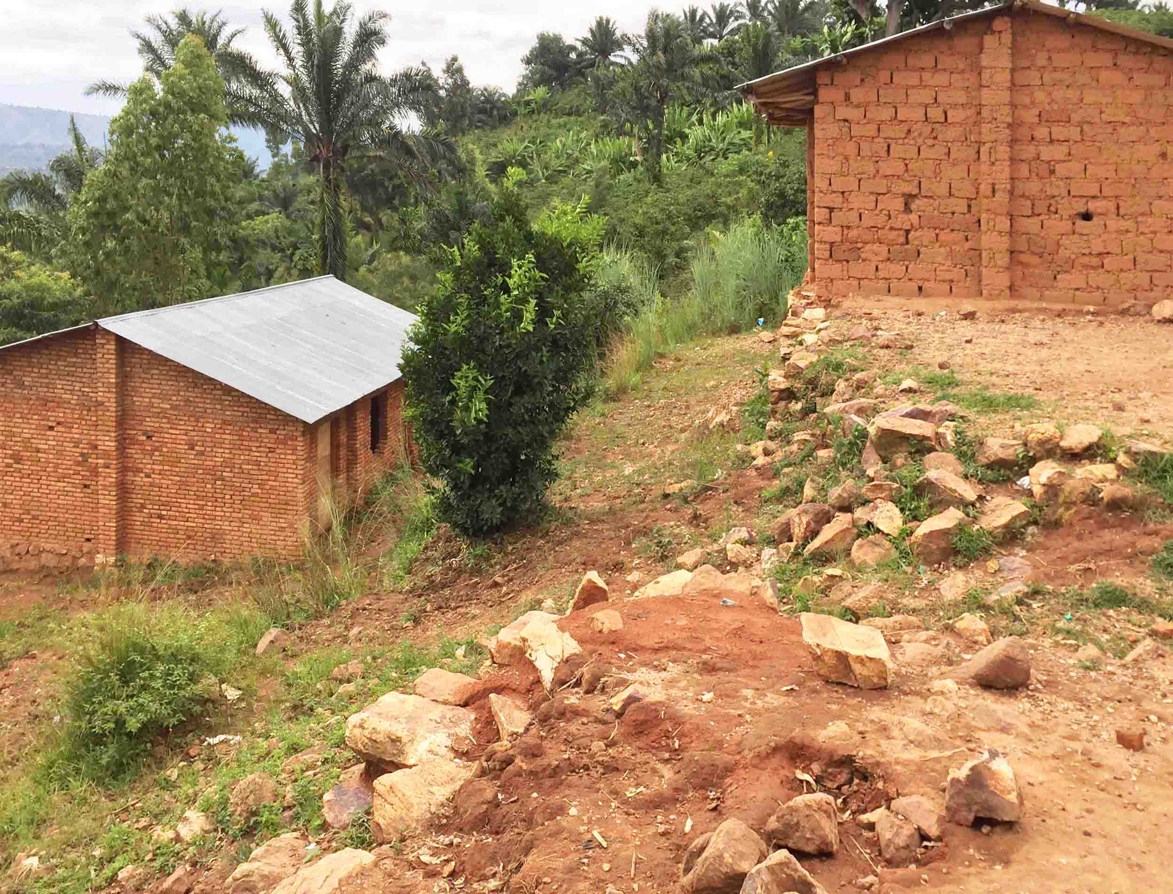

ECOFO Kigondega. Photo Theunynck.

1. The cost of a classroom built by a school community is on average 8-9 million BIF equivalent to an average unit cost of 91 US $/m2 (value 2016). The dimensions are small - often 7x6m = 42 m2 - and there is no veranda. The cost is detailed later in the chapter on the Performance Based Financing Approach (FBP).

**Table 9. Unit costs of classrooms built by communities using their own means**



Source: données collectées sur le terrain et calcul des auteurs

1. **The technical quality and durability of CW-constructions and those managed entirely by communities higly uneven and most often low.** This is understandable. If goodwill and energy are there, most of the resources are drawn from the limited means of very poor communities. Everything is therefore at a minimum of below standards. Foundations are most often below standards. The walls are not stiffened by a concrete structure; there is no concreted reing-beams to prevent disorders in the walls in case of soil compaction or seismic shakes. Flooring and roof-frames are basic. The latter are poorly hung on the walls, making the roofs vulnerable to storms, as illustrated in Fig. 8.

**Fig. 8. Poor durability of Community Construction**

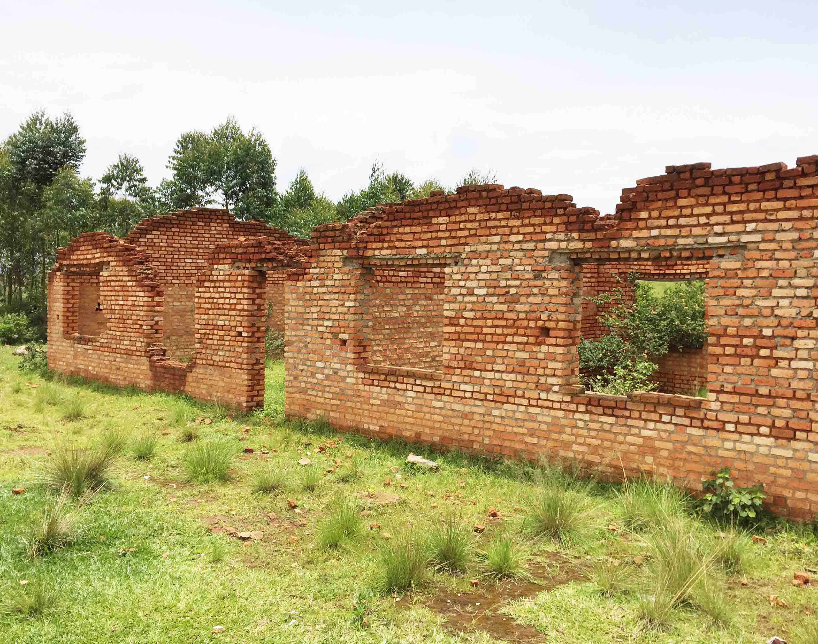

Source: ECOFO Shombo, Photo Theunynck

**A new communal approach: FONIC**

1. **During the PSDEF period, the FONIC financed municipalities for the realization through direct contract management (MOC) of approximately 150 classrooms per year in 2013 and 2014, and 1,479 classrooms in 2016.** Education is clearly the priority of the municipalities. In 2014, for example, they allocated 55% of their budget to the education sector out of the non-earmarked [non-affecté] 6.45 billion BIF envelope. Of this amount, the largest share (54%) went to the construction of 150 new rooms (average unit cost 12.75 million BIF), the second (17%) financed the supply of materials for 167 classrooms. In 2016, thanks to the tenfold increase in the allocation of the FONIC (59.5 billion BIF), the communes built 1,017 classrooms.**[17]** That said, the available documentation does not say the number built for Basic Education, Post-Basic, or TVET. A succinct description of FONIC is provided below in Box 3.

**Box 3.** **The FONIC**. The *Fonds National d’Investissement Communal* was created in 2007[18] with the assistance of the GIZ et la CTS[19]. It is a public institution of an administrative nature governed by public law, with legal and management autonomy, under the supervision of the Ministry in charge of decentralization. Its objective is to channel domestic and external financing to local authorities, to ensure the equalization of resources to municipalities, and to support the implementation of communal projects. Funds are channeled to communes through two types of widows: a non-earmarked window [guichet non-affecté] and several windows earmarked for specific sectors [*guichets affectés*]. Its Operation Manual was revised in 2013, i.e. the same year the PSEDF started.

1. **The FONIC's budget is increasing and the method of operation of the communes with FONIC funds has improved: since 2013 onwards, the municipalities are bidding for complete works.** In 2014 and 2015, FONIC was allocated BIF 3.5 and 6.5 billion, respectively, under the "non-allocated window", i.e. approximately BIF 27 and 50 million per commune respectively, and BIF 800 and 500 million respectively under of the earmarked window [*guichet affecté*] for education guichet ]. In 2016, the budget of the non-earmarked widow office increased tenfold to BIF 59. 5 billion, while its Procedures Manual was revised in 2013 so that the municipalities would issue full-work calls for tender, abandoning the previous hybrid procedure Box 4 summarizes some key elements of the Operation Manual

**Box 4.** **The FONIC's Operation Manual (OP) of 2013.** The communes draw up a project preliminary proposal [*dossier d'avant projet*] which they submit to the FONIC. Once approved, a financing agreement is signed between FONIC and the municipality and the budget is transferred to the municipality's account. The initial version of the 2007 MOP was revised in 2013 with support of GIZ, drawing on the FADL procedures manual created in 2011 by the BTC-funded PADLPC. As in the FADL, in the new version of the FONIC MOP of 2013, municipalities are now bidding for complete works following the Public Procurement Code. The tools of the FONIC's monitoring system now count the number of classrooms constructed, rehabilitated, completed, and / or equipped, as well as the number of latrine blocks.

1. **FONIC uses the standard classroom-block plan provided by the Ministry of Education.** A set of classrooms (a block) consists of 3 classrooms of 6.72x8.72m, or 58.60 m2, for a theoretical occupation of 50 students (25 table-benches) per class, which corresponds to a unit space of 1.17m2 per pupil --low for interactive pedagogy. See Figure 9. The block also includes a front veranda. The plan in Fig. 9a shows: a) the presence of a platform in front of the blackboard, which is not recommended because it hinders the movement in a wheelchair; and (b) the indication of expansion joints in the floor slab, which is an excellent and necessary specification -- but which is so seldom included in other projects that it should be emphasized here. The cross- section in Fig. 9b shows two reinforced concrete rows (bottom and top), which, together with the concrete columns of angles and stiffening of the facades, constitutes an armature sufficient to make the constructions para-seismic for seismic shocks of average amplitude. However, it is also noted that: (a) the interior level of the rooms is only 15 cm above the outside floor, which creates a vulnerability to the entry of runoff water during very heavy rain; and (b) there is no ramp to pass from the interior floor to that of the veranda to facilitate access for students in wheelchairs.

|  |  |
| --- | --- |
| **FFig. 9a. and 9b. Cross section and plan of the FONIC classroom-block** | |
|  |  |
| Source: Bidding document under FONIC financing collected in one commune. | |

1. **The standard plan for the sanitary block could be improved** (Fig 11b).It has 4 cabins, 2 for each sex, with different entrances by sex but side by side. The cabins are on single pit type. The device has four disadvantages: (a) even with separate entrances, the contiguity of girls’ and boys’ sanitary facilities is not recommended; it is advised that the girls’ block should be geographically distant from that of boys in order to reduce the risk of harassment which tends to reduce in turn the use of sanitary facilities by girls; b) the pit system is ventilated, which is in conformity with standard requirements, but it does not allow manual emptying and is therefore not suitable for schools where the dual pit system alternatively used is preferable; (c) the sanitary facilities are not suitable for use by children with a physical handicap; and, d) there is no handwashing facility.
2. **The average unit cost of classrooms built by municipalities in 2014 with FONIC funding is low compared to international costs.** It is BIF 14.3 million per classroom (2014) equivalent to US$ 8,090 per classroom or 126 US$/m2 (excluding tax, value 2016$). This total cost, including the direct cost of works (enterprise contract) and the indirect cost of the service provided by the site controller/supervisor; however, it does not include the cost of FONIC for the financial management of the program. The cost of project management is one of the sites for which data were available was US$18/m2, i.e. 17.6% of the direct cost of the work to be supervised, which is, on the other hand, a high rate per project in comparison with international standards for this service (see details of calculations in Annex 1).

**Table 10. Unit cost of classrooms built by municipalities with FONIC financing in 2014.** 

Sources: For the direct cost of construction, data is provided by the FONIC on the 2014 program (150 new classrooms, For the cost of the project management, data of a contract consulted, Shombo commune

1. **The direct unit cost of the works in 2016, observed through 2 contracts, is even lower: 102 US$/m2.** The price difference between the two contracts is large: from 83 to 121 US$/m2. However, this on-the-spot review of only 2 contracts corresponding to 6 classrooms are not as representative of the national average cost as those in 2014 that covers 150 classrooms. It would be useful to have detailed FONIC data available for the entire 2016 program.

**Table 11. Direct unit cost of classrooms built by municipalities with FONIC financing in 2016.**



Sources: One contract in Shombo commune (Karusi province) and 1 contract in Gitega commune, Gitega province.

1. **The quality of the work financed by the FONIC has not been evaluated.** There is no technical audit or technical supervision report available. Under the FONIC funds, municipalities use the services of a technical supervisor to controller the works, which is good practice. It would be useful for the FONIC to have a technical audit of the buildings it finances.

**C2. School construction financed by donor support**

**The Common Fund for Education [*Fonds Commun de l'Education*] FCE**

1. **The FCE (common pooled fund), UNICEF and Belgium through the FADL[20] were the most important partners for school building during the PSDEF.** The FCE includes funds from AFD, DFID, Norway, and Luxembourg, and the Global Partnership for Education (GPE). The FCE mainly financed basic education up to 75% of the sector's expenditure from 2010 to 2014, and secondary and technical education to a much lesser extent. In terms of construction, the FCE financed two of the three modalities planned by the PSDEF, namely the direct contract management by communes [*Maîtrise d'ouvrage communale* (MOC)] and the delegation of contract management to agencies [*Maîtrise d'ouvrage déléguée* (MOD)], though excluding the 3rd modality which was the delegation to communities. The 2013 FCE program was shared between the first approach (MOC) for 20 communes (6 billion BIF) ​​and the second approach (MOD) with ABUTIP for 38 basic education schools (14.5 billion BIF). The 2014 FCE program (BIF 20 billion) was entirely devoted to financing the MOC approach. The 2015 crisis led to the withdrawal of donors and the suspension of the FCE, but the GPE remained active in Burundi. In 2016, keeping the same priorities, the remaining GPE financing was restructured and its management transferred to UNICEF, which incorporated this responsibility to its PACEF project[21]. The next potential donation of the GPE will be administered by the AFD**.**[22]

**Box 5. The Common Fund for Education (FCE).** This fund was established in 2009 by a group of PTFs to support Education with a Manual of Procedures inspired form this of the IDA-financed PARSEB and revised in 2010 to implement the *Budget d'affectation Spéciale* (BAS) created in 2010, isolated from the general budget to receive FCE funds. As of 2011, the FCE, financed by the Belgian Cooperation, AFD, DFID, Norway and Luxembourg, was chosen to receive GPE funds in 2012. The funds were administered by CTB while UNICEF was the coordinating agency. The rules of the FCE are described in the document of the Belgian Cooperation for the GPE (2012). A more recent detail of the procedures is described in the Manual of Procedures of the Common Fund for Education in Burundi - Revised January 2014.

1. **The operational modalities of the FCE (common pooled funding) are set out in its 2014 Procedures Manual prepared jointly by the relevant PTFs and the Government.** The FCE is under the authority of the Permanent Secretary of the Ministry of Education. Available resources are determined annually by the PTFs upstream of the Department's budget framework and are housed in a special budget (BAS). Operation arrangements for school construction are of two types: (a) either under the responsibility of municipalities through direct contract management (MOC), funded though financing agreements A or B, depending on whether they have to build 3 classrooms or more. In such cases, municipalities are responsible for the management of procurement and contracts for works, equipment, and services of supervision/control; or (b) delegation to contract management agencies which contracts are procured under the responsibility of the Ministry's Public Procurement Management Unit (CGMP) as all other contracts funded by the FCE. All procurement procedures are those of the 2008 Public Procurement Code. The funding PTF’s in the FCE to provide *a priori* no-objection notices (NOAs) on contracts for buildings outside communal works. A 2014 ordinance raised the minimum threshold of *a priori* non-objections for construction contracts to 250 million BIF. Supervision of the construction program is carried out by BISEM. The FCE's financial supervision is done monthly, and the technical monitoring and financing report (RSTF) is semi-annual and consolidated annually. Contacts are signed with tax, and the VAT is reimbursed by OBR to the Ministry of Education.

**Delegation of contract management to ABUTIP (MOD)**

1. **As part of the PSDEF (2013-2016), ABUTIP has built 480 basic education classrooms funded by the FCE** and is also completing the PTPGU project started in 2010. ABUTIP implements the programs entrusted to it in accordance with its own Procedure Manual for Procurement of Works and Contracts. The agency has adopted the construction plans used by the Ministry of Education.

**Box 6. ABUTIP** is an AGETIP-type contract management agency, created with a private NGO status in 2003, as part of an IDA-funded project and member of the AFRICAP network. Members of the General Assembly are government agencies and NGOs. It is headed by a Director General appointed by the Government. Like all agencies of this type, ABUTIP has its own Procedural Manual whose initial version received no objection from IDA.

1. **The standard ABUTIP construction design is almost identical to that of the FONIC.** As illustrated in Figures 9b and 10b, the design and the plan dimensions are identical. The three differences are: (a) the position of the cabinet, to the right of the table for the FONIC and to the left for the ABUTIP, which leads to a difference in the positioning of the windows on the main façade, (b) the exiting platform (not recommended) in the FONIC plan that does not exist in the ABUTIP plan, and (c) the obligation of expansion joints in the FONIC floor-slab is not included in the ABUTIP plan, which should be improved in this regards.

|  |  |
| --- | --- |
| **Fig. 10a and 10b. Cross-section and floor plan of the ABUTIP classroom block** | |
|  |  |
| Source : ABUTIP | |

1. **The standard ABUTIP sanitary block is greater than that of the FONIC and includes the essential elements**. As illustrated in Fig 11a, it has 8 cabins, 4 for each sex, with entries by sex on opposite facades. For each sex, one of the cabins is well arranged (size, grab bars, and seat) for use by children with reduced mobility. There is a hand-washing arrangement. However, this sanitation facility has two of the disadvantages present in FONIC: (a) the sanitary facilities for girls and boys are in the same block, rather than in two geographically separate blocks, and (b) the cabins are on a single VIP pit, which does not allow manual emptying and is therefore not appropriate in rural areas (see ASCQE 2.7).

|  |  |  |
| --- | --- | --- |
| **Fig. 11. Standard sanitary plans** | | |
| **11a. ABUTIP** | **11b. FONIC** | **11c. UNICEF** |
|  |  |  |
| Source: ABUTIP | Source : DAO type du FONIC | Source : UNICEF |

1. **The average unit cost of classrooms built by ABUTIP is 25 M BIF duty-free per classroom in 2013, corresponding to 16,683 US $/clrm or 264 US$/m2** (2016US$).This unit cost includes cost for work (work contract), service for control, and service for delegated contract management (agency's fee is 6% of the amounts managed). The data are an average of the 30 schools of the ABUTIP FCE-II program.

**Table 12. Unit cost of the classrooms built by ABUTIP in 2013.**



1. The unit cost of the ABUTIP classrooms is subtantially higher than that of the municipal works on FONIC funds (126 US$/m2). However, the buildings that managed ABUTIP are chosen from schools that present the greatest implantation difficulties (the most steep slopes), which increases the unit costs compared to what they would be in less topographically difficult terrain. Fig. 12 illustrates such a condition. A detailed analysis - but not possible in this study - would be to isolate the cost of buildings (with a fixed design standard) from those of adaptation to land adaptation and land development (which is dependent on topography).

**Fig.12. School built by ABUTIP**

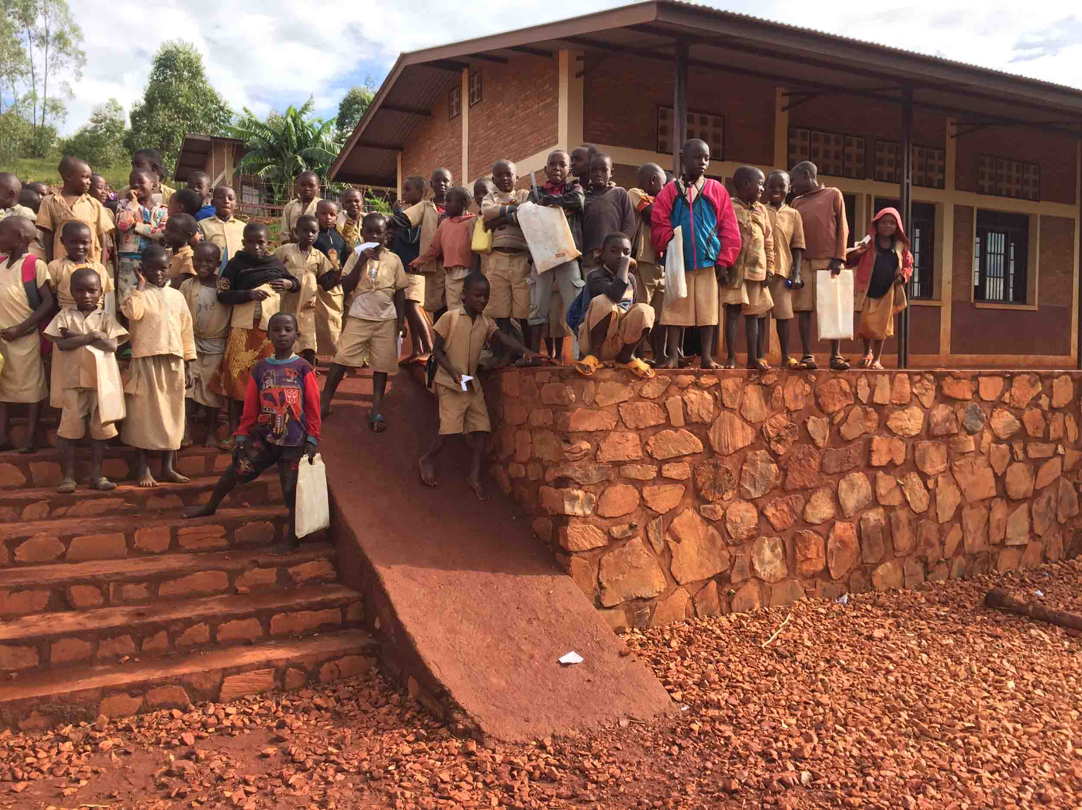

Source: Photo Theunynck 2017

**Contract management delegation (MOD) to UNICEF**

1. **UNICEF had constructed 63 classrooms (and associated latrines / water points) as project owner (2013-2015) and 382 classrooms as MOD during the PSDEF period (2013-2017).** The MOD management program consists of 2 parts: (i) 162 classrooms in 2015-2017 under FCE funds as part of the initial plan of the PSDEF; and (ii) 157 classrooms when UNICEF became the GPE manager instead of the CTB. This last wave of construction was then integrated by UNICEF in its PACEF project (Program of Support to the Consolidation of Fundamental Teaching). Then, procurement for works and services for technical supervision/control are performed in accordance with its own procurement procedures.
2. **The UNICEF classroom plan is very similar to that of the Ministry of Education.** The design is also based on a block of 3 classrooms with a net area 1m2 larger than this of ABUTIP and FONIC due to slighlty larger classroons (16 cm more). The width of the veranda is slightly smaller. Classrroms are equipfed with false-ceilings. A complete school consists of 9 classrooms, 2 latrine blocks with 5 cabins each and a drinking water point (water supply / drilling) and the rainwater harvesting system.

**Fig. 13. UNICEF standard floor-plan**



Source: UNICEF. MOD. Standard drawings 2016

Source:

1. **The sanitary block is well designed** (Fig 11c). It is composed of 5 cabins. Four of them are upon double-alternating pits which allows safe waste management over time, and the last cabin is specifically equipped for children with physical disabilities, two essential characteristics that the 2 other models of ABUTIP and FONIC do not have. The desirable improvements are: a) embossed footrests in the 4 standard cabins; and (b) a larger size for the box used by children living with a physical handicap to allow wheelchair entry. However, this box should be larger because, according to this drawing, the wheelchair must remain outside, obliging the user to depend on personal assistance to get in. The block also includes a hand-washing facility.
2. **The average unit cost of UNICEF-built classrooms is BIF 28.3 million per classroom (2013) equivalent to 19,197 US$/clrm or US $ 259 US$/m2** (without tax, value 2016$). This cost is an average of the UNICEF program carried out from 2013 to 2015 in which UNICEF is contract management agency (MOD). contracts out according to its own procedures. The program consists of 7 contracts for as many schools, each of 9 classrooms giving a total of 63 classrooms. UNICEF also paid for services of supervision/control of works, the cost of which is not available. Data are not available for the management costs of UNICEF nor the overhead of the institutions.

**Table 13. Unit cost of classrooms constructed by UNICEF in 2013-2015**



Source : authors' calculation om the basis of UNICEF data

1. UNICEF launched a consultation for the development of a "*School Building Strategy" to guide its support in Burundi. UNICEF considers that "lessons learned highlight the capactiy limits of UNICEF's direct implementation of IEBs. The modalities of implementation such as delegated project management (MOD) and the community approach with specialized technical assistance proves necessary* ".[23]

**Direct contract management by Communes (MOC) during the PSDEF**

1. **During the period of the PSDEF which starts in 2013, the FCE was the main donor of the Communes for the implementation of the communal direct contract management approach (MOC).** At this time, as discussed above (para 4.10), three projects that had been initiated earlier and also funding the MOC approach, will continue during PSEDF, namely: (i) the ADB-funded ECAP/PAPSE project that started in 2009 and will end in 2013; (ii) the IDA-funded PTPGU that started in 2010 and will be completed in 2014; and the Belgian-funded PADLPC project that started in 2012 and will be completed in 2014.
2. **During the PSDEF, 657 classrooms (and associated sanitary facilities) were built by municipalities through the MOC approach in 219 schools belonging to 73 communes (out of 129) in 8 provinces (out of 18) under MoE's overseeing through BISEM.** According to the 2016 BISEM report, the FCE-finded MOC program of 2013 --of BIF 5 billion (US$ 3.2 million)-- started in 57 sites in 3 provinces for a total of 198 classrooms. In 2014, with a budget slightly over 18 billion BIF (US $ 11.6 million), the MOC was extended to 5 other provinces. With these funds, 33 municipalities in the 8 provinces built 459 classrooms in 153 schools. The PSDEF's FCE-funded MOC program was closely monitored by the Office of School Infrastructure, Equipment and Maintenance (BISEM). The start-up was slow: no classrooms were delivered in 2013. From 2014 onwards, municipalities were assisted by technical assistance for contract management, named AMOC[24], provided by NGOs (Gutwara Naz, Twitezimbere and PDO) and by the PADLC project, to accompany them in the course of the program[25]. Fig. 14 illustrates the geographic distribution of the MOC program in 2013-15.

**Fig. 14. Location of MOC construction sites 2013-2015**

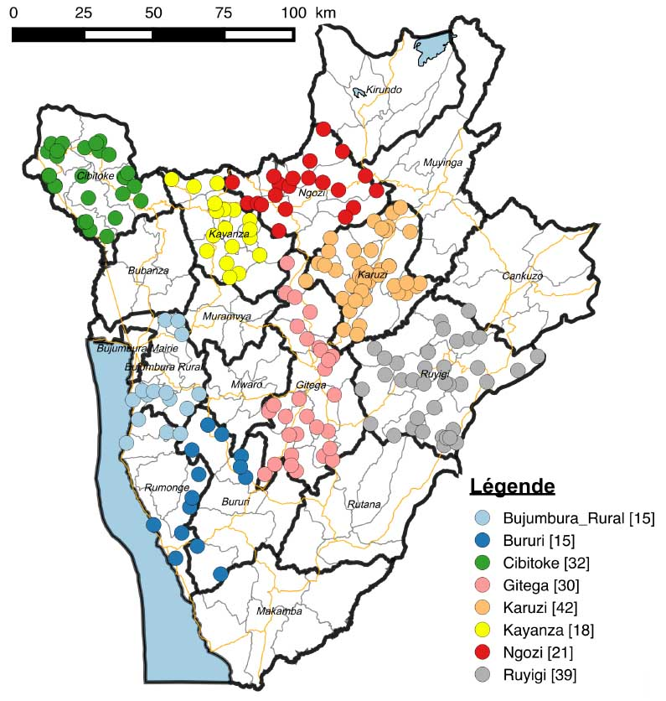

Source: Belgium Technical Cooperation, in BISEM 2016.

1. **The standard plans for the classrooms are those of the Ministry of Education,** therefore identical to those of ABUTIP already mentioned, both for the classroom block and the latrines.
2. **The unit cost of classrooms built by municipalities through the MOC approach on FCE funds is on average BIF 19,12 million (without tax, value 2014) equivalent to 13,981 US$/clrm or 185 US$/m2** (without tax, value 2016$)**.** The average cost was calculated on the basis of 25 works contracts, a sample of one third of the total, and two contracts of services for technical supervision/control. Note that, on this basis, the average cost of project management represents 13% of the average cost of the works, which is a high ratio relative to other countries for the same service.

**Table 14. Unit cost of the classrooms built by communes through direct contract management (MOC) **

Source: authors’ calculation from BISEM data.

1. **The quality of the work is average.** The program has not been subject to an independent technical audit; however, it was supervised by BISEM with funds from the BAS of the FCE. The final BIDEM's supervision report was prepared with CTB's technical support. It finds that out of the 168 sites visited (77% of the total), one quarter (44) have "imperfections to correct", the first cause of which is attributed to the lack of close monitoring by the supervision firms (AMOC), and too low intensity of the general supervision by the BISEM itself. The works on the construction sites were generally late and some technical supervisors/controllers had sometimes abandoned the most delayed ones before the end of the works. In general, the Communes did not correctly supervise the contracts of the site-supervisor/controller, some of which were paid in full although their contract was not completed. An independent technical audit covering all approaches (MOC and MOD, FCE and UNICEF, FONIC and Communities) would be desirable to carry out a comparative assessment, based on the same analysis criteria, to determine the relative technical performance of each program.

**IV-D. The Performance-Based Financing (PBF) pilot project**

1. **The School's Performance-Based Financing (PBF) approach was piloted in Bubanza Province in 2014-2016 in 81 schools out of the province's 225 schools in parallel to the PSDEF.** Although the approach was not conceptualized to finance buildings, but rather "soft" activities in education, nevertheless, "hard" activities such as school buildings have been carried out by some communities on PBF funds. However, this is in line with the approach, because it is fundamentally based on community decisions about how best to use the funds to achieve the educational goals they set. Although the PBF pilot took place during the PSDEF period, the school buildings or this pilot are not considered part as a part of the PSDEF implementation, although they were carried out during the same period. For this reason, they are not included in this study under chapter C dedicated to PSEDF and are described in the present chapter D which is specific to them. However, they fully belong to the category of constructions initiated and managed entirely by the communities, and they are similar to those described in the previous chapter C1, paragraphs 4.17 and 4.18.
2. **The PBF methodology for the Education pilot was inspired from a similar approach in the health sector** that stared ten years ago and achieved to be nationwide scale scaled up 4 years ago. On first analysis, the pilot in the education sector seems to be a success, despite it is stopped since 2017 due to external funding cessation. It has demonstrated the effectiveness of approaches based on the funding of schools according to their results. In a simplified way, the approach works as follows: the school community (teachers and parents) sets up an annual action plan with quarterly benchmarks to improve the educational service offered by the school to pupils with quantified objectives of students' results. If the quarterly objectives are met, the school receives funding that allows it to implement the actions of the following quarter. The flexibility of the use of these funds is great. The observation is that the school communities prioritize the financing of "good" inputs, in order to achieve the targeted results in terms of student learning. Details of the analysis are given in Study 4 of this research. The question is whether such an approach is "compatible" with a large program construction of school infrastructure.
3. **Is the construction of classrooms an activity that could be part of an action plan part of this performance based funding approach?** The question necessarily arises insofar as: (a) financing a construction is not a recurring expense, such as is the activities funded under a PBF annual action plan; and (b) the cost of construction is much larger than that of educational activities typically financed in an FBP action plan. The two FBP schools visited by the mission illustrate two ways of answering the question posed above.
   * **A small private school decided not to include construction in its PBF action plan.** The school is locate in the city-center and enrolls about 450 students in 9 classrooms, all in single grade per classroom. It does not have the ambition to grow and could not, anyway, because its cramped terrain is already full. Its infrastructure problem (unresolved) involves the construction of a fence-wall because, located right in the city center, the school is constantly crossed by passers-by. The PBF subsidies, amounting to BIF 5 million per year, are fully allocated by the Management Committee to "soft" quality improvement activities because, from its point of view, a fence wall is just far too high to be financed in the PBF.

**Fig. 15. A small school in the RBF project pilot that did not include construction**

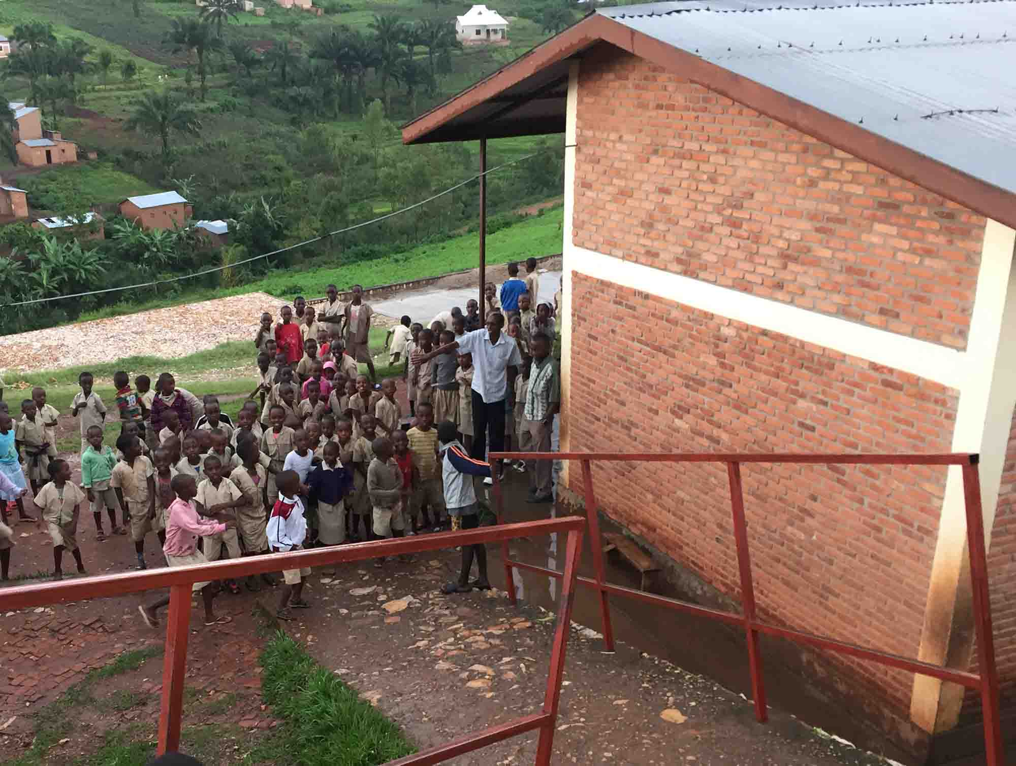

Photo Theunynck 2017

* + **A medium-sized public school has included the construction of a classroom in its PBF action plan.** The school enrolls 1035 pupils. Each quarter, PBF subsidies are BIF 2.3 million. In 2016, the Management Committee devoted most of these funds to the construction of a classroom that it chose as a priority in its annual action plan. The project was spread over a school year financed by the PBF funds plus a parents' contribution of 2000 BIF per pupil. The school met all the objectives of its action plan (with priority given to the congestion of rooms) and fulfilled all the other quality criteria that trigger PBF funding**.**

|  |  |  |
| --- | --- | --- |
| **Fig. 16. A school where the Management Committee decided and implemented the construction of a classroom** | | |
|  |  |  |
| Source : Ecole de Bubanza II. Nouvelle salle de classe et Comité de Gestion de l'Ecole. Photo Theunynck. | | |

1. **The inclusion of a building component in the continuation of the PBF program seems possible and desirable.** Minimal school infrastructure is required to offer good conditions for teaching activities. From this perspective, the school's action plan should then have two distinct components: (1) a section devoted exclusively to "soft" activities related to the quality of education; and (2) a component for the "hard" activity exclusively devoted to construction. The addition of a classroom to relieve overcrowding or to accommodate a certain year of education is not yet a prerequisite for the implementation of these "soft" actions. However, it seems necessary that the "hard" part of the school project should have its own processes and criteria.
2. **In a PBF perspective, it would be desirable for a community-based construction program to be organized on a modern method of community empowerment for construction, i.e.: acting as delegated contract management authority on behalf of the Ministry of Education (see details in below Chapter VI) .** The existence in each school of Management Committees made up of representatives of teachers and parents of pupils, organized for the implementation of their school project is an important asset. In many other countries such as Benin, Togo, Côte d'Ivoire and Madagascar, their school management committees are empowered to play the role of delegated contracting authority. This empowerment includes: (i) the financial management of the funds for the construction project, (ii) the procurement of works and furniture through local competition (Local Competitive Bidding - LCB) and the competitive selection and contracting of a civil engineering technician for the technical supervision and control of works on behalf of the Management Committee.
3. **The inclusion of a construction component in the FBP program would benefit from the strategic gradual expansion of this program.** In such a context of gradual scale-up, the community capacity-building program (the Management Committees) could be implemented in the same geographical expansion scheme through a Grassroots Management Training program (see CSEEQ 4.3).

**V. Comparative analysis of the unit costs of school buildings during the PSDEF**

**Box 7. Methodological note on unit cost calculation.** The methodology aims to ensure good national and internatio-nal comparability of unit costs. It includes 8 points. (1) Only the cost of the classrooms is considered and not that of the sanitary facilities because the plan of the former is more standardized than this of the latter; and its cost is also less site specific than the second one whose difficulty arises from realizing the underground pit that is highly dependent on geology; (2) Unit costs are actual costs as set out in the contracts of the successful tenderers; (3) The unit cost of classrooms shall be calculated on the basis of the cost of the classroom-block in the works contract, excluding the costs of the other works in the contract; (4) To neutralize the impact of differences in classroom's area in different projects, the unit cost per m2 is considered; (5) The "gross area" is considered, i.e.: the thickness of the walls included - which is a standard for calculating costs in the construction industry; (6) In this calculation, the surface of the porch is weighted by a coefficient of 50% because it is a covered-but-non-enclosed area - which is also an international standard for calculating construction costs; (7) Current costs per m2 in local currency are converted to current US $ to make them internationally comparable - for this purpose, the official annual exchange rate published by the World Bank is used; and (8) Current US$ amounts are actualized to US$ of a reference year to offset the effect of differences in contract dates - inflation is calculated from the deflator index of the US GNP published by the World Bank.

1. **The outputs of the comparative analysis are the following** (Fig 17)**:**

**Fig. 17. Unit costs of classrooms built during the PSDEF in 2013-2016 according to the implementation modalities** 

Source: Authors' calculation

* ***The community-based approach is the less expensive*;** but the quality of works is lower than this of MOD and MOC approaches.
* ***The MOC approach is more cost-effective than the MOD approach*;** and municipalities have been more cost-efficient with FONIC funds.
* ***The MOD approach is the less cost-effective***; and ABUTIP is more cost-effficient than UNICEF; more-over if indirects costs would have been taken into account

The differences in the quality of works are not properly assessed in the absence of any technical audit of the works performed by all actors. This analysis should be usefully complemented by a parallel comparative technical evaluation to compare qualities and costs.

1. **The quality of the construction is uneven and depends on the construction approach.** Burundi has a high-quality standard construction plan currently being implemented by the Ministry and used by ABUTIP, FCE and FONIC. From the point of view of the quality of the work, it seems that the first one is at the upper end of the spectrum, while the other two are of a lower quality due to the lack of supervision/control by technical supervisors (FCE) or by the municipalities, as mentioned in the BISEM's final report. The works by the communities is at the other end of the spectrum, with average poor quality (provided the walls are made of fired bricks), and very poor quality and durability when the bricks are of dried clay. Across the country, students are inequitably served in terms of the quality of their schools, depending on whether they are lucky enough to be in a classroom built on external funding or in a classroom built by their parents. It is desirable to find a solution to reduce this type of inequity. A reflection to develop a strategy of school building that tackles this problem is desirable.

**VI. Options for the Future**

**Option 1. Delegation of contract management to empowered communities.**

6.1. **Community-based dynamics should continue to form the foundation of a national school building strategy**. In terms of basic education, the educational environment of the child is the family and the school. We have seen in the past, and we still see in the present Burundi, the powerful involvement of parents and communities in the development of the education system. The importance of which is well understood at central and communal levels in Burundi, and actively supported by them. It may be in fact that community and parental enthusiasm for the school is not unrelated to the willingness and ability of students to achieve good results - as seen in the most recent international assessments – in spite of the particularly difficult conditions in which they study. On this basis, it seems fair to imagine a future for the Burundian educational system in which communities will continue to play a leading role in a modernized framework, and in particular within the framework of educational decentralization.

6.2. **Communal-level project management is a remarkable step forward, and the crucial role of municipalities at the local level is now well established**. Communal project management is key to planning schools in line with other investments of communal level, in particular networks (water and electricity), and compliance with environmental and social safeguards. In addition, communes play a crucial role in identifying potentially usable land for the construction of schools and for securing the administrative status of the selected land. Within the framework of the PSDEF, some communes have successfully mastered the direct construction of school buildings, which gives them a good working knowledge of this exercise.

6.3. **Direct contract management by the communal authorities faces the usual constraints at this level, in any decentralized system to the communal level**, especially when, as in Burundi, communes are composed up of numerous communities. Schools are not the only type of infrastructure which competency has been transferred to communes by the decentralization law. Communes have the owner's responsibility [*maîtrise d'ouvrage*] of all the projects included in their Communal Plans for Community Development, the number of which will increase as the country develops and the increase in tax transfers continues. Communes, whose capacities are structurally limited, will face increasing difficulty in successfully meeting all their obligations as contracting authorities via the sole exercise of *direct* contract management, i.e. the MOC as practiced so far. As long as they have few projects in their portfolio, MOC-type processes can proceed without too much difficulty. However, the desirable shift to a larger scale - and in particular to meet the immensity of the school building needs referred to earlier in part II - will be structurally constrained by the limitation of the technical capacities of the communes.

1. **Communes can solve these difficulties through the delegation of contract management to communities for the construction of their schools.** In such cases, the local communities act as delegated contracting authority (MOD) on behalf of their commune. Evidence exists in many countries that local communities can successfully play the role of MOD for the management of small-scale construction of low complexity and cost - such as the construction of classrooms or school sanitation facilities. Such a delegation of contract management is a direct implementation of the "principle of subsidiarity", which is the regulatory principle of systems composed of several layers of responsibility (see box 8 below). When the communes are the "owners" of schools [maîtres d'ouvrage], the delegation of contract management to the concerned communities is not in any way an abandonment of their responsibility as *Maîtres d'ouvrage*, but another way of organizing the exercise of this responsibility for greater efficiency. Their own experience of *direct* contract management during the 2012-2016 phase of the PSDEF puts the communes in a good foot to further oversee the delegation to the communities. Such arrangement is currently successfully implemented in Africa in Benin and Tanzania (see Box 9). In Europe, of the 28 countries of the Union (2017), more than two thirds (19) delegate the construction of primary schools to local communities, and in half of these countries (9) the communities receive this delegation from their commune and the other from the region or the state. (See SCEEQ 1.6).

**Box 8. The principle of subsidiarity**. This principle establishes that the local organization representing the interests of the grassroots community is best placed to take responsibility for the implementation of the construction project that concerns the community. Applied to the construction of schools, the principle establishes that the concerned school community of the village is in a position to be more effective than the State or its commune to implement its school construction project. When the country is decentralized and communes have transferred powers to build schools, if they adopt the principle of subsidiarity for the implementation of their Local Development Plan, this translates into the following two-pronged implementation arrangement: on the one hand, the commune would directly manage the implementation of a multi-community scale infrastructure which management, by nature, cannot be delegated; and, on the other hand, under the principle of subsidiarity, it is in the interest of the commune to delegate to the concerned communities the management of the implementation of community-scale constructions such as schools, for more effective implementation.

**Box 9. Implementation by municipalities of the principle of subsidiarity in Benin**. The decentralization in Benin dates back to 1999. The communes were then given competence for the construction of the primary schools: they are the projet management authorities [*maîtres d'ouvrage*]. Since 2005, the municipalities are applying the principle of subsidiarity and, on this basis, they delegate contract management to the communities concerned for the implementation of small basic infrastructures such as schools. Communities are empowered to act as contract management agents [*maîtres d'ouvrage délégués*] on behalf of their commune. Since 2013 the FADeC, which is the national mechanism to channel public funds municipalities from the Ministry of Decentralization (a mechanism similar to the FONIC), has been updated through the creation of a specific window from which the municipalities draw the financial resources to finance the communities to which they delegate contract management for works. Since 2005 more than 5,000 classrooms have been built under this mechanism, twice as many as the Ministry of Education's projects have built during the same period through MOD agencies, and has a cost 60% lower than that of agencies. The quality of the work is equivalent in both approaches.

1. **Empowering communities to endorse the responsibility for contract management does not mean abandoning the proper rules of contract management, nor the procurement proper rules**. When the communes delegate their project management to the concerned communities so that the latter can carry out this task in their place, the communities must respect good practices, such as:

(a) Good practices for project management: the contracting authority procures three contracts: one works contract, one furniture contract, and one contract for the services of technical supervision/control of works. Standard drawings and standard contracts used by communities are provided by the Ministry through the communes.

(b) Good practices for procurement: (i) contracts for works and furniture must be procured through Local Competitive Bidding B) on the basis of simplified documents; (ii) service contract for the technical/supervision control is procured through competitive selection on the basis of a short list competition based on a long list of qualified technicians held by the Ministry and provided to the communes for their communities. Simplified procurement templates are established by the Ministry and guarantee full efficiency, economy and transparency.

As project managers, communes finance communities and oversee them in the execution of their MOD mandates. They handover the works and register the new buildings in their patrimonial accounts; then they take responsibility for their maintenance, still assisted by the communities for implementation.

6.6. **With this approach, the quality of the constructions carried out by the communities is likely to be acceptably good**, because on each site, the work of the construction contractor is individually controlled by a qualified technician [*maître d'oeuvre*] recruited by each community. Payments for the works by the community are made in installments (for foundation, walls, roofing and finishes) on the basis of the certification of works well done by the *maître d'oeuvre*. The role of the communal technician is then to ensure that the *maîtres d'oeuvre* do their job well. At the central level, the role of BISEM/Ministry engineers is to oversee the technical quality of the work of the *maîtres d'oeuvre* (including proposing sanctions where necessary).

6.7. **Construction costs could also be more economical with this approach**. The comparative analysis of the cost effectiveness of construction programs in Africa shows that decentralized approaches (communes and communities combined) lead to average savings of 50% compared to centralized approaches (Ministry or MOD agency) when the quality of the work is equivalent; and that delegated approaches to project management by the communities (delegation from the Ministry or municipalities) lead to an additional average saving of one third of the cost. (see ASCQE 5.1)

6.8. **Such an approach has two positive externalities**: a) Local Competitive Biddings (LCP) offer business opportunities to smaller local firms that are not always able to respond to National Competitive Bidding (NCB); b) a large number of contract opportunities could also be offered to graduates of the civil engineering courses in technical education - for the service of technical supervision/control of works on a small building site. Experience in other countries has shown that there is a large number of technicians trained in civil engineering on the market, but they occupy jobs outside their competences (for example, as a taxi driver) because of lack of job opportunities offered by large construction or in engineering firms. According to data collected by the mission, annually, more than 15 graduates with Bac-III qualifications in Civil Engineering, 42 in Structures and Materials, and more than 10 3rd-degree graduates come onto the job market.

6.9. **Finally, the exploration of this option is in line with the development of the third strategy of constructions that is listed in the PSDEF text,** as above-mentioned in chapter IVB, para. 4.12 and Box 2. In addition to the MOD and MOC approaches, the PSDEF is actually considering the exploration of a strategy with grants to communities for the construction of their schools. The present option of a delegation of contract management form on the project management delegated by communes to communities, is in line with this perspective.

**Option 2. Align communal financing channels**

6.10. **Another option could be to harmonize procedures at the communal level for financing school buildings**. Today, there are two channels: the FONIC and the (currently suspended) FCE. Were it reinstated, the partners and the Government could initiate a reflection to harmonize the financing systems of the communes and lead to the use of a single national funding mechanism. This would simplify management at the communal level and allow for a better monitoring and evaluation system than the current system.

6.11. This would require a revision of the FONIC's Procedures Manual so that it would be useable by the donor partners who set up the FCE. On the occasion of such reflection, if the aforementioned approach of delegation by the commune to the communities was envisaged - at least for a trial - this modality could be considered within the framework of the creation of a specific window of the revised FONIC. A modality of similar nature has been seen in Benin, in the FADeC fund (equivalent to the FONIC) set up by the Ministry of Decentralization for the financing of Beninese municipalities for the implementation of their Communal Development Plans.

**Option 3. Incorporating a formal Construction Component into the Performance-based Financing Approach (PBF)**

6.12. **As mentioned earlier (section IV), Burundi has just completed a pilot project on Performance-Based Education (PBF) funding**. The experience has proved successful and can form the basis for a gradual transition to the national level, following the model of the Health sector, where the PBF approach has now become the regular mode of operation. It has also been seen that it would be preferable for construction activities to be dealt with in the PBF on their own specific terms. Indeed, the financial scale of a building is too large for a construction activity to be treated in the same way as the other education activities of much smaller scale. When this is the case, we saw that even a very small construction siphons all PBF funding for a year.

6.13. **The approach of empowering communities to build their own school - as described in Option1 - fits perfectly into the dynamics observed in the PBF approach.** These two approaches have in common to place the school community at the heart of the decision-making and implementation processes, in addition to making the community 100% accountable for the results of their activities. There is little doubt that, if the two approaches were interrelated, the prospect of building may provide an additional incentive for communities to improve their educational outcomes.

6.14. **Specific funding mechanism**. As part of this reflection, it would be advisable to explore with the concerned actors the practical ways in which funding for the construction of school infrastructure - coming from the commune or the Ministry - could be combined with PBF funding in order to achieve synergy between the two and use construction funds as an additional lever for school communities to further improve the educational performance of their children.

**Option 4. Develop a National School Construction Strategy**

6.15. **It is desirable that the MEESRS develop a National Strategy for School Construction**. The strategy would take stock of the situation in 2017, provide a long-term vision, and specify steps to move towards the materialization of that vision. To be useful, the development of a National Strategy should not only be conceived as the production of a document, but rather as a process. The result would be better achieved and the strategy better applied onwards if the process were to be partnership-based, including all the actors involved around the Ministry: projects, agencies, municipal representatives, NGOs, CBOs, institutions and TFPs, and where possible representatives of the communities, who contribute to the implementation of school buildings. The exercise can provide an opportunity for further reflection on the convergence of approaches and to consolidate what has already been achieved, and also to explore new avenues for a rapid and economical transition for scaling-up. A first form of action could be to set up a think-tank group, led by the Ministry, with experts from these organizations. The work of the UNICEF office in Burundi, carried out as part of the development of its BCO's strategy for the construction and equipment of basic infrastructure 2017-2018, would support the development by the MEESRS of its national strategy, in particular the two studies that UNICEF will undertake in 2017, namely: (a) a national diagnosis of the state of school construction, and (b) the development of a normative framework for construction (norms and standards), especially regarding inclusion and school-friend-child aspects. For its part, the World Bank could be available to contribute.

6.16. **The MEESRS national strategy document for school construction could be structured around the following themes**:

* 1. Assessment of school infrastructure, including land issues;
  2. Availability of land and appropriation methodology for school-network extensions;
  3. Assessment of the activities and projects that have contributed and are contributing to the production of the school facilities in the context of decentralization, with all approaches considered, whatever the project and the funding, and the modality of implementation, including community organization;
  4. Analysis of the performance of different approaches in terms of production capacity, quality of work, and cost-effectiveness, and lessons learned from these analyzes;
  5. Mechanisms and tools (criteria) for the planning of new construction at community, communal and national levels;
  6. Standards for school construction including inclusion (girls, children with disabilities) and the mitigation of environmental risks (floods, landslides, seismic risk);
  7. Standard construction plans and standard procurement documents including aspects related to inclusion, and environmental and social risks;
  8. Implementation strategy for buildings - roles and responsibilities of actors at the central, communal and community levels. Review of options in light of the implementation of the subsidiarity principle. What types of MOC projects? What types of projects should the municipalities delegate to an Agency specialized in MOD such as ABUTIP? What types of projects should the municipalities delegate to the concerned communities?
  9. Costs of construction, mechanisms for the transfer of funds to municipalities, mechanism for funding communities by the municipalities, where appropriate;
  10. Mechanisms for managing funds at different levels (community-, commune- and central level), mechanisms and tools for reporting;
  11. Mechanisms and tools for monitoring and evaluation of all operations that emerged during the Strategy period; evaluation of the Strategy at the end of its period of validity; proposal for revision for the following period; and mechanism for the adoption of the revision.

Current UNICEF studies cover some of these issues. A specific study is likely to be necessary to address the issues of land availability and the solutions to the problems posed in this regard.

6.17. **The approach to environmental and social safeguard measures**. It would be desirable that this issue should not be dealt with on a project-by-project basis but dealt with within a broader national school management framework, depending on the need for expansion and upgrading of existing standards, regardless of the project and its source of funding. A study on the preparation and adoption by the Government of a national framework for environmental and social management of school building projects could be carried out in parallel with the preparation of the Construction Strategy with its conclusions integrated into the Strategy. Such a study would include a categorization of the types of risks and a predetermined list of mitigation measures, as well as a simple "screening" mechanism of the envisaged lands to determine the category to which they belong. Only potential lands which, exceptionally, could not fall into anyone of the categories according to an exceptional specific risk, would be subject of a specific environmental and/or social study.

6.18. **The Disbursement-linked Indicator (DLI) Approach.** This World Bank approach is available since 2011. Among other things, it allows the financing of construction programs, insofar as the infrastructure envisaged is neither complex nor of a large-size building. School building programs can be funded through DLIs. This approach allows, under certain circumstances, an immediate first disbursement based on a DLI obtained prior to project approval. Such first disbursement could be linked to the adoption by the Government of a comprehensive construction strategy acceptable to the Bank, accompanied by a manual of procedures detailing the implementation of the Strategy, with the environmental and social management framework built in. This first disbursement allows the program to be launched, and the following disbursements would be linked to outcome indicators measuring the progress of the program - which must necessarily follow the provisions of the strategy and the procedural manual. No prior no-objection from the Bank would be necessary as regards procurement. The Bank and the Government would monitor the performance of the program's procurement system during the implementation of the operation. If performance were found to be unsatisfactory, the government would be required to take corrective action in a timely manner. In order to be considered, such an approach calls for: (a) strong leadership; (b) a strategy and an enforcement manual for actors; and (c) a permanent and effective monitoring mechanism by the government whose work may not be subject to unforeseen events and d) a rigorous monitoring by the financial partner(s).

**Option 5. Preparing a school construction program**

6.19 Elements to consider for develop a small or medium-scale community-empowerment program for school construction.

a. ***Focus*** : Options are : early grades of primary schools (Cycle I and II of Fundamental), latest grades of primary school (Cycle III of Fundamental) or middle school (Cycle IV of Fundamental). Late entry, gross intake ratio and large class size, and large repetition rate in grade 1 as well as and high drop out between grade 1 and 2, tend to justify focus on early grades[26].

b. ***Macro-planning/targeting*** : Options are : new schools vs. existing schools or preferably a combination of both. For the creation of new schools, priorities may be given to areas where the distance home-to-school is an obstacle to access and retention - the distribution of ratio of OOSC age 7-12 is a possible targeting criteria (Fig. 18). For investment in existing schools, the targeting criteria may combine 2 weighted criteria: (i) the ratio number of pupils per teaching/group (see average in Grade 1 in Fig.18b), as quality education deteriorates when this ratio is over 40 pupils; and (ii) the number of sub-standard/non-durable classrooms to be replaced.

|  |  |
| --- | --- |
| **Fig. 18a. OOCS by province - age 7-12** | **Fig.18b. Average grade 1 class size** |
|  |  |
| Source. ECVMB 2013/2014 | UIS and admin data 2013/2014 and 2014/2015. Note: The grade 1 class size refers to non-multigrade classes |

c. ***Implementation arrangement***. As detailed in above-mentioned option 1, according to lessons learned from experience in other countries, the potential most cost-effective implementation mechanism is the Community-Empowerment approach within the Communal decentralization context. This approach tend to generate savings compared to Local Governments' direct implementation, while ensuring good quality works. All schools have a School Management Committee. They have already some sort of experience in school construction under the "community works" organized by local authorities or through their own initiatives. The PBF pilot has shown that they have the ability to manage a school project and related funds, provided that they receive appropriate training and assistance. In a new vision for a more efficient development, School Management Committees may be empowered by Communes through specific Financial Agreements (grants) to manage funds and contracts for their school construction project, on behalf of the communes.

d. ***Micro-planning***. Detailed criteria for the identification/selection of new land or the expansion of the land of existing schools should be developed and agreed upon with the relevant authorities to ensure that project-financed investment will be done on lands that have a cleared legal status as regards ownership as well as social/environmental safeguards.

e. ***Communities' capacity enhancement***. Grassroots management training (GMT) may be provided to targeted communities, using GMT modules and tools that can be developed on the basis of these successfully used in other countries such as Togo. Benin and/or Madagascar. GMT training services may be provided through partnerships with experienced NGOs such as Twitezimbere (that had past experience with communities through BURSAP-I and II projects in 1995-2006 and recent experience with communes as AMOC under FCE (2013-2016), Cordaid (experience in training communities under the PBF pilot), or other similar NGOs.

f. ***Communes' capacity enhancement***. Communes may be trained to empower their communities, delegate to them contract management, and adequately supervise them. Supervision capacity by Communes implies regular supervision budget, monitoring protocols and reporting.

g. ***Unit cost***. In the perspective of contract management delegation from communes to communities, the volume of works should be based on a "minimum package of infrastructure" limited to: (i) a 2-classrom block with furniture and eventually comprising an office-storeroom area; (ii) 2 sanitation blocks (one for boys and one for girls; (iii) water access and (iv) a green-fence. In this minimum package, the supply of water should remain centrally managed through NCB because of the complexity of the operations highly depending from local geologic conditions; while the rest should be delegated by communes to communities and managed by the latter through LCBs. The total unit cost of such operation includes direct and indirect costs.

* Direct costs are estimated on the basis of the maximum cost of a "classroom-equivalent". A "classroom-equivalent" is composed of the classroom itself, its furniture and the ratio per classroom of an office-storeroom, sanitation blocks, water point and green-fence. The estimation is a maximum-cost, based on the actual costs of FONIC, of US$ 9,815 and US$ 11,740 per classroom excluding and including taxes respectively -- corresponding to the unit costs of 126 and 149 US$/m2 in 2016$, as above-mentioned on Table 10 of paragraph 4.24. Indeed, one may also assume that the delegation form communes to communities may generate in Burundi the 25% cost-saving observed in other countries (see ASCQE 5.1). However, to be prudent, the present initial estimate is rather based on a "conservative" assumption, i.e. the FONIC costs. In addition to the unit cost of the classroom, the estimation adds the cost of furniture, and the ratio per classroom of the costs of the office-storeroom, the sanitation, water point and green-fence. The total of direct costs may be estimated to US$18,600 and 22,200 per "classroom-equivalent", respectively excluding and including taxes.
* Indirect costs include : (i) technical supervision/control of the works by a competent technician competitively hired by the community (max 10% of the direct cost of works) and by a specialist in water point implementation; (i) provision of grassroots management training - GMT (estimated 7% of the direct cost of works on the basis of international experience), (iii) management costs incurred by the community, and (iv) the supervision costs by communes and by BISEM respectively 2% of the direct costs of works). Above-mentioned percentages are purely indicative and should be adjusted after discussion with the Ministry.
* As a whole unit cost of the full package (direct and indirect costs) is estimated to be under a maximum of US$22,000 and US$26,140 per classroom-equivalent, respectively without and with taxes, and actualized to the anticipated inflation during the period of a future project. Details of the estimation are in Annex 1.

h. ***Flow of funds***. Funds may be channeled from the center to communes through FONIC under a specific arrangement within its own operation manual. Then from Communes to communities through contractual Financial Agreements as detailed in the Operation Manual.

i. ***Management and supervision by Ministry/BISEM***. Capacity enhancement should be provided to the BISEM to carry out the organization, coordination and supervision of the overall program implemented by the various actors. The BISEM would be responsible to develop and permanently update a Monitoring system and to have periodic evaluations carried out by independent expertise (technical audits, beneficiary assessments, score cards, etc.

j. ***Implementation procedures manual (IPM***). A Manual detailing roles and responsibilities of the various actors, and provided a complete tool-box of standards documents for procurement, plans, contract and financial management would be necessary.

**VII. Two environmental and social issues**

**Seismic risk**

7.1. **Seismic risk in Burundi is significant in the western part of the country**. The country is on the *western rift valley* line, which has experienced numerous earthquakes of great magnitude (see Figure 18a). The epicenter of the violent earthquake of September 22, 1960, which caused considerable damage, was on this line, very close to Bujumbura. The National Risk Prevention Strategy document indicates that seismic hazards are high in the western strip of the country, along the borders with DRC and Rwanda, and on the shores of Lake Tanganyika. (Figure 18b). The same area is also exposed to the greatest risk of landslides (Fig.18c). Some points in this zone also include the risk of heavy floods, notably the Bujumbura region and the coastal areas of the southern provinces of Bururi and Makamba. The Government's Priority and Strategic Action Plan for 2012-2015 includes awareness-raising on the protection of public amenities and infrastructures, in particular schools [...] against disaster risks.

|  |  |  |
| --- | --- | --- |
| **Fig. 18. Seismic risk and landslide risk in Burundi** | | |
| **18a. Seismic activity in the Rift valley (magnitudes 4 to 8)** | **18b. Ranking of seismic risk by zones** | **18c. Ranking of landslide risk by zones** |
|  |  |  |
| Source: Midzi et al. 1999 | GdB 2012a. page 30 | GdB 2012a. page 28 |

7.2. **Reducing the vulnerability of school buildings to natural hazards**. The standardized building plan for classrooms is well designed to deal with seismic risk. It includes two chain joints (top and bottom) and reinforced concrete structure stiffeners as recommended by the EMI-EA guidelines based in Kampala. However, alongside the constructions that follow this model (FCE, FONIC, ABUTIP and UNICEF), most of the construction done by communities do not have these structural reinforcements and are therefore highly vulnerable to seismic risk as well as landslides/soil compaction risks. In addition, it should be noted that mitigation of seismic risk is not achieved only by good building structure. It also requires that arrangements be made for the location of buildings on the ground (for example, a sufficient distance from slopes). Field visits indicate that these measures are often not respected. The location of school buildings also plays a crucial role in reducing the vulnerability of schools to the risk of flooding. Finally, due to the increase in population densities and the concomitant scarcity of available land, the need for *vertical* expansion of schools will quickly arise. Multistoried buildings must respect several additional rules to be para-seismic. For all the above reasons, it appears necessary that the Ministry develops a small construction guide that summarizes the key points to respect for the establishment and construction of schools so that they are not vulnerable to the risks of natural disasters such as earthquakes, landslides and floods. This guide is intended for communes and communities. The development of such a guide could be part of the development of the school building strategy mentioned above.

**The use of fired brick**

7.3. **The continued use of fired brick in school constructions poses an environmental problem**. Because of its landlocked situation, imported building materials arrive in Burundi at a high price. A visit across provinces shows that cement-based materials are rare and sparingly used, never for the production of blocks of walls where, instead, handcrafted wood-fired bricks are used, raising the question of wood as combustible, which directly contributes to the overexploitation of trees. The MEESRS’ experience in stabilized soil bricks (SSB, in French *briques de terre stabilisée -- BTS*) as an alternative to fired brick is inconclusive. This is in line with international experience. As in other countries facing the same problem, it is likely that the alternative is the cement block. In any case, the study on the National Strategy for School Buildings will have to address this issue to outline possible solutions.

-o-o-o-o-o-o-o-

**Références**

Banque Mondiale 2006. "Burundi : diagnostic et perspectives pour une nouvelle politique burundaise dans le contexte de l'éducation gratuite pour tous." A country Status Report. Executive Summary in English, Juin 2006.

Banque Mondiale 2007. "Le Système Educatif Burundais. Diagnostic et Perspectives pour Une Nouvelle Politique Educative dans le Contexte de l'Education Primaire Gratuite pour Tous.: Département pour le Développement Humain de la Région Afrique. Document de travail de la Banque Mondiale No. 109. Banque Mondiale. 2007.

Banque Mondiale 2016. "*Rapport d'Etat sur le Système Educatif National. Pour une politique éducative plus inclusive et axée sur la qualité. Burundi 2016*".

BISEM 2016. "*Constructions scolaires sous maitrise d'ouvrage communale sur financement du FCE, Rapport de Finalisation*." Avril 2016-Mai 2016.

Bucumi 2017. "« *Malgré les bonnes réalisations accomplies, quelques défis ont été relevés* " cité par Avit Ndayiragije dans "ABUTIP - Bilan des réalisations." Publication de Presse Burundaise. Février 2017.

CTB 2012. "*Programme de Financement 2013-205. Don de 52.9 million USF du Partenariat Mondial pour l'Education. Pour la mise en œuvre du Plan Sectoriel de Développement de l'Education et de la Formation (PSDEF) du Burundi*." Coopération Belge au Développement. Juillet 2012.

CTB 2013. "La brique en terre stabilisé porteuse d'avenir". Ministère de l'Enseignement de Base et Secondaire, de l'Enseignement des Métiers, de la Formation Professionnelle et de l'Alphabétisation. CTB Burundi. 2013.

https://www.btcctb.org/sites/default/files/fiche_capitalisation_brique_crue_0.pdf

CTB 2015. "*Burundi : la planification par les communes au bénéfice de ses citoyens*". Coopération Technique Belge (CTB). 3 Mars 2015. ReliefWeb report 11 Mars 2015. http://reliefweb.int/report/burundi/la-planification-par-les-communes-au-b-n-fice-de-ses-citoyens

CTB 2015a. "*La planification par les communes au bénéfice de ses citoyens - Recommandations issues des expériences des communes de la province de Cibitoke au Burundi*". Coopération Technique Belge (CTB). 2015. http://reliefweb.int/sites/reliefweb.int/files/resources/La%20planification%20par%20les%20communes%20au%20b%C3%A9n%C3%A9fice%20de%20ses%20citoyens_PADLPC.pdf

CTB 2016. "*La Maitrise d'Ouvrage Communale au Burundi : c'est possible !*" Coopération Technique Belge (CTB). https://www.btcctb.org/sites/default/files/la_maitrise_douvrage_communale_au_burundi_-_experiences_du_projet_dappui_au_developpement_local_et_a_la_participation_citoyenne_padlpc.pdf

EMI-EA 2008. “*Architectural Design Guide*”. Engineering Ministries International – East Africa. Kampala.2008. http://emiea.org/documents/eMiEA_Architectural_Design_Guide.pdf

EuropAid 2014. "*Evaluation conjointe de la coopération de l'Allemagne, de la Belgique, de la Commission Européenne, de la France, des Pays-Bas, du Royaume Uni et de la Suède avec le Burundi, Rapport final. Volume 2 - Annexes imprimables*." Société d'Etudes et d'Evaluation Sarl, Euréval, GFA Consulting Group, SIPU International. Commission de l’Union Européenne. Luxembourg, le 27 février 2014.

Guichaoua 1991. "*Les "travaux communautaires" en Afrique Centrale*" André Guichaoua, Professeur de Sociologie a l'Université de Lille. in: Tiers-Monde, tome 32, No 127, 1991

IEG 2007. "*Second Social Action Project*" - P064510. ICR Review. Independent Evaluation Group (IEG), Report Number: ICRR12608. 10 May 2007.

IEG 2000. "Social Action Project". ICR Review. Operation Evaluation Department (OED). ICRR No. 10709/ 23 August 2000.

PDD 2012. "*Rapport d'état du système éducatif burundais*". Gouvernement du Burundi, Banque mondiale, UNESCO Pôle de Dakar. Juin 2012.

GdB 2010. "Loi N°1/02 du 25 janvier 2010 portant révision de la loi N°1/016 du 20 avril 2005 portant organisation de l'Administration Communale.

GdB 2016a. "Loi No 1/16 du 25 mai 2015 portant modalités de transfert de compétences de l'Etat aux Commines. Cabinet du Président

MEBSEMFPA 2014. "Rapport National de l'EPT 2025" par Corinthe Nzohabonayo et Chantal Bajinjura. Bujumbura, décembre 2014. Ministère de l'Enseignement de Base et Secondaire, de l'Enseignement des Métiers, de la Formation Professionnelle et de l'Alphabétisation (MEMSEMFPA). Octobre 2015.

MEESRS 2015. "Annuaire 2014/2015. Tome 1: Statistiques de l'Enseignement Préscolaire et Fondamental. Bureau de la Planification et des Statistiques de l'Education. Ministère de l'Education, de l'Enseignement Supérieur et de la Recherche Scientifique (MEESRS) Octobre 2015.

Obura & Bird 2009. "*Education Marginalization in Post-Conflict Settings: A Comparison of Government and Donor Responses in Burundi and Rwanda*." Anna P. Obura and Lyndsay Bird. Background paper prepared for the Education for All Global Monitoring Report 2010. Reaching the marginalized. UNESCO 2010/ED/EFA/MRT/PI/35, Education For All Global Monitoring IIEP/UNESCO. Report. 2009.

Pogarsky 2012. "*Etude sur les modalités de construction de salles de classe au Burundi*." Philippe Pogarsky. Juin 2012. Etude préparatoire du PSDEF financées par l'AFD (voir RDB 2012, page 51.

RdB 2012. "*Plan Sectoriel de développement de l'éducation et de la formation 2012-202*0". République du Burundi. Juillet 2012.

RdB 2012a. "*Annexes du Plan Sectoriel de développement de l'éducation et de la formation*". République du Burundi. Juillet 2012.

RdB 2013. "Manuel des Procédures Techniques et Financières du Fonds National d'Investissement Communal - FONIC. Version 1.0. 2013

RdB 2014. "*Manuel des Procédures du Fonds Commun de l'Education au Burundi - Version Révisée - Janvier 2014*". Ministère de l'Enseignement de Base et Secondaire, de l'Enseignement des Métiers, de la Formation Professionnelle et de l'Alphabétisation. Ministère de l'Enseignement Supérieur et de la Recherche Scientifique. Ministère des Finances et de la Planification du Développement Economique, AFD, Coopération Belge au Développement. Norwegian Ministry of Foreign Affairs, CTB et UNICEF.

Simuzeye 2015. "La problématique des matériaux de construction au Burundi." Théodose Simuzeye. Département des Sciences de la Terre, Université du Burundi, 24 février 2015.

Stoupy 2014. "Fonds Commun Éducation. Mission de supervision 20-26/03/2014. Rapport supervision GPE." Olivier Stoupy. Coopération Technique Belge (CTB), Agence Belge de Développement.

Theunynck et al. 2017. "ASCQE 2.1. Distance to School and the Educational Consequences." World Bank, 2017

Theunynck et al. 2017b. "ASCQE 2.2. Is Bigger Better". World Bank.

Theunynck et al 2017c.

UNICEF 2016. "Stratégie de construction et d'équipement d'infrastructure de base 2017-2018.: UNICEF Burundi, Novembre 2016.

World Bank 1993. Social Action Project (Twitezimbere)". Staff Appraisal Report. Report No 11167-BU. April 20, 1993.

World Bank 2000. "Social Action Project". Implementation Completion Report. Report No: 20302-BU, July 20, 2000.

World Bank 2007. "*Second Social Action Project*." Implementation Completion and Results Report. Report No: ICR00045. January 26, 2007.

World Bank 2007a. "Education System Reconstruction Support Project (Projet d'Appui à la Reconstruction du Système Educatif Burundais). Project Appraisal Document. Report No: 38438. January 24, 2007.

World Bank 2007. "Community and Social Development Project." (Projet d'Appui au Développement Communautaire et Social-PRADECS). Project Appraisal Document. Report No: 38738. February 22, 2007.

World Bank 2012. "Education Sector Reconstruction Project." Implementation Completion and Results Report (IDA-H2730). Report No: ICR2429. December 20, 2012 .

World Bank 2013. "Community and Social Development Project." (Projet d'Appui au Développement Communautaire et Social-PRADECS) Implementation Completion and Results Report (IDA-H2800). Report No:2798. June 26, 2013

World Bank 2015. "Public Works and Urban Management Project" (Projet de Travaux Publics et de Gestion Urbaine). Implementation Completion and Results Report. Report No: 3572. December 28, 2015.

**Annex 1**

**Estimation of a unit cost per classroom according to a new implementation approach**



**Notes**

1. Statistical Yearbook 2013-2014, page 70 (MEESRS 2015)
2. This table shows school that offer only year 1 are 1% of all schools; schools that offer only year 1 and year 2, 1% of all schools; schools that offer only year 1 to 3 are 2% of all schools and so on.
3. This is because these are new classrooms built for the few students (for the moment) who make it to these years.
4. During the visit of March 16th, 2017, the Governor of Bubanza mentioned that the last-week storm destroyed 60 houses, 3 churches and 6 classrooms.
5. The EGRA 2011 report (Varly & Mazunya) suggests that the threshold is 40 students (p.44).
6. Household survey QUID 2002, cited in ECSR 2007, Table II.12. Page 40 (Banque Mondiale 2007)
7. QUIBB survey in 2006, cited in ECSR 2012, Table II.4. p.53, and p. 54 (GdB 2012)
8. ECSR 2007, page LLII (Banque Mondiale 2007
9. PME Blog, consulted on March 27, 2017. http://www.globalpartnership.org/fr/country/burundi
10. Pogarsky 2012, Annex 15, page 61.
11. Pogarsky 2012, p. 27.
12. *Agence Burundaise pour la Réalisation des Travaux d’Intérêt Public* – a Contract Management Agency (CMA).
13. CTB 2015a, page 1.
14. See Pogarsky 2012.
15. Meeting with the *Conseiller Principal Chargé de Misions a la Présidence de la République*.
16. See Guichaoua 1991.
17. Data sheet provided by FONIC to the World Bank mission on March 25, 2017.
18. The FONIC was created by Decree N° 100/260 dated August 30, 2007.
19. Coopération Technique Allemande and Coopération Technique Suisse.
20. FADL. *Fonds d'Appui au Développement Local*
21. PACEF : *Programme d'appui à la consolidation de l'enseignement fondamental*
22. http://www.globalpartnership.org/fr/blog/le-gpe-acteur-neutre-dans-les-situations-de-crise-le-cas-du-burundi
23. UNICEF 2016. Page 7.
24. AMOC. Appui à la Maîtrise d'Ouvrage Communale / Assistance to communal direct contract management.
25. Stoupy 2014, page 4.
26. See EGLP Concept Note.