ZAMBEZI RIVER AUTHORITY
E4648
KARIBA DAM REHABILITATION WORKS

TERMS OF REFERENCE (TOR)

FOR CONSULTANCY SERVICES TO CARRY OUT
ENVIRONMENTAL AND SOCIAL IMPACT ASSESSMENT

Contents

1.0 INTRODUCTION 59
2.0 THE KARIBA DAM REHABILITATION WORKS 4
2.1 Plunge Pool reshaping works 5
2.1.1 Context and objectives of the project 5
2.1.2 Description of the works 6
2.1.3 Phasing of the works 7
2.2 Spillway rehabilitation works 9
2.2.1 Context and objectives of the project 9
2.2.2 Description of the works 10
2.2.3 Phasing of the works 11
3.0 PRINCIPLES AND OBJECTIVES OF PROPOSED CONSULTANCY SERVICES 12
4.0 SCOPE OF PROPOSED CONSULTANCY SERVICES 13
4.1 Phase I: Baseline and Work Program 13
4.1.1 Compilation and Initial Review of Documents and Data 13
4.1.2 Policy, Legal, and Institutional Framework. 14
4.1.3 Project Description 17
4.1.4 Baseline Conditions 17
4.1.5 Site Visits 18
4.1.6 Baseline Workshop 18
4.2 Phase II: Environmental and Social Impact Assessment 18
4.2.1 Environmental and Social Impacts 19
4.2.2 Public Consultation 20
4.3 Phase III: Risk Management and Mitigation 20
4.3.1 Environmental and Social Risk Management and Mitigation 21
4.3.2 Environmental and Social Management Plan 21
4.3.3 Resettlement Policy Framework 23
4.3.4 Costing 24
4.3.7 Presentation and Reporting 24
5.0 REQUIRED EXPERTISE OF KEY PERSONNEL 24
6.0 DELIVERABLES 26
7.0 SERVICES AND FACILITIES TO BE PROVIDED BY THE CLIENT 28
7.1 Documentation 28
7.2 Equipment and Tools 28
7.3 Office Space and Facilities 28
7.4 General Assistance 28
8.0 IMPLEMENTATION TIME SCHEDULE 28
9.0 CONTRACT 29

1.0 INTRODUCTION
The Zambezi River Authority (ZRA) has been mandated by the Governments of Zambia and Zimbabwe to operate and maintain the Kariba Dam complex, and therefore intends to carry out the reshaping of the Plunge Pool and the spillway refurbishment.

The ZRA is a statutory body jointly owned by the Governments of Zambia and Zimbabwe. The ZRA came into being on October 01, 1989 as a result of parallel legislation tabled before the parliaments of the Republics of Zambia and Zimbabwe. This followed the reconstitution of its predecessor, the Central African Power Corporation (CAPCO). The generating assets were subsequently handed over to the two national power utilities, the then Zambia Electricity Supply Corporation, now ZESCO Limited (ZESCO) and the then Zimbabwe Electricity Power Supply Authority now represented by Zimbabwe Power Corporation (ZPC). These two utilities now account for about 90% of ZRA’s revenue. The ZRA has responsibility of the operation and maintenance of Kariba Dam Complex, investigation and development of new dam sites on the Zambezi River and collecting, processing, analysing and disseminating hydrological and environmental information pertaining to the Zambezi River and Lake Kariba.

The ZRA is governed by a Council of Ministers consisting of four members from the two Contracting States. The common Ministries in the council are those responsible for Energy and Finance. In terms of the Zambezi River Authority Acts, the Council of Ministers gives direction, through the ZRA Board of Directors, to the Authority to ensure the most efficient use of the Zambezi River and any other infrastructure developed on it. The Council may also prescribe anything which in its opinion is necessary or convenient for the better exercise of the functions of the Authority.

The ZRA has four main strategic functions, which are outlined in the schedule to the Zambezi River Authority Acts Nos. 17 and 19 of 1987 of Zambia and Zimbabwe, respectively. These are:
- In consultation with the national electricity undertakings investigate the desirability of constructing new dams on the Zambezi River and make recommendations thereon to the Council;
- Subject to the approval of the Council, construct, operate, monitor and maintain any other dams on the Zambezi River;
- Make such recommendations to the Council as will ensure the effective and efficient use of waters and other resources of the Zambezi River; and,
- Submit development plans and programmes to the Council for approval.

2.0 THE KARIBA DAM REHABILITATION WORKS

The Kariba arch dam was constructed between 1956 and 1959 across the Zambezi River.
It supplies water to two underground hydropower plants located on the north (left) bank in Zambia and on the south (right) bank in Zimbabwe. Both power stations were constructed in 1975 with a combined capacity of 1200 MW later upgraded to 1266 MW and recently increased to 1470 MW.
The Kariba dam evacuates excess water from the lake through its spillway made of 6 sluices located approximately 80 m above the river level downstream of the dam.

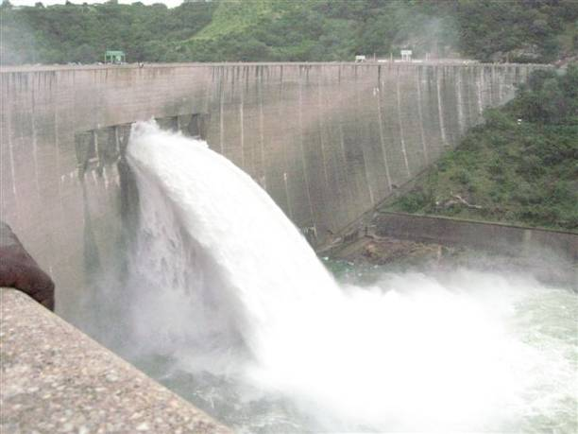
Figure 1: Photo of Kariba dam showing 1 of the 6 sluices spilling

2.1 Plunge Pool reshaping works

2.1.1 Context and objectives of the project
In the course of the first 20 years of sustained heavy spillage episodes, the river bedrock was scoured down to 80 m below the normal water level and resulted in what is now known as the “Plunge Pool”. There is a major concern over its natural development in the future, if an intense spillage episode were to occur in case of exceptional Zambezi floods.
In order to control its future development and avoid dam toe weakening, the studies came to the conclusion that the best solution would consist in an enlargement of the plunge pool, mainly downstream but also on both banks. This reshaping should indeed facilitate the evacuation of spillage flows downstream, and avoid the concentration of turbulence in a restricted and confined area.
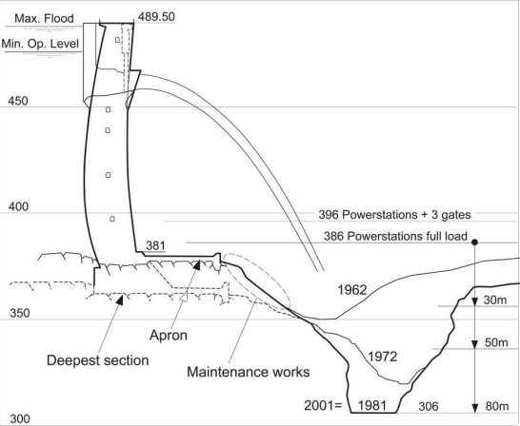
2011 =
Figure 2: Sketch of the present Plunge Pool situation

2.1.2 Description of the works
The Plunge Pool Reshaping works consist in the enlargement of the plunge pool scoured in the riverbed, mainly downstream but also on both banks. Therefore, it consists mainly of rock excavation performed in the riverbed.
The figures below show the geometry of the final plunge pool, which represents a volume to be excavated of approximately 300 000 m³. The future plunge pool is composed of ten successive steps.
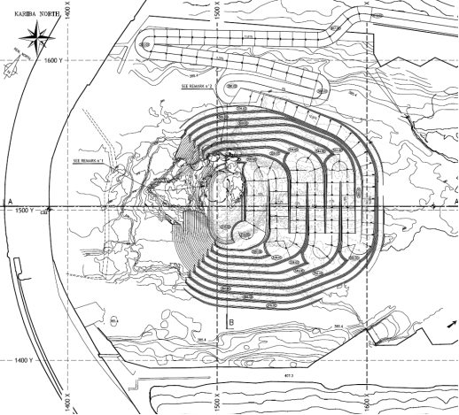
Figure 3: Plunge pool reshaping - plan view

The excavations will be performed in the dry with the drill-and-blast method.
Trucks will transport the blasted material from the plunge pool area to the deposit area. Preliminary investigations indicate that an area located 2.5 km away on the north bank could be suitable.
Given the importance of these works and their surrounding structures (i.e. the dam and powerhouses), the excavation works must be perfectly controlled. Control can only be achieved in dry excavation. Therefore, the river will have to be dried out in the plunge pool area. The following works must be carried out in order to do so:
- Build a cofferdam downstream of the plunge pool and upstream of the powerhouses’ outlets (the discharge from both powerhouses’ outlets is around 1150 m³/s);
- Pump the water out of the plunge pool area to dry the riverbed and release it in the downstream Zambezi river (with a pumping discharge of around 0.4 m³/s);
- Keep pumping the water out of the plunge pool area for the duration of the works (the pumping discharge varies from 0.04 to 0.14 m³/s), except in spillage period.
Additional drilling, injections, and concreting inside the plunge pool area will be needed in order to complete the project.

2.1.3 Phasing of the works
Main constraint
Flood management during construction is a key feature of this project.
The three-month peak flood period of the Zambezi River usually takes place from February to April. The spillage season of the Kariba dam usually takes place from January to August (the spillage season and the high-flood season do not overlap because a reservoir rule curve is applied to provide a sufficient damping capacity in advance, in order to regulate the high floods). Limited amounts of water are usually spilled every now and then in order to closely match the reservoir level rule from January to August.
Because the works are located at the toe of the dam, they must be performed during the non-spillage period, which leaves a short time window.
The compatibility of the works and the necessary spillage have been studied in the detailed design of the project to extend and ensure the non-spillage seasons –the works can be carried out in the plunge pool for 7 months, after which time all materials and equipment will have to be dismantled to allow for the 5 months spillage period, before the works can be resumed for another 7 months.
As a result, the reservoir operation and spillage management will be slightly modified when the works are taking place. One continuous spillage episode will occur in December-April and it will be ensured that the plunge pool area is dry over the May-November period. The amount of water and duration of the spillage episode will depend on the actual hydrological situation at the time of the works.
General works schedule
The works will start with the rehabilitation and construction of the access road and site installations.
The figure below highlights the existing roads that will be used during the works and the new stretches that should be built.
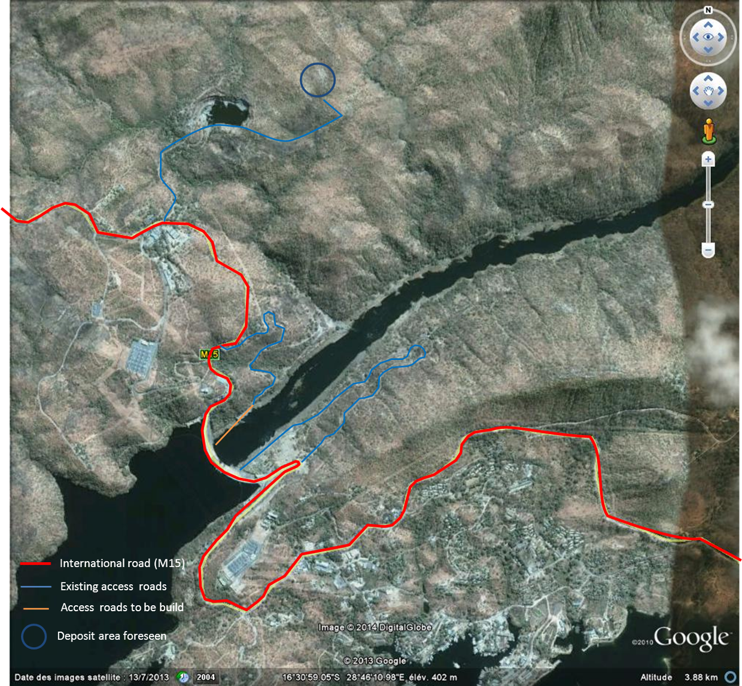
Figure 4: Access roads on site
The cofferdam will then be constructed, and the plunge pool water level will be lowered by pumping, after which the excavation works can start.
Excavation and pumping will be carried out simultaneously. While excavations are being carried out on one of the Plunge Pool steps, the pumps will keep lowering the water level underneath. The objective is to be able to excavate continuously even when switching from one step to the next one situated below it.
Once the plunge pool excavation works are completed, some concreting works will be performed to reinforce the weak areas of the plunge pool. The cofferdam and access road to the plunge pool will be removed from the riverbed. Finally, the work site (including all installations and roads) will be restored.
This global phasing will be split over several seasons because of the spillage issue. Before a spillage occurs, all material equipment and contractors, consultants and employees shall be removed from the plunge pool, and the cofferdam shall be prepared for a spillage episode. Once the spillage season is over, the cofferdam will be put back in operation and the water will be pumped out of the plunge pool area so that the works can be resumed.
The “preparation” of the cofferdam for the spillage can mean, depending on its design, either its complete or partial removal, or no specific measures being taken if its destruction by the flood is accepted.
When the cofferdam is put back in operation after the spillage, it could consist in either its complete or partial reconstruction, or its complete reconstruction with the cleaning of the riverbed if it was destroyed and washed away by the flood.

2.2 Spillway rehabilitation works

2.2.1 Context and objectives of the project
The spillway is located in the arch dam. It is made of six sluices equipped with downstream gates yielding a total capacity of 9000 m³/s. A reservoir rule curve is imposed to create a buffer volume of 23.2 km³ in order to safely pass the 10 000 year return period flood.
To date, the sluices can be inspected or repaired in the dry when closed by a set of stopbeams in still water (downstream gates closed). Considering the distorting effects of the concrete swelling on the geometry of the spillway (Alkali-Aggregate Reaction) and the ageing of the hydro-mechanical equipment (now operated for 50 years), planned and unplanned maintenance operations in the dry should become more frequent. In addition the upstream grooves are in poor condition and need refurbishing.
To address the need for maintenance and to be able to close the sluices in any circumstance (including cases where a downstream gate is jammed partially or fully opened), the Zambezi River Authority plans to equip the spillway with an emergency gate. This new gate will be operated by a new gantry and will slide into the rehabilitated upstream grooves.
These works will take place after the Plunge Pool reshaping works in order to spill through possibly adjacent gates without deepening further the existing Plunge Pool.

2.2.2 Description of the works
The new emergency gate shall close by its own weight against full water flow if one of the downstream floodgate is jammed in a semi-opened position. It is handled by a gantry and lowered or lifted as a whole. It slides into the refurbished upstream grooves.

The new gantry located on the dam crest will be able to lift or to lower the gate as a whole. It is mounted on rails and transfers the emergency gate from one sluice to another.

Installing the new emergency gate involves rebuilding the grooves, the sills, the lintels, the surrounding concrete and partly the top of piers.

The refurbishment works within the sluices (grooves, sill, and lintel) will be done after dewatering the sluices to perform the works in dry condition. A specially designed temporary cofferdam facility will be built for this operation. It will be placed on the upstream face of the spillway in front of one sluice before dewatering it.

The works involve a significant amount of underwater works consisting in grouting of construction joints and cracks, anchoring of rebars, control by divers or ROV during cofferdam installation and un-installation.

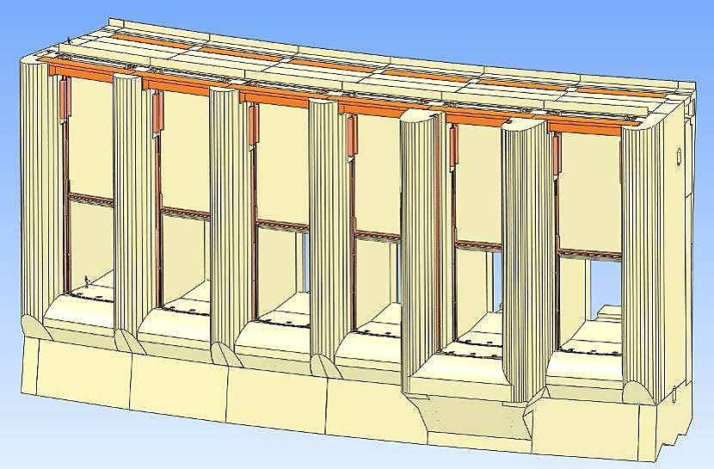
Figure 5: Upstream view of the spillway (arch not shown)

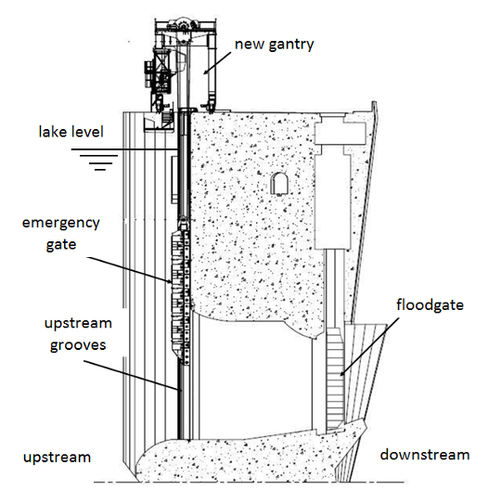
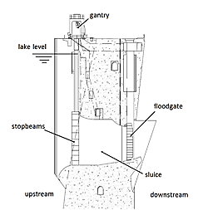
Figure 6: Vertical cross section of the spillway (left = before the works, right = after the works)

2.2.3 Phasing of the works
Main constraint
As for the Plunge pool works, flood management during construction is a key feature of this project.
For the works, it has been considered that the spillage period would take place between February and May.
The spillage period has an impact on the work duration as - for safety reason - the temporary cofferdam cannot be installed, un-installed or transferred from one sluice to another one during spilling.

However once the temporary cofferdam is installed in front of a sluice, it has been assumed that some spillage could take place during the works as long as the number of gates which could be opened are sufficient to follow the reservoir rule and pass the flood.

As the works are located in the spillway, the number of gates which can be opened for spillage during the works is reduced. Up to a 50 year flood, the floods can be managed by spilling with three gates. For higher floods requiring spillage through more gates than the available ones - and in any case for the 10 000 year flood (design flood) - the cofferdam shall be removed before the flood.

Lake Level management during the works
The temporary cofferdam is designed to stay in place between the maximum extreme level (crest level) and the minimum operating level (for downstream power stations). Its installation and operation range is smaller. Outside of the operation range, the works behind the cofferdam should be stopped since leaks or overflow could become important.
During the whole duration of the works, the Rule Curve should be adapted so as to keep the Lake Level as far as possible under 486.50, in order to optimize sequencing of the works without major disruption during refurbishment of one sluice and when floating cofferdam switches between sluices.
For safety reasons, it cannot be installed nor transferred from one sluice to another one during spilling.
General works schedule
The construction schedule will depend on the spillage duration governed by the specific hydrological conditions during the works.

The on-site works to refurbish the spillway shall be performed after the plunge pool reshaping.

The works will start with the site installations, the construction of the spillway and the associated access road. The cofferdam will then be constructed.

The refurbishment of one sluice takes one year, from the installation of the temporary cofferdam to its removal. The cofferdam is successively transferred from one sluice to the adjacent one.

The works are assumed to last around 8 years from Contract’s award.

3.0 PRINCIPLES AND OBJECTIVES OF PROPOSED CONSULTANCY SERVICES
The objective of the Environmental and Social Consultancy Services is to evaluate the design of the Kariba dam rehabilitation works, undertake the required Environmental and Social Impact Assessment (ESIA) and prepare an integrated Environmentl and Social Management Plan or any other associated instruments to ensure the sustainability of project through appropriate preventive, mitigation and monitoring interventions.

The Consultancy Services will produce an ESIA for the Kariba dam rehabilitation works, along with Environmental and Social Management Plans (ESMPs) and Resettlement Policy Framework (RPF).

The ESIA should inform the Governments of Zambia and Zimbabwe, the ZRA, national power utilities, interested and affected parties and other stakeholders about potential environmental and social impacts and risks associated with rehabilitation works of the Kariba dam. This will include those potential impacts at the dam site and surrounding areas, any upstream and or downstream impacts.

The ESIA should be prepared based on information gathered from stakeholders, relevant government agencies, and active participation and consultation with all persons directly or indirectly impacted by the works associated with rehabilitation of the Kariba dam.

The procedure of data acquisition, analysis and interpretation conducted must be transparent and according to accepted international standards and practice.

All services will adhere to national legislative requirements and international best practice, such as the World Bank safeguard policies, such that they will allow for mobilization of the required resources for the rehabilitation of the dam within the shortest possible time.

4.0 SCOPE OF PROPOSED CONSULTANCY SERVICES
The consulting services will be conducted in three phases:
- Baseline and Work Program
- Environmental and Social Impact Assessment
- Risk Management and Mitigation (including the ESMP and RPF)

4.1 Phase I: Baseline and Work Program

4.1.1 Compilation and Initial Review of Documents and Data
As a first step in the execution of the Consultancy Services, the Consultant shall hold consultations with the ZRA and shall acquaint themselves with the Zambezi River Basin and environmental and social requirements in Zambia and Zimbabwe along with any regional or international obligations.

The Consultant shall collect documents related to environmental and social aspects of the Zambezi River Basin, and especially the proposed Kariba dam rehabilitation works. The documents should include, but not be limited, to
- Detailed Design studies for the Plunge Pool reshaping and the replacement of the existing stopbeams of Kariba dam spillway, by an emergency gate in rehabilitated grooves
- Prospectus Note

During the intial phase, the Consultant shall compile all available environmental and social baseline data, including maps, aerial surveys and related reports of the project area. etc., relevant for the Kariba dam rehabilitation. This will include, but not necessarily be limited to, the following.

4.1.2 Policy, Legal, and Institutional Framework.
The Consultant will review and describe the policy, legal, and administrative framework within which the ESIA is to be carried out. This will include a description of the pertinent regulations, protocols and standards pertaining to the project and their implication on the project and will cover those in Zambia and Zimbabwe, as well as at international and regional level. An overview of the implementation arrangements, including the roles and responsibilities of all relevant agencies, will be detailed.

Relevant international environmental and social agreements to which both countries are party will be identified and any obligations with implications for the project identified and described. This should include, but not necessarily be limited to, the UNESCO World Heritage Convention, RAMSAR Convention on Wetlands of International Importance, etc.

The environmental and social requirements of potential financiers should be reviewed and described in terms of potential obligations.

Reference should be made, but not limited to, the following:
- Zambezi River Authority Act
- Zambian Water Resources Management Act
- Zimbabwe Water Act
- Zambia Environmental Management Agency
- Zimbabwean Environmental Management Agency
- SADC Revised Protocol on Shared Water Courses
- Agreement on the Establishment of the Zambezi Watercourse Commission
- African Development Bank Integrated Safeguard System (see summary below)
- World Bank Safeguard Policies (see summary below)
- World Bank Group Environmental, Health and Safety Guidelines
- Equator Principles
- IFC Performance Standards

Operational Safeguards Triggered
 | AfDB |  | IDA
Labor Conditions & Occupational Health and Safety | OS5 | Yes | - | -
Environmental Assessment | OS1 | Yes | OP/BP 4.01 | Yes
Physical Cultural Resources | OS2 | No | OP/BP 4.11 | Yes
Involuntary Resettlement | OS2 | No | OP/BP 4.12 | Yes
Natural Habitats / Biodiversity & Ecosystem Services | OS3 | Yes | OP/BP 4.04 | Yes
Pest Management | OS3 | No | OP 4.09 | No
Forests | OS3 | No | OP/BP 4.36 | No
Pollution Prevention & Hazardous Materials | OS4 | Yes | - | -
Indigenous Peoples | - | - | OP/BP 4.10 | No
Safety of Dams | - | - | OP/BP 4.37 | Yes
Projects on International Waterways | - | - | OP/BP 7.50 | Yes
Projects in Disputed Areas | - | - | OP/BP 7.60 | No

Labor Conditions & Occupational Health and Safety (OS5)

Environmental Assessment (AfDB OS 1 and WBG OP/BP 4.01), Both the African Development Bank and the World Bank have specific provisions pertaining to environmental assessment for all Bank financed development projects. According to these policies the Bank classifies proposed projects into one of three categories, depending on the type, location, sensitivity, and scale of the project and the nature and magnitude of its potential environmental impacts. The Kariba dam rehabilitation Project has been classified as Category A under the WB safeguard policies and a Category I under the AfDB. A proposed project is classified as Category A/I if it is likely to have significant adverse environmental impacts that are sensitive, diverse, or unprecedented. For a Category A/I project, the Recipient is responsible for preparing a report, such as an ESIA.

Bank policy also requires that an environmental assessment is initiated as early as possible in project processing and is integrated closely with the economic, financial, institutional, social, and technical analyses of a project. The commissioning of an environmental assessment is the responsibility of the Recipient and the Bank reviews the findings and recommendations of the ESIA to determine whether they provide an adequate basis for decision making with regard to the project.

Natural Habitats (OP & BP 4.04) The Bank supports the protection, maintenance, and rehabilitation of natural habitats and their functions in its economic and sector work, project financing, and policy dialogue and expects borrowers to apply, a precautionary approach to natural resource management. In the context of current project implementation and development the following elements of Bank policy will apply: i) promotion and support to natural habitat conservation and improved land use and the rehabilitation of degraded natural habitats; ii) the Bank does not support projects that involve significant conversion or degradation of critical natural habitats. ; and, iii) wherever feasible, Bank-financed projects are sited on lands already converted (excluding any lands that in the Bank's opinion were converted in anticipation of the project).

The Bank does not support projects involving the significant conversion of natural habitats unless there are no feasible alternatives for the project and its siting and comprehensive analysis demonstrates that overall benefits from the project substantially outweigh the environmental costs. If the environmental assessment indicates that a project would significantly convert or degrade natural habitats, the project includes mitigation measures acceptable to the Bank. Such mitigation measures include, as appropriate, minimizing habitat loss (e.g., strategic habitat retention and post-development restoration) and establishing and maintaining an ecologically similar protected area.

Physical Cultural Resources (OP & BP 4.11) This policy addresses physical cultural resources, which are defined as movable or immovable objects, sites, structures, groups of structures, and natural features and landscapes that have archaeological, paleontological, historical, architectural, religious, aesthetic, or other cultural significance. Physical cultural resources may be located in urban or rural settings, and may be above or below ground, or under water. Their cultural interest may be at the local, provincial or national level, or within the international community The Bank assists countries to avoid or mitigate adverse impacts on physical cultural resources from development projects that it finances. The impacts on physical cultural resources resulting from project activities, including mitigating measures, may not contravene either the borrower’s national legislation, or its obligations under relevant international environmental treaties and agreements.

Involuntary Resettlement (OP & BP 4.12) This policy applies to all land acquisition and any changes in access to resources due to a project and/or subproject. The policy applies whether or not affected persons must move to another location. Where the exact impacts are not confirmed or subject to final decisions by Contractors during the works, such as the final routing of access roads, the dumping site and the slipway, a Resettlement Policy Framework (RPF) shall be prepared.

Safety of Dams (0P& BP 4.37) Dam safety is a matter of significant importance in many countries in the world today because of the presence of a large number of dams, existing, under construction or planned. The safe operation of dams has significant social, economic, and environmental relevance. When the World Bank finances new dams, OP 4.37 requires that experienced and competent professionals design and supervise construction, and that the borrower adopts and implements dam safety measures through the project cycle. The policy also applies to existing dams where they influence the performance of a project. In this case, a dam safety assessment should be carried out and necessary additional dam safety measures implemented. OP 4.37 recommends, where appropriate, that Bank staff discuss with the borrowers any measures necessary to strengthen the institutional, legislative, and regulatory frameworks for dam safety programs in those countries. OP 4.37 is triggered by this project and will be addressed according to Bank policies and guidelines, including preparation of Dam Safety Studies.

International Waterways (OP &BP 7.50) This policy applies to any river or body of surface water that flows through, two or more states, whether Bank members or not. This policy applies to irrigation systems, dams and flood control measures. If such a project is proposed, the Bank requires the beneficiary state to formally notify the other riparians states of the project and its Project Details. OP 7.50 is triggered by this project and riparian notification will be issued to all nine riparians states. Notification has been made in accordance with provisions of SADC Protocol / ZAMCOM Agreement and meeting the requirements of OP 7.50.

4.1.3 Project Description
The Consultant will:
- Describe the major activities to be undertaken during the works related to the rehabilitation project and its geographic, ecological, social, and temporal context, including any off site investments that may be required (e.g., access roads, water supply, housing, and raw material and product storage facilities). Indicate the need for any resettlement plan (see also Section 4.3.3 below), including a map or maps showing the project site and the project's area of influence.
- Outline any alternatives under consideration; the alternatives should include but not be limited to design and technology selection. Site-specific maps of the project area (Scale 1:50,000 or larger) should be provided, showing the project site, all environmental and social characteristics of relevance to the project and its assessment.

4.1.4 Baseline Conditions
The Consultants will review and assess the dimensions of the study area and describe relevant physical, biological, chemical, socio-economic and cultural conditions, including any changes anticipated before the project commences. The baseline conditions should also take into account current and proposed development activities within the project area but not directly connected to the project.

Baseline data should include, but not limited to, the following:
- Physical environment: geology, topography, soils, climate and meteorology, surface and ground water hydrology, river flows, baseline water and air quality and sedimentation, and physical cultural resources;
- Biological environment: flora, fauna, rare, endangered or endemic species, IUCN Red List Species, Important Bird Areas, etc., including amphibians and reptiles, birds, fish, large and small mammals (i.e. bats), plants, economic plants and medicinal plants, sensitive habitats, significant natural sites, etc.; species of commercial importance, and species with potential to become nuisances, vectors or dangerous;
- Socio-cultural environment including gender disaggregated population data, migration pattern, land use, planned development activities, community structure, employment, distribution of income, goods and services, recreation/tourism, public health, prevalence and distribution of waterborne diseases and cultural properties.
- Data should be relevant to decisions about project design, or mitigatory measures. This should also consider identification of potential borrow sites, quarries, access roads etc. It should also include a preliminary review of the Emergency Preparedness Plan and associated national disaster response plans. The section will include a description of the methodology used to collect information and data and indicating the accuracy, reliability, and sources of the data.

4.1.5 Site Visits
The Consultant shall conduct initial site visits at the dam site, slipway site, deposit area, and upstream and downstream reaches to familiarize themselves with the environmental and social characteristics.

4.1.6 Baseline Workshop
The Consultant shall prepare a Baseline Report with their findings during the initial phase and report this at a Workshop chaired by ZRA. The Baseline Report shall include what data and information have been collected, the results of the site visits, the proposed plan for field investigations, and any deviations in the proposed detailed methodology compared to what was specified in the contract.

Based on the feedback from the Client and other stakeholders the Consultant shall update the final methodology and work plan for the study.

4.2 Phase II: Environmental and Social Impact Assessment
The Consultant shall carry out an independent and integrated environmental and social impact assessment for the proposed Kariba Dam Rehabilitation Works. The ESIA shall be presented following the description of the scope of work contained herein. The ESIA shall include an Executive Summary that concisely discusses significant findings, recommended actions and associated costs. Each section of the scope of work described herein should include a description of the methodology used to collect, compile and analyze all data and information. The ESIA will further include a set of annexes that shall include, but not necessarily be limited to the following:
(i) List of those involved in preparation of the report (individuals and organizations).
(ii) References, including both published and unpublished written material.
(iii) Record of interagency and consultation meetings, including consultations for obtaining the informed views of the affected people and local nongovernmental organizations (NGOs).
(iv) Tables presenting the relevant data referred to or summarized in the main text, including species lists.
(v) List of associated and supporting reports (e.g. Specialist Reports, such as those on biodiversity, cultural resources, and others as needed, Engineering Reports, Resettlement Policy Framework, etc.).

4.2.1 Environmental and Social Impacts
The Consultant will predict and assess the potential positive and negative impacts associated with the Kariba dam rehabilitation. This will include direct and indirect impacts, short and long-term duration; along with any potential cumulative impacts. This will be done in quantitative terms to the extent possible in line with the methodology agreed and the baseline established during the Phase 1: Baseline and Work Program.

The Consultant will identify and estimate the extent and quality of available data, key data gaps, and specifies topics that do not require further attention. Mitigation measures and any residual negative impacts that cannot be mitigated will be identified and taken forth through appropriate Environmental and Social Management Plans and Resettlement Policy Framework during the third phase. Opportunities for environmental and social enhancement will be identified.

Environmental and social impacts (including direct and indirect, short and long-term, induced and cumulative) associated with the project at and around the site focussing on both positive and negative impacts as well as bio-physical, chemical, social, economic and cultural components of the environment associated with the construction, operation and decommissioning of the project.

The environmental and social assessment should include, but not be limited to, the following:
- land use for the access roads, worksite facilities, slipway, borrow pits, quarries, and dumping sites;
- environmental and social impacts of temporary limitations of crest traffic, and transport, storage;
- the impacts of blasting activities on the environment, through management of the transport, storage, use and disposal of explosives;
- water quality regimes of the river and reservoir, upstream and downstream of the dam (including potential oil spillages in the reservoir and in the river downstream the dam, failure of the downstream cofferdam, failure of the temporary cofferdam during the rehabilitation works;
- specifically establish a baseline sediment level downstream of the dam to determine any changes during implementation of the works on the plunge pool;
- siltation, in the reservoir area below the downstream cofferdam during the rehabilitation works ;
- review the historical hydrology, model predictions on inflows in during implementation period, highlight any longer term predictions with respect to climate change
- environmental and social impacts of potential alteration of river flow regimes during the rehabilitation works (regulated flows, etc.);
- review the design criteria and proposed operating procedures during the rehabilitation of Kariba dam to assess any impacts associated with potential changes to the natural flow regime
- aquatic wildlife during the rehabilitation works, including fish, benthos, and other aquatic life, particularly endemic, rare or endangered species, those of conservation concern or economic importance, ;
- terrestrial wildlife and biodiversity, with special focus on particularly endemic, rare or endangered species, during the rehabilitation works
- existing protected areas or other sites of conservation or special management interest;
- identify areas at risk and, based on desk top review of publically available data, assess the potential impacts in the event of an adverse event during implementation of the works, including but not limited to human settlements, key infrastructure, protected areas, etc.

4.2.2 Public Consultation
The Consultants will be required to undertake a two stage formal public consultation (one at the inception stage for the purposes of scoping, and another one to present key findings and mitigation to stakeholders) to ensure that all interested and affected stakeholders are involved in the ESIA process and their views incorporated into the final ESIA report. This should be based on a consultation programme to be shared with the ZRA during the baseline phase. Evidence of consultation should be provided in the report.

Specifically, the Consultant will propose an effective, comprehensive public consultation strategy which should include its objective, list of stakeholders to be consulted, methods for reaching these stakeholders, the scheduling of consultation activities, and how the consultation efforts will be analyzed.

The Consultants will maintain a record of interagency and consultation meetings, including consultations for obtaining the informed views of the affected people and local non-governmental organizations (NGOs). The record will specify any means other than consultations (e.g., surveys) that were used to obtain the views of affected groups and local NGOs. Minutes should be kept for all consultation meetings with project affected persons and included in an annex of the ESIA.

All relevant materials will be provided to affected groups in a timely manner prior to consultation and in a form and language that is understandable and accessible to the groups being consulted.

4.3 Phase III: Risk Management and Mitigation

4.3.1 Environmental and Social Risk Management and Mitigation
Rehabilitation of hydro-electric projects involves various risks at different stages viz., planning, design, construction and operation. The Environmental and Social Impact Assessment Phase will provide an analysis of potential risks associated with the rehabilitation of the Kariba dam. Based on this assessment, this phase will identify options and define recommended measures to be taken to prevent, eliminate, reduce, mitigate or manage associated risks and develop any opportunities for environmental and social enhancement.

4.3.2 Environmental and Social Management Plan
The Consultant will prepare an Environmental and Social Management Plan (ESMP) covering both works components of the project. This will consist of the set of mitigation, monitoring, and institutional measures to be taken during the rehabilitation works to eliminate adverse environmental and social impacts, offset them, or reduce them to acceptable levels. Specific provisions relating to one or other (or both) of the works components should be clearly identified and these should reduce residual adverse impacts to levels that are compatible with the standards imbedded in the applicable Safeguard Policies. The plan will include the actions needed to implement these measures and any other potential measures to enhance positive impacts, including training and capacity building.

Specific consideration should be afforded to the preparation of a Blasting Management Plan to be implemented by the Contractor during implementation. The Blasting Management Plan should be structured to ensure minimal risk to community members, property, infrastructure and personnel. The plan should consist of, but not necessarily be limited to, the following components: i) the transport and storage of explosives and risk during blasting activities; ii) timing of all blasts to be communicated to the community and surrounding areas at least 12 hours before blasting to occur; iii) processes and procedures for evacuation of community members surrounding the blast area; iv) management options to limit blast intensity.

The Consultant will propose an Environmental and Social Management Plan which should be in tabular form and should specify the predicted impacts, mitigation and monitoring measures/enhancement measures, institutional responsibilities, budget estimate and schedule of these measures. This should include specific provisions to be included in all Contract documents outlining the necessary chance find procedures in relation to physical cultural resources. The Consultant should estimate the costs of implementing this plan, including all capital, recurrent operating and training costs. The Environmental and Social Management Plan must identify the information needed to guide management decisions, including recommendations on the source of funding for all recurrent costs associated with mitigation and monitoring measures. It should clearly indicate responsibilities for lead agencies, stakeholders and any training needs that should be undertaken to ensure its proper implementation.

The Consultant shall prepare a draft bill of quantities for all monitoring, mitigation and impact management measures required under the ESMP. These will be used for inclusion in tender documents for any works contracts. This should include Environmental Rules for Contractors to follow, in order to minimize adverse construction-related environmental and social impacts, along with clear penalties for non-compliance.

The ESMP will include an Environmental and Social Monitoring Plan by which all mitigation measures recommended in the Environmental and Social Management Plan will be monitored. This should include:
- performance monitoring of how well project construction and operation - including the implementation of key mitigation measures - are carried out from an environmental and social (including health and safety) perspective; and,
- outcome monitoring of key selected environmental and social indicators (such as for reservoir and river water quality, indicator species of conservation or special management interest etc.). The ESMP should specify the activities of the project, key monitoring parameters, the frequency and duration of monitoring, resources required, skilled personnel needs, authorities responsible for monitoring and means of verification.

The ESMP will provide an overview of the implementation arrangements, roles, and responsibilities of all relevant agencies in implementation and monitoring compliance with the ESIA and the ESMP. This should include a review of the authority and capability of institutions at different levels (e.g. local, district, provincial/regional, and national), and their capacity to manage and monitor implementation. The analysis may extend to new laws and regulations, new agencies or agency functions, inter-sectorial arrangements, management procedures and training, staffing, operation and maintenance training, budgeting, and financial support.

The ESMP shall specifically outline the responsibilities of the Contractors in the preparation and implementation of a Contractors ESMP (CESMP) and the development of Environmental and Social Method Statements. This will include Risk Assessments for each activity and the recruitment of qualified personnel specifically for this purpose. These requirements will be included as part of the Tender Documents.

The ESMP shall similarly outline the responsibilities of the Supervising Engineer. This will include, but not necessarily be limited to, monitoring and enforcing implementation of the CESMP through suitably qualified personnel recruited. These provisions will be included as part of the Tender Documents.

For institutions responsible for implementation of the overall project and subsequent plans, the ESMP will identify any training and capacity building programs that will need to be provided and determine what, if any, technical assistance may be needed.

4.3.3 Resettlement Policy Framework
A Resettlement Policy Framework (RPF) will be prepared as a separate stand-alone document. The purpose of the RPF is to clarify resettlement principles, organizational arrangements, and design criteria to be applied to subprojects to be prepared during project implementation. This will provided the framework for prior agreement on a transparent mechanism in the event that any land acquisition is required for activities where the exact impacts are not confirmed or subject to final decisions by Contractors during construction, such as the final routing of access roads, quarries, borrow pits, dumping sites and the slipway.

The RPF should cover, but not necessarily be limited to, the following elements:
(a) a brief description of the project and components for which land acquisition and resettlement may be required, such as access roads, construction camps, borrow pits, dumping sites, etc.;
(b) principles and objectives governing resettlement preparation and implementation;
(c) a description of the process for preparing and approving resettlement plans;
(d) estimated population displacement and likely categories of displaced persons, to
the extent feasible;
(e) eligibility criteria for defining various categories of displaced persons;
(f) a legal framework reviewing the fit between borrower laws and regulations and
Bank policy requirements and measures proposed to bridge any gaps between
them;
(g) methods of valuing affected assets;
(h) organizational procedures for delivery of entitlements, including potential for
income generation;
- a description of the implementation process, linking resettlement implementation to civil works;
(j) a description of grievance redress mechanisms;
(k) a description of the arrangements for funding resettlement, including the
preparation and review of cost estimates, the flow of funds, and contingency
arrangements;
(l) a description of mechanisms for consultations with, and participation of,
displaced persons in planning, implementation, and monitoring; and
(m) arrangements for monitoring by the implementing agency and, if required, by
independent monitors.

4.3.4 Costing
The Consultant shall prepare a cost estimate for implementation of the ESMP associated with the Kariba Dam Rehabilitation Program with break-down in local and foreign currency. The cost estimate shall be prepared on the basis of prevailing market prices. The reference price level and exchange rate(s) should be provided. For all construction and equipment associated with implementation of the ESMP, prices should be based on collected information from potential suppliers. An estimate for administration, legal costs, land acquisition, resettlement, compensation, social, and environmental measures outlined in the ESMP shall be included along, with the basis for their estimate.

The Consultant shall determine the criteria for estimating physical contingencies for the various project components and the price escalation during implementation shall be provided.

4.3.7 Presentation and Reporting
The Consultant shall present the Environmental and Social Impact Assessment, the ESMP and the RPF as separate volumes.

The draft ESIA Report, the draft ESMP and the draft RPF will be presented to the Client and stakeholders at a consultation workshop prior to finalization. This will ensure all potential impacts are properly identified. Based on feedback from the consultative process the Consultant shall finalize the reports.

All consultations will be properly managed and documented through the Public Consultation Strategy and minutes of all meetings. This shall be included as part of the final report.

5.0 REQUIRED EXPERTISE OF KEY PERSONNEL

The Consultant shall ensure a team of international experts with extensive experience from similar environmental and social assessments of large dam, or related infrastructure, projects. The project management and key personnel must have experience from projects in Africa and the team should be supported by local expertise as far as possible. To adequately address the core issues of the study, the Consultant’s key personnel should be composed of at least the following:

1) Team Leader – Environmental Impact Assessment Expert
A professional with at least a Master Degree in Environmental Management and at least 15 years of experience in the assessment of the environmental impact of large dam, or related, projects. In demonstrating the professional experience, the Team Leader shall prove to have been involved in at least 5 (five) projects of a similar nature based in international contracts. In addition, the Team Leader shall be a person with good oral and written communication skills and shall demonstrate a high level of organizational skills.

2) Water Resources Expert
A Water Resources Expert with at least a Master Degree in Water Resources Management or its equivalent and at least 10 years relevant experience in water management planning.

The Water Resources Expert shall be a key member of the consultancy team and play a key role in the planning and implementation of the overall assessment and as such is expected to prove to have been involved in at least 5 (five) projects of a similar nature based in international contracts.

3) Aquatic Ecologist
Aquatic Ecologist with at least a Master Degree and at least 10 years relevant experience in aquatic ecology, fisheries or related field and mitigation plan preparation. Expertise in identifying species of conservation or management interest in the project area will be an advantage.

The Ecologist shall be a key member of the consultancy team and play a key role in the planning and undertaking of the environmental assessment for the project and as such is expected to prove to have been involved in at least 3 (three) projects of a similar nature based in international contracts.

4) Terrestrial Ecologist
Terrestrial Ecologist with at least a Master Degree in Ecology, or equivalent discipline, and at least 10 years relevant experience in ecological management or related field and mitigation plan preparation. Expertise in identifying plant or animal species of conservation or management interest in the project area will be an advantage.

The Ecologist shall be a key member of the consultancy team and play a key role in the planning and undertaking of the environmental assessment for the project and as such is expected to prove to have been involved in at least 3 (three) projects of a similar nature based in international contracts.

5) Sociologist
A professional sociologist with at least a Master degree in Social Sciences or equivalent and at least 10 years relevant experience in social impact assessment and mitigation plan preparation.

The Sociologist shall be a key member of the consultancy team and play a key role in the planning and undertaking of the social assessment for the project and as such is expected to prove to have been involved in at least 3 (three) projects of a similar nature based in international contracts.

6) Public Consultation Facilitator.
A qualified specialist with not less than ten (10) years of cumulative experience developing and implementing public awareness and consultation strategies.

The Public Consultation Facilitator will be responsible for planning and implementing a transparent public consultation strategy targeting affected communities and will have specific experience working as a public participation specialist on at least two (2) dam projects of similar nature and complexity, of which at least one must be from sub-Saharan Africa.

7) Civil Engineer
A professional engineer with at least 15 years of experience in the reconnaissance, siting, general layout design and output optimization of hydropower plants/schemes.
The Engineer shall be a key member of the consultancy team and shall play a key role in informing the planning and execution of the feasibility study and as such is expected to prove to have been involved in at least 3 (three) projects of a similar nature based in international contracts.

8) Additional Expertise
Additional expertise that shall have smaller but essential inputs may include, but may not be limited to:
- Occupation Health and Safety Specialist
- Public Health Specialist
- Explosives and Blasting Expert
- Gender Specialist
- Agricultural Economist
- Geologist / Geomorphologist
- Ornithologist
- GIS Specialist
- Legal Specialist
- Economist
- Hydrologist

6.0 DELIVERABLES
The Client considers of utmost importance the timely elaboration and submission of pertinent reports and briefings during the course of the work of very high importance. Therefore, apart from submitting the reports, the Consultant shall be expected to hold monthly updates/briefings/video conferences with the ZRA on works in progress and problems encountered.

The Consultant shall prepare and submit reports of the consultancy to the Client in one [1] electronic copy, preferably in MS Word, on CD ROM and hard copies as specified in the Table below. The reports and briefing shall be written and held in English.

The draft and the final reports shall be submitted as hard copies and in electronic form to the ZRA as specified. After incorporating the necessary modifications to the drafts the edited technical reports shall be submitted to the ZRA no later than three weeks after approval of the draft report.

The Client is engaging an independent Panel of Experts to assist in the review and oversight of the Consultant.

Summary of the Expected Deliverables
Report No. | Report Description | No. hard copies | Due date  (No. of weeks from commencement date)
1 | Draft Baseline Report & Work Program (including Public Consultation Report) | 15 | 4
2 | Final Baseline Report & Work Program | 20 | 6
3 | Draft Environmental & Social Impact Assessment (including Public Consultation Report) | 15 | 16
4 | Draft Environmental & Social Management Plan and Resettlement Policy Framework (including draft bills of quantities for monitoring, mitigation and impact management for inclusion in tender documents for all works) | 15 | 16
5 | Final Environmental & Social Impact Assessment | 15 | 20
6 | Final Environmental & Social Management Plan and Resettlement Policy Framework (including final bills of quantities for monitoring, mitigation and impact management for inclusion in tender documents for all works) | 15 | 20

7.0 SERVICES AND FACILITIES TO BE PROVIDED BY

THE CLIENT

7.1 Documentation
The ZRA shall provide documents, where available, such as previous power development master plans, feasibility studies reports, environmental assessments, operational data for the existing power generation, transmission and distribution systems, etc., that may be required for the performance of the services.

7.2 Equipment and Tools
All equipment and tools needed to undertake the study shall be provided by the Consultant.

7.3 Office Space and Facilities
The Consultant shall provide own office facilities, for the execution of the services. The ZRA shall render all possible assistance to the Consultant in the timely acquisition and securing of such office space required for the execution of the Services.

7.4 General Assistance
The ZRA shall provide assistance in obtaining working permits, residence visas, exit, re-entry and exit visas for the Consultant’s staff, other licensing documents, etc. ZRA shall also provide assistance in facilitating and expediting customs procedures in connection with importation of equipment and materials necessary for the Consultant’s services and for the personal use of the Consultant’s staff.

8.0 IMPLEMENTATION TIME SCHEDULE
It is preferred that the consultancy services shall be undertaken and completed within a period of five (5) calendar months, i.e. twenty (20) weeks. In the Consultant’s proposal it should be taken into account how any additional investigations can be accommodated.

9.0 CONTRACT
It is envisaged that the Consultancy Services Contract will be a lump-sum Contract, modeled on the World Bank’s guidelines for the selection and employment of Consultants.

Significant conversion is the elimination or severe diminution of the integrity of a critical or other natural habitat caused by a major, long-term change in land or water use.

