Senn Nuclear Power Plant Project for Italy, September 16, 1959

January 2016
number 063
originally published: september 2008
The World Bank Group Archives Exhibit Series contains exhibits originally published on the Archives’ external website beginning in 2002. When the Archives’ website was transferred to a new platform in 2015, it was decided that older exhibits would be converted to pdf format and made available as a series on the World Bank’s external database, Documents & Reports.

These exhibits, authored by World Bank archivists, highlight key events, personalities, and publications in the history of the World Bank. They also bring attention to some of the more fascinating archival records contained in the Archives’ holdings.

To view current exhibits, visit the Exhibits page on the Archives’ website.

Senn Nuclear Power Plant Project for Italy, September 16, 1959
The Bank had been considering the development of nuclear power on a commercial basis since 1955. In June 1956 the Bank issued a report examining the status of nuclear power development at that time. It concluded, based on the information then available, that there were good prospects that power could be produced by a nuclear plant at costs competitive, or close to competitive, with power produced by a conventional plant.
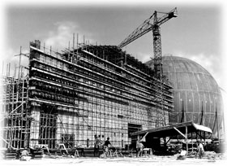  In the foreground is the main station, with the giant sphere for the nuclear reactor in the background, 1961. Photo: SENN | 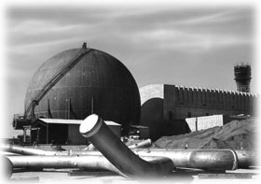  On the left is the gigantic sphere, which houses the nuclear reactor. On the right is the powerhouse to contain the generators and the water tower. In the foreground are the specially welded stainless steel pipers to convey steam from the reactor to the

The Bank examined several locations where a nuclear power plant might be considered. The conditions in southern Italy appeared favorable. In July 1957, the Government of Italy and the Bank agreed to sponsor a joint study, known as ENSI (Energia Nucleare Sud-Italia), of the possibilities of a nuclear power station in Southern Italy. The Bank also set up an International Panel to provide advice and guidance on the nuclear aspects of the Project ENSI study.

The site selected for the construction of the nuclear power plant was on the Garigliano River, between Rome and Naples. The site was chosen not only because of good supply of cooling water and favorable conditions for the release of waste gasses and disposal of radioactive waste, but also because the plant could be easily linked with the extensive generation and distribution system of the utility shareholders of Societa Elettronucleare Nazionale (SENN). SENN was designated by the Italian Government as the company which would own and operate the nuclear plant. General Electric Company was responsible for the design and construction of the nuclear aspects of the plant, supply of equipment and fabrication of fuel.

 |  | 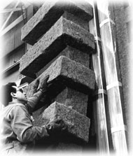  Packing nuclear fuel elements manufactured by the General Electric Company for shipment to Garigliano nuclear power station, December 1962. Photo: General Electric |  | 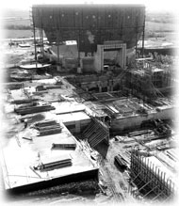  The photo shows the foundation of the giant sphere for the nuclear reactor in the background, 1960. Photo: SENN
The plant incorporated a boiling water-cooled and -moderated nuclear reactor fueled by enriched uranium. A huge steel sphere housed the nuclear section of the plant, including the steam vessels, With a diameter of 160 feet—greater than that of St. Peter’s in Rome—the sphere served both as a pressure chamber for the reactor and to contain any radioactivity which might result from a nuclear accident. Great care was therefore taken to ensure that the sphere was completely airtight.

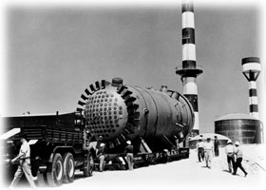  Boiling water reactor vessel arriving at the Garigliano site, December 1962. Photo: General Electric. | 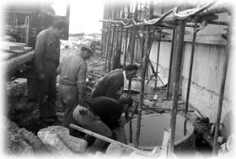  Italy’s first nuclear power plant is under construction on the Garigliano River, March 1962.
The plant began operation in 1964. In August 1978 it was shut down due to damage to one of the two secondary steam generators. In March 1982 the Italian Electricity Generating Board declared the plant to be out of service. While the Bank has continued to monitor developments in the field of nuclear energy, the loan to Italy for the nuclear plant on the Gargliano River remains its only loan for that form of energy.

