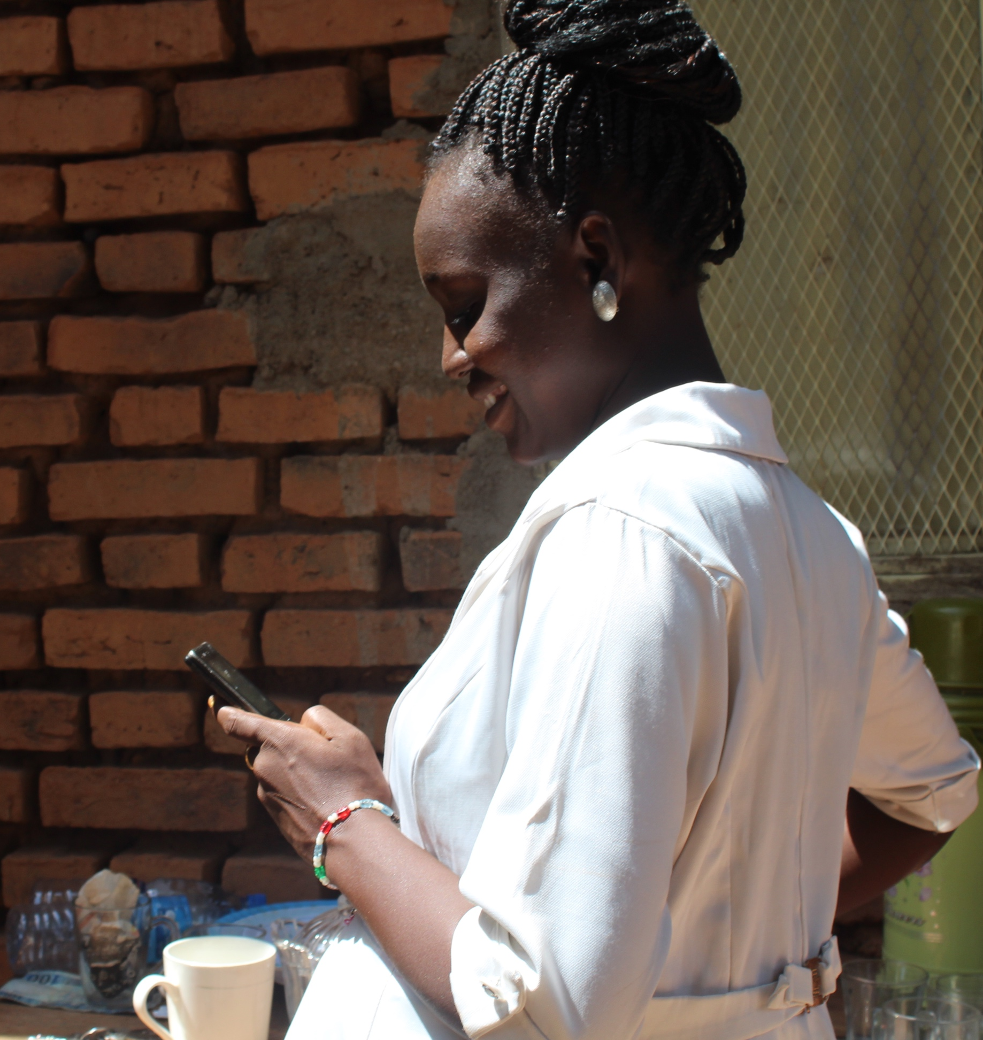
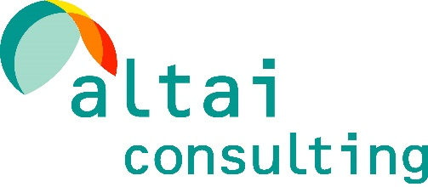
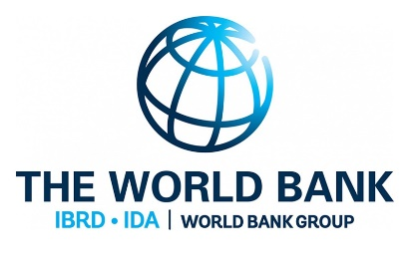
Juba, South Sudan. Unless specified otherwise, all pictures in this report are credited to Altai Consulting
MoBile Money Ecosystem Survey IN South SUDAN
Exploring the current and future potential of using mobile money for effective humanitarian and development cash-programming

Executive Summary

Prepared by Altai Consulting for the World Bank | South Sudan – June 2019

Background
- South Sudan’s recent conflict and ongoing insecurity have eroded the country’s development potential, increased vulnerability, and exacerbated the need for humanitarian assistance. Hundreds of thousands of people have lost their lives, over one third of the population has been displaced, and a little over half of the population continues to be severely food insecure. The on-going economic crisis has also aggravated already weak poverty and macroeconomic indicators, resulting in extremely high levels of inflation that reached 131 percent in 2018, rapid currency devaluation, and near universal rates of poverty estimated at nearly 90 percent in 2018.
- While a revitalized peace agreement was signed in September 2018, the long-term prospects for a peaceful resolution to the ongoing conflict are tenuous. The agreement was expected to reinforce a permanent ceasefire, create an enabling environment for humanitarian assistance delivery, institute critical reforms, and establish a new transitional government of national unity by May 2019. Unfortunately, conflict persists in parts of the country, and key milestones for establishing power-sharing arrangements have been missed. Consequently, the pre-transition period has been extended from May to November 2019. It is uncertain whether this is realistic given the complexity in establishing new security arrangements and agreeing on a new structure for subnational governments.
- In this setting, cash assistance could provide a flexible and cost-efficient means of providing effective and dignified assistance to poor and vulnerable households. A scale-up of cash assistance is thus being considered by many humanitarian and development agencies working in South Sudan, underpinned by a wider global commitment to increase the use of cash for delivery of humanitarian and development assistance, as appropriate. Given the role that cash plays in many national social protection schemes globally and in the region, humanitarian cash assistance can also strengthen linkages with longer-term development approaches. In South Sudan, an increase in predictable and reliable cash-assistance could therefore facilitate the roll-out of safety nets that build local resilience.
- However, scale up of cash assistance comes with a host of operational risks in Fragility, Conflict and Violence (FCV) affected contexts. The political situation remains highly volatile, with frequent outbreaks of local-level violence. In such a context, any leakages risk fueling conflict. Due to very limited physical and virtual infrastructures, cash needs to be physically transported from one location to another, which is not only costly, but risky for those who undertake it. Moreover, an influx of cash assistance could also place beneficiary populations at risk of predatory violence.
- Mobile money could offer a promising means of mitigating risks of cash assistance and improving the delivery of cash assistance in South Sudan, while increasing financial inclusion. Based on similar experiences from elsewhere in East Africa, notably Somalia, mobile money could therefore provide a flexible and cost-efficient means of delivering effective and dignified cash assistance to poor and vulnerable households in South Sudan. It can help reduce leakages by eliminating the need for ‘middlemen’ or ‘gate-keepers’. It can also provide a more secure mean of receiving and storing cash for the recipient – e.g. by decreasing the visibility of cash distribution, thereby protecting beneficiaries from threats, violence or theft. Where network coverage permits, mobile money can facilitate cash distribution in remote or inaccessible areas, as well as reduce transfer and related logistical costs. By delivering assistance directly to a recipient’s mobile device, mobile money can further help mitigate the ‘push-and-pull’ effect associated with set cash distribution points. Finally, using mobile money could encourage uptake of digital financial services, thereby expanding financial inclusion among the un-banked.
- Greater use of mobile money could also be a small but important step towards creating a more formal economy. A large proportion of the economy and trade in South Sudan remains informal and cash-based. However, mature mobile money systems could foster the formalisation of the economy, integrating informal sector users into business networks, formal banking and insurance, and linking to the Government through social security, tax, and secure wages payments. As of May 2019, no formal mobile money services were available in South Sudan. However, two companies have been licensed and will allegedly launch services by the end of June 2019
- The World Bank Group commissioned a research project to explore the current and future potential of using mobile money for more effective humanitarian and development cash assistance in South Sudan. Research undertaken employed a mixed methods research methodology, which examined both the supply- and demand-side of the market to provide a complete picture of the existing mobile money landscape.
- This report presents findings from the supply-side and demand-side research undertaken. The purpose of this report is to provide a snapshot of the current mobile money ecosystem in South Sudan, and to shed light on the demand for mobile money, as well as on the benefits, barriers, and risks associated with future adoption. It therefore focuses on the potential of using mobile money as a transfer mechanism for cash assistance in South Sudan’s current political, economic, and regulatory environment.

RESEARCH METHODOLoGY
- Research undertaken was based on four main research components: i) background research and a desk review of South Sudan’s telecommunications and financial sectors; ii) qualitative supply-side research based on Key Informant Interviews (KIIs) with government actors, representatives from the private sector, humanitarian and development partners, as well as In-Depth Interviews (IDIs) with airtime resellers and mobile money agents, money transfer operators and traders; iii) a demand-side quantitative household survey and iv) qualitative demand-side research based on Focus Group Discussions with vulnerable groups (women, the urban poor, rural residents, Internally Displaced Populations, returnees and elderly people). The desk review aimed to provide insights on South Sudan’s telecommunications and financial sectors. KIIs took place with government representatives, telecommunications and financial sectors actors, and humanitarian and development partners engaged in cash assistance. IDIs were carried out with airtime resellers, mobile money agents, money transfer agents, and traders. The household survey included 1,648 households across 9 counties – seven targeted by the World Bank-funded Safety Net and Skills Development Project (SNSDP) and two (Wau, Malakal) to represent conflict-affected households (see Figure 1). While the survey is only representative at the county level, it provides a comprehensive snapshot of the country ’s population as a whole, as it includes i) the three greater regions, including both urban and rural areas, ii) IDPs, iii) ethnically diverse households, and iv) areas that have been severely impacted by the conflict, including more recent waves of displacement following the July 2016 violence.
Figure 1: Counties selected for the research 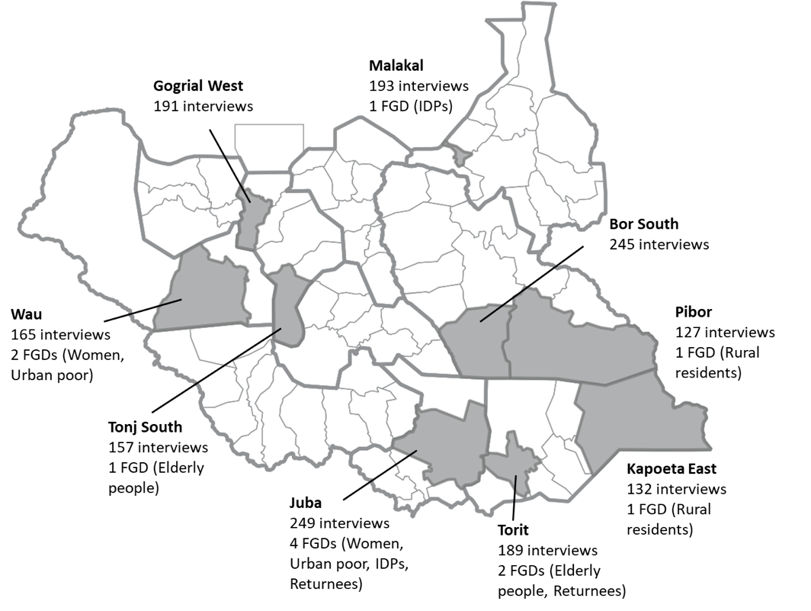

Telecommunication services in South Sudan

Background
- South Sudan’s telecommunications sector is among the least developed in the world, and therefore provides a challenging environment for the uptake of mobile money services. At the time of independence in 2011, increased liberalization and competition in various sectors, including the telecommunications sector, signaled potential for high growth and service expansion. However, the rules and regulations that were in place – notably those governing licenses and spectrum dues – were not consistent across all the MNOs operating in the country, resulting in fragmentation. Notably, MTN and Zain are still operating under a Memorandum of Understanding dating back to 2008, while the formal award of official operating licenses from newly independent South-Sudanese regulatory authorities had yet to take place as of May 2019.
- Following the outbreak of the conflict in 2013, progress quickly stalled – eventually reversing many of the gains that had been made heretofore. First, network coverage markedly declined. Many towers were destroyed or damaged during the course of fighting. According to KIIs, others were deliberately shut down by government authorities, particularly those located in opposition-held areas, to curb the activity of rebel forces. Second, investments decreased. Instability, market insecurity and increasing input costs discouraged investors. Finally, the client base shrank, due to both massive displacement and economic turmoil, as well as decreasing purchasing powers.
- In recent years, the sector has been characterized by low degree of liberalization, leading to greater market concentration and weaker competition. Most notably, in March 2018, Vivacell, the country’s largest MNO (and according to many, the one providing the best network coverage) was shut down by the government. In July 2017, the Ministry of Information, Communication, Technology and Postal Services (MoICTPS) officially announced the launch of a new telecommunications company, Niletel, in which the state holds a 25 percent share. Niletel is yet to offer any services, and thus does not appear to be operational.
- South Sudan telecommunications sector is currently among the weakest in the world. It suffers from poor network coverage in most parts of the country, and nearly absent in many rural areas. Following the shutdown of Vivacell, many former subscribers were absorbed by Zain and MTN. As these operators scramble to adjust to an unexpected increase in subscribers, network access has deteriorated, even in many urban centers. Moreover, the departure of Vivacell has also led to patchy infrastructure and network coverage elsewhere. Further, interconnection is missing. Typically, an area is covered either by Zain or MTN, rarely both, such that when an area is only covered by one operator, users of the other operator cannot access the mobile networks. Finally, regulatory uncertainty has also deterred investment.
- The institution in charge of regulating the ICT sector is the NCA, which was established in 2011 by the National Communications Bill. The mandate of the NCA is to: (i) promote and regulate the ICT sector, (ii) establish a conducive environment that favors ICT services, and (iii) ensure accessible, reliable, and affordable communication services and technologies, nationwide. It is in charge of licensing communication networks, equipment, and broadcasting services; approving pricing and costing methods, as well as regulating tariffs; and establishing procedures for interconnectivity between operators. Based on the statutes in the Bill, the NCA should also aim to “protect national security”, and is ultimately “answerable” to the President of the Republic of South Sudan as well as the MoICTPS.

Access to telecommunications in South Sudan
- Penetration of mobile phones is low and uneven across areas. Overall, 45 percent of the population owns a phone, but this varies across locations. While 63 percent of urban residents and 64 percent of PoC site residents own a phone, only 38 percent of rural residents do. Phone ownership is also very unbalanced against main socio-economic characteristics. A high gender gap prevails, as 56 percent of males own a phone, against 34 percent of females. Literate people also have significantly higher rates of phone ownership. Similarly, the likelihood of owning a phone increases with education level. Phone ownership is, however, homogeneous across different age groups. The low access to phones in South Sudan has therefore resulted in limiting the access to phone ownership to privileged groups (literate, educated males). In Somalia, for instance, where phone penetration is as high as 92 percent, the gender gap is inverted. This suggests that women could constitute a large untapped market, should phone penetration increase in South Sudan.
- The main barriers to phone ownership are linked to supply-side challenges, with first and foremost being the high cost of handsets. Sixty-six percent of the people in South Sudan who do not own a phone noted that they are too expensive; 27 percent mentioned that they lived too far from where they could buy a phone; and 26 percent considered that it would not be useful as there is no network coverage where they live. This compares to 18 percent who mentioned not being able to charge their phone due to poor access to electricity; 14 percent who would not be able to get a SIM card; 10 percent who can use other people’s phones.
- Socio-economic characteristics, though not perceived as such, also seem to constitute barriers to phone ownership. Indeed, literacy and gender are the main drivers of phone ownership, before income and the location of residence. The impact of gender on the likelihood of owning a phone could reflect lower access to personally owned resources for women, who often share a phone with another woman in their household. It could also reflect the perceived higher risks associated with owning a phone for women.
- Given the barriers to phone ownership, phone sharing seems to be a common practice, particularly within a household. Indeed, 17 percent of the population do not own a phone, but share a phone with someone who does. Of these, 60 percent of those who do not own a phone but share one, do so with someone within the household. Phone sharing is considered as a convenient way to pool resources between household members, as mobile handsets are unaffordable for many individuals. Phones can also be considered as a resource to share within the community and in case of need.
- Similarly to phones, penetration of SIM cards is low and uneven across geographic zones, with 66 percent of urban residents and 61 percent of the PoC site residents declared owning a SIM card, compared to 41 percent of rural residents. SIM card owners also often own SIM cards from several operators, as a way to mitigate the main operators’ uneven coverage and lack of interconnection. Among SIM card owners, 37 percent own two SIM cards, as a way to mitigate the main operators’ uneven coverage and lack of interconnection. As Figure 2 shows, some geographic patterns are also easily identifiable.
Figure 2: Operators' coverage per county, based on SIM card distribution (N=1,230)

- According to the results of the household survey, the Know Your Customer (KYC) regulation introduced in 2011 seems to be well enforced. Indeed, 94 percent of SIM cards were registered, mainly upon presentation of a national ID, and despite a low penetration of any form of ID. ID owners are over-represented among SIM card owners, which suggests that current KYC requirements are a barrier to phone ownership for the most vulnerable, that are less likely to own an ID. Remarkably, the survey found that the regulation is not only enforced in MTN and Zain official branches, but also in informal small shops and airtime resellers shops, where 39 percent of SIM cards are purchased and where 90 percent of SIM cards were also registered. However, although SIM card sharing is not as common as phone sharing (5 percent of the population uses a shared SIM card), this could nonetheless challenge traceability of transactions.
- Vulnerable groups have less access to phones and face specific constraints. Both the most and the least vulnerable are deterred by the cost of phones, but the most vulnerable are also mainly deterred by their lack of numerical literacy, whereas the least vulnerable mainly report the lack of network coverage, detailed in Figure 3. This suggests that personal barriers are more at play for the most vulnerable, which would require specific mitigation measures to increase uptake.
Figure 3: Barriers to owning a phone faced by people who do not own a phone, different vulnerability levels (N=1,493)

- A significant gender gap also remains in access to phones, with as much as 22 percentage point difference between phone ownership by men and women. Moreover, women share phones more often than men, generally with someone in the household. This does not compensate, however, for their lower access to personal phones. On the contrary, men have access to personal phones more often than women. When men share a phone with someone, they also usually share it outside of the household. A similar gender gap is at play for SIM card ownership, of 18 percentage points. Women also tended to say more often that they are not allowed to own a phone (10 percent of women who do not own a phone) than men (5 percent). Women who report not being allowed to own a phone, however, are in average younger by four years than those who report other reasons (24 years old in average). This could therefore reflect the fact that girls and young women are more discouraged to own a phone.
- IDPs have less access to phones and SIM cards than the rest of the population. This trend is mainly driven by reduced sharing practices. Overall, IDPs mentioned similar barriers to owning a phone as the rest of the population, but tended to declare more often that they were not be allowed to own a phone (10 percent) than the rest of the population (5 percent). They also tended to report less often personal barriers, suggesting a higher perceived usefulness of, and familiarity with, phones, than for the rest of the population. After one or several displacement incidents, telecommunications are indeed perceived as a necessary means of keeping contacts with family and relatives.
- Rural residents also have a reduced level of access to phones. This reflects the lack of network coverage in rural areas, the lack of access to electricity and the difficulty in obtaining a SIM card due to remoteness of services. These features of the weak telecommunications sector are indeed mentioned significantly more often by rural residents as reasons for not having a phone. Similarly, they also have less access to SIM cards.
- The urban poor have low access to phones compared to the rest of the urban population, and the same goes with SIM cards. The main barrier seems to be an economic, as 65 percent of the urban poor report that phones are too expensive.
- Given the above dynamics, it appears that limited and poor provision of telecommunications services has compounded the ability of South Sudanese people to access mobile services. Access to phones and SIM cards is low, even compared to other countries in the region. This is further exacerbated by the limited usage of phones, including very low usage of mobile broadband. Vulnerable groups in particular face specific barriers to access telecommunication services, likely to affect mobile money provision, as access could be undermined for a large part of the population. This therefore calls for mitigation measures that are tailored to the needs and barriers of specific vulnerable groups.

Financial services in South Sudan

Background
- South Sudanese people have low access to formal financial services and predominantly rely on cash to conduct transactions, largely due to lack of other options. South Sudan’s financial sector continues to suffer from the consequences of years of war and financial mismanagement. Faced with a challenging political instability and macroeconomic situation, commercial banks have had to scale down in the aftermath of the 2016 conflict. The credit sector has also prioritized short-term financing, on a timeline of weeks or months. However, the latest World Bank’s Economic Brief (2019) pointed to gradual improvement of the business sentiment and slow recovery of the financial sector, with deposits and lending activities picking up in the second half of the 2018 fiscal year.
- The financial sector rapidly developed post-independence, featuring a plethora of new market entrants, alongside plans to expand existing range of financial service providers. However, this expansion was not driven by local consumer demand. In spite of a large number of actors, the banking sector is dominated by a handful of players. KCB South Sudan Limited, Equity Bank, Ecobank South Sudan Limited, Cooperative Bank of South Sudan, Nile Commercial Bank and Charter One Bank appear to dominate the banking sector.
- The financial sector is regulated by the BoSS, which was established in July 2011 by the Bank of South Sudan Act. Its primary objective is to ensure monetary and domestic price stability. Other objectives include: (i) holding and managing the State’s foreign exchange reserve; (ii) licensing, regulating and supervising banks and other regulated entities; (iii) establishing and enforcing minimum bank reserve requirements; (iv) collecting economic and financial data; and (v) receiving deposits, and maintaining account for units of government, foreign central banks, and international institutions. The Governor of the BoSS (who serves as chairman of the Bank’s board) is appointed by the President of the Republic. Moreover, the Bank’s Board is proposed by the Governor and must be approved by the President. The BoSS also acts as Banker and advisor to, and as fiscal agent of, the Government.
- A number of new regulations have been passed in recent years to improve the financial sector regulatory environment. The 2017/2018 Finance Act established the custom tax rates applicable to various imported goods, as well as withholding tax, sales tax and excise tax rates. Notably, the excise duty for telecommunication services increased from 10 percent to 15 percent, in connection with this Act. This led to an increase in the price of telecommunications, as the burden of the increased taxation was transferred to the customers. In 2017, the BoSS also introduced a new monetary policy, aiming to tackle soaring inflation, regulate foreign currency trading and combat money laundering. The extent to which these measures will have an impact on the telecommunication sector is yet to be determined.

Financial literacy and inclusion
- Financial literacy is low in South Sudan, as people have limited knowledge of financial services. Half of the population indicate that they have never heard of insurance or loans services and a third report of having never heard of savings services. Financial literacy is equally low across age groups and types of residence (rural, urban, PoC site). However, there are large differences across gender, literacy levels, and counties. Men tend to be more informed of the existence of different financial services. Predictably, literate people also have higher levels of financial literacy. Finally, there is geographical divide, such that half of the surveyed population in urban Juba (47 percent) knows about digital payments, against 16 percent of the population in urban Malakal, where fewer financial institutions are present. This highlights the large role that both literacy and proximity to services play in financial literacy.
- The lack of knowledge of different financial services is compounded by limited exposure to financial transactions, even with regard to day-to-day activities such as managing household finances. A large part of the population (43 percent) does not track their expenses and sources of income, and this trend is even more acute for rural residents, women, and illiterate people. This suggests that the population at large could benefit from sensitization to financial practices to build their money management know-how, which could in turn swell demand for digital financial services.
- Current levels of financial inclusion in South Sudan are extremely low, with significant gap between rural and urban areas. A majority of the population (59 percent) does not feel financially included and has unmet financial needs. Further, financial inclusion level is significantly lower in rural areas, with 65 percent of rural residents perceiving themselves as not being financially included, compared to 48 percent of urban residents. In fact, the urban poor are likely to be the most financially included among the four vulnerable groups because they live in urban areas. As expected, prevalence of financial inclusion is significantly higher among literate respondents and for those who attended university. Gender does not seem to be a driver of financial inclusion.
- This perceived lack of financial inclusion can be explained by two factors. These include: i) barriers that prevent them from accessing formal services; and ii) constrained financial practices that are limited to subsistence financial behavior. Given the breadth and depth of wide-spread poverty and vulnerabilities, most households only handle their finances to meet their most basic needs and confront shocks to ensure basic sustenance. They pay relatively little attention to future planning, and rarely engage in financial management and investment in physical or human capital, which could financially empower them in the long run.
- Access to formal financial services, such as banking, is extremely limited. Only 13 percent of the population owns a bank account, mainly comprising of literate males from urban areas. Literacy, gender, and type of residence are the main drivers of bank account ownership, playing a more prominent role than income. Reported barriers to access to bank services are numerous. Some relate to distance and affordability (banks are too far away or too expensive), but for a significant share of respondents, banks are also perceived to be not useful, as 36 percent say that they do not have the resources to use financial institutions, and 22 percent reported not needing financial services at a formal institution. This likely reflects a lack of understanding of the benefits individuals could reap from formal financial services.
- Bank accounts are mainly used to ensure security of money, rather than for specific financial services or functionalities that they could offer. Bank accounts are mainly used for personal purposes (for 65 percent of bank account owners) rather than for business purposes (for 29 percent). Main accessed services are savings, for half of bank account owners. Access to bank-enabled digital payments, on the other hand, are only used by a minority, as 39 percent use debit or credit card payments and 24 percent conduct wire transfers. Finally, very few use banks to take out loans (19 percent of bank account owners) or subscribe to insurance services (5 percent).
- Cash is the predominant means of conducting financial transactions. It is the main method to pay for consumption and durable goods, utility bills, and health and education expenses. Wages and allowances are also mainly received in the form of cash. This is corroborated by qualitative evidence.
- Only a minority of the population relies on more elaborate financial practices, such as domestic and international transfers, and saving and borrowing schemes. Such practices remain heavily dependent on informal methods. Financial habits rarely pertain to investments in assets to build or sustain livelihoods, or in physical or human capital, but rather mainly support emergencies and daily life contingencies. The lack of access to formal services sometimes forces South Sudanese to adopt other innovative and informal practices to transfer money internationally. Those methods involve interpersonal transfers based on existing relationships and trust.
- Only a minority of the population saves money. As few as 39 percent of those surveyed saves. Of those who do save, a large proportion uses it to cover basic expenses in times of hardships and/or emergencies. For few, savings is also used to invest in physical capital or in human capital. The methods to save are also informal: people mostly save by keeping cash in a safe place or by buying livestock. A majority do not save because they do not have money to do so. Additionally, they do not see the need to save. Again, this suggests that financial behaviors are constrained both by an absence of financial resources, and low financial literacy levels that prevent people from appreciating the longer-term benefits of saving.
- Borrowing practices are even scarcer than saving practices. Only 24 percent of the surveyed population borrowed money over the past twelve months. Borrowing is mostly used to cover for basic expenses, such as food, and to cover for health expenses. It is therefore a way to tackle hardships, rather than a way to jumpstart or maintain new businesses or sustainable livelihoods. Loans are predominantly informal and obtained from friends, family or relatives (for 63 percent of those who borrowed). Qualitative evidence also suggests that local shops play a role in providing loans and developing in-built social networks that act as informal safety nets by selling food on credit or opening tabs, in case of need.
- There seems to some distrust towards formal financial service providers contributed by low financial literacy and lack of access to formal financial services. According to a fifth of the surveyed, banks do not meet their needs, do not provide services of quality and are not trustworthy. While there is no clear pattern across genders or age groups, this dissatisfaction increases for rural residents and in certain counties. In Pibor, 9 people out of 10 surveyed consider that banks do not meet their needs, do not provide services of quality, and are not trustworthy.
- As an alternative to other types of formal financial services, cash is valued for its convenience and accessibility, despite the higher security risks of carrying cash. Cash is perceived as easy to use and physically access. Contrary to banks, it also does not require to register or open an account. However, cash remains associated with low safety, both in terms of personal safety and in terms of security of money. This is aggravated by the South Sudanese context, where the national currency value is low and quickly depreciating, forcing people to carry large amounts of notes and to store value in kind, for instance in the form of cattle.
- Factors driving financial behaviors appear to be mainly sociodemographic rather than behavioral or structural (Figure 4). Literacy appears to be a main driver of all financial practices, having a positive impact on the probability of transferring money domestically and internationally, saving and borrowing. Gender also has an impact, as being a woman decreases the probability of saving. Finally, the type of residence can also influence such practices. For instance, living in a rural area increases the probability of borrowing, likely reflecting stronger community relationships and informal safety nets. Financial practices are also influenced by socio-economic conditions. Seventy-two and 69 percent of those who do not transfer money domestically and internationally, respectively, declared having no money to do so. Similarly, 87 percent of those who do not save reported not having any money to save.
Figure 4: Sociodemographic factors affecting financial behavior
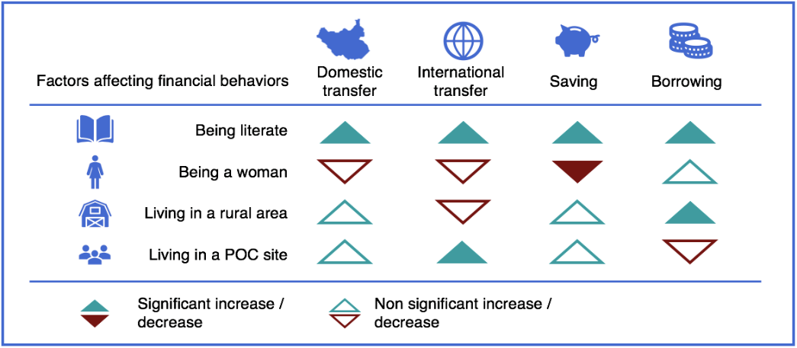
- Behavioral factors are also at play, but to a lesser extent. The main behavioral factors that shape financial behavior are lack of knowledge of specific transactions and lack of trust in available services. For instance, 14 percent of those who do not borrow pointed to the lack of trust in services, while 12 percent reported not being aware of available services.
- Structural constraints also shape financial behaviors, but to a lesser extent. Structural constraints are mainly at play for international transfers and borrowing practices. Fifteen percent of those who do not transfer money internationally and 21 percent of those who do not borrow do not rely on those financial practices because services are not accessible where they live.

Mobile money in South Sudan
- While discussions regarding the prospects for mobile money in South Sudan has been going on since indepenence, an Electronic Money Regulation (EMR) was only adopted at the end of 2017. It provides a regulatory framework for e-money circulation and transactions, whereby licensed banks and non-bank institutions (such as MNOs) can circulate mobile money. Overall, the regulation was drafted to align with global best practices, and follows most of the recommendations made by regulatory experts. The WB in particular provided technical assistance in drafting regulations. Notably, it includes provisions related to (i): licensing; (ii) meeting capital requirements; (iii) maintaining a robust information system; (iv) safeguarding customer funds; (v) implementing KYC and Anti-Money Laundering (AML) procedures; (vi) ensuring interoperability; and (vii) contracting agents.
- By the end of 2018, the Bank of South Sudan issued licenses to two third-party companies to develop mobile money services, with services reportedly to be launched in June 2019. These include Trinity Technologies and Lukiza (also known as ‘Nilepay’). Conversely, neither Zain nor MTN have been granted a license, despite having applied. Others entities also appear interested in applying. The Cooperative Bank, which is currently developing mobile banking services said that it plans to soon apply for a mobile money license.
- The mobile money business model the GRSS has opted for – a non-bank mobile money model with licenses exclusively issued to third-party companies at this stage – is uncommon. While a non-bank model, whereby licensed banks and non-bank institutions (such as MNOs) can circulate mobile money, is commonly seen in Eastern, Southern and parts of Western Africa, licenses are most often issued to MNOs or banks, and not to third-party companies. According to international best practice, an open and level playing field where financial regulators allows different types of mobile money providers, notably MNOs and banks, into the market is essential for mobile money to succeed.
- At the time of writing (June 2019), neither of the licensed third-party companies were operational, which means that no formal mobile money services are available in South Sudan. However, both Trinity Technologies and Lukiza plan to roll out services by the end of June 2019, under the names M’Gurush and Nilepay, respectively, based on a partnership with Zain. Trinity started its communication and advertisement campaign in Juba in May 2019, and announced having trained some 300 potential agents, and recruiting more. Lukiza launched its advertising campaign in June 2019. Nonetheless, the launch plans of mobile money are still unclear. For example, although services are planned to be rolled out soon, starting with marketing campaigns, information on cost structure and business model remains unavailable, making it difficult to understand how the roll out of mobile money services would look in practice.
- Despite being satisfactory on paper, de facto regulation of the mobile money industry has been characterized by lack of transparency and low degree of liberalization. Specifically, given that the regulation clearly details the process required to apply for, and obtain, a mobile money license, it appears contradictory that existing MNOs have not yet been granted a license. One reason for this could be to enable licensed third-party companies to act as an intermediary between MTN and Zain to generate greater interoperability. However, this assumption is undermined by the fact that the licenses have been granted to two separate third parties that will operate two different systems.
- Overlapping regulatory authority, along with lack of competiton, were referenced by key informants as some of the major characteristics of the sector. While regulatory authority over e-money now falls squarely with the BoSS, under the 2017 ERM, MNOs also need to obtain a “no-objection letter” issued from the NCA, which adds additional layers to the authorizing environment, potentially generating inefficiencies in terms of ease of “doing business.”
- The EMR does not cover how the GRSS intends to tax mobile money. However, some insights can be gained from practices implemented in other East African countries. Experiences from Kenya and Uganda seem to indicate that the GRSS should explore the possibility of introducing an excise tax on operators’ revenues according to international best practices.
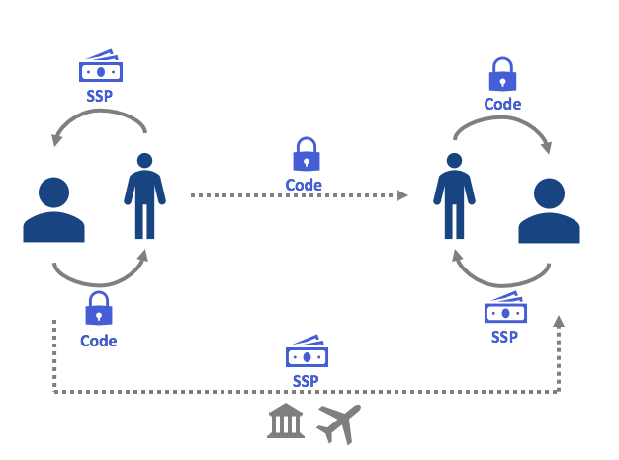
- A variety of informal value transfer services exist in South Sudan for sending and receiving money domestically. These are based on moving funds through a third party agent network, as illustrated by Figure 5. South Sudanese tend to be more familiar with money transfer agents than with banks, as they allow mere one-time over-the-counter (OTC) transactions, and do not require opening and maintaining an account or paying the associated fees. However, an ID is required for the sender. It is important to note that the costs of these services vary from one operator to another, with fees ranging from 2 percent to 5 percent of the total transaction. Moreover, Informal Value Transfer Systems (IVTSs) are only located in cities, where the customer base and access to liquidity is larger. As such, IVTSs do not have nation-wide coverage, and therefore do not have branches in all cities.
Figure 5: Functioning of money transfer operators for domestic transfers
- Regional and international transactions are conducted through formal value-transfer services. While there is anecdotal evidence of IVTSs having branches outside of South Sudan, and supporting regional transactions, most IVTSs only conduct domestic transactions. International transfers are instead supported by formal value-transfer services such as Dahabshiil, which has branches in Juba, Wau, Aweil and Bor. While IVTSs conduct transactions in the local currency, transactions with Dahabshiil are conducted in USD (both to send and receive), even though the fees can be paid in SSP. Fees vary depending on the origin and destination of the transfer, but are higher than those of domestic transfers conducted by IVTS. An ID is also required for the sender.
- Informal and formal money transfer operators are the most common method to transfer money. Seventy-three percent of those surveyed said that they know of money transfer services. This is a higher share than those who know of other types of services like loans, savings or insurance. South Sudanese also predominantly use money transfer operators to transfer money, both domestically (i.e. 53 percent of those who transferred domestically over the past twelve months), and internationally (i.e. 60 percent of those who transferred internationally). This reflects a perceived cost-efficiency of these services, as 48 percent of people who transferred money domestically use this method because they consider it is cheap. However, it also indicates a lack of knowledge of, or lack of access to, other methods.
- Overall, perceptions towards money transfer operators are positive, with majority of people considering them to be trustworthy, to meet customer needs, and to provide quality services. Interestingly, users of money transfer operators also tend to have better perceptions of money transfer operators, which suggests that these services are, in practice, satisfactory.
- However, money transfer operators are still associated with insecurity of money and unreliability. Indeed, one third of the population (30 percent) surveyed associates money transfer operators with low security of money. Arguably, money transfer operators’ operations still involve moving around with large amounts of cash, putting persons and money at risk. A third of those surveyed (30 percent) also views money transfer operators as unreliable, as branches sometimes close without users being aware of it.
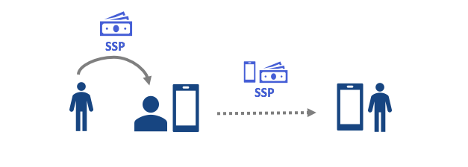
- Airtime transfers are also sometimes used as an alternative to the transfer of hard local currency. Senders can ask an agent to send airtime to a recipient in exchange for cash. Recipients receive the airtime on their phones and can then use it for airtime, or cash it out. Airtime can also be transferred through one’s mobile account without going to an airtime trader. Agents do not charge fees to send airtime on behalf of a customer. Cashing out, however, incurs a charge, which was considered high by all traders. Also, airtime traders cover the whole country, though the majority are concentrated in urban areas. However, as airtime trading is not interoperable (i.e. airtime can only be traded between people who use the same operator), sending airtime to certain areas can be challenging due to uneven coverage of MTN and Zain.
Figure 6: Functioning of airtime trading
- Airtime is perceived as a good alternative to cash, and is traded as an alternative form of cash. Twenty-one percent of airtime traders said that they use it as an alternative to cash, as it can be difficult to access or exchange cash, and can make people vulnerable to theft. Likewise, sending cash to physically remote recipients is burdensome. Sixteen percent surveyed also reported using it as an alternative to cash because they do not trust the local currency. Airtime instead allows cash to be stored in equivalent minutes, and is thus less subject to inflation. Thirty-five percent reported using airtime to send or receive money from friends or relatives, while 18 percent kept it on their phones to cash out when needed. Likewise, 21 percent of airtime traders use it to conduct business transactions, while 7 percent use it to buy goods or services.
- Airtime trading is therefore considered as a time-efficient, but costly, way to transfer value. Half (52 percent) of the population consider airtime trading to be quick, while the main deterrent to trading airtime seems to be its high cost, notably due to high fees to cash out. Accordingly, 33 percent of the surveyed population consider the lack of value for money a disadvantage of airtime trading.
- While local mobile money services have not yet been launched in South Sudan, some services are already accessible, through foreign operators (MTN Uganda, Safaricom). With a large number of South Sudanese living in neighboring countries having fled repeated cycles of conflicts, mobile money services provide by foreign operators are used in the country to facilitate the flow of remittances between South Sudan and the region. Domestic transactions can also be conducted. There are two different ways to access these services, (i) through a personal subscription, and (ii) OTC transactions.
- Mobile money transactions through foreign operators constitute a grey area and are conducted informally, but are still a common practice. First, these transactions are illegal, as the BoSS and the NCA have not granted a license to either Safaricom or MTN Uganda authorizing them to have services in South Sudan. Second, knowledge of the prevailing regulations governing the mobile money sector is limited among agents. There are two main reasons why people do not use mobile money services through foreign operators. These are: (i) lack of knowledge and (ii) lack of access to services, since they require obtaining a Safaricom or MTN Uganda SIM card, or to visit a mobile money operator.
- A handful of commercial banks in South Sudan have also begun rolling out mobile banking services. Mobile banking is being spearheaded by Cooperative Bank, which has developed a dedicated mobile application. Cooperative Bank has also rolled-out agency banking in various locations, known as Kofi Jarana (“neighbor” in Arabic) by partnering with existing IVTSs to create cash points where customers can withdraw money and make deposits. However, inadequate network coverage and access to termination points for customer cash-out appear to be hampering delivery of both these services. Eco Bank has also developed mobile banking services. Services currently available support the following types of transaction: (i) transferring funds (Cooperative Bank, Eco Bank); (ii) withdrawing money through a bank agent (Cooperative Bank); and (iii) paying bills or topping up airtime (Eco Bank). Use of mobile banking, however, remains limited.

DEMAND for MOBILE MONEY IN sOUTH sUDAN
- The research revealed high demand for mobile money, both from humanitarian and development partners, and from the general population. Over the past decade, humanitarian and development partners have increasingly started providing cash to beneficiaries to address vulnerabilities. Cash assistance presents several advantages to beneficiaries, including (i) choice; (ii) lower costs; (iii) dignity and empowerment; and (iv) multiplier effects for local economies and trade, as it increases demand for markets.
- Nonetheless, cash assistance still comes with a host of challenges and operational risks, particularly in FCV contexts such as South Sudan. These include, among others: (i) delays in distributing cash in field locations; (ii) high implementation cost; (iii) potential arbitrage due to the official vs. parallel exchange rate market; (iv) safety and protection issues, particularly of women; (v) risks of leakages; (vi) fueling illicite activities; (vii) malpractices by transfer agents; and risks of increased population movements due to push-and-pull effects of set aid distribution points.
- Due to the above risks and challenges, demand for mobile money is high among humanitarian and development partners as a mechanism to enhance cash-based aid delivery. There are numerous ways in which mobile money has been leveraged in other countries to facilitate more effective and accountable delivery of cash assistance. Specifically, effective use of mobile money as a transfer platform has improved the timeliness and cost effectiveness of aid delivery and mitigated some of the risks associated with cash assistance.
- Among the beneficiaries of cash assistance, lengthy steps related to registration and collection and long travel time to collect the assistance are common. These logistical impediments, combined with security challenges, hamper the level of satisfaction of cash-transfer beneficiaries with distribution modalities. Further, a quarter of cash transfer beneficiaries reported that receiving cash assistance resulted in tensions within the community and pressures from friends and relatives to share the cash. As such, mobile money could be a more optimal, confidential and safer mechanism of channeling cash directly to the beneficiaries. It would mitigate risks associated with travel required to collect the cash, queuing for long hours, and intra-households and community tensions vis-à-vis reduced visibility of cash distribution.
- Evidence suggests that there is significant interest for mobile money services among the South Sudanese population. First, the existence of informal, or proxy, mobile money services demonstrates that people are looking for alternative mechanisms to transfer money. Second, a significant part of the South Sudanese population seems familiar with mobile money services, largely owing to displaced family members seeking refuge in neighboring countries, as well as to trade across South Sudan’s borders in Kenya and Uganda. Trust in mobile devices and digital financial transactions is high, with 70 percent of the population reported having trust in the mobile phone as a tool to store and transfer money and 66 percent as having trust in their mobile phones to receive salaries or allowances – although this decreases for the most vulnerable respondents and women.
- The high demand for mobile money services spans across all potential usages of mobile money, with strong positive attitude towards the use of mobile money services for saving purposes. This signals that potential customers would be willing to store money on their mobile money account without cashing it out, thus contributing further to the development of the mobile money ecosystem. Purchase and transfer of airtime and internet bundles are also mentioned by many (70 percent). Mobile money services to pay for goods and services (i.e. utility bills) follow (60 percent). Reimbursement of loans is the least mentioned service (56 percent).
- A way to quantify demand for mobile money relates to self-declared willingness to pay. On average, the willingness to pay by the surveyed population reaches 185 SSP (US$ 0.70), which represents 5 percent of the population’s average monthly income. This seems rather high when compared in the region (i.e. Kenya). However, this can be explained by the fact that there is strong demand across all the sociodemographic groups, which is justified by the fact that financial services in South Sudan are underdeveloped. Second, as many moneys transfer services charge between 2 and 5 percent of the transacted amount, customers are equating their willingness to pay for mobile money with what they currently pay to access these services in terms of time and money to get to the money transfer services’ agents would likely add up to this estimated 2 percent.
- To unlock the potential of mobile money, service providers should pay attention to the cost, accessibility, and user-friendliness of services provided. Indeed, several enabling conditions would need to be in place to permit the launch of mobile money, the lack of which could reduce potential customers’ uptake of these services, as illustrated in Figure 7.
Figure 7: Enabling conditions for the take-up of mobile money services
Focus Box 1: Demand of mobile money services by vulnerable groups
The four vulnerable groups analyzed (IDPs, women, urban poor and rural residents) also demonstrated a high demand for mobile money services, not statistically different from that of the general population. The most willing to take up the services are the urban poor, with a 90 percent potential adoption rate. The least willing are women, with an 84 percent adoption rate. Concerning the services in which these groups would be interested, there are only slight differences compared to the general population. IDP respondents are more willing to use mobile money for international transfers, payments of goods and services, airtime purchase and transfers, and reimbursement of loans. Additionally, rural residents and the urban poor feel, relatively more than the general population, that the existence of more cost-efficient services to those available today is crucial.
The two vulnerable groups that show major deviations from the general population are women and the urban poor. Women indicate willingness to pay higher transaction values through different services, despite having a significantly lower income with respect to the general population. In fact, as confirmed by the qualitative data, women are the ones handling payments for household expenses. Furthermore, they have reported needing to travel long hours to make certain payments. This could explain why their willingness to pay for mobile money services as a ration of their monthly average income is slightly higher than that of the general population (6 percent versus 5 percent). This could also account for why they would be particularly eager to take up mobile money services, despite having lower literacy, ID ownership and access to mobile phones than men, as it would result in time and money savings.
The urban poor are those who indicated the lowest estimated transaction values through all services and the lowest willingness to pay in general. This is explained by the fact that they have the lowest average monthly income among the four vulnerable groups analyzed, even lower than women. As such, even though they showed strong demand for local mobile money services, the cost factor will be crucial in determining whether they would actually adopt mobile money.

BENEFITS OF MOBILE MONEY
- The main benefits of mobile money are linked to its effectiveness, as it is a quick, easy and cheap way of transferring money. Benefits of mobile money as a delivery mechanism include: (i) increased effectiveness; (ii) increased cost efficiency; (iii) improved safety and protection of beneficiaries and project staff; (iv) mitigated risks of leakages; and (v) lower opportunity cost of cash transfers for beneficiaries.
- According to the surveyed population, the top benefits of utilizing mobile money to deliver cash transfers relate to logistical advantages, and increased freedom and personal safety of beneficiaries. Sixty-seven percent of the population identified having to travel less to get assistance as a major benefit, while 62 percent thought that the use of mobile money services for cash-based transfers would carry fewer restrictions and a greater freedom to spend the money as preferred, which could enhance their dignity. Fifty-four percent reported increased personal safety as a key benefit, and 45 percent reported security of the money received as important benefit, both of which were more strongly felt by rural residents. Furthermore, for a quarter of the sample, the fact that it does not need to be cashed out and can instead be used to perform digital financial transactions was also attractive. Further, beneficiaries of humanitarian assistance are significantly more likely to identify certain benefits of using mobile money – faster delivery of support, confidentiality of the amount received, the option to keep the money on the account – compared to non-beneficiaries.
- In addition to cash-transfer beneficiaries, the general population of South Sudan can also benefit from the introduction of mobile money. In particular, mobile money can i) ease financial transactions, ii) increase safety of people and of money, and iii) build resilience. This is well evidenced in other FCV countries in East Africa, such as Somalia. Research on the Mobile Money Ecosystem in Somalia commissioned by the World Bank highlighted that Somalis associated mobile money with eased transactions; gains in time and money; and increased resilience, as remittances and financial help from friends and relatives could be easily received in the event of a shock. To a lesser extent, they also associated mobile money with a lower risk of theft and improved personal security as it eliminates the need to carry cash.
- Nonetheless, the general population does not seem to associate mobile money with better economic well-being or access to services. Even though 75 percent of potential customers were willing to take up saving services once mobile money is available, only 17 percent of respondents felt that this represents a benefit in terms of expanded saving possibilities for livelihood opportunities. Instead, the benefit of increased resilience to shocks as a result of faster transfers from friends, relatives and humanitarian organizations was mentioned by 28 percent of the surveyed population. The two least mentioned benefits were better access to basic services (i.e. health, education) and to new opportunities (i.e. new skills, jobs), and increased social connectivity to community members, each reported by 15 percent of respondents.
- Long term benefits stemming from mobile money, are likely underestimated due to lack of exposure to services. Notably, mobile money has proven to increase resilience to shocks in other neighboring countries. For instance, it played a great role during the last drought that hit Somalia as it facilitated financial support from friends, relatives, and humanitarian and development partners. In fact, 60 percent of Somalis who were affected by the drought considered that mobile money helped them, or could have helped them, to be less acutely affected by the drought.
- Promoting financial inclusion to the unbanked population could be another benefit stemming from the introduction of mobile money in South Sudan. In Somalia, 85 percent of mobile money users stated that mobile money has fostered their financial inclusion. Examples from Kenya show that M-PESA has increased financial inclusion for the most vulnerable groups, such as women, as they are able to have personal savings without seeking permission from their husbands, and for farmers, as they are able to access insurance services which rely on the Safaricom platform.
- Research indicates that mobile money could have a strong potential to foster financial inclusion in South Sudan. Three quarters of the population thought that mobile money could help increase financial inclusion, by making it easier to perform financial transactions within South Sudan (75 percent), by financially connecting mobile money customers to other countries (49 percent) and by helping customers access other financial services, e.g., savings, loans or banking (for 41 percent). Literacy is significantly positively correlated with the perception that mobile money could increase financial inclusion through the variety of channels listed above.
- Perception of mobile money as fostering financial inclusion is positively correlated with prior exposure to mobile money services. Current users of foreign mobile money services are significantly more inclined to believe that mobile money would help increase financial inclusion. In fact, only 12 percent say that it would not make them feel more financially included, versus 28 percent for non-users (Figure 8).

Figure 8: Mobile money and financial inclusion, across mobile money users and non-users (N=1,648)
- Finally, mobile money could also stimulate the economy, but this benefit is perceived mostly by supply-side actors. All interviewed agents perceived mobile money as an opportunity for increased profits for their businesses, and for the private sector in general. They argued that mobile money would: i) increase the number of customers buying goods and services, thereby generating more business opportunities; ii) reduce cases of armed robbery, thereby increasing safety of businesses; and iii) reduce the cost of sending money when making financial transactions, e.g., when paying suppliers, among others. One of the traders also stressed that it could allow customers living in remote areas to send mobile money to the traders’ accounts, and then to receive the goods directly in their village, thus reducing the need and cost to travel in order to shop.
- The perceived benefits of mobile money are homogeneous across the different vulnerable groups analyzed (women, IDPs, urban poor and rural residents), mirroring those identified by the general population. The main benefits identified by these groups were the increased efficiency of financial transactions and increased personal safety, as well as the security of money itself. Based on qualitative evidence, mobile money services could be particularly beneficial to women as they tend to be in charge of paying all household expenses and lose significant amount of time traveling to paying said expenses.

- While the IDPs and the urban poor tend to be optimistic about the potential of mobile money to positively impact financial inclusion, the same does not apply to rural residents. The proportion of IDPs and the urban poor reporting that they would not feel more financially included using mobile money versus cash was significantly lower than in the general population (9 percent for IDPs; 4 percent for the urban poor, versus 25 percent for the general population). Interestingly, for the urban poor, mobile money is perceived to mostly facilitate financial inclusion by easing money transfers within South Sudan, rather than through enabling connections to other countries or easing access to other financial services, as mentioned by the general population. Conversely, rural residents are less inclined to believe that mobile money could help increase their financial inclusion (30 percent said that it would not make them more financially included, versus only 12 percent in urban areas).
- Across all vulnerable groups, benefits of mobile money for boosting financial inclusion are positively correlated with exposure to the service and usage. Similarly to the general population, vulnerable respondents who currently use mobile money services through foreign operators are significantly more convinced of the benefits of mobile money for financial inclusion. For instance, among IDPs who use mobile money, only 5 percent think that they would not feel more financially included than when using cash, compared to 11 percent among IDPs who do not use mobile money. This also applies to rural residents, such that, among those use mobile money, 15 percent think that they would not feel more financially included than using cash, compared to 32 percent among those who do not use mobile money.

Barriers preventing the adoption of mobile money
- Despite the immense potential of using mobile money in cash assistance and in benefitting the general population and the economy, there are a number of multi-dimensional barriers associated with its adoption. Many of these are closely linked to the FCV context of South Sudan, including continued instability and conflict, lack of infrastructure, and chronic underdevelopment.
- South Sudan’s infrastructure base remains among the lowest in the world, and contribute to structural barriers that could hinder the adoption and uptake of mobile money services. These structural barriers are compounded by the continued political instability and insecurity that frequently disrupts, and even halts, private sector activity and investment in infrastructure. Key structural barriers include:
- Poor network coverage is the main structural barrier, mentioned by 69 percent of the respondents. According to a third of the surveyed population, the quality of the network is either poor or very poor, and 63 percent said that the network is sometimes shut down. Qualitative data confirmed that the network quality is often not adequate to conduct basic operations, and that people are constrained to making calls very late at night in order to avoid network congestion.
Network quality is significantly worse in rural areas such that rural residents need to travel long distances to reach a place with adequate network. Thirty-three percent of rural residents affirm that the network is poor or very poor versus 22 percent of urban residents. In addition, 74 percent of rural residents have to travel at least 30 minutes to reach adequate network, versus 44 percent of urban residents. Inadequate network quality has a severe negative impact on the potential for adoption and uptake of mobile money services.
- Lack of access to electricity to charge phones is also a key barrier, even more so in rural areas. Thirty-seven percent of the population mentioned electricity as a barrier. Further, access to electricity in rural areas is significantly lower than in urban areas, with 65 percent of rural residents having no access to electricity (versus 45 percent in urban areas). Access to electricity is highest in PoC sites (70 percent), but this is due to the fact that they are close to urban areas. Additionally, they may enjoy an easier access to electricity from being based in the UN compound.
- Low level of phone penetration (45 percent) is also a significant structural barrier, specifically in rural areas and among women. In fact, 58 percent of respondents in rural areas perceive the lack of a mobile phone as a barrier versus 41 percent of urban residents. Similarly, the low phone penetration is felt as a barrier to the uptake of mobile money services significantly more by women than men: 58 percent of female respondents perceive the lack of mobile phone as a barrier versus 48 percent of male respondents.
- Distance to MNOs’ agents can also be an obstacle for the adoption of mobile money services, especially in rural areas. Eighty-three percent of rural residents needs to travel at least 30 minutes on foot to reach the closest MNO’s branch or agent. Agents are significantly more reachable in urban areas, but 40 percent of urban residents still have to travel between 30 minutes and 2 hours to reach the closest agent. Similarly, the average cost of travelling to reach an agent is three times higher for rural residents (240 SSP/US$ 0.90) for rural residents versus 77 SSP (US$ 0.30) for urban residents.
- From the supply-side research, interconnection appears to be a major challenge, as it contributes to the fragmentation and isolation of large parts of the country, with some areas only covered by MTN and others only by Zain. This could prevent users from sending money to, or receiving money from, a person using the network provided by an operator different from their own. This could further enhance negative peer effects, making it harder for operators to build a critical mass of users to sustain the wide adoption of the system.
- Several socio-economic barriers could also challenge the adoption and uptake of mobile money These barriers are most acute among the poorest and most vulnerable households that would generally be targeted by cash transfers programs.
- Protracted decades-long conflict coupled with an economic decline has contributed to chronic underdevelopment. Consequently, many people cannot afford mobile phones and telecommunications expenses, and there is a strong perception that people would not be able to afford mobile money services, which is felt more acutely in rural areas and by PoC residents. Forty-two percent of respondents thought that mobile money services would be too expensive, and 21 percent said that they do not have enough money to put on a mobile money account. The latter view reaches 23 percent and 29 percent in rural areas and PoC sites, respectively, compared to 13 percent in urban areas.
- High rates of general and financial illiteracy are also likely to impede the broad adoption of mobile money services. However, despite the pervasive illiteracy, only a quarter of the respondents thought that illiteracy can be a significant barrier for the uptake of mobile money services. This barrier is felt as most severe by groups with higher illiteracy rate, namely women (30 percent of women see literacy as a main barrier versus 19 percent of men) and rural residents (28 percent of rural residents see literacy as a main barrier versus 13 percent of urban residents). The literature supports this relative optimism, as other countries with extremely low literacy rates, e.g. Somalia, have managed to develop a vibrant mobile money ecosystem.
- Low ID ownership is also a major barrier. A significant share of respondents (41 percent) do not have any form of identification document, which could prevent them from subscribing to mobile money services, as some proof of identification is required even for Tier 1 accounts, as per the EMR. Indeed, obtaining a national ID costs money and requires travelling to places relatively far, which makes it beyond reach for many. The lack of ID is thus perceived as a significant barrier to adoption of mobile money by 31 percent of population.

Figure 9: Socioeconomic barriers for mobile money as perceived by respondents (N=1,648)
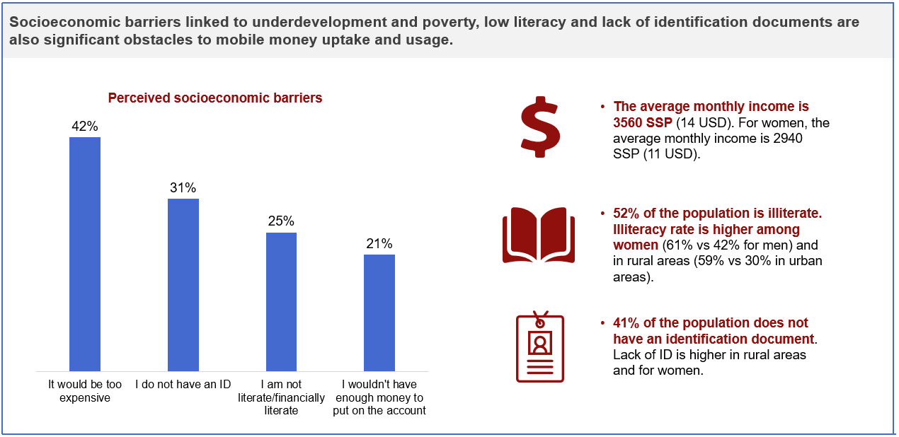
- From the demand-side research, behavioral barriers do not seem to play a big role and are unlikely to act as obstacles to the adoption of mobile money services. Contrary to what was suggested by the supply-side research, findings from the demand-side research reveal that it is unlikely that there would be resistance to the introduction of mobile money. Interviewed informants during the supply-side research described numerous possible instances of beneficiaries pushing back against the adoption of new systems, such as biometric registration. The lack of knowledge, awareness and experience of new systems were cited as possible factors fueling the resistance to change, to be best addressed through community awareness and sensitization initiatives. However, results from the demand-side research do not confirm this assumption. FGD respondents exhibited an inclination to explore new alternatives. In addition, the uptake and usage of mobile money services are also likely to be encouraged by local leaders: 72 percent of the respondents believe that, should South Sudanese mobile money services be launched, religious leaders and local chiefs would encourage their adoption.
- The demand-side survey reveals a strong support from potential mobile money customers with respect to KYC requirements, despite the supply-side research suggesting that resistance to KYC requirements might also be a barrier. Supply-side informants indicated that the population might be reluctant to register their personal details when opening a mobile money account, due to low levels of understanding of the purpose of registration, and out of fear that registration might lead to the loss of access to additional resources (i.e. by double-registering or stockpiling food tokens). Yet, 78 percent of respondents affirmed that it would be a positive development if identity documentation was systematically required to buy a SIM card or to open a mobile money account. Indeed, most respondents associate the implementation of KYC regulations when opening a mobile money account with greater money safety and the reduction of fraud and illicit activities.
- Negative network effects as a potential barrier to adoption was, however, evident. Sixteen percent of the surveyed population thought that few people and businesses around them would use mobile money, and as such that the benefits from adopting this new system would be insignificant. This finding highlights the pernicious role that network effects can play. A mobile money service with few users is not very valuable, so there is little incentive for new users to join, a pattern referred to as ‘excess inertia’. This could hinder wide adoption of the system, should mobile money providers not manage to attract a critical mass of early adopters.

- The demand-side household survey confirmed distrust in the financial system and the telecommunications system among certain groups; yet, they do not seem to constitute a strong barrier to adoption. A third of the surveyed population felt that telecommunications companies are untrustworthy, and 36 percent felt that the services provided by MNOs do not meet customers’ needs. However, limited trust in the system was mentioned as a barrier to adoption by only 7 percent of the surveyed population, which suggests that dissatisfaction with MNOs’ services will not necessarily impede the uptake of mobile money. This result echoes the lack of other services available (Section ‎4): while in doubt with MNOs’ ability to provide quality services, they are still willing to try out any alternative system that may be put in place.
- Some groups are likely to have troubled access to mobile money services due to more acute structural and socioeconomic barriers (Figure 9). Women face more acute socioeconomic barriers than men, while behavioral barriers play a minor role. The urban poor are subject to more acute socioeconomic and structural barriers, while additionally showing signs of resistance to KYC requirements; and rural households show the highest levels of vulnerability across the board. IDPs, on the other hand, face barriers to a similar degree to the general population.
Figure 10: Structural and socioeconomic barriers across vulnerable groups (N=1,648)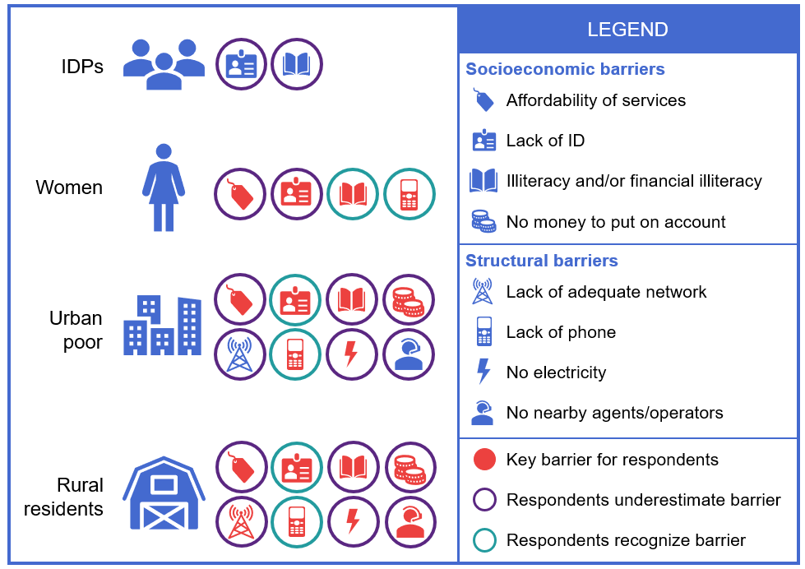
- Women are likely to face severe barriers in accessing mobile money services, mostly due to a gender gap in socioeconomic characteristics. First, women are more likely to be poor or illiterate, as girls continue to be undereducated. This is perpetuated by the high rates of child marriage, further hindering their access to mobile money and related services. This correlates to huge disparities in living standards, with men earning 50 percent more than what women earn. Second, as mentioned previously, women are less likely to own an ID, with a 17-percentage point difference between the rates of ID ownership between men and women in favor of men. Third, women are significantly less likely to own a phone.
- In comparison, behavioral barriers play a minor role in preventing women from accessing and using mobile money. South Sudanese societies are traditionally patriarchal, establishing men as heads of household and as the main decision makers in society. In the traditional division of responsibilities, men engage in the public sphere, whereas women focus on activities at home. As such, women are potentially less likely to be in a position to use mobile money services if men are mostly in charge of the households’ financial transactions. Yet, the qualitative data highlighted that women are instead usually in charge of household activities, including payment of households’ expenses such as utility bills, health expenses and school fees. Additionally, women do show a strong demand for mobile money services, as highlighted in Section ‎6.
- The urban poor are significantly more vulnerable to socioeconomic barriers than the average urban population. However, the urban poor do not perceive their low income and low literacy rate as major challenges to adopt mobile money services, while the lack of ID is strongly perceived as such, i.e. by 45 percent of the urban poor. Nonetheless, structural barriers also play a major role in hindering the urban poor’s potential access to mobile money. Sixty-five percent of them lack access to electricity, against 45 percent of the urban population. Furthermore, they enjoy a lower access to mobile phones. This barrier is felt by 70 percent of urban poor, against 41 percent of the urban population. The urban poor also exhibits a bigger resistance to KYC protocols for buying a SIM card and/or opening a mobile money account, largely due to the fact that they have lower ID ownership than the urban population, combined with the lowest income levels among all the vulnerable groups.
- Rural residents suffer most severely from the various barriers to access mobile money services. Indeed, all structural barriers are significantly worse for the rural population: they have a lower rate of phone ownership, and lower access to electricity, adequate network and telecommunications agents. Furthermore, trust levels towards MNOs and satisfaction of their services are lower in rural areas. Yet, similar to urban poor households, rural residents seem to underestimate these barriers: only lack of ID and low access to mobile phones are mentioned significantly more by rural residents, while other socioeconomic and structural barriers are not as strongly felt in rural areas, despite in reality being worse.
- IDPs, on the other hand, do not significantly show signs of more acute challenges in accessing mobile money. On average, IDPs demonstrate a similar level of income, literacy and ID ownership than of the general population. Similarly, this vulnerable group does not stand out in terms of phone ownership and access to adequate network, electricity and agents. In fact, two thirds of the IDPs indicated that they did not think their displaced status would induce any additional barriers to access mobile money. For instance, less than a fifth (23 percent) of IDPs characterized the lack of ID as a potential barrier they would face, against 37 percent for the general population, while only 17 percent felt literacy might be a challenge (against 31 percent).

Risks of Mobile Money
- While barriers to the adoption of mobile money need to be considered in assessing the feasibility of using mobile money for cash programming, risks associated with mobile money also need to be carefully evaluated. A number of risks associated with the adoption of mobile money in South Sudan are endogenous. In addition, exogenous risks such as the South Sudanese fragile context, characterized by high illiteracy, poor level of infrastructure development, volatile political and security conditions, and weak regulatory and institutional environment, has made the endogenous risks particularly acute. These are presented in Figure 10.
Figure 11: Main endogenous and exogenous risks for the entire sample (N=1,648)
Exogenous risks
- The use of mobile money is vulnerable to technical issues or a system collapse. Given the poor network coverage in South Sudan, and high risk of network shutdowns, possible incidents of technical issues or system collapse, whether temporary or permanent, cannot be underestimated. The unreliability of mobile money services would raise two risks: i) preventing people from cashing out money or from using their mobile money account at the moment when they most need it; and ii) deteriorating trust in the system, and consequently, disincentivize uptake. For instance, 62 percent of the population fear not being able to transfer money when they want to due to inadequate network, 48 percent due to a government-imposed shutdown, and 16 percent due to system collapse (i.e. the operator shuts down or the system collapses).
- The potential degree of complexity in using mobile money for financial transactions can lead to personal errors. Twenty-eight percent of the population mentioned risks associated with personal errors, for instance sending money to the wrong number, or forgetting the PIN of their mobile money account, a concern shared across all socio-demographic profiles. While this risk is relevant to all country contexts, even those with mature mobile money markets such as Kenya, it is further exacerbated in South Sudan due to the population’s high illiteracy levels and low capacity to master the use of new technologies.
- Risks of fraud may negatively influence the population’s perceptions of mobile money and impede its adoption. Twenty percent of the population is concerned with fraud, which can take several forms with regards to mobile money. These include, for instance, receiving a fake SMS stating that funds were wrongly sent to the mobile account owner and should be sent back to a specific number, or being asked to resend money because the transaction was unsuccessful when it was not. High levels of illiteracy in South Sudan significantly increase the likeliness of recipients and users to become victims of such fraud schemes. Moreover, the communal nature of society in South Sudan increases opportunities of another type of fraud, whereby one’s PIN code is misappropriated by someone whose help had been required in order to conduct a transaction. Specifically, women seem to be significantly more afraid of having their mobile money on their accounts stolen (mentioned by 30 percent of women versus 21 percent of men).
- Mobile money is vulnerable to liquidity shortages. Unavailability of liquid cash outside of urban centers could prevent users from cashing out when needed. This is a major risk for mobile money-enabled cash assistance, as beneficiaries are likely to only withdraw cash, at least in the short term, which means that it would be difficult for agents to rebalance. Ensuring that customers can always cash out is likely to be very challenging in South Sudan, owing to the lack of termination points where customers could cash out in some remote areas, and the difficult logistics associated with transferring bulk cash in the country.
- Liquidity management is perceived as a key challenge by mobile money providers, and they are developing strategies to cope with this risk. Both Lukiza and Trinity Technologies are reportedly developing a well-defined agent network structure, with a combination of agents and master agents (agents of agents who can manage liquidity of agents). Agents will likely be traders, gas stations and MNO’s agents. Master agents will likely be banks. In particular, Trinity has an agreement with Equity Bank since March 2019, while Lukiza is discussing with Cooperative Bank.
- The development of mobile money may exacerbate security risks. Security conditions are extremely volatile in South Sudan. The major political conflict is also likely to cause escalation of local armed conflict between communities, often fuelled by (lack of) access to scarce resources like water and land, cattle herding and basic needs. Moreover, the South Sudanese police severely lacks the institutional capacity and resources to systematically address law and order issues. In such a context, security of mobile money agents is also a significant concern, as they would have to keep enough liquid cash on hand to perform cash-out transactions and could thus become the target of violence. More generally, moving cash around and managing liquidity of mobile money agents would entail security risks.
- The adoption of mobile money also raises data protection issues. Beneficiary and consumer data would need to be protected, but processes to ensure this are not yet in place. Indeed, there currently is no national legal framework for data protection in South Sudan, which means that financial sector actors, including mobile money providers, are not requested to follow procedures to keep personal data secure and protect customers’ privacy. This further poses a substantial risk in terms of potential misuse of personal data for predatory actions for illicit activities.
- Finally, money laundering is a key issue. Even though regulations were drafted to curb money laundering, notably through mandatory SIM card registration, compliance with KYC and AML requirements remains hampered by several issues, including lack of ID coverage.
- The adoption of mobile money may also have several exogenous risks, which relate to the functioning of markets and the realities of South Sudan’s economy, including unstable markets, easier channeling of resources to illicit activities, and risks of weakening traditional social safety nets. Exogenous risks are overall perceived to be less pervasive, but evidence also suggests that they should not be trivialized, as they can have high impact if they were to materialize.
- Mobile money may flood markets with increased amounts of cash which cannot be absorbed. Cash transfers, notably when disbursed through mobile money, require functional and elastic markets to be effective. Most key informants noted that some urban areas (i.e. Juba, Renk, and Wau) and some border areas, have relatively robust and resilient markets. However, they also highlighted that this is not the case in other parts of the country. These are due to: i) weak physical infrastructure, including poor road networks, resulting in high costs of procuring and moving goods; ii) protracted political crisis and ensuing insecurity; and iii) currency and cash liquidity issues, as the parallel market exchange rate continues to be close to double the official exchange rate, leading to local currency liquidity drying up frequently.
- Evidence reveals that traders cannot always meet the increased demand generated by cash transfers. Traders confirmed that markets do not always meet customers’ needs. Furthermore, they highlighted seasonal trends in supply, with some markets being less functional during the rainy season when it becomes difficult to secure adequate supply of goods due to the worsening of roads conditions. Lack of market functionality is exacerbated in “hard-to-reach” opposition held areas, which also tend to be where humanitarian needs are highest.
- Massive flows of cash from cash assistance, coupled with low market functionality, could have several negative consequences. Demand-side results reveal that markets functioning is very heterogeneous across types of residence and counties. Markets are significantly less developed in rural areas, with 66 percent of rural residents stating that they do not always find what they want in the market, versus 58 percent in urban areas. As such, there is a risk that some markets would be unable to absorb injections of cash from mobile money, distorting local markets, inducing shortages, and resulting in price hikes for communities, largely contradicting the purpose and principles of cash assistance. Also, it can generate increased operational costs if partners need to introduce traders to bring in basic commodities which can be bought by the cash transferred – as was sometimes required in some humanitarian projects.
- The development of mobile money may result in the channeling of resources to illegal groups in some areas through boosted markets. Mobile money could expand and strengthen markets. However, some of these markets are controlled by illicit groups, creating risks of enriching them through mobile money transfers. Eight percent of the population declared being afraid that mobile money would ease the financing of illicit activities. Additionally, changing market structures, which are entangled with power dynamics as parties compete to control supply roads and markets, could fuel tensions between different elite groups.
- Lastly, mobile money may weaken traditional safety nets by monetizing the economy. South Sudan’s economy has been traditionally based on reciprocal relationships of kinship. Even if these practices are less pervasive than they used to be, they are still present in some rural areas. In these areas, injection of large amounts of cash with mobile money would lead to the monetization of the economy, subsequently potentially putting people in a position where they have to find money to cover their needs beyond the traditional systems of exchange and reciprocity. This can create negative coping strategies, and can also make people more vulnerable in times of shocks, in case their social capital is damaged.

Mitigation strategies
- Measures could be implemented to mitigate some of these risks, based on experiences from countries that share similar features. Experiences from East African countries that have widely embraced mobile money, such as Kenya and Uganda, illustrate how fraud can be mitigated in the context of high illiteracy rates, for example by developing services to investigate reported transactions, reversing them if needed, or voice services for illiterate people. As for AML measures, there is a growing interest among humanitarian and development partners to explore whether biometrics could be integrated into the design of a mobile money system. Some telecommunications companies in East Africa are also exploring such possibilities. Table 1 provides a summary of the above-discussed risks, including their potential impact on the mobile money ecosystem as well as mitigation strategies to effectively address them.
Table 1: Mitigation strategies for endogenous and exogenous risks
Risk | Risk description | Risk impact | Mitigation measures
Fraud | Receiving a fake SMS stating that funds were wrongly sent to the mobile account owner and should be sent back to a specific number, being asked to resend money because the transaction was unsuccessful when it was not, etc. | Loss of money for mobile money users  Loss of trust in the system | Agent and consumer fraud awareness programs (cf. M-PESA in Kenya)  Customer due diligence measures (KYC), that may include biometric identification systems, to ensure only subscribers whose identity can be verified (and, in the case of legal entities, who are properly licensed) have access to mobile money services (cf. M-PESA in Kenya)  Agent due diligence and compliance monitoring (cf. Easypaisa in Pakistan)  Screening to detect suspicious transaction patterns (cf. Easypaisa in Pakistan)  Robust customer recourse and escalation procedures (cf. ZAAD in Somaliland)
Personal errors | Sending money to the wrong number, or forgetting the PIN of mobile money account | Negatively influencing the users’ perception of mobile money systems | Capacity building through awareness programs (cf. M-PESA in Kenya)  User-friendly interface (cf. M-PESA in Kenya)  Voice recognition software (cf. EVC+ in Somalia)  Systems to investigate reported transactions and reverse them if needed (cf. MTN in Uganda and M-PESA in Kenya)
System collapse or technical issues | Temporary or permanent network shutdowns | Preventing people from cashing out or using mobile money when they need to, leading to a deterioration of the trust in the system | Sensitization aiming to obtain a firm commitment from the government (e.g., through an MoU) to ensure standards for network maintenance and quality  Sensitization aiming to obtain firm commitment from the government to secure property rights of MNOs and create a sound regulatory environment so as to increase expected profits associated with investment  Thorough tests of systems by a third party/government agency before the launch to make sure it works, with subsequent regular inspections
Liquidity shortages | Unavailability of liquid cash | Preventing people from cashing out when they need to | Robust agent distribution network (cf. ZAAD in Somaliland)  Wide adoption of merchant payments to reduce cash-out needs (cf. ZAAD in Somaliland)  Ongoing monitoring of transactions to identify agent locations where cash is in higher demand
Security risks | Security of mobile money agents while performing cash-out transactions | Theft of money and violence against mobile money agents | Strict security protocols to be followed by agents  Operational costs related to security integrated into the service providers’ cost structure
Data protection issues | The protection of consumers’ personal data is not guaranteed | Potential misuse of personal data for predatory actions, e.g. to gather intelligence on specific groups | National legal framework for data protection (cf. 2019 Data Protection and Privacy Act in Uganda)  Emergency response plan for mitigating data breaches and informing customers
Money laundering | Use of mobile money by criminal organizations to facilitate illicit activities | Facilitation of criminal activities | Customer due diligence measures (KYC) to ensure only subscribers whose identity can be verified (and, in the case of legal entities, who are properly licensed) have access to their networks (cf. M-PESA in Kenya)  Regulations prohibiting the offering of digital financial services by unlicensed entities (cf. Kenya, Uganda, Nigeria)
Unstable markets | Mobile money may flood markets with increased amounts of cash that they cannot absorb | Shortages, price hikes | Market readiness assessments for each new location  Analysis on effect of mobile money in national monetary policy
Channeling resources to illegal activities | Enriching illegal groups through boosting markets under their control | Support illegal groups and fuel conflict | Customer due diligence measures (KYC) to ensure only subscribers whose identity can be verified (and, in the case of legal entities, who are properly licensed) have access to their networks (cf. M-PESA in Kenya)  Traceability and accountability of payments through improved transfer dashboards
Weakening traditional safety nets | Monetization of the economy endangering traditional systems of exchange and reciprocity | Induce negative coping strategies and increase vulnerability to shocks | Community-level awareness programs to ensure mobile money is seen as a way to enhance safety nets rather than deteriorating them

LEARNING FROM OTHER CONTEXTS
- South Sudan can learn from the experience of mobile money scale-up in other FCV countries, namely Somalia. The focus box below reflects on the success of mobile money in Somalia and examines lessons learned that could potentially be applied in South Sudan.
Focus Box 2: Why is mobile money so successful in Somalia?
Despite the fragility and under-developed financial institutions, Somalia has one of the most active mobile money markets in the world, outpacing most other countries in Africa. Mobile money has superseded the use of cash in Somalia, with over 75 percent of adult Somalis using mobile money services regularly. It has also become the most widely used transfer mechanism for cash assistance, by allowing cash disbursement to beneficiaries in an effective and cost-efficient way, and enabling providers to deliver cash assistance in remote areas, where other transfer mechanism cannot reach.
Despite the regulatory vacuum, several factors have encouraged the impressive uptake of mobile money in the country:
- F1. Given Somalia’s complex political environment and volatile security conditions, investments in telecommunications have been almost exclusively led by Somalis, both from the diaspora and within the country. This is substantially different than telecommunications in other countries in Africa, which have traditionally been dominated by incoming large MNOs (including Zain and MTN). As a result, the ICT sector has been able to leverage Somali social and business networks, and has created products uniquely suited to the Somali context.
- F2. ICT is one of the bright stars of the Somali economy. Mobile money has built on very high phone penetration, with nine out of 10 Somalis above the age of 16 years who own a mobile phone. Further, MNOs are among the most recognizable and trusted brands.
- F3. Operators have adopted a business model based on indirect revenues — gain on increased airtime sales and greater customer retention. They are therefore able to offer mobile money services to users as a “free” service (without transaction charges or fees). Affordability of services has been a key enabling factor given low income per capita in Somalia.
- F4. Operators have quickly understood the importance of promoting bill and merchant payments to build a vibrant ecosystem of institutions and businesses using the system, which in turn has driven usage among the general population. MNOs concentrated their early efforts on two target groups: merchants and employers, to immediately create a mobile money system that did not require users to cash-in and cash-out. They notably spent a lot of time educating merchants about the service.
- F5. MNOs have increasingly formed part of large conglomerates, which enables the operators to propose attractive services, such as the possibility to transfer remittances directly to recipients’ mobile money accounts. Such a service has driven usage as remittance flows remain critical to a large part of Somali households.
- F6. Nomadic populations, that make up for a quarter of the population, move around a great deal to find adequate pasture and water for their livestock. Mobile money suits well their lifestyle.
Somalia and South Sudan share a number of characteristics, like the depreciation of their local currency, limited access to traditional banking services and lack of other effective and accessible alternatives. As such, mobile money could rapidly become an effective substitute for cash in South Sudan, as it has become in Somalia, should the necessary conditions exist. While some enabling factors that have supported rapid growth in Somalia are country specific (F1, F2, F6), some lessons learned from the successful experience of mobile money in Somalia could be applied to South Sudan. These include the need to create an attractive value proposition with a low-fee business model, the commitment to salary payments and merchant payments, and the development of value-added services such as the possibility of receiving remittances from Kenya or Uganda on mobile money accounts.

Recommendations
- Mobile money holds immense potential in South Sudan. In particular, mobile money can be the future of cash assistance in the country. It can enable humanitarian and development partners to reach a significant number of beneficiaries not yet reachable, and help improve the timeliness and cost-effectiveness of cash delivery. It also has the potential to mitigate some of the problems associated with cash delivery in South Sudan, including fiduciary and security risks. Furthermore, with a negligible rate of bank account ownership in South Sudan, mobile money could be a game-changer in terms of financial inclusion in the long term, once more reliable and extensive network infrastructure is built and a more enabling legal and regulatory framework is in place and enforced.
- However, there are a number of multi-dimensional barriers that will hinder the adoption of mobile money in the country in the short to medium term. These include on-going instability and conflict; structural barriers such as poor network coverage and limited access to electricity; socio-economic barriers such as chronic underdevelopment and low literacy rates; and, to a lesser extent, behavioral barriers such as lack of knowledge of available services.
- Mobile money itself is also associated with a number of risks, both endogenous and exogenous. These notably include fraud, money laundering, security risks for agents and risks relating to the functioning of markets (see Section 9).
- Yet, despite the risks associated with mobile money, the risks of not using mobile money run even higher in the longer term. As evidenced by the research, current methods of cash assistance delivery not only entail cost and time inefficiencies, but also present higher risks of predatory violence and leakages compared to mobile money (see Section 6). Arguably, risks of fraud and money-laundering can be worse in a cash-based economy, while mobile money can increase traceability and transparency of financial flows. Moreover, for the general population, not using mobile money equates to maintaining status quo, which is characterized by a lack of affordable financial services, low trust in the banking system, and low financial inclusion levels, especially for the most vulnerable that are currently unbanked. To the contrary, if barriers to use mobile money, as well as endogenous and exogenous risks, are properly assessed, they can, to some extent, be tackled or mitigated.
- Given that service development is in its infancy, the development of a mobile money ecosystem in South Sudan provides a window of opportunity to build a system from scratch that meets international standards. Mobile money is about to be launched and all signs indicate that it will progressively grow, despite the substantial barriers and risks the research highlighted. As such, it is advisable that the humanitarian and development partners engage in this sector early to ensure that risks and barriers are addressed in a sustainable way, and that measures undertaken are aligned with global good practices. Conversely, ignoring this window of opportunity can risk the sustainability of mobile money development and its potential for inclusion. As such, in order to prevent mobile money from entrenching existing inequalities, as well as to ensure that the risks previously underlined are effectively mitigated, the early involvement of development partners is crucial.
- However, efforts aimed at supporting the scale up of mobile money services need to take into account the current uncertain political situation and tenuous peace process, as well as potential exacerbation of conflict risks. As such, it is recommended that efforts start small and adopt a “learning-by- doing” approach in the short term, with a focus on supporting the delivery of more efficient and effective cash assistance for the benefit of poorest and vulnerable households in need and establishing risk mitigation measures to minimize impacts on market functionality, fueling illicit activities, and undermining traditional safety nets, among others. Should the country situation improve and peace and stability, as well as broader governance arrangements, be consolidated, then a number of reform efforts can be undertaken in the medium to long term, with the aim of promoting an enabling environment and supporting broader mobile money ecosystem development.
- This section details, for each group of relevant stakeholders (development partners, Government authorities, and MNOs and third-party mobile money service providers), a set of enabling conditions required for the development of mobile money, in the short term. It then provides a set of medium to long term recommendations to expand revenue opportunities for mobile money service providers and trigger a new wave of product development for the mobile money sector as a whole, with linkages into broader social safety nets as well as wider digital transformation agenda.

Recommendations for humanitarian and development partners
- In the immediate term, humanitarian and development actors should be wary of a “rush to mobile money”, as a number of key issues would need to be addressed priori to wider uptake. It would therefore be critical to be cautious in the beginning and pilot approaches in “easy” and stable locations to allow for “proof of concept” and opportunities for learning, while ensuring that risks associated are carefully mitigated, to the extent possible.
- Pilots for humanitarian and development cash-based programming should be implemented in places with relatively stable network access, and with functional markets to serve as “proof of concept” cases. These could include for example Juba, Wau, Yambio or Rumbek. Implementing such pilots would involve a number of preparatory activities.
- Market readiness and socio-political risk should be assessed prior to any pilot and strong monitoring and evaluation should be conducted to better understand the impact of mobile money as a transfer mechanism. Market readiness assessments should be conducted to ensure that local markets in locations selected are in a position to absorb an influx of liquidity via mobile money, without adversely distorting market conditions. Political economy and socio-political risk assessments should also be carried out to understand the importance of market-level factors at play to ensure that mobile money will not inadvertently fuel illicit activities. Finally, strong monitoring and evaluation systems should be established to better understand the impact of mobile money, as a transfer mechanism, to support learning and developed a viable “proof of concept” that can be scaled.
- Access to handsets, SIM-cards and electricity to recharge phones for pilot beneficiaries should be subsidized and/or facilitated. Handsets are required to access mobile money services. Pilot beneficiaries may lack phones and/or SIM cards that are required to access mobile money, and one of the main barriers to access is unaffordability. Humanitarian and development actors should consider providing privileged access to handsets and SIM cards for beneficiaries to mitigate this barrier. Partners could also consider deploying solar systems, with charging points in communities, targeting specific locations where they plan to use mobile money for cash transfers.
- Pilots should be of an adequate duration such that the benefits outweigh the setup costs linked to introducing mobile money for cash assistance.
- In the medium to long term, development partners should also create partnerships with key public and private sector actors to address bottlenecks that hamper the launch and uptake of mobile money and inform a business case for private investments in mobile money. New partnerships could offer a promising means of ensuring that payment services provided are tailored to the needs of new bulk payers (i.e. humanitarian and development partners). For instance, improved bulk payment portals could be customized for humanitarian and development partners in line with their internal standard operating procedures for payments approval and disbursal. Likewise, customized transfer tracking and reporting dashboards could be developed, whereby they can track every payment and investigate any problem that may arise. Humanitarian and development organisations could also help inform the business case for mobile money expansion, e.g. by providing population statistics and predicted demand trends (e.g. from pilot case studies), to demonstrate the wider opportunities presented by cash transfer programmes. Finally, significant investment is necessary to address the barriers to mobile money services. Partnerships could help cover setup costs. For example, partners could dedicate time and resources to train beneficiaries on mobile money use and benefits, a critical foundation to ensure success of mobile money services.

Recommendations for Government authorities
- In the short term, the necessary conditions for a conducive environment rely on a strong commitment from the Government to promote market competitiveness. First, to enable the development of a mobile money ecosystem, the government has an important part to play in creating a more conducive environment in which innovations and investments can flourish, through greater liberalization and measures aimed at fostering competition. Second, ensuring that the network always remains operational is critical. This would encourage investment in infrastructure, as the risk of further network shutdowns decreases expected profits.
- In the medium to long term, a wider mobile money uptake then requires interoperability between MNOs and third-party mobile money providers. Given that MTN covers some areas, while Zain covers others, interoperability between MNOs and between third-party mobile money service providers, would need to be established. Further, the BoSS could establish provisions for an aggregator, that can link financial systems to enable interoperability. Development partners can support in providing necessary technical assistance to the BoSS and NCA, as appropriate.
- The Government should also draft and enforce regulations to protect users’ private information and mitigate risks of fraud and money laundering. Regulations outlining what kinds of customer information will be collected, how this data can be shared, and what types of security measures need to be implemented with regard to data transmission and data storage are necessary. Furthermore, systematically enforcing KYC requirements are key to mitigating the risks of fraud and money laundering. Users need to possess a government-recognized proof of identity, so that KYC requirements can effectively be enforced. The development of a national ID system could be facilitated by leveraging existing biometric registration exercises conducted by humanitarians and development actors. In the meantime, the tiered approach to ID (supported by the current regulation) will reduce identification requirements for people opening accounts that have transaction and/or balance limits.

Recommendations for MNOs and third-party mobile money service providers
- In the short term, a number of enabling conditions would need to be in place to enable the launch of formal mobile money services in South Sudan. First, the development of mobile money will require the design of services tailored to potential mobile money users. As the relative cost-efficiency of mobile money services vis-a-vis current alternatives is found to be the main enabling factor for adoption, creating an attractive value proposition to unlock the potential of mobile money is necessary. In the case of South Sudan, the transactions are likely to largely be cash-in and cash-out in the short term, and the balance being maintained in the accounts would be minimal. Therefore, reducing costs might not be feasible given the business considerations, without subsidizing mobile money service providers, as discussed above. Second, accessibility of mobile money services was mentioned as a key enabling condition by a significant share of the population. Mobile money providers should thus consider deploying roving agents who move around markets, and placing additional agents in communities targeted for cash assistance during a pay-out period. Third, given low digital and financial literacy levels, awareness and capacity building should accompany the deployment of these services. Leveraging the benefits of mobile money will depend on users understanding the system, including how to use it and how to avoid fraud, personal errors etc. This could be achieved through communication campaigns, sensitization programmes and training sessions. Similarly, the development of an accessible and culturally appropriate helpline service as well as a reimbursement scheme, in case of theft, would likely increase adoption by making services more user-friendly and attractive. Toll-free call centres and/or information points, in the local dialects, are advised.
- Robust monitoring and screening arrangements should be put in place to mitigate the risks of fraud, money laundering and leakages. Mobile money service providers have at their disposal a range of detective and preventive control methods to reduce such risks. Fraud should be addressed through awareness-raising campaigns. Systematic screening should be undertaken to detect and identify suspicious transaction patterns, as this could mitigate risks related to money laundering and financing of illicit activities. KYC procedures should also be strengthened to ensure effective monitoring, enforcement and that transactions are associated with true beneficiaries.
- In the medium to long term, infrastructure investments are crucial to improve the connectivity of potential mobile money users. At least 2G mobile coverage is needed to develop mobile money services, and adequate infrastructure thus constitutes a pre-requisite for mobile money. Given that South Sudan’s telecommunications infrastructure remains largely under-developed, an significant investments will be required to gradually expand and upgrade telecommunications infrastructure. High deployment costs (due to the difficult terrain and lack of supporting infrastructure to deploy equipment), coupled with low commercial returns (due to low population densities and low purchasing power), will render services not commercially viable on their own, at least in the short to medium term. Promoting the deployment of the networks will thus require innovative funding solutions. In particular, Public-Private Partnerships (PPPs) could be explored to address current market failures, subsidize plans to improve networks and reduce investment risk in areas where market forces alone are insufficient to provide adequate coverage. When expanding the connectivity infrastructure, strengthening access to energy is also a priority, and can potentially be supported by sharing the electricity provided for the connectivity infrastructure in the communities, e.g., by installing additional solar capacity when deploying ICT infrastructure, allowing for the extra available energy to be purchased by citizens and local businesses.
- Mobile money service providers should prevent liquidity shortages through development of a robust agent distribution network and the inclusion of traders and merchants in the system. While deploying roving agents is a short-term solution to facilitate adoption of mobile money services, a robust agent distribution network, that is able to manage liquidity and operate within a reasonable distance from beneficiaries, is paramount to develop a mobile money ecosystem. Existing systems, including airtime resellers and IVTSs, should be leveraged as agents, since they already have access to liquidity. Other intermediaries, such as traders and gas stations, are also likely candidates. Additionally, local banks and larger money transfer companies, like LEM, could serve as a potential network of master agents as they have a relatively wide-reaching network of branches and are more liquid. Additionally, promoting merchant payments would reduce cash-out needs, and consequently liquidity management issues. It would also create positive network effects and ensure that mobile money stays within the system. Traders and merchants could receive subsidies for the acquisition of payment devices in the short term. Awareness efforts should also include utility companies to promote digital payments of bills.
- In order to then build out a complete ecosystem, and foster wider financial inclusion, a number of initiatives could be undertaken to drive the usage of mobile money accounts. If clients transact regularly, and if mobile money stays within the system, it will increase revenue for operators who then can re-invest in expanding related network. On the other hand, if the beneficiaries only cash-out, mobile money revenues will remain low, making initial investments hard to recover. Mobile money staying in the system would also mitigate liquidity challenges. Mobile money service providers should consider incentivizing people to keep money on their mobile money accounts (akin to a saving account), if pricing models allow. Likewise, firms should be incentivized to send salaries through mobile money and the payments of civil servants (assuming relative security and stability and improved fiscal position by the Government to pay salaries) should be shifted to mobile money. Similarly, while initially, mobile money service providers could launch restricted usage services, which are less likely to flood markets, once these products have been tested, and once markets have proved resilient, mobile money service providers could transition to more evolved products, such as mobile credit when transaction histories enable credit scoring. Given the crucial role of remittances flows for the South Sudanese population, services providers could also partner with remittances companies to develop attractive services aimed at transferring funds directly on users’ mobile money accounts.
- Mobile money services providers must ensure that women and the most vulnerable segments are not excluded from mobile money. Research showed a significant gender divide in phone penetration, that is likely to be mirrored in mobile money penetration. Therefore, specific nuanced interventions would be required to ensure uptake by women. Similarly, in the long run, it will be particularly important to mitigate the risks of skewing the benefits of mobile money towards the well-educated and wealthy, entrenching digital divides and inequalities. Instead, once a stable customer base is achieved, mobile money service providers should ensure that investments in ICT and mobile money benefit the bottom of the pyramid, including those in rural areas. As such, substantial efforts and strategic partnerships with development partners will remain needed, to reach universal access and ensure that vulnerable groups, such as women and marginalized populations, can reap the benefits of wider mobile money uptake.

OCHA. “South Sudan Situation Report”. May 2019
World Food Programme. “WFP South Sudan Crisis - Report #240.” March 2019.
World Bank. “South Sudan Economic Brief”. April 2019.
Ibid.
In 2016, largest donors and humanitarian partners acknowledged during the Humanitarian Summit the underutilization of cash assistance worldwide, after which they committed to its more extensive use in appropriate contexts.
Cash Learning Partnership. The State of the World’s Cash Report. February 2018
Somalia is a good example of the role that mobile money can play to increase financial inclusion and build greater resilience to shocks. Humanitarian response for the 2016/17 drought largely used mobile money to transfer cash to the most affected, channeling key resources and income and supporting critical purchases, thereby helping people to be less acutely affected by the drought. Mobile money also enhanced financial inclusion and is regularly used to transfer money domestically and internationally, conduct payments and receive loans.
A total of 38 KIIs were conducted, in the capital city, Juba, between January 21 and May 21, 2019. They encompassed 9 interviews with actors from the government, 11 with actors from the financial and telecommunications sector, and 7 with development and humanitarian partners.
A total of 38 IDIs were conducted in the nine selected counties, over the period January 21, 2019 – May 11, 2019 (see Table 1). They comprised 14 interviews with airtime resellers and mobile money agents, 11 with money transfer operators, and 13 with traders
The first entrant was Ugandan telecommunications group Gemtel, also known as the ‘Green Network,’ licensed by the Government of Republic of Southern Sudan in 2006. Next was Vivacell in 2009, 75 percent of whose share was owned by the Lebanese Fattouch Investment Group, while the remaining 25 percent was held by Wawat Securities, subsidiary of the Sudan’s People Liberation Movement (SPLM). After came Sudatel, Zain Sudan, and MTN Sudan in 2008 who were the main catalyst for larger network expansion.
This was epitomized by the temporary shut-down of the network in the Upper Nile in January 2014 for “security reasons”, and more recently across the entire country in January 2018. https://radiotamazuj.org/en/v1/news/article/south-sudan-government-shuts-down-3g-network
TeleGeography Authoritative Telecom Data. “South Sudan.” Available at: https://www.telegeography.com/products/commsupdate/lists/country/south-sudan/
The National Communications Authority issued Niletel’s license in 2018.
TeleGeography. GlobalComms Database. March 2018.
In depth interviews with traders, KIIs with representatives of the telecommunications sector
All differences in statistics presented in this report are significant at the 5 percent level.
Unaffordability of phones can mostly be explained by extremely low purchasing power, and to some extent by an unfavourable taxation regime. While telecommunications services are charged with an excise duty at a rate of 15 percent, in line with other countries in East Africa, the import tax rate on mobile phones is high at 20 percent. This compares to only 10 percent in Kenya.
Interconnection refers to the physical and logical linking of public electronic communications networks used by the same or a different undertaking in order to allow the users of one undertaking to communicate with the users of the same or another undertaking or to access services provided by the parties involved or other parties who have access to the network.
As will be detailed further in section ‎8, 41 percent of the population does not own any form of ID.
People who declared that they had been displaced within South Sudan after December 2013 due to conflict, violence, human rights violence, natural or man-made disasters, and people living in PoC sites.
Urban poor were defined as people living in urban areas whose living conditions do not meet three out of five different criteria: i) durable housing of a permanent nature that protects against extreme climate conditions; ii) sufficient living space which means not more than three people sharing the same room; iii) easy access to safe water in sufficient amounts at an affordable price; iv) access to adequate sanitation in the form of a private or public toilet shared by a reasonable number of people; v) security of tenure that prevents forced evictions. More details can be found in Annex 5.
World Bank. South Sudan Economic Brief. April 2019.
World Bank. South Sudan Economic Brief. April 2019.
Ding, Shannon; Wyett, Kelly; and Werker, Eric. South Sudan: The Birth of an Economy. 2012.
Regulated entities include banks, foreign exchange dealers, money service providers, electronic money institutions and payment system operators.
Government of South Sudan. Bank of South Sudan Act. 2011.
South Sudan Tribune. “South Sudan call rates to increase, says regulatory body”. 1 February 2018. Available at: http://www.sudantribune.com/spip.php?iframe&page=imprimable&id_article=64621
The East African. “New South Sudan rules to tame illicit fund transfers”. 28 July 2017. Available at: https://www.theeastafrican.co.ke/business/New-South-Sudan-rules-to-tame-illicit-fund-transfers/2560-4035932-wnhlhl/index.html
Financially included being defined as being able to access useful and affordable (formal and informal) services that meet their needs.
Anecdotal qualitative evidence also reveals that traditional systems of exchange, e.g. barter trade, can be used to conduct transactions, especially in rural areas.
Global System for Mobile Communications Association. Report on Mobile Money Policy and Regulatory Handbook. September 2018.
Interoperability refers in this report to platform-level interoperability, which permits customers of one service to send money to customers of another service.
Trinity Technologies is a subsidiary of Trinity Holdings and Trinity Energy Limited, an Oil Marketing Company (OMC) specializing in import and distribution of petroleum products.
Niletel and Nilepay are two distinct and unrelated companies.
In this report, we use the narrow definition of mobile banking, understood as electronic services provided by a bank to access banking services. Mobile banking is therefore distinct from mobile money insofar as mobile money transactions rely on a mobile money account, rather than on a bank account, and do not have to be supported by banking institutions.
GSMA 2018, Mobile Money Policy and Regulatory Handbook
MTN reportedly has not partnered with mobile money service providers due to long decision processes and timely back and forth between South Sudan and South Africa. On the other hand, Zain is still pushing to get a license to develop mobile money services in South Sudan. They allegedly accepted to partner with mobile money providers to not miss the uptake in mobile money. They, however, developed a platform that would be scalable to support their services, should they eventually get the authorization to launch mobile money.
As per the ERM.
The sender gives cash (in SSP) to an agent, who provides him/her with a transfer code. This code is then used by the recipient to retrieve the money from an agent in another geographic location. Agents in turn rely on banks, or physical delivery of cash to transfer funds when one of the branches runs out of liquidity.
Although information provided by different agents was conflicting.
IDIs with traders.
IDIs with mobile money agents and airtime traders
More details on the usages and perceptions of cash in Section ‎4.3.
MNOs adjust the prices of airtime to keep up with inflation, meaning that they tend to increase nominal prices to maintain real prices. This involves that the nominal value of the stored minutes increases, and can partly mitigate inflation.
Only marginally do users resort to M-BIRR Ethiopia, hence the analysis focuses on Safaricom and MTN Uganda’s services.
KII with a representative of the humanitarian and development sector.
KII with a representative of the private sector.
Eco Bank South Sudan website. Consulted on 13/03/2019. Available at: https://www.ecobank.com/sd/personal-banking/countries; Cooperative Bank South Sudan website. Consulted on 13/03/2019. Available at: https://co-opbankss.com/.
Ibid.
Ibid.
Morawczynski, O. Examining the Usage and Impact of Transformational M-Banking in Kenya. 2009
World Bank. Republic of South Sudan - Systematic Country Diagnosis. 2015
These figures differ from the ones published in the Systematic Country Diagnosis (World Bank, 2015), which states that only 2 percent of the population has access to electricity. Here, the figures are higher as respondents thought of access to electricity in general in their community, not specifically in their homes. In particular, the question asked respondents to specify how many hours per day they have access to electricity, so sometimes people have access to electricity for few hours per day even if they do not have electricity at home (i.e. neighbors’ house, work premises, etc.)
Findings from the World Bank South Sudan National ID System Status suggests that South Sudan currently has 170 registration devices spread across the country and embassies. This information has not been confirmed by informants, who indicated that registration is still mostly handled in the capital city.
IDIs with traders.
KII with representative from the humanitarian sector. 24 January 2019; KII with representative from the public sector. 22 January 2019. For instance, the PIU for the WB-funded SNSDP program explained that some beneficiaries were wary of biometric registration because they thought the red light of the fingerprint pad indicated that the machine would “suck blood.”
KII with the Programme Implementation Unit. 23 January 2019.
KII. Representative from the humanitarian sector, 24 January 2019.
United Nations Development Programme. South Sudan-Human Development Indicators, Human Development Reports. Available at: http://hdr.undp.org/en/countries/profiles/SSD.
World Bank. South Sudan Economic Brief. April 2019
https://www.africanews.com/2018/10/01/sudan-to-print-100-pound-banknotes-to-ease-liquidity-crunch//
Because of the rains, the period from June until January is nearly impossible for overland access and for supply chains to be maintained. Many markets in rural areas, such as those in Pibor, simply close and the traders depart until the next dry season. Also confirmed by Conflict Sensitivity Resource Facility. Cash-based Programmes and Conflict: Key areas of interaction and options for conflict-sensitive programming in South Sudan. March 2018.
KII with representative from the humanitarian sector, 28 January 2019; KII with representative from the humanitarian sector, 23 January 2019.
A voice-user interface makes spoken human interaction with computers possible, using speech recognition to understand spoken commands and questions.

