Small area estimates of income poverty in Croatia: methodological report

# **Introduction**

**The At-Risk-of-Poverty (AROP) rate indicates the percentage of individuals within a country who live on less than 60 percent of the median national equivalized disposable income after social transfers. It is one of the main indicators derived from the European Union Statistics on Income and Living Conditions Survey (EU-SILC). In Croatia the EU-SILC is representative at the NUTS**[1]**-1 level as well as at the NUTS-2. The National at-risk-of poverty rate for 2012**[2] **in Croatia is 20.4 percent. While regional poverty rates are considerably different between Continental and Adriatic Croatia, 22 and 17 percent respectively. Nevertheless it is possible that poverty levels within NUTS-2**[3] **spatial units, differ considerably.**

**Figure 1: EU-SILC poverty map at level of representativeness**

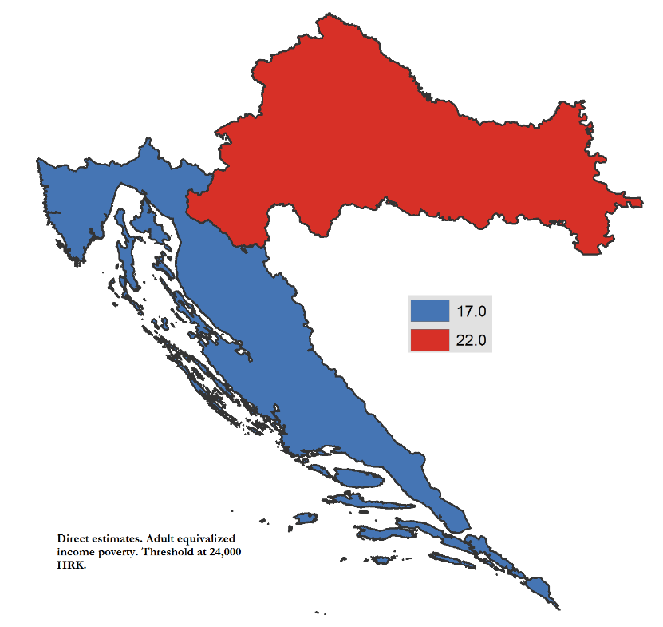

**Poverty figures at lower levels of aggregation (for example NUTS-3, LAU-1, or LAU-2) for Croatia are not possible with the EU-SILC.** Geographical levels at which direct estimates lack the required precision are referred to as small areas (Guadarrama et al., 2015). Small area estimation (SAE) methods are those which seek to overcome the lack of precision. SAE methods achieve this by incorporating data sources with larger coverage. **These methods present a way to circumvent the low representativeness of household survey methods by taking advantage of larger coverage surveys such as a census. In practice household surveys provide a satisfactory measure of welfare but possess low coverage, while the census has the coverage but lacks a suitable welfare measure. SAE methods take advantage of the best attributes of each data source in order to obtain welfare measures at levels of aggregation below those of the household survey’s representativeness. The use of SAE methods provides estimates of higher precision for small areas than those obtained using a household survey alone. Higher precision of welfare for smaller areas allows policy makers to better target assistance and interventions to the most disadvantaged communities.**

**The Census of Population, Households and Dwellings of 2011 for the Republic of Croatia when combined with the 2012 EU-SILC facilitates the estimation of welfare at the household level. This makes obtaining poverty rates for areas below those of the EU-SILC’s representativeness possible. The small area estimation methodology used to obtain the estimates follows the one proposed by Elbers, Lanjouw, and Lanjouw (ELL) (2003).**[4] **The methodology is perhaps the most widely used for small area estimation, and has been applied to develop poverty maps in numerous countries across the globe. Through the application of the analysis predicted poverty rates at the NUTS-3,**[5] **as well as at the LAU-2**[6] **levels are obtained.**

# **Modeling approach**

**The ELL method is conducted in 2 stages. The first stage consists in fitting a welfare model using the 2012 EU-SILC data via ordinary least squares (OLS), and correcting for various shortcomings of this approach to arrive at generalized least squares estimates (GLS). It should be noted that the variables included in the welfare model of the 2012 EU-SILC must be restricted to those variables that are also found on the 2011 Census. This allows us to generate the welfare distribution for any sub-population in the 2011 Census, conditional on the sub-population’s observed characteristics (ELL, 2002).**

**After correcting for shortcomings, the estimated regression parameters, standard errors, and variance components from the EU-SILC model provide the necessary inputs for the second phase of the analysis. The second stage of the poverty mapping exercise consists in using the estimated parameters from the first stage, and applying these to the 2011 Census data in order to predict welfare at the household level. Finally, the predicted welfare measure is converted into a poverty indicator which is then aggregated in order to obtain poverty measures at the desired level of aggregation (NUTS-2, NUTS-3, or LAU-2).**

**Before fitting the welfare model, a comparison between the observable household characteristics from the EU-SILC and the Census is necessary. The purpose of the comparison is to ensure that variables have similar distributions, and that these have similar definitions across data sources. Because the exercise consists in predicting welfare in the census data using parameters obtained from EU-SILC observed characteristics, it is imperative that the observed characteristics across surveys are comparable.**

**The next step in the ELL methodology consists in estimating a log adult equivalized household income model which is estimated via *OLS.* The transformation to log income is done because income tends to not be symmetrically distributed (graph 1), taking the logarithm of income is done to make the data more symmetrical.**

**Figure 2: Adult equivalized income and natural logarithm of equivalized income**



**The household income model is:**

**where is the adult equivalized income of household *h* in municipality *c*, are the household and locality**[7] **characteristics, and is the residual. In the specified model the use of Households within a same municipality are usually not independent from one another and the following specification is used to account for this:**

**where and are assumed to be independent from each other and uncorrelated with the observables, . Households in the same location share the same , and it is expected that the larger the variance of the less precise the estimates of welfare will be when the spatial correlation of the residuals is ignored.**

**The estimation of and is done utilizing Henderson’s method III (Henderson, 1953).**[8] **In the case where the variance of the household specific error, , is assumed to vary across households a parametric form of heteroscedasticity is assumed and modeled as:**

**where .** [9] **Making use of these estimates it is possible to obtain an estimate for** . The existence of the variance parameters require a re-estimation of the welfare model given that the *OLS* assumptions are unlikely to hold. The variance covariance matrix utilized for the GLS estimates is household cluster specific, and where the interrelatedness between households within a cluster is also allowed.[10]

Once GLS estimates are obtained it is possible to move on to the second stage of the exercise. Small area estimates of welfare (and standard errors) are obtained by applying the parameter and error estimates from the survey to the census data. In order to do this we must simulate welfare. Since poverty indices are based on non-linear forms of log adult equivalized income simulations are ideally suited for obtaining estimates of these measures. A value of log income per adult equivalent for each household is simulated making use of the , , and the parameters from the first stage, where each simulation is equal to:

**For each simulation a set of**  are drawn from bootstrapped versions of the EU-SILC sample.[11] On the other hand for the location and household disturbance terms we obtain their variance parameters, and , from the bootstrapped version of the EU-SILC. and are thus drawn from a normal distribution assuming mean zero and variances equal to and , respectively. If we define as a function that maps the estimated adult equivalized income measure to a poverty measure such as the at-risk of poverty head-count-rate (FGT 0) then the estimated mean poverty rate for a municipality is equal to:

**where is the population expansion factor (number of household members in household divided by the total population of Croatia in the census).**

**An alternative for the estimation of is to use the information from the survey, Empirical-Best estimation (EB). The best estimate available to us of , for a particular municipality is that which comes from the survey . Therefore making use of this information the estimates for the municipalities, cities, and districts of Zagreb that are present in the EU-SILC are tighter since more information is included into their drawing. For all locations that are not present in the EU-SILC, the use of EB makes no difference, since for these localities there is no additional information and thus their data generation process is still normal with mean zero and variance** .

**Within the estimated measures there are three main sources of error: model error, error due to the disturbance, and due to computation error. These three sources of error, as noted by ELL (2003) are not correlated.**

**The error in the welfare measure within a municipality due to the disturbance arises as a result of unobserved components of income within a particular locality. The smaller the population of the targeted municipality the larger this error will be, and thus limits the degree of disaggregation possible. The exact point at which this becomes unacceptable depends on how well the model fits the data.**

**The model error depends entirely on the properties of the first stage estimators it is independent from the population size of the municipality. Within a given municipality the magnitude of this error component will also depend on how different the variables are in that municipality from those of the EU-SILC data.**

**Finally, computation error is due to the method used for computation. This error can be made as small as possible depending on computational resources at hand. Because often simulations are a finite number, the larger the number of simulations, the smaller the error due to computation will be.**

# **Data description**

**The poverty mapping analysis requires two sources of data. In this instance the Croatian EU-SILC for 2012, and the Census of Population, Households and Dwellings of 2011 for the Republic of Croatia. The EU-SILC for 2012 is an ideal household survey for the SAE analysis because incomes reported in the 2012 EU-SILC correspond to 2011 calendar year, and thus are for the same time period as the census.**

Small area estimation is done under the assumption that the same underlying population is being captured by the survey and the census. This last assumption will be valid if both datasets are from the same time frame. Nevertheless, the inclusion or the use of datasets that are from differing time periods, or if the survey is not representative of the population, will break down this assumption. This last remark is more salient in instances where there have been considerable shocks in between the collection of the survey and the collection of the census (Bedi et al. 2007).

## **EU-SILC 2012, Croatia**

**The EU-SILC data is the EU reference source for comparative statistics on income and social exclusion. The 2012 EU-SILC for Croatia was made up of 5,853 households and is representative at the NUTS-2 level. The at risk of poverty threshold**[12] **in Croatia for 2012 (income year 2011) is 24,000 HRK. Using this poverty threshold, the at-risk-of-poverty head count rate is 20.4 percent.**

**The 2012 EU-SILC uses the 2001 Census as a sampling frame. The survey is performed as a stratified two-stage sample.**

**The at-risk-of-poverty threshold is obtained by including all households, among these 2 have reported negative net disposable incomes. For purposes of the analysis done these households are no longer included. The households included in the EU-SILC dataset come from 370 municipalities. Finally, all municipalities with less than 3 households in the EU-SILC must be removed for the analysis.**[13] **The final sample for the EU-SILC is made up of 5,618 households.**

## **Census of Population, Households and Dwellings 2011, Population by Sex and Age**

**The 2011 Census for Croatia was provided by the Croatian Bureau of Statistics.**[14] **The census includes key information on demographics of the household, education, labor force status, economic activity, occupation type, and labor status in main job. Along with these characteristics, the census also has information on the type of dwelling, the status of the dwelling, number of rooms in the dwelling, living area of the dwelling, and the construction year.**

## **Variable comparison between EU-SILC and Census**

**Because small area methods require an estimation of a welfare model in the first stage which will then be applied to the census it is necessary that the choice of correlates matches across surveys. This not only requires variables to be similar, but requires that these have similar distributions. The selection of candidate variable is done in a two stage process:**

1. **Comparison of questionnaires between the EU-SILC and the Census. The comparison yields a first set of candidate variables for the estimation. Candidate variables must come from similar questions.**
2. **Comparison of the distribution of the candidate variables across datasets. The comparison is undertaken at the level of Republic of Croatia and at the NUTS-2 level. The comparability of the variables across surveys ensures that the welfare model from the 2012 EU-SILC can be applied to the Census such that reliable income estimates for the population can be derived.**

**Making use of all variables that meet the above criteria several welfare models are estimated via *OLS*. Unlike most of econometrics, the purpose of the model is not to find any causal relationships but to find a model that best reflects the income level of a household. The income of a household is assumed to be a function of the number of household members present in the household, and the age composition of the household members. Additionally, income is assumed to be a function of the marital status of individuals aged 15 and over, their level of education, their occupation, and the sector in which they are employed in. In addition, and while likely not a determinant of income, we include a variable which reports the area of the dwelling in square meters. This variable is expected to have reasonable correlation with welfare. Finally, the use of location means of household level variables are included.**[15] **This is done in order to explain the variation in welfare due to location as much as possible and thus improve precision of the welfare estimates.**

**Table 1 contains a listing of the candidate variables for use in the model. The EU-SILC and the Census contain a comprehensive set of variables which match the criteria for modelling income at the household level. Both datasets contain information on the number of household members present in a household. Given that the sampling frame for the 2012 EU-SILC is the previous Census (Census of Population, Households and Dwellings 2001) it is not unexpected that the first moments of the EU-SILC and Census are somewhat different. Nevertheless, at the national level the means of the candidate variables match up considerably well.**

**The mean values for the EU-SILC and for the Census are presented. The final choice of variables for the model is not only dependent upon how well the variables match up, but on how well they explain the variation of income.**

**As the numbers on Table 1 illustrate, the two datasets match up quite well. The age groups, proportion of males, and household size are very close to one another, even at the statistical area level the variables are comparable with one another (Table 1A).**

**Comparison between labor market variables also reveal that the datasets are close to each other with some differences arising in some of the occupations. Similarly these slight differences are also reflected at the regional level comparisons.**

**Given that the differences that arise are not considerable all of the variables are valid candidates for the welfare model to be estimated in the next stage. Variables that are highly correlated are not included simultaneously. Keeping this in mind the selected model is the one which maximizes the adjusted R-squared of the model, but at the same time conforms to prior beliefs of how should the variable be related to income.**

**Table 1: Population weighted candidate variable means in Census and EU-SILC**

|  |  |  |
| --- | --- | --- |
| **Variable name** | **Census** | **EU-SILC** |
| Male | 0.483 | 0.482 |
| Age [0,5) | 0.050 | 0.045 |
| Age [5,15) | 0.103 | 0.106 |
| Age [15,30) | 0.186 | 0.186 |
| Age [30,65) | 0.486 | 0.490 |
| Age [65+) | 0.174 | 0.172 |
| **Household size (Share of individuals living in household type)** |  |  |
| Households size of 1 | 0.088 | 0.088 |
| Households size of 2 | 0.183 | 0.183 |
| Households size of 3 | 0.202 | 0.202 |
| Households size of 4 | 0.248 | 0.247 |
| Households size of 5 | 0.143 | 0.143 |
| Households size of 6 | 0.076 | 0.073 |
| Household size of 7 or more | 0.060 | 0.063 |
| **Occupation (15+) (Share of individuals in households with at least one member)** | | |
| Manager | 0.051 | 0.032 |
| Professionals | 0.150 | 0.142 |
| Technicians | 0.182 | 0.132 |
| Clerical support | 0.129 | 0.118 |
| Service and sales | 0.223 | 0.214 |
| Skilled agriculture | 0.041 | 0.051 |
| Craft and trade | 0.153 | 0.167 |
| Machine operators | 0.112 | 0.117 |
| Elementary occupations | 0.091 | 0.071 |
| **Labor status, age 15-64 (Share of individuals in households with at least one member)** | | |
| Employed | 0.742 | 0.724 |
| Retired | 0.497 | 0.503 |
| Student | 0.220 | 0.213 |
| Disabled | 0.038 | 0.024 |
| Other | 0.749 | 0.726 |
| **Industry, age 15-64 (Share of individuals in households with at least one member)** | | |
| Agriculture, mining, and fishing | 0.065 | 0.068 |
| Manufacturing | 0.189 | 0.195 |
| Services and Sales | 0.630 | 0.572 |
| **Share of members with education in HH (age 15-64)** |  |  |
| Primary education | 0.086 | 0.071 |
| Lower secondary | 0.199 | 0.196 |
| Upper secondary | 0.547 | 0.595 |
| Tertiary education | 0.169 | 0.138 |
| **Dwelling characteristics** |  |  |
| Square meters | 87.542 | 88.942 |

# **Model results**

**The initial welfare model corresponding to equation (1) is presented in column 1 of Table 2. The adjusted R-Squared for the model is (0.52) reflecting that the chosen model explains the variation on income well. In addition to the variables present in both the Census and EU-SILC, variable means for municipalities, cities, and districts of Zagreb are obtained from the Census and introduced to the model; these variables are introduced to improve precision by reducing the unexplained variation in income due to location. With the inclusion of these variables the ratio of the variance of over the model’s MSE is 0.035. The low ratio illustrates the key role the variables play in improving precision of the estimates.**

**Table 2: Weighted OLS & GLS estimates for Income model: 2012 EU-SILC**

|  |  |  |
| --- | --- | --- |
|  | Coeff. WOLS | Coeff. GLS |
| Intercept | 8.4124*** | 8.5379*** |
| No children under 5 | -0.104*** | -0.0781*** |
| No children between 5 and 15 | -0.1322*** | -0.1294*** |
| One child between 5 and 15 | -0.0795** | -0.0834** |
| No indiv. with lower secondary | 0.0433** | 0.045** |
| No indiv. with primary | 0.2104*** | 0.1671*** |
| One individual with primary | 0.1113 | 0.0943 |
| One person with tertiary education | 0.1123*** | 0.0989*** |
| Two people with tertiary education | 0.1207*** | 0.1299*** |
| 1 member HH | 0.8795*** | 0.9324*** |
| 2 member HH | 0.7396*** | 0.8062*** |
| 3 member HH | 0.533*** | 0.5899*** |
| 4 member HH | 0.3815*** | 0.4271*** |
| 5 member HH | 0.1972*** | 0.2414*** |
| 6 member HH | 0.1801*** | 0.2069*** |
| Nat. log Sq. M | 0.1091*** | 0.0933*** |
| No married ind. In HH | -0.1337*** | -0.134*** |
| Proportion of dwellings built 1990-2000 | 0.3398** | 0.3602** |
| Proportion of dwellings with sewerage | 0.0967*** | 0.0891*** |
| Proportion of HH with pension income | 1.0688*** | 0.994*** |
| Municipal employment rates | 0.9721*** | 0.9221*** |
| No ind. is a clerk | -0.1071*** | -0.1107*** |
| No ind. is elementary teacher | 0.0743* | 0.0752** |
| No ind. is a manager | -0.2233*** | -0.224*** |
| No ind. is a professor | -0.174*** | -0.1781*** |
| No ind. is a technician | -0.1427*** | -0.1298*** |
| Northwest × no lower education | 0.0966*** | 0.074** |
| Northwest × 2p retired | 0.0101 | 0.0251 |
| Central East × lnM2 | 0.1009** | 0.1074*** |
| Central East × 2p workers | -0.0755* | -0.0819** |
| Central Eastern | -0.3389* | -0.3659** |
| Adriatic | 0.1142*** | 0.1063*** |
| 1 retiree | 0.2299*** | 0.1921*** |
| 2 retirees | 0.2733*** | 0.2303*** |
| 0 administrative workers | 0.085* | 0.0788** |
| 0 public employees | -0.1317*** | -0.1248*** |
| 1p working in HH | 0.5493*** | 0.5428*** |
| 2p working in HH | 0.3499*** | 0.3463*** |
| 3p working in HH | 0.1464*** | 0.1529*** |
| Adjusted R-squared | 0.52 |  |
| Ratio of variance of η over Mean Sq. error | 0.035 |  |
| Number of observations | 5,618 | 5,618 |
| *, **, *** significant at the 10, 5, 1 percent level respectively. All households which have inconsistent labor information are removed. | | |

**As noted in section 2, it is likely that income levels within a location are highly correlated and as a consequence. Additionally, error terms will likely have differing variances across observations (). Due to these issues the model is re-estimated using Generalized Least Squares (GLS). The results for the GLS fitted model are presented in column 2 of Table 2.**[16]

**Equivalized income is positively correlated to household size. The omitted group is households with 7 or more individuals. Furthermore, equivalized income is negatively correlated to the absence of children in the household. Under the modified OECD scale, when comparing two households with equal household income, the household with lower adult equivalents will have greater adult equivalized income. Thus, all else equal, a household with 2 adults and a child will have greater adult equivalized income than one with 3 adults. Households with retirees also have greater equivalized incomes, this is most likely due to pensions being received by these individuals. After labor the most important source of labor income in Croatia is pension income.**

**Education is also strongly correlated to equivalized income, households with members who have tertiary education have on average greater equivalized incomes. Also correlated to income is the presence of working members and most of the labor variables included are significantly correlated to equivalized income. Among these variables, the presence of working members have the greatest coefficients.**

**Location, and location variable means are also correlated to equivalized income. Adult equivalized income is negatively correlated to being located in Central and Eastern Croatia as opposed to being in the Northwest. On the other hand residing in the Adriatic is positively and significantly correlated to adult equivalized income. In addition, equivalized income is positive and significantly correlated to localities with higher shares of households with pension incomes, households with sewerage, and dwellings built between 1990 and 2000.**

# **Poverty results**

**The coefficients estimated in the previous section provide the necessary inputs in order to estimate the first part of equation 4 ( by combining coefficients with the Census variables. The vectors of disturbances for households are unknown, and must be estimated. As mentioned before, the error component is decomposed using Henderson’s method III, and the coefficients, , are obtained by bootstrapped samples of the EU-SILC data. The model chosen is where and are drawn from a normal distribution, with their respective variance structures. Finally, empirical best methods are chosen since these incorporate more information and are thus expected to provide a better fit.**

**The clustering used for estimations is at the municipal, city, and districts of Zagreb level, the resulting poverty map aggregated to the NUTS-3 level is presented in Figure 3 and at the municipal, city, and districts of Zagreb level in Figure 4. The resulting poverty rates used for validation of the small area estimation undertaken are presented in Table 3. These compare the poverty rates obtained from the small area estimation to the direct estimates from the EU-SILC at the statistical area level. This provides support to the quality of the estimates obtained.**

**Table 3: Poverty rates from EU-SILC and from poverty map exercise**

|  |  |  |  |  |  |  |
| --- | --- | --- | --- | --- | --- | --- |
| Statistical region | AROP EU-SILC | | | | | |
| EU-SILC | 95% CI | | Predicted | 95% CI | |
| Northwestern | **16.7%** | 13.6% | 20.4% | **14.1%** | 12.8% | 15.5% |
| Central & Eastern | **29.1%** | 26.2% | 32.2% | **28.0%** | 25.7% | 30.2% |
| Adriatic | **17.0%** | 14.0% | 20.6% | **17.4%** | 15.8% | 19.1% |
| Total | **20.4%** | 18.5% | 22.4% | **19.2%** | 18.0% | 20.4% |
| Note: Poverty line is at 24,000 HRK per adult equivalent | | | | | | |

**Results at the NUTS-3 spatial unit level are presented in Table 4. These estimates illustrate the heterogeneity within the country. Within the Adriatic region poverty rates range from 11.9 to 25.2 percent, within Continental Croatia (composed of the Northwestern, and Central and Eastern statistical area) poverty ranges from 9.8 percent in Grad Zagreb, to 35.9 percent in Brodsko-posavska. Poverty levels within the Central and Eastern statistical area are considerably greater than the country average.**

**At the municipal, city, and districts of Zagreb level further heterogeneity is revealed. In the Continental NUTS-2 region certain pockets of high poverty levels are detected, particularly in the Central and Eastern statistical region. In the Adriatic region some municipalities with higher poverty rates are also observed. The results of the poverty map suggest an overall spatial clustering of poverty; this is further analyzed in section 6, where basic analysis of the spatial association is undertaken.**

**Figure 3: Poverty Map for Croatia (NUTS-3 poverty headcount)**

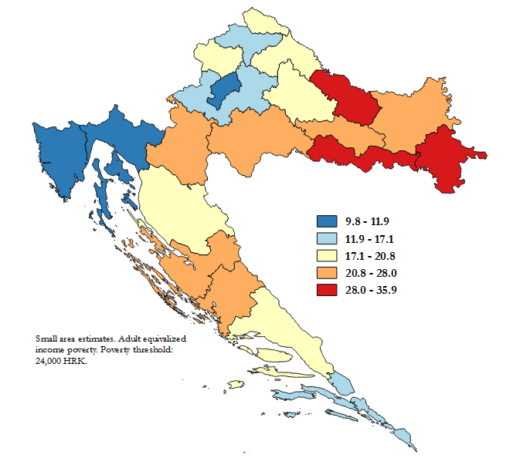

**Finally, the distribution of the Republic of Croatia’s population that is at-risk-of-poverty is illustrated in Figure 5. The County with the lowest concentration of poor is in the Adriatic region, Ličko-senjska. The county is one of the least populated in the country, and although it has an at-risk-of-poverty rate which is close to 20 percent it has the fewest poor. On the other hand Grad-Zagreb which is the least poor county in the Republic of Croatia with an at-risk-of-poverty rate close to 10 percent has the third highest concentration of the country’s poor.**

**Figure 4: Poverty Map for the Republic of Croatia (poverty headcount for municipalities, cities, and districts of Zagreb)**

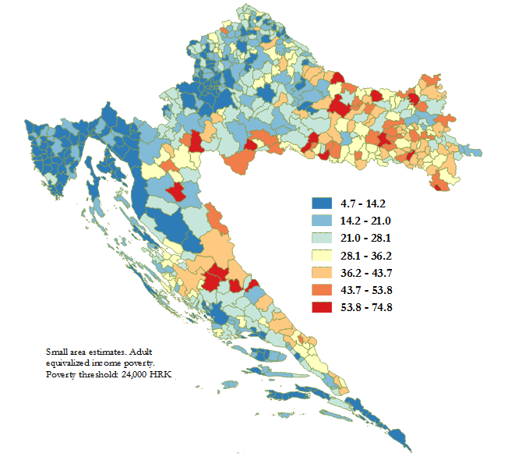

**Table 4: County level poverty estimates**

|  |  |  |  |  |  |  |  |  |
| --- | --- | --- | --- | --- | --- | --- | --- | --- |
|  | **EU-SILC direct estimates** | | |  | **H3-EB Model prediction** | | | |
| **Statistical Area** | **AROP** | **95% CI** | | **NUTS-3 (counties)** | **Population** | **AROP** | **95% CI** | |
| **Northwestern** | 16.7% | 13.6% | 20.4% | Zagrebačka | 311,918 | 16.7% | 13.9% | 19.5% |
| Krapinsko-zagorska | 129,393 | 18.8% | 15.9% | 21.7% |
| Varaždinska | 170,380 | 17.1% | 14.6% | 19.7% |
| Koprivničko-križevačka | 112,540 | 20.3% | 17.4% | 23.3% |
| Međimurska | 110,888 | 20.8% | 17.5% | 24.0% |
| Grad Zagreb | 772,340 | 9.8% | 8.0% | 11.6% |
| **Central & Eastern** | 29.1% | 26.2% | 32.2% | Sisačko-moslavačka | 168,534 | 23.7% | 19.6% | 27.8% |
| Karlovačka | 125,722 | 23.2% | 19.4% | 27.1% |
| Bjelovarsko-bilogorska | 117,420 | 20.0% | 15.6% | 24.5% |
| Virovitičko-podravska | 83,129 | 33.4% | 28.7% | 38.2% |
| Požeško-slavonska | 75,912 | 26.5% | 21.1% | 31.9% |
| Brodsko-posavska | 154,863 | 35.9% | 31.6% | 40.1% |
| Osječko-baranjska | 297,230 | 28.0% | 24.8% | 31.1% |
| Vukovarsko-srijemska | 174,324 | 31.9% | 28.4% | 35.3% |
| **Adriatic** | 17.0% | 14.0% | 20.6% | Primorsko-goranska | 290,446 | 11.9% | 10.0% | 13.8% |
| Ličko-senjska | 49,766 | 19.8% | 15.7% | 24.0% |
| Zadarska | 167,029 | 25.2% | 20.9% | 29.5% |
| Šibensko-kninska | 107,345 | 24.7% | 20.7% | 28.8% |
| Splitsko-dalmatinska | 445,049 | 19.5% | 16.9% | 22.0% |
| Istarska | 204,025 | 11.9% | 9.6% | 14.1% |
| Dubrovačko-neretvanska | 118,707 | 14.5% | 11.3% | 17.8% |
| **Republic of Croatia** | 20.4% | 18.5% | 22.4% |  | 4,186,960 | 19.2% | 18.0% | 20.4% |
| Note: Poverty line is at 24,000 HRK per adult equivalent | | | | |  |  |  |  |

**Figure 5: Distribution of the poor by NUTS-3 spatial units for the Republic of Croatia**

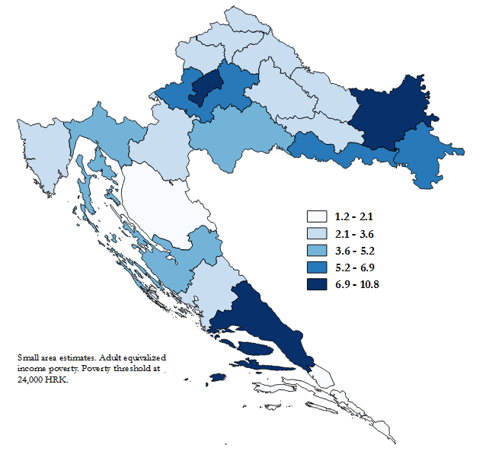

# **The use of poverty maps**

## **Local** indicators of spatial association of poverty

Using the poverty map output we seek to determine if there is a pattern to how poverty rates of municipalities, cities, and districts of Zagreb are distributed within the Republic of Croatia. When analyzing geographical data it is assumed that things that are closer are more related to things that are farther away (Tobler, 1970). This supposes that two municipalities that are closer together will be more alike than municipalities which are farther away.

As noted in Section 5 and in Figure 4, there appears to be some spatial clustering in the results from the poverty maps. In fact the Central and Eastern statistical area seems to be lagging behind the Adriatic and Northwest. This illustrates a divergence within the Continental NUTS-2 region. Poverty rates in Central and Eastern regions are considerably greater than the rest of the country, and the region appears to be a hotspot for poverty. Furthermore, there appears to be a clear demarcation of low versus high poverty areas. Insofar as determining if there is in fact spatial correlation we rely on Global Moran’s I as well as Local Moran’s I statistic.

In order to obtain undertake analysis of spatial association it is necessary to establish a degree of spatial proximity between the locations in Croatia. In order to do this, a spatial weights matrix is used, which relies on the row-standardized inverse distances between the center of the municipalities and the surrounding municipalities. This ensures that nearer neighbors have a greater influence on the analyzed outcomes, in this instance poverty rates.

The presence of spatial association is confirmed by a global Moran’s I index of 0.52 which is significant at the 1 percent level. Local Moran’s I can aide in identifying which localities have a statistically significant relationship with its neighbors. Spatial autocorrelation facilitates the identification of high poverty areas noted in the map presented in Figure 4 **(particularly in the Central and Eastern statistical area within the Continental NUTS-2)**, as well as low poverty areas (**around Zagreb and the surrounding areas of Istarska**). These results bring to light the challenges that arise for regional development, and add a new layer to the discussion.

Figure 6 presents the results for the Global and Local Moran’s I statistics. The significant Global Moran’s I of 0.52 suggest that there is spatial autocorrelation. **Additionally, the map illustrates regions which are significantly different from their neighbors, and regions which are high-poverty areas and low poverty areas. All colored areas show a significant relationship to their neighbors. Those locations marked as “High – High” (“Low-Low”) are areas where poverty is significantly greater (lower) than the neighborhood’s poverty and are greater (lower) than the average poverty among municipalities, cities and districts of Zagreb.**

**A cluster of high poverty is clearly delineated in the Eastern Central statistical area (Figure 6 and 7). In Zagreb and surrounding areas a cluster of low poverty is highlighted, the same holds true for the north of the Adriatic region. Municipalities, cities, and/or districts of Zagreb marked as low-high outliers and the high-low outliers are particularly of interest. While poverty may be high (low) in particular areas, there are some municipalities that have a significantly lower (higher) level of poverty than its surroundings. These are mostly observed in the Adriatic and Eastern Central areas.**

**The hot spot analysis in Figure 8, brings to light a demarcation and separation between regions. This was also evident in the results from the OLS and GLS (see Table 2). All three statistical areas are different. Independently from the NUTS-2 classification which aggregates the Northwestern statistical area and the Eastern and Central statistical area, when it comes to welfare these areas are considerably different.**

**Figure 6: Poverty Map for the Republic of Croatia (Spatial association of headcount poverty)**

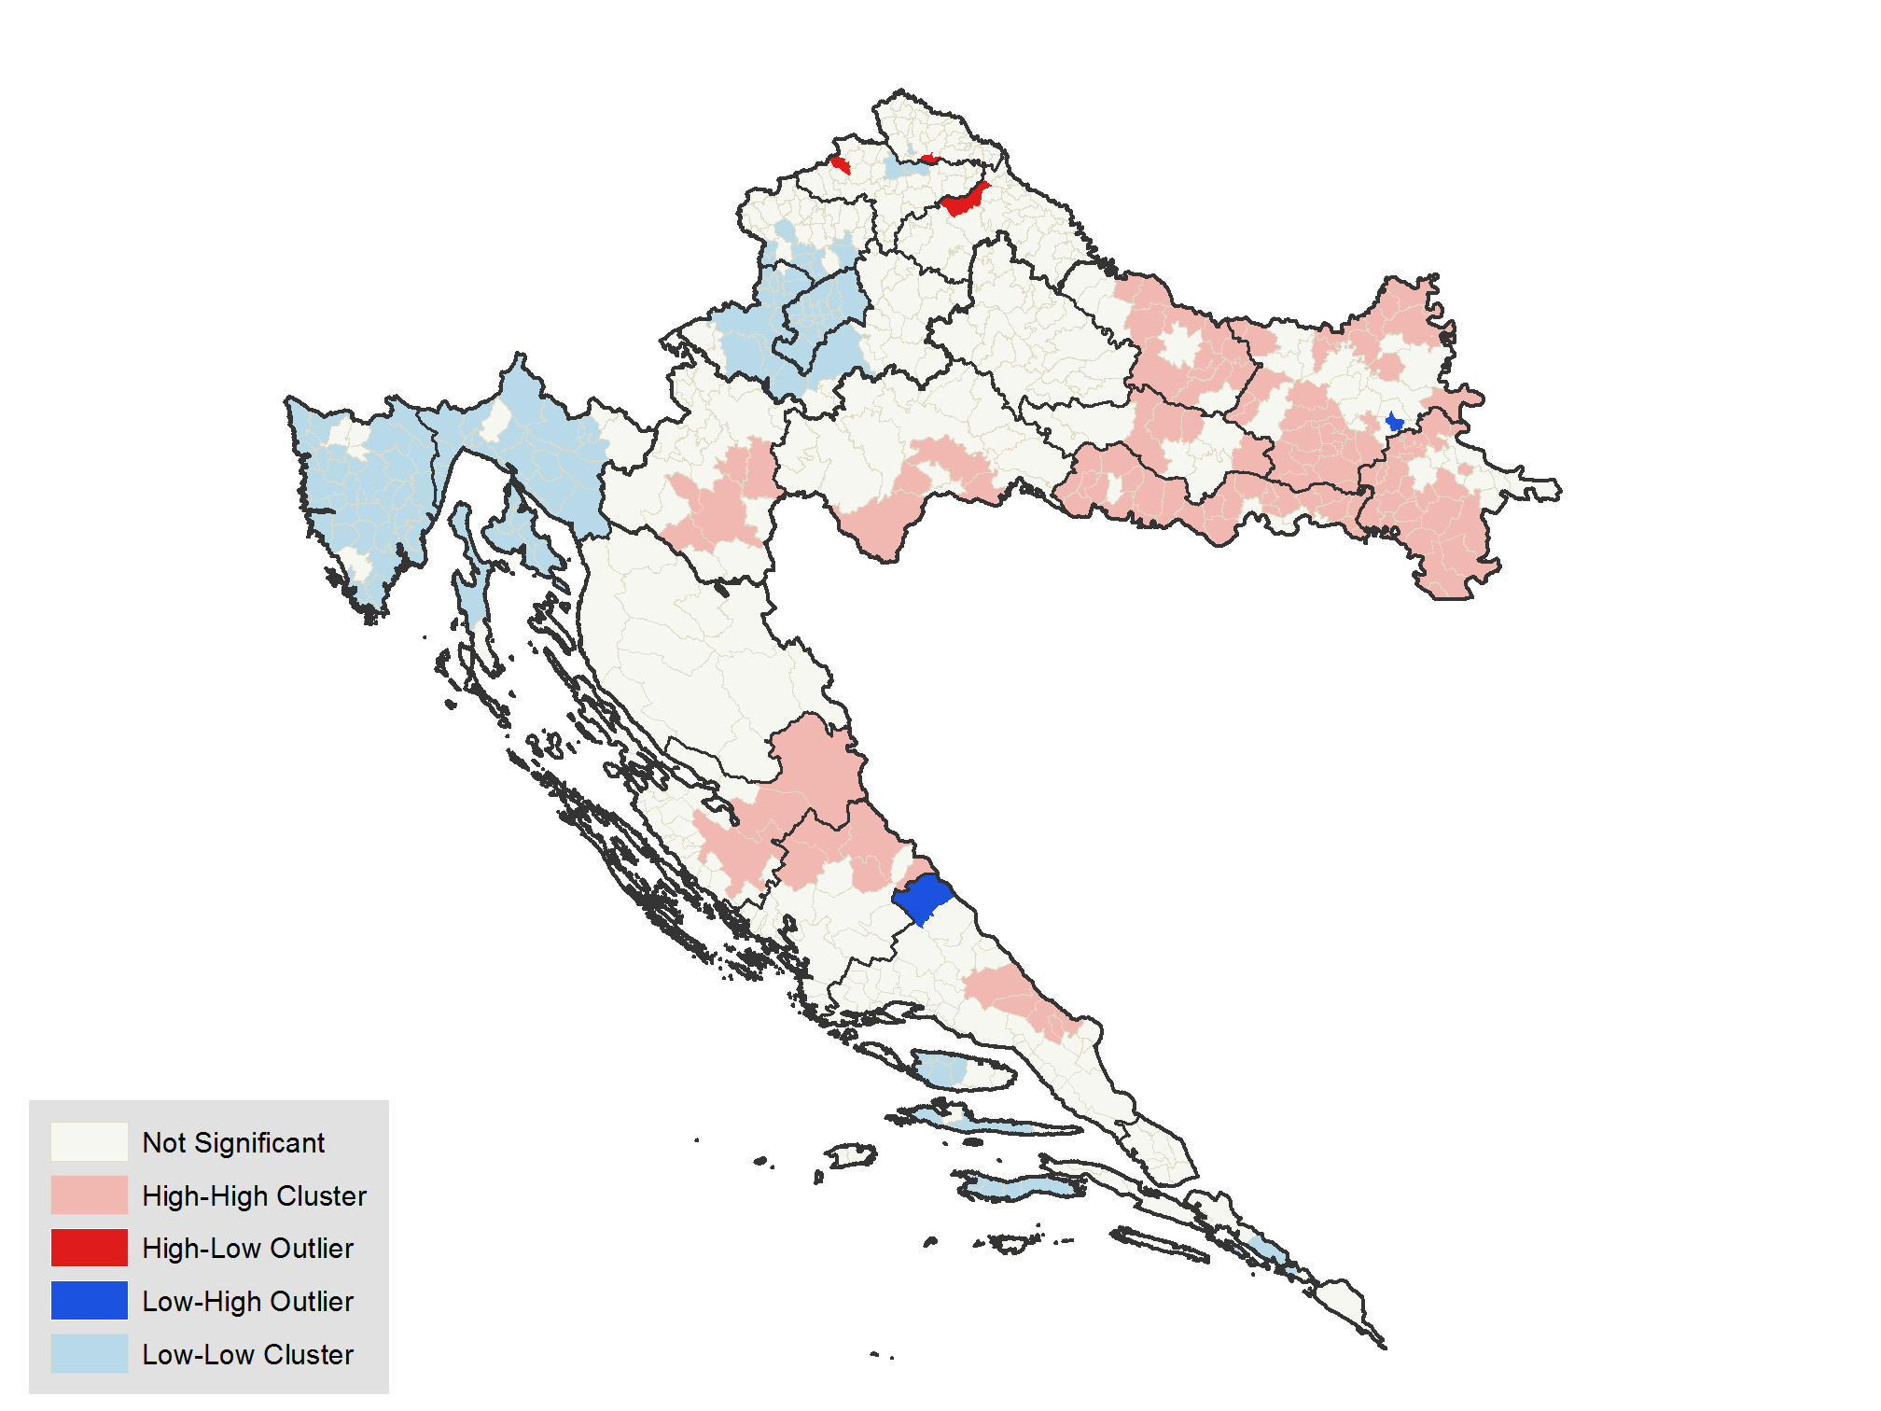

**Figure 7: Poverty Map for the Republic of Croatia: hot spot analysis (Getis-Ord Gi)**

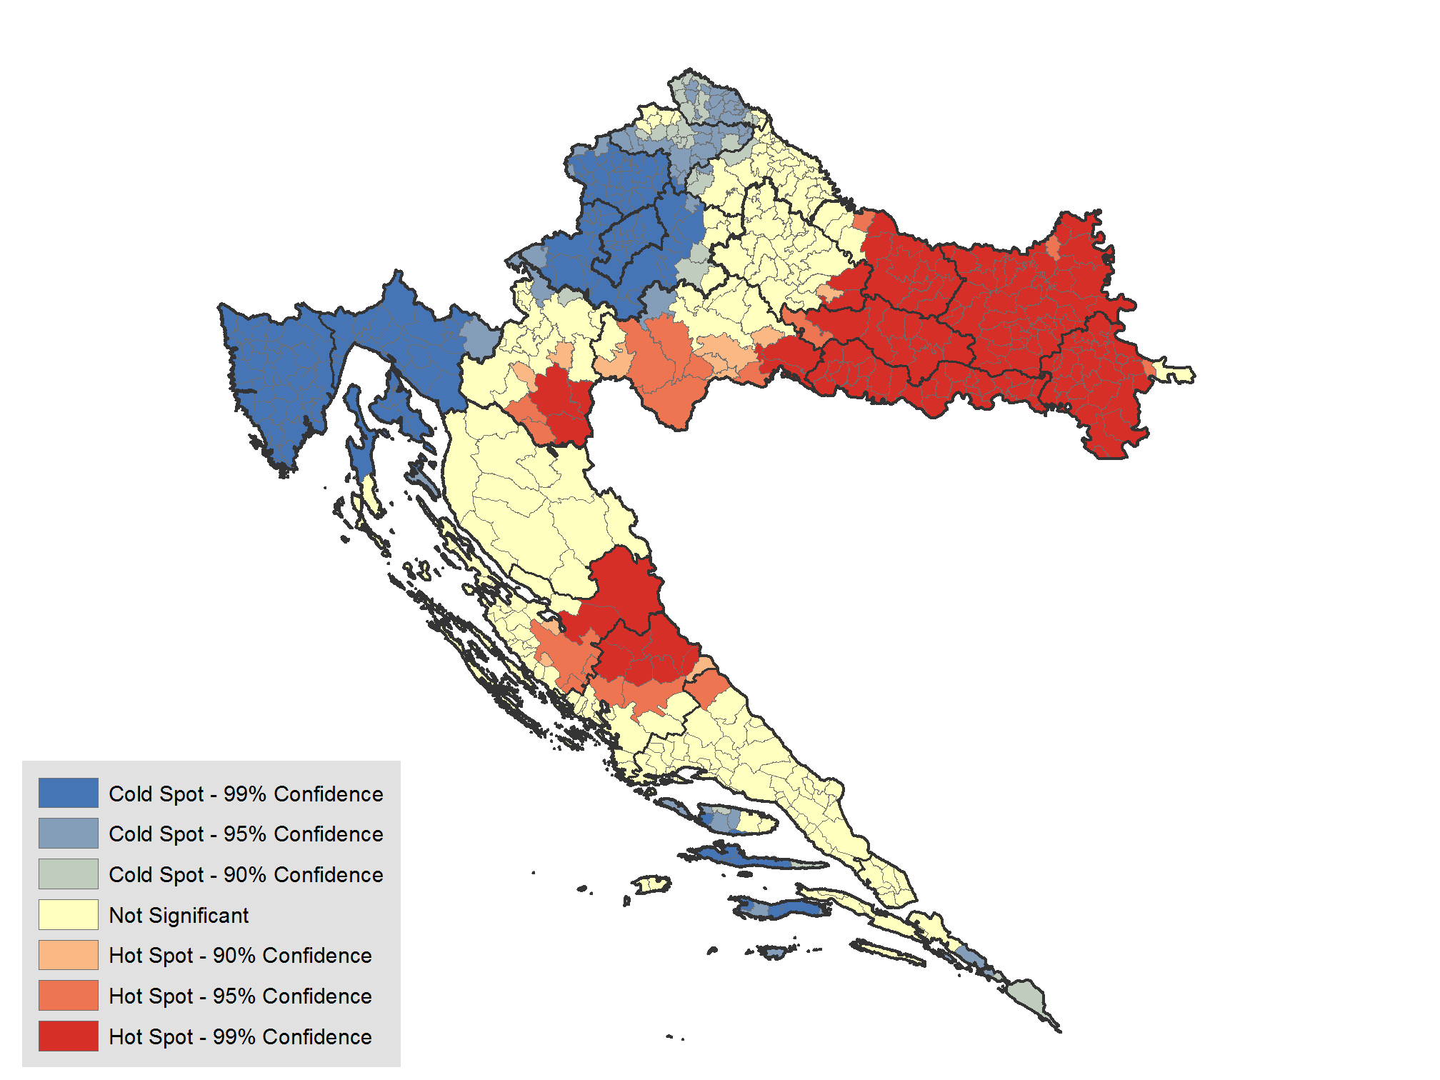

# **Concluding remarks**

Direct poverty estimates from the EU-SILC are only reliable at the statistical area level, and thus at the NUTS-2 level. This complicates the analysis of poverty at more disaggregated levels since the reliability of direct estimates are questionable. Data from the Census of Population, Households and Dwellings 2011 coupled with small area estimation techniques aide policy makers overcome the lack of precision at lower geographical levels. The results from the poverty mapping exercise, coupled with spatial analysis reveal the heterogeneity of poverty in Croatia.

Results from spatial analysis reveal that there is a cluster of high poverty in the Central and Eastern region of Croatia. There is a clear poverty demarcation in the country, where the Central and Eastern part of the country is clearly doing worse than the rest of the country. Results also reveal that while the Continental NUTS-2 spatial unit, may seem poorer than the Adriatic, the result is mainly driven by the aggregation of the two statistical regions (Northwest, and the Central and Eastern statistical regions).

The use of the poverty map in order to assist in the guidance of resource allocation can help policy makers achieve considerable gains in poverty reduction. Additionally, the visual format of the maps is simple to understand which makes it easy for the population at large to take notice of where their community stands compared to the rest of the country. Moreover, because the maps are based on established data sets, these are objective. As a consequence the maps may help prevent subjective decision making. Given the mentioned uses of the poverty maps these are valuable component of the policy maker’s tool kit when trying to decide where limited funds can be distributed among the population which needs assistance.

# **References**

Baric, M., & Williams, C. (2015). Tackling the undeclared economy in Croatia. South-Eastern Europe Journal of Economics, 11(1).

Bedi, T., Coudouel, A., & Simler, K. (Eds.). (2007). More than a pretty picture: using poverty maps to design better policies and interventions. World Bank Publications.

Elbers, C., Lanjouw, J. O., & Lanjouw, P. (2002). Micro-level estimation of welfare. World Bank Policy Research Working Paper, (2911)

Elbers, C., Lanjouw, J. O., & Lanjouw, P. (2003). Micro–level estimation of poverty and inequality. Econometrica, 71(1), 355-364.

Elbers, C., Fujii, T., Lanjouw, P., Özler, B., & Yin, W. (2007). Poverty alleviation through geographic targeting: How much does disaggregation help?. Journal of Development Economics, 83(1), 198-213.

Guadarrama, M., Molina, I., & Rao, J. N. K. (2016). A Comparison of Small Area Estimation Methods for Poverty Mapping. STATISTICS IN TRANSITION new series and SURVEY METHODOLOGY, 41.

Tobler, W. R. (1970). A computer movie simulating urban growth in the Detroit region. Economic geography, 46(sup1), 234-240.

Van der Weide, R. (2014). GLS estimation and empirical bayes prediction for linear mixed models with Heteroskedasticity and sampling weights: a background study for the POVMAP project. World Bank Policy Research Working Paper, (7028).

# **Appendix**

## Mathematical appendix

The discussion below presents the methodology detailed by ELL (2002 and 2003). Interested reader should refer to these documents for the full discussion.

From the estimation of equation 1 we obtain the residuals *u*ˆ*ch* , and by defining *u*ˆ*c.* as the weighted average of *u*ˆ*ch* for a specific cluster we can obtain *e*ˆ*ch* :



The variance of the location effect () is given by:

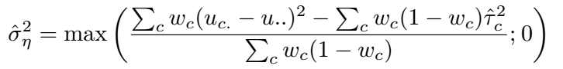

where (where the represents the cluster’s weight) and:

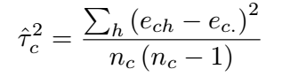

where ( is the number of households in the cluster). The parametric from of heteroscedasticity is presented as:

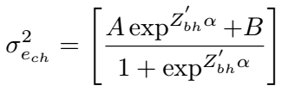

This is simplified by setting and , which leads to the simpler form that can be estimated via regular OLS:

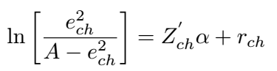

By defining and using the delta method the household specific variance for is equal to:

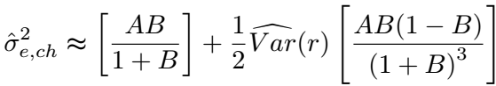

The use of and allows us to get the variance covariance matrix used for the OLS estimates:

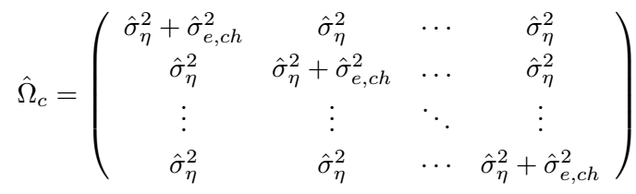

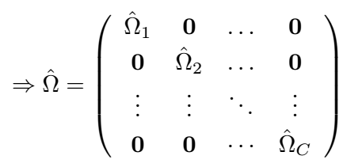

The estimates for the GLS detailed by ELL (2003) are:



and



In response to criticisms of the methodology an extensive revision was made to the methods, including the addition of empirical best estimation, by Van der Weide (2014). For a detailed discussion on the EB approach and the other changes implemented readers are guided towards Van der Weide (2014).

The revisions include an improved GLS estimator:



and a new variance covariance matrix:



These are the estimates used for the second stage of the estimation (detailed in the methods section).

## **Poverty mapping software**

One of the most common small area methods used for poverty mapping was proposed by Elbers, Lanjouw, and Lanjouw (2003). This methodology has been widely adopted by the World Bank and has been applied in numerous poverty maps conducted by the institution. In its eﬀorts to make the implementation of the ELL methodology as simple as possible, the World Bank created a software package that could be easily used by anyone. The software, PovMap (Zhao, 2006), has proven to be an invaluable resource for the World Bank as well as for many statistical agencies seeking to create their own poverty maps. The software is freely available and has a graphical user interface which simplifies its use.

Poverty map results produced in this document have all made use of the PovMap software. The PovMap software can be downloaded, free of charge, at <http://iresearch.worldbank.org/PovMap/PovMap2/>.

## **Additionaltables and graphs**

**Table 1A: Population weighted candidate variable means in Census and EU-SILC at the Statistical Area levels**

|  |  |  |  |  |  |  |
| --- | --- | --- | --- | --- | --- | --- |
|  | Northwest | | Central & Eastern | | Adriatic | |
| **Variable name** | **Census** | **EU-SILC** | **Census** | **EU-SILC** | **Census** | **EU-SILC** |
| Male | 0.4777 | 0.4771 | 0.4843 | 0.4832 | 0.4873 | 0.4870 |
| Age [0,5) | 0.0515 | 0.0442 | 0.0476 | 0.0512 | 0.0483 | 0.0400 |
| Age [5,15) | 0.1021 | 0.1079 | 0.1082 | 0.1050 | 0.0992 | 0.1059 |
| Age [15,30) | 0.1872 | 0.1873 | 0.1897 | 0.1897 | 0.1817 | 0.1817 |
| Age [30,65) | 0.4937 | 0.4964 | 0.4764 | 0.4801 | 0.4899 | 0.4920 |
| Age [65+) | 0.1655 | 0.1642 | 0.1782 | 0.1740 | 0.1810 | 0.1805 |
| **Household size (Share of individuals living in household type)** | | | |  |  |  |
| Households size of 1 | 0.086 | 0.087 | 0.086 | 0.087 | 0.088 | 0.090 |
| Households size of 2 | 0.175 | 0.173 | 0.181 | 0.183 | 0.195 | 0.196 |
| Households size of 3 | 0.200 | 0.199 | 0.189 | 0.189 | 0.215 | 0.217 |
| Households size of 4 | 0.243 | 0.244 | 0.237 | 0.238 | 0.260 | 0.257 |
| Households size of 5 | 0.144 | 0.143 | 0.154 | 0.147 | 0.133 | 0.140 |
| Households size of 6 | 0.083 | 0.089 | 0.085 | 0.081 | 0.061 | 0.046 |
| Household size of 7 or more | 0.070 | 0.065 | 0.067 | 0.074 | 0.047 | 0.053 |
| **Occupation (15-64) (Share of individuals in households with at least one member)** | | | | | |  |
| Manager | 0.066 | 0.032 | 0.031 | 0.015 | 0.052 | 0.048 |
| Professionals | 0.188 | 0.173 | 0.107 | 0.103 | 0.145 | 0.140 |
| Technicians | 0.214 | 0.151 | 0.140 | 0.095 | 0.183 | 0.140 |
| Clerical support | 0.150 | 0.129 | 0.103 | 0.072 | 0.127 | 0.145 |
| Service and sales | 0.220 | 0.192 | 0.192 | 0.187 | 0.254 | 0.263 |
| Skilled agriculture | 0.035 | 0.037 | 0.064 | 0.106 | 0.025 | 0.021 |
| Craft and trade | 0.169 | 0.202 | 0.145 | 0.151 | 0.140 | 0.141 |
| Machine operators | 0.122 | 0.135 | 0.118 | 0.112 | 0.093 | 0.099 |
| Elementary occs. | 0.090 | 0.067 | 0.103 | 0.069 | 0.081 | 0.080 |
| **Labor status, age 15-64 (Share of individuals in households with at least one member)** | | | | | |  |
| Employed | 0.793 | 0.762 | 0.689 | 0.671 | 0.732 | 0.727 |
| Retired | 0.497 | 0.513 | 0.515 | 0.527 | 0.492 | 0.470 |
| Student | 0.223 | 0.226 | 0.220 | 0.192 | 0.221 | 0.216 |
| Disabled | 0.036 | 0.016 | 0.052 | 0.045 | 0.030 | 0.016 |
| Other | 0.727 | 0.725 | 0.794 | 0.754 | 0.745 | 0.703 |
| **Industry, age 15-64 (Share of individuals in households with at least one member)** | | | | | |  |
| Agriculture, mining, and fishing | 0.052 | 0.047 | 0.112 | 0.130 | 0.041 | 0.040 |
| Manufacturing | 0.225 | 0.241 | 0.191 | 0.177 | 0.147 | 0.158 |
| Services and Sales | 0.684 | 0.605 | 0.532 | 0.469 | 0.655 | 0.624 |
| **Share of members with education in HH (age 15-64)** | | |  |  |  |  |
| Primary education | 0.075 | 0.067 | 0.107 | 0.074 | 0.081 | 0.074 |
| Lower secondary | 0.184 | 0.195 | 0.263 | 0.252 | 0.162 | 0.149 |
| Upper secondary | 0.536 | 0.569 | 0.521 | 0.580 | 0.578 | 0.639 |
| Tertiary education | 0.206 | 0.170 | 0.110 | 0.093 | 0.179 | 0.139 |
| **Dwelling characteristics** |  |  |  |  |  |  |
| Square meters | 90.711 | 87.120 | 92.523 | 95.296 | 83.187 | 85.564 |

**Table A2: Alpha model**

|  |  |  |
| --- | --- | --- |
|  | Coeff. | Std Err. |
| 1 Retiree | -0.2663** | 0.1066 |
| No service sector workers | 0.3921*** | 0.1407 |
| 1 working person | -0.289** | 0.147 |
| 2 working persons | -0.2543** | 0.1208 |
| Constant | -5.5976*** | 0.1786 |
|  |  |  |
| Adj. R2 | 0.0019 |  |
| Observations | 2,229 |  |

**Figure A1: NUTS 3 Poverty estimates and 95% confidence intervals**



**Figure A2: Poverty in the districts of Zagreb**

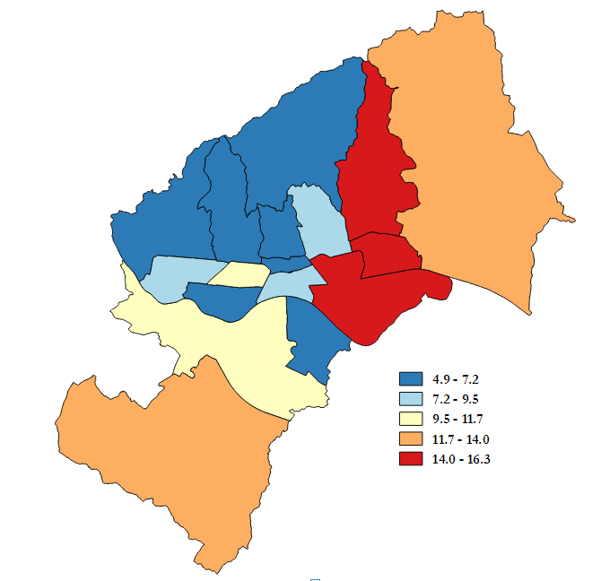

**Table 3A: Poverty indicators by LAU-2**

| **Location** | **Population** | **Head count poverty** | **Std. Err. Head count poverty** | **Poverty Gap** | **Std. Err. Poverty Gap** | **Poverty Gap Sq.** | **Std. Err. Poverty Gap Sq.** | **Share of poor** |
| --- | --- | --- | --- | --- | --- | --- | --- | --- |
| Donji Grad | 35,609 | 6.90 | 1.60 | 1.60 | 0.40 | 0.50 | 0.20 | 0.30 |
| Gornji Grad-Medvešèak | 29,750 | 5.50 | 1.80 | 1.20 | 0.40 | 0.40 | 0.20 | 0.20 |
| Trnje | 41,021 | 7.30 | 1.60 | 1.70 | 0.40 | 0.60 | 0.20 | 0.30 |
| Maksimir | 47,362 | 7.50 | 2.40 | 1.70 | 0.60 | 0.60 | 0.20 | 0.40 |
| Pešæenica-Žitnjak | 55,057 | 16.00 | 3.20 | 4.40 | 1.00 | 1.80 | 0.40 | 1.00 |
| Novi Zagreb-istok | 58,052 | 6.60 | 1.70 | 1.40 | 0.40 | 0.50 | 0.20 | 0.40 |
| Novi Zagreb-zapad | 56,647 | 10.40 | 2.30 | 2.50 | 0.60 | 0.90 | 0.30 | 0.70 |
| Trešnjevka-sjever | 54,197 | 9.90 | 2.60 | 2.40 | 0.70 | 0.90 | 0.30 | 0.60 |
| Trešnjevka-jug | 65,555 | 6.80 | 1.70 | 1.50 | 0.40 | 0.50 | 0.20 | 0.50 |
| Èrnomerec | 37,577 | 6.80 | 2.20 | 1.50 | 0.60 | 0.50 | 0.20 | 0.30 |
| Gornja Dubrava | 60,882 | 16.10 | 3.90 | 4.20 | 1.20 | 1.70 | 0.50 | 1.10 |
| Donja Dubrava | 35,871 | 16.30 | 3.50 | 4.30 | 1.10 | 1.80 | 0.50 | 0.70 |
| Stenjevec | 50,678 | 8.70 | 2.20 | 2.10 | 0.60 | 0.80 | 0.20 | 0.50 |
| Podsused-Vrapèe | 44,580 | 6.80 | 1.40 | 1.50 | 0.40 | 0.50 | 0.10 | 0.30 |
| Podsljeme | 18,858 | 4.90 | 1.50 | 1.10 | 0.40 | 0.40 | 0.10 | 0.10 |
| Sesvete | 68,924 | 12.70 | 6.80 | 3.30 | 2.00 | 1.30 | 0.90 | 1.00 |
| Brezovica | 11,720 | 12.30 | 3.80 | 2.90 | 1.10 | 1.10 | 0.40 | 0.20 |
| **Grad Zagreb** | **772,340** | **9.80** | **0.90** | **2.40** | **0.30** | **0.90** | **0.10** | **8.60** |
| Andrijaševci | 4,020 | 37.50 | 8.90 | 11.10 | 3.20 | 4.80 | 1.60 | 0.20 |
| Antunovac | 3,610 | 21.30 | 7.80 | 5.70 | 2.50 | 2.30 | 1.10 | 0.10 |
| Babina Greda | 3,516 | 42.60 | 10.90 | 13.10 | 4.20 | 5.70 | 2.10 | 0.20 |
| Bakar | 8,211 | 16.00 | 4.80 | 4.00 | 1.40 | 1.50 | 0.60 | 0.10 |
| Bale - Valle | 1,125 | 13.80 | 4.80 | 3.30 | 1.30 | 1.20 | 0.50 | 0.00 |
| Barban | 2,688 | 10.70 | 5.80 | 2.50 | 1.70 | 0.90 | 0.70 | 0.00 |
| Barilović | 2,967 | 23.90 | 8.60 | 6.60 | 2.80 | 2.70 | 1.30 | 0.10 |
| Baška | 1,658 | 12.60 | 4.90 | 2.90 | 1.40 | 1.00 | 0.60 | 0.00 |
| Baška Voda | 2,773 | 21.60 | 6.30 | 5.70 | 1.90 | 2.20 | 0.80 | 0.10 |
| Bebrina | 3,185 | 40.30 | 10.70 | 12.40 | 4.30 | 5.50 | 2.20 | 0.10 |
| Bedekovčina | 7,759 | 20.00 | 5.50 | 5.30 | 1.70 | 2.10 | 0.80 | 0.20 |
| Bednja | 3,954 | 31.60 | 7.30 | 9.30 | 2.70 | 4.00 | 1.30 | 0.10 |
| Beli Manastir | 9,459 | 32.50 | 6.40 | 10.50 | 2.60 | 4.80 | 1.40 | 0.30 |
| Belica | 3,150 | 12.30 | 5.10 | 2.90 | 1.30 | 1.00 | 0.50 | 0.00 |
| Belišće | 10,509 | 36.20 | 10.20 | 11.60 | 4.00 | 5.30 | 2.10 | 0.40 |
| Benkovac | 10,934 | 42.30 | 8.60 | 13.20 | 3.50 | 5.80 | 1.80 | 0.50 |
| Berek | 1,437 | 39.90 | 10.50 | 13.10 | 4.20 | 6.10 | 2.20 | 0.10 |
| Beretinec | 2,117 | 18.30 | 7.50 | 4.40 | 2.10 | 1.70 | 0.90 | 0.00 |
| Bibinje | 3,969 | 30.30 | 8.50 | 8.50 | 3.00 | 3.50 | 1.50 | 0.10 |
| Bilje | 5,590 | 23.00 | 6.40 | 6.50 | 2.10 | 2.70 | 1.00 | 0.10 |
| Biograd Na Moru | 5,501 | 17.00 | 6.30 | 4.30 | 1.90 | 1.60 | 0.80 | 0.10 |
| Bizovac | 4,456 | 23.00 | 7.00 | 6.00 | 2.20 | 2.40 | 1.00 | 0.10 |
| Bjelovar | 39,061 | 15.80 | 5.00 | 4.20 | 1.60 | 1.70 | 0.70 | 0.70 |
| Blato | 3,460 | 6.00 | 3.10 | 1.10 | 0.70 | 0.40 | 0.20 | 0.00 |
| Bogdanovci | 1,877 | 24.20 | 8.40 | 6.30 | 2.70 | 2.40 | 1.20 | 0.10 |
| Bol | 1,576 | 16.50 | 5.90 | 4.00 | 1.60 | 1.50 | 0.70 | 0.00 |
| Borovo | 4,857 | 41.80 | 7.80 | 13.00 | 3.30 | 5.80 | 1.80 | 0.20 |
| Bosiljevo | 1,253 | 24.70 | 6.30 | 7.00 | 2.20 | 2.90 | 1.10 | 0.00 |
| Bošnjaci | 3,748 | 43.00 | 9.90 | 14.20 | 4.40 | 6.50 | 2.40 | 0.20 |
| Brckovljani | 6,432 | 26.20 | 7.20 | 7.40 | 2.40 | 3.10 | 1.10 | 0.20 |
| Brdovec | 11,048 | 13.70 | 4.00 | 3.30 | 1.10 | 1.20 | 0.40 | 0.20 |
| Brestovac | 3,691 | 40.20 | 11.60 | 12.20 | 4.50 | 5.20 | 2.20 | 0.20 |
| Breznica | 2,188 | 27.70 | 9.40 | 7.60 | 3.10 | 3.10 | 1.40 | 0.10 |
| Brinje | 3,180 | 33.30 | 7.30 | 9.70 | 2.70 | 4.10 | 1.40 | 0.10 |
| Brod Moravice | 849 | 20.30 | 5.60 | 7.00 | 2.10 | 3.50 | 1.20 | 0.00 |
| Brodski Stupnik | 2,950 | 47.20 | 15.10 | 15.40 | 6.60 | 6.90 | 3.50 | 0.20 |
| Brtonigla - Verteneglio | 1,622 | 14.60 | 5.90 | 3.30 | 1.50 | 1.20 | 0.60 | 0.00 |
| Budinščina | 2,390 | 36.10 | 10.70 | 10.50 | 3.90 | 4.40 | 1.90 | 0.10 |
| Buje - Buie | 5,102 | 10.70 | 4.40 | 2.50 | 1.20 | 0.90 | 0.50 | 0.10 |
| Buzet | 6,048 | 6.90 | 3.40 | 1.50 | 0.90 | 0.50 | 0.30 | 0.00 |
| Cerna | 4,489 | 37.30 | 8.00 | 11.20 | 3.10 | 4.80 | 1.50 | 0.20 |
| Cernik | 3,562 | 40.10 | 9.40 | 12.40 | 3.90 | 5.40 | 2.00 | 0.20 |
| Cerovlje | 1,650 | 12.20 | 5.50 | 2.70 | 1.30 | 1.00 | 0.50 | 0.00 |
| Cestica | 5,504 | 34.90 | 6.90 | 10.70 | 2.40 | 4.90 | 1.20 | 0.20 |
| Cetingrad | 1,921 | 32.10 | 11.00 | 9.40 | 4.20 | 3.90 | 2.10 | 0.10 |
| Cista Provo | 2,310 | 42.40 | 11.40 | 13.10 | 4.70 | 5.70 | 2.40 | 0.10 |
| Civljane | 226 | 64.00 | 13.30 | 22.50 | 7.00 | 10.60 | 4.00 | 0.00 |
| Cres | 2,777 | 10.70 | 4.60 | 2.40 | 1.20 | 0.80 | 0.50 | 0.00 |
| Crikvenica | 10,947 | 13.00 | 2.80 | 3.10 | 0.80 | 1.20 | 0.30 | 0.20 |
| Crnac | 1,445 | 41.80 | 8.80 | 12.80 | 3.70 | 5.50 | 1.90 | 0.10 |
| Čabar | 3,748 | 4.70 | 3.70 | 0.90 | 0.90 | 0.30 | 0.30 | 0.00 |
| Čačinci | 2,758 | 37.90 | 8.80 | 11.30 | 3.30 | 4.80 | 1.60 | 0.10 |
| Čađavica | 1,983 | 33.90 | 10.60 | 9.70 | 3.80 | 4.00 | 1.80 | 0.10 |
| Čaglin | 2,363 | 46.30 | 9.80 | 15.20 | 4.40 | 6.90 | 2.40 | 0.10 |
| Čakovec | 26,422 | 17.20 | 3.10 | 5.30 | 1.00 | 2.50 | 0.50 | 0.50 |
| Čavle | 7,071 | 12.20 | 4.10 | 2.90 | 1.10 | 1.00 | 0.50 | 0.10 |
| Čazma | 7,926 | 13.20 | 4.20 | 3.20 | 1.10 | 1.20 | 0.40 | 0.10 |
| Čeminac | 2,780 | 27.40 | 6.80 | 7.30 | 2.20 | 2.90 | 1.00 | 0.10 |
| Čepin | 11,299 | 19.50 | 6.50 | 5.10 | 2.00 | 2.00 | 0.90 | 0.30 |
| Darda | 6,746 | 45.50 | 8.40 | 16.00 | 3.70 | 7.80 | 2.10 | 0.30 |
| Daruvar | 11,482 | 10.80 | 3.40 | 2.50 | 0.90 | 0.90 | 0.30 | 0.10 |
| Davor | 2,967 | 33.70 | 10.20 | 9.60 | 3.70 | 3.90 | 1.80 | 0.10 |
| Delnice | 5,747 | 12.90 | 3.70 | 3.40 | 1.10 | 1.40 | 0.40 | 0.10 |
| Desinić | 2,604 | 26.40 | 9.30 | 7.00 | 2.90 | 2.80 | 1.30 | 0.10 |
| Dežanovac | 2,706 | 37.80 | 13.90 | 11.30 | 5.80 | 4.90 | 3.00 | 0.10 |
| Dicmo | 2,753 | 29.90 | 8.50 | 8.50 | 3.00 | 3.50 | 1.40 | 0.10 |
| Dobrinj | 2,051 | 14.00 | 5.30 | 3.20 | 1.50 | 1.10 | 0.60 | 0.00 |
| Domašinec | 2,217 | 24.70 | 7.60 | 7.40 | 2.50 | 3.30 | 1.20 | 0.10 |
| Brela | 1,698 | 14.50 | 5.30 | 3.50 | 1.50 | 1.30 | 0.60 | 0.00 |
| Donja Dubrava | 1,895 | 17.60 | 6.20 | 4.30 | 1.80 | 1.60 | 0.80 | 0.00 |
| Donja Stubica | 5,375 | 15.00 | 5.10 | 3.70 | 1.40 | 1.40 | 0.60 | 0.10 |
| Donja Voća | 2,392 | 44.60 | 7.20 | 14.30 | 3.00 | 6.40 | 1.60 | 0.10 |
| Donji Andrijevci | 3,666 | 32.30 | 7.70 | 9.50 | 2.90 | 4.00 | 1.40 | 0.10 |
| Donji Kraljevec | 4,527 | 12.90 | 4.80 | 3.00 | 1.30 | 1.10 | 0.50 | 0.10 |
| Donji Kukuruzari | 1,634 | 61.20 | 8.80 | 21.90 | 5.00 | 10.50 | 3.00 | 0.10 |
| Donji Lapac | 2,028 | 47.20 | 11.70 | 15.70 | 5.30 | 7.20 | 2.90 | 0.10 |
| Martijanec | 3,788 | 16.60 | 6.60 | 3.90 | 1.80 | 1.40 | 0.80 | 0.10 |
| Donji Miholjac | 9,275 | 29.30 | 5.70 | 8.20 | 1.90 | 3.40 | 0.90 | 0.30 |
| Muć | 3,838 | 25.50 | 7.10 | 6.60 | 2.30 | 2.50 | 1.00 | 0.10 |
| Proložac | 3,491 | 38.30 | 8.70 | 11.70 | 3.40 | 5.10 | 1.70 | 0.20 |
| Donji Vidovec | 1,378 | 21.10 | 6.00 | 6.10 | 1.90 | 2.60 | 0.90 | 0.00 |
| Draganić | 2,665 | 23.10 | 6.70 | 7.00 | 2.30 | 3.10 | 1.10 | 0.10 |
| Draž | 2,681 | 47.90 | 10.40 | 16.10 | 4.70 | 7.50 | 2.60 | 0.10 |
| Drenovci | 4,969 | 44.60 | 8.90 | 14.60 | 4.00 | 6.60 | 2.10 | 0.30 |
| Drenje | 2,592 | 51.60 | 10.80 | 17.30 | 4.90 | 8.00 | 2.70 | 0.20 |
| Drniš | 7,422 | 22.80 | 6.20 | 5.90 | 2.10 | 2.30 | 0.90 | 0.20 |
| Drnje | 1,832 | 19.20 | 5.80 | 5.90 | 1.90 | 2.70 | 1.00 | 0.00 |
| Dubrava | 5,023 | 31.80 | 9.60 | 8.80 | 3.40 | 3.50 | 1.60 | 0.20 |
| Dubrovnik | 41,417 | 7.80 | 2.30 | 1.80 | 0.60 | 0.60 | 0.20 | 0.40 |
| Duga Resa | 11,120 | 19.00 | 7.00 | 4.90 | 2.30 | 1.90 | 1.00 | 0.20 |
| Dugi Rat | 6,982 | 26.00 | 7.10 | 7.10 | 2.30 | 2.80 | 1.00 | 0.20 |
| Dugo Selo | 17,201 | 16.80 | 4.90 | 4.30 | 1.50 | 1.70 | 0.60 | 0.30 |
| Dvor | 5,478 | 45.20 | 8.10 | 14.80 | 3.70 | 6.70 | 2.00 | 0.30 |
| Đakovo | 26,790 | 30.20 | 6.00 | 8.70 | 2.10 | 3.70 | 1.00 | 0.90 |
| Đelekovec | 1,490 | 18.70 | 5.40 | 4.90 | 1.70 | 1.90 | 0.80 | 0.00 |
| Đulovac | 3,171 | 43.50 | 12.40 | 14.10 | 5.10 | 6.50 | 2.70 | 0.20 |
| Đurđenovac | 6,598 | 36.50 | 7.00 | 10.80 | 2.50 | 4.60 | 1.20 | 0.30 |
| Đurđevac | 8,090 | 23.90 | 5.30 | 7.70 | 1.90 | 3.60 | 1.00 | 0.20 |
| Đurmanec | 4,150 | 17.80 | 6.90 | 4.20 | 2.00 | 1.50 | 0.80 | 0.10 |
| Erdut | 7,108 | 48.30 | 11.70 | 16.00 | 5.20 | 7.30 | 2.80 | 0.40 |
| Ernestinovo | 2,064 | 14.40 | 6.00 | 3.30 | 1.60 | 1.10 | 0.60 | 0.00 |
| Ervenik | 1,098 | 62.80 | 11.00 | 22.70 | 6.00 | 10.80 | 3.50 | 0.10 |
| Farkaševac | 1,889 | 30.90 | 11.30 | 9.40 | 4.10 | 4.20 | 2.00 | 0.10 |
| Ferdinandovac | 1,739 | 22.40 | 9.20 | 6.30 | 2.90 | 2.60 | 1.40 | 0.00 |
| Feričanci | 2,093 | 39.00 | 9.10 | 12.10 | 3.70 | 5.30 | 1.90 | 0.10 |
| Fužine | 1,570 | 10.40 | 4.20 | 2.30 | 1.10 | 0.80 | 0.40 | 0.00 |
| Garčin | 4,729 | 41.70 | 10.30 | 13.30 | 4.10 | 5.90 | 2.10 | 0.20 |
| Garešnica | 10,258 | 26.70 | 5.70 | 7.90 | 2.00 | 3.40 | 1.00 | 0.30 |
| Generalski Stol | 2,586 | 23.90 | 7.10 | 6.10 | 2.10 | 2.40 | 0.90 | 0.10 |
| Glina | 8,757 | 28.10 | 6.30 | 8.10 | 2.20 | 3.40 | 1.10 | 0.30 |
| Gola | 2,389 | 22.90 | 6.80 | 6.00 | 2.00 | 2.40 | 0.90 | 0.10 |
| Goričan | 2,777 | 17.80 | 5.40 | 4.30 | 1.50 | 1.60 | 0.60 | 0.10 |
| Gorjani | 1,564 | 40.10 | 11.00 | 12.10 | 4.20 | 5.20 | 2.00 | 0.10 |
| Gornja Stubica | 5,258 | 23.30 | 6.70 | 6.00 | 2.00 | 2.30 | 0.90 | 0.10 |
| Gornji Bogićevci | 1,957 | 52.60 | 7.50 | 18.70 | 3.70 | 9.00 | 2.20 | 0.10 |
| Gornji Kneginec | 5,252 | 20.70 | 6.10 | 5.30 | 1.80 | 2.00 | 0.70 | 0.10 |
| Gospić | 12,320 | 14.10 | 3.60 | 3.50 | 1.00 | 1.30 | 0.40 | 0.20 |
| Gračac | 4,661 | 43.40 | 8.40 | 13.80 | 3.60 | 6.10 | 1.80 | 0.20 |
| Gračišće | 1,416 | 11.50 | 4.70 | 2.60 | 1.20 | 0.90 | 0.50 | 0.00 |
| Gradac | 3,237 | 25.80 | 9.00 | 7.30 | 3.10 | 3.00 | 1.50 | 0.10 |
| Gradec | 3,601 | 25.70 | 7.80 | 7.10 | 2.60 | 2.90 | 1.20 | 0.10 |
| Gradina | 3,799 | 55.60 | 9.20 | 19.20 | 4.60 | 9.00 | 2.60 | 0.20 |
| Gradište | 2,627 | 34.20 | 8.00 | 10.00 | 3.00 | 4.20 | 1.50 | 0.10 |
| Grožnjan - Grisignana | 733 | 19.10 | 5.40 | 4.60 | 1.60 | 1.70 | 0.70 | 0.00 |
| Grubišno Polje | 6,383 | 19.40 | 4.20 | 5.30 | 1.30 | 2.10 | 0.60 | 0.10 |
| Gundinci | 2,013 | 58.50 | 11.40 | 20.50 | 5.80 | 9.70 | 3.30 | 0.10 |
| Gunja | 3,637 | 60.30 | 8.20 | 23.20 | 4.50 | 11.80 | 2.70 | 0.20 |
| Hercegovac | 2,378 | 15.90 | 6.20 | 4.00 | 1.80 | 1.50 | 0.80 | 0.00 |
| Hlebine | 1,271 | 23.20 | 6.90 | 6.60 | 2.30 | 2.90 | 1.10 | 0.00 |
| Hrašćina | 1,535 | 22.10 | 6.80 | 5.30 | 2.00 | 1.90 | 0.80 | 0.00 |
| Hrvace | 3,595 | 39.60 | 10.80 | 11.80 | 4.20 | 5.00 | 2.10 | 0.20 |
| Hrvatska Dubica | 2,070 | 47.60 | 8.10 | 15.60 | 3.60 | 7.00 | 2.00 | 0.10 |
| Hrvatska Kostajnica | 2,734 | 27.40 | 7.80 | 7.40 | 2.70 | 2.90 | 1.30 | 0.10 |
| Breznički Hum | 1,314 | 25.00 | 9.20 | 6.70 | 2.90 | 2.60 | 1.30 | 0.00 |
| Hum Na Sutli | 4,851 | 11.80 | 5.70 | 2.80 | 1.60 | 1.00 | 0.70 | 0.10 |
| Hvar | 4,218 | 12.10 | 4.00 | 2.80 | 1.00 | 1.00 | 0.40 | 0.10 |
| Ilok | 6,500 | 19.30 | 5.80 | 5.00 | 1.80 | 1.90 | 0.80 | 0.10 |
| Imotski | 10,671 | 39.20 | 9.20 | 12.70 | 3.80 | 5.70 | 2.00 | 0.50 |
| Ivanec | 13,447 | 16.90 | 3.20 | 4.20 | 0.90 | 1.60 | 0.40 | 0.30 |
| Ivanić-Grad | 14,292 | 20.60 | 4.40 | 5.60 | 1.40 | 2.30 | 0.60 | 0.30 |
| Ivankovo | 7,762 | 36.70 | 6.90 | 10.50 | 2.60 | 4.40 | 1.20 | 0.30 |
| Ivanska | 2,908 | 24.50 | 8.40 | 7.00 | 2.70 | 3.00 | 1.30 | 0.10 |
| Jakovlje | 3,813 | 15.00 | 5.40 | 3.60 | 1.50 | 1.30 | 0.60 | 0.10 |
| Jakšić | 3,986 | 26.70 | 7.50 | 7.50 | 2.60 | 3.10 | 1.20 | 0.10 |
| Jalžabet | 3,120 | 23.40 | 6.50 | 6.20 | 2.00 | 2.50 | 0.90 | 0.10 |
| Jarmina | 2,440 | 31.10 | 9.80 | 8.50 | 3.30 | 3.40 | 1.50 | 0.10 |
| Jasenice | 1,395 | 25.60 | 9.00 | 6.60 | 2.80 | 2.50 | 1.20 | 0.00 |
| Jasenovac | 1,987 | 34.40 | 10.10 | 10.00 | 3.70 | 4.10 | 1.80 | 0.10 |
| Jastrebarsko | 15,625 | 13.10 | 3.90 | 3.20 | 1.10 | 1.20 | 0.40 | 0.20 |
| Jelenje | 5,277 | 19.20 | 6.00 | 4.70 | 1.70 | 1.80 | 0.70 | 0.10 |
| Jelsa | 3,556 | 16.10 | 6.90 | 4.00 | 2.10 | 1.50 | 0.90 | 0.10 |
| Josipdol | 3,723 | 30.00 | 8.80 | 9.10 | 3.10 | 4.10 | 1.50 | 0.10 |
| Kali | 1,628 | 18.90 | 9.00 | 4.50 | 2.80 | 1.60 | 1.20 | 0.00 |
| Kanfanar | 1,541 | 8.10 | 3.60 | 1.80 | 0.90 | 0.60 | 0.40 | 0.00 |
| Kapela | 2,939 | 37.50 | 10.20 | 11.50 | 4.00 | 5.00 | 2.00 | 0.10 |
| Kaptol | 3,446 | 40.20 | 10.00 | 12.70 | 4.00 | 5.60 | 2.00 | 0.20 |
| Karlobag | 915 | 25.90 | 10.30 | 7.00 | 3.70 | 2.80 | 1.70 | 0.00 |
| Karlovac | 54,120 | 18.00 | 2.80 | 4.80 | 0.90 | 1.90 | 0.40 | 1.10 |
| Kastav | 10,346 | 9.20 | 3.40 | 2.10 | 0.90 | 0.70 | 0.30 | 0.10 |
| Kaštela | 38,044 | 20.30 | 5.20 | 5.20 | 1.60 | 2.00 | 0.70 | 0.90 |
| Kijevo | 415 | 24.40 | 8.40 | 5.90 | 2.50 | 2.10 | 1.00 | 0.00 |
| Kistanje | 3,429 | 74.80 | 8.60 | 32.50 | 6.40 | 17.80 | 4.40 | 0.30 |
| Klakar | 2,251 | 29.60 | 8.30 | 8.10 | 2.90 | 3.30 | 1.40 | 0.10 |
| Klana | 1,966 | 9.70 | 4.00 | 2.20 | 1.00 | 0.80 | 0.40 | 0.00 |
| Klanjec | 2,911 | 8.90 | 4.00 | 2.00 | 1.00 | 0.70 | 0.40 | 0.00 |
| Klenovnik | 2,006 | 20.30 | 7.20 | 5.20 | 2.20 | 2.00 | 0.90 | 0.00 |
| Klinča Sela | 5,108 | 14.50 | 6.30 | 3.50 | 1.80 | 1.30 | 0.70 | 0.10 |
| Klis | 4,738 | 23.10 | 5.20 | 6.00 | 1.60 | 2.30 | 0.70 | 0.10 |
| Kloštar Ivanić | 5,990 | 27.50 | 7.70 | 7.70 | 2.70 | 3.20 | 1.30 | 0.20 |
| Kloštar Podravski | 3,200 | 41.00 | 8.30 | 15.40 | 3.70 | 8.00 | 2.10 | 0.10 |
| Kneževi Vinogradi | 4,517 | 41.50 | 9.10 | 13.30 | 3.80 | 6.00 | 2.00 | 0.20 |
| Knin | 15,011 | 42.70 | 7.70 | 14.00 | 3.40 | 6.30 | 1.80 | 0.70 |
| Komiža | 1,519 | 16.30 | 5.40 | 3.90 | 1.50 | 1.40 | 0.60 | 0.00 |
| Konavle | 8,549 | 10.40 | 4.60 | 2.40 | 1.20 | 0.90 | 0.50 | 0.10 |
| Končanica | 2,340 | 11.20 | 6.20 | 2.70 | 1.70 | 1.00 | 0.70 | 0.00 |
| Konjščina | 3,658 | 18.60 | 8.00 | 4.80 | 2.50 | 1.80 | 1.10 | 0.10 |
| Koprivnica | 29,930 | 14.70 | 2.30 | 3.80 | 0.70 | 1.50 | 0.30 | 0.50 |
| Koprivnički Bregi | 2,270 | 20.50 | 4.90 | 5.20 | 1.50 | 2.00 | 0.70 | 0.10 |
| Koprivnički Ivanec | 1,972 | 19.70 | 7.60 | 5.00 | 2.30 | 1.90 | 1.00 | 0.00 |
| Korčula | 5,585 | 12.70 | 5.70 | 2.90 | 1.60 | 1.10 | 0.60 | 0.10 |
| Koška | 3,889 | 34.80 | 8.40 | 10.30 | 3.20 | 4.40 | 1.60 | 0.20 |
| Kotoriba | 3,080 | 25.80 | 5.70 | 9.40 | 2.20 | 4.80 | 1.30 | 0.10 |
| Kraljevec Na Sutli | 1,727 | 10.30 | 4.20 | 2.10 | 1.00 | 0.70 | 0.40 | 0.00 |
| Kraljevica | 4,490 | 11.50 | 3.90 | 2.60 | 1.00 | 0.90 | 0.40 | 0.10 |
| Krapina | 12,105 | 13.00 | 3.90 | 3.10 | 1.00 | 1.20 | 0.40 | 0.20 |
| Krapinske Toplice | 5,249 | 14.00 | 5.60 | 3.50 | 1.60 | 1.30 | 0.70 | 0.10 |
| Križ | 6,794 | 26.90 | 6.20 | 7.30 | 2.00 | 2.90 | 0.90 | 0.20 |
| Križevci | 20,631 | 15.10 | 4.60 | 3.70 | 1.30 | 1.40 | 0.60 | 0.40 |
| Krk | 5,951 | 10.50 | 5.20 | 2.30 | 1.30 | 0.80 | 0.50 | 0.10 |
| Krnjak | 1,826 | 48.20 | 10.50 | 16.20 | 4.80 | 7.50 | 2.70 | 0.10 |
| Kršan | 2,913 | 15.90 | 5.40 | 4.00 | 1.60 | 1.50 | 0.70 | 0.10 |
| Kula Norinska | 1,608 | 37.70 | 9.60 | 11.60 | 3.80 | 5.10 | 2.00 | 0.10 |
| Kutina | 22,337 | 19.70 | 4.00 | 5.50 | 1.30 | 2.30 | 0.60 | 0.50 |
| Kutjevo | 6,165 | 30.70 | 8.50 | 8.70 | 3.00 | 3.60 | 1.40 | 0.20 |
| Labin | 11,497 | 6.70 | 3.10 | 1.40 | 0.80 | 0.50 | 0.30 | 0.10 |
| Lanišće | 328 | 17.80 | 6.90 | 4.00 | 2.00 | 1.40 | 0.90 | 0.00 |
| Lasinja | 1,612 | 15.00 | 6.60 | 3.80 | 1.90 | 1.50 | 0.80 | 0.00 |
| Lastovo | 792 | 16.50 | 7.20 | 4.00 | 2.10 | 1.50 | 0.90 | 0.00 |
| Legrad | 2,185 | 11.80 | 4.60 | 3.00 | 1.30 | 1.10 | 0.50 | 0.00 |
| Lekenik | 5,885 | 22.90 | 6.20 | 6.10 | 1.90 | 2.50 | 0.90 | 0.20 |
| Lepoglava | 7,437 | 22.70 | 6.40 | 6.10 | 2.10 | 2.40 | 1.00 | 0.20 |
| Levanjska Varoš | 1,016 | 60.50 | 9.50 | 23.40 | 5.60 | 11.90 | 3.60 | 0.10 |
| Lipik | 6,002 | 22.50 | 6.40 | 6.10 | 2.10 | 2.40 | 0.90 | 0.20 |
| Lipovljani | 3,450 | 17.50 | 6.30 | 4.30 | 1.80 | 1.60 | 0.80 | 0.10 |
| Lišane Ostrovičke | 686 | 32.30 | 10.00 | 9.70 | 3.90 | 4.20 | 2.00 | 0.00 |
| Ližnjan - Lisignano | 3,806 | 14.10 | 4.60 | 3.40 | 1.30 | 1.30 | 0.50 | 0.10 |
| Lobor | 2,818 | 25.50 | 6.10 | 6.60 | 1.90 | 2.50 | 0.80 | 0.10 |
| Lokve | 1,004 | 15.60 | 5.40 | 3.60 | 1.50 | 1.30 | 0.60 | 0.00 |
| Lovas | 1,207 | 15.70 | 7.50 | 3.80 | 2.10 | 1.40 | 0.90 | 0.00 |
| Lovinac | 995 | 13.20 | 6.30 | 3.30 | 1.80 | 1.30 | 0.80 | 0.00 |
| Lovran | 4,033 | 9.50 | 3.80 | 2.20 | 1.00 | 0.80 | 0.40 | 0.00 |
| Lovreć | 1,691 | 35.10 | 9.80 | 10.50 | 3.80 | 4.50 | 1.90 | 0.10 |
| Ludbreg | 8,223 | 10.70 | 4.20 | 2.60 | 1.10 | 1.00 | 0.50 | 0.10 |
| Lukač | 3,568 | 41.30 | 6.90 | 12.80 | 2.70 | 5.60 | 1.40 | 0.20 |
| Lupoglav | 918 | 13.70 | 6.20 | 3.10 | 1.60 | 1.10 | 0.60 | 0.00 |
| Ljubešćica | 1,837 | 21.80 | 6.20 | 5.60 | 1.90 | 2.20 | 0.80 | 0.00 |
| Mače | 2,511 | 30.60 | 8.00 | 8.20 | 2.80 | 3.30 | 1.30 | 0.10 |
| Makarska | 13,684 | 11.60 | 3.40 | 2.80 | 1.00 | 1.10 | 0.40 | 0.20 |
| Mala Subotica | 5,274 | 24.80 | 4.60 | 9.40 | 1.80 | 5.00 | 1.10 | 0.10 |
| Mali Bukovec | 2,185 | 21.40 | 7.10 | 5.80 | 2.20 | 2.40 | 1.00 | 0.10 |
| Mali Lošinj | 7,916 | 14.70 | 4.50 | 3.40 | 1.20 | 1.20 | 0.50 | 0.10 |
| Malinska-Dubašnica | 3,050 | 13.40 | 5.20 | 3.10 | 1.40 | 1.10 | 0.60 | 0.00 |
| Marčana | 4,199 | 13.70 | 4.00 | 3.30 | 1.10 | 1.20 | 0.50 | 0.10 |
| Marija Bistrica | 5,889 | 18.30 | 4.80 | 4.60 | 1.40 | 1.70 | 0.60 | 0.10 |
| Marijanci | 2,358 | 28.60 | 8.10 | 7.50 | 2.50 | 2.90 | 1.10 | 0.10 |
| Marina | 4,496 | 24.00 | 5.90 | 6.20 | 1.90 | 2.40 | 0.80 | 0.10 |
| Martinska Ves | 3,393 | 26.30 | 7.50 | 7.10 | 2.50 | 2.80 | 1.10 | 0.10 |
| Maruševec | 6,275 | 15.00 | 4.30 | 3.70 | 1.10 | 1.40 | 0.50 | 0.10 |
| Matulji | 11,121 | 11.10 | 4.10 | 2.60 | 1.10 | 1.00 | 0.50 | 0.10 |
| Medulin | 6,374 | 6.20 | 3.20 | 1.40 | 0.80 | 0.50 | 0.30 | 0.00 |
| Metković | 15,956 | 29.00 | 7.20 | 8.40 | 2.50 | 3.50 | 1.20 | 0.50 |
| Mihovljan | 1,921 | 35.00 | 8.10 | 10.10 | 3.00 | 4.20 | 1.40 | 0.10 |
| Mikleuš | 1,449 | 47.60 | 10.30 | 15.40 | 4.60 | 6.90 | 2.50 | 0.10 |
| Milna | 1,022 | 14.50 | 6.30 | 3.40 | 1.80 | 1.20 | 0.70 | 0.00 |
| Mljet | 1,061 | 20.10 | 6.40 | 5.30 | 2.10 | 2.10 | 0.90 | 0.00 |
| Molve | 2,147 | 23.70 | 8.10 | 6.10 | 2.50 | 2.40 | 1.10 | 0.10 |
| Podravska Moslavina | 1,153 | 35.10 | 9.40 | 10.20 | 3.40 | 4.30 | 1.60 | 0.00 |
| Mošćenička Draga | 1,526 | 10.10 | 4.30 | 2.30 | 1.10 | 0.80 | 0.40 | 0.00 |
| Motovun - Montona | 916 | 19.60 | 6.90 | 5.10 | 2.10 | 1.90 | 0.90 | 0.00 |
| Mrkopalj | 1,205 | 12.80 | 5.50 | 2.90 | 1.40 | 1.00 | 0.60 | 0.00 |
| Mursko-Središće | 6,209 | 24.90 | 7.00 | 7.90 | 2.40 | 3.70 | 1.20 | 0.20 |
| Našice | 15,912 | 24.30 | 5.80 | 7.00 | 1.90 | 3.00 | 0.90 | 0.40 |
| Nedelišće | 11,700 | 23.90 | 4.10 | 8.40 | 1.50 | 4.20 | 0.80 | 0.30 |
| Nerežišća | 845 | 13.80 | 5.80 | 3.00 | 1.50 | 1.00 | 0.50 | 0.00 |
| Netretić | 2,791 | 22.20 | 7.30 | 5.70 | 2.20 | 2.20 | 0.90 | 0.10 |
| Nin | 2,710 | 23.00 | 6.90 | 6.00 | 2.40 | 2.30 | 1.10 | 0.10 |
| Nova Bukovica | 1,769 | 50.50 | 9.70 | 17.00 | 4.50 | 7.80 | 2.50 | 0.10 |
| Nova Gradiška | 13,880 | 26.70 | 6.10 | 7.90 | 2.10 | 3.40 | 1.00 | 0.40 |
| Nova Kapela | 4,108 | 35.20 | 9.70 | 10.00 | 3.50 | 4.00 | 1.70 | 0.20 |
| Nova Rača | 3,391 | 20.20 | 7.20 | 5.20 | 2.10 | 2.00 | 0.90 | 0.10 |
| Novalja | 3,613 | 16.20 | 5.30 | 3.80 | 1.40 | 1.40 | 0.60 | 0.10 |
| Novi Marof | 13,103 | 14.20 | 3.80 | 3.40 | 1.00 | 1.30 | 0.40 | 0.20 |
| Novi Vinodolski | 4,976 | 13.90 | 4.30 | 3.40 | 1.20 | 1.30 | 0.50 | 0.10 |
| Novigrad - Cittanova | 4,145 | 9.30 | 3.50 | 2.10 | 0.90 | 0.70 | 0.40 | 0.00 |
| Novigrad Podravski | 2,758 | 32.90 | 7.50 | 10.10 | 2.70 | 4.60 | 1.30 | 0.10 |
| Novska | 13,404 | 25.20 | 7.80 | 7.10 | 2.70 | 2.90 | 1.30 | 0.40 |
| Nuštar | 5,486 | 25.00 | 6.90 | 7.00 | 2.30 | 2.90 | 1.00 | 0.20 |
| Nijemci | 4,643 | 38.30 | 12.30 | 11.80 | 4.80 | 5.20 | 2.40 | 0.20 |
| Obrovac | 4,254 | 43.70 | 9.30 | 14.50 | 4.10 | 6.70 | 2.30 | 0.20 |
| Ogulin | 13,687 | 19.60 | 5.30 | 5.20 | 1.60 | 2.10 | 0.70 | 0.30 |
| Promina | 1,048 | 27.20 | 9.70 | 6.90 | 3.10 | 2.60 | 1.30 | 0.00 |
| Okučani | 3,362 | 63.10 | 10.90 | 24.00 | 6.60 | 12.10 | 4.20 | 0.20 |
| Omiš | 14,654 | 27.10 | 6.70 | 7.50 | 2.30 | 3.00 | 1.00 | 0.50 |
| Omišalj | 2,973 | 14.00 | 4.90 | 3.70 | 1.50 | 1.50 | 0.70 | 0.00 |
| Opatija | 11,369 | 12.40 | 4.00 | 2.90 | 1.10 | 1.10 | 0.40 | 0.20 |
| Oprisavci | 2,481 | 24.70 | 7.30 | 6.50 | 2.20 | 2.60 | 1.00 | 0.10 |
| Oprtalj - Portole | 850 | 19.30 | 7.80 | 5.00 | 2.40 | 1.90 | 1.00 | 0.00 |
| Opuzen | 3,133 | 18.60 | 6.50 | 4.70 | 2.00 | 1.80 | 0.90 | 0.10 |
| Orahovica | 5,090 | 25.40 | 6.70 | 6.90 | 2.30 | 2.80 | 1.00 | 0.10 |
| Orebić | 4,031 | 9.00 | 5.00 | 2.00 | 1.30 | 0.70 | 0.50 | 0.00 |
| Oriovac | 5,719 | 33.50 | 7.80 | 9.80 | 2.90 | 4.20 | 1.40 | 0.20 |
| Biskupija | 1,688 | 56.70 | 11.40 | 18.90 | 5.60 | 8.50 | 3.10 | 0.10 |
| Oroslavje | 6,039 | 14.20 | 4.00 | 3.50 | 1.10 | 1.30 | 0.50 | 0.10 |
| Osijek | 105,841 | 18.30 | 3.20 | 4.90 | 1.00 | 1.90 | 0.40 | 2.20 |
| Otočac | 9,516 | 17.30 | 4.00 | 4.50 | 1.20 | 1.80 | 0.50 | 0.20 |
| Otok | 5,401 | 41.70 | 11.50 | 12.90 | 4.70 | 5.70 | 2.40 | 0.30 |
| Ozalj | 6,537 | 27.00 | 10.40 | 7.40 | 3.30 | 3.00 | 1.50 | 0.20 |
| Pag | 3,802 | 11.30 | 4.60 | 2.50 | 1.20 | 0.90 | 0.40 | 0.00 |
| Pakoštane | 4,090 | 39.90 | 10.50 | 12.50 | 4.40 | 5.50 | 2.30 | 0.20 |
| Pakrac | 8,345 | 24.10 | 5.90 | 6.60 | 2.00 | 2.60 | 0.90 | 0.20 |
| Pašman | 2,069 | 29.00 | 9.60 | 7.80 | 3.30 | 3.10 | 1.50 | 0.10 |
| Pazin | 8,570 | 18.40 | 10.20 | 4.60 | 3.00 | 1.80 | 1.30 | 0.20 |
| Perušić | 2,636 | 25.00 | 8.30 | 7.00 | 2.80 | 2.90 | 1.30 | 0.10 |
| Peteranec | 2,648 | 29.50 | 6.70 | 10.10 | 2.50 | 5.00 | 1.30 | 0.10 |
| Petlovac | 2,350 | 45.70 | 9.00 | 14.60 | 3.90 | 6.50 | 2.00 | 0.10 |
| Petrijanec | 4,695 | 24.10 | 7.20 | 8.40 | 2.50 | 4.30 | 1.40 | 0.10 |
| Petrijevci | 2,761 | 30.20 | 8.30 | 8.50 | 2.80 | 3.50 | 1.30 | 0.10 |
| Petrinja | 23,896 | 19.00 | 4.50 | 5.10 | 1.50 | 2.00 | 0.70 | 0.50 |
| Petrovsko | 2,643 | 25.20 | 8.00 | 6.70 | 2.40 | 2.70 | 1.10 | 0.10 |
| Pićan | 1,805 | 12.60 | 5.40 | 2.80 | 1.40 | 0.90 | 0.50 | 0.00 |
| Pisarovina | 3,661 | 10.40 | 4.70 | 2.40 | 1.20 | 0.90 | 0.50 | 0.00 |
| Pitomača | 9,782 | 40.80 | 6.20 | 13.50 | 2.50 | 6.30 | 1.40 | 0.50 |
| Plaški | 2,057 | 52.40 | 10.20 | 17.10 | 4.80 | 7.70 | 2.60 | 0.10 |
| Pleternica | 11,115 | 28.70 | 8.10 | 8.00 | 2.90 | 3.20 | 1.30 | 0.40 |
| Ploče | 9,776 | 21.00 | 6.20 | 5.50 | 2.00 | 2.10 | 0.90 | 0.20 |
| Podbablje | 4,679 | 35.30 | 6.70 | 10.90 | 2.60 | 4.80 | 1.30 | 0.20 |
| Podcrkavlje | 2,544 | 33.80 | 8.30 | 10.20 | 3.20 | 4.40 | 1.60 | 0.10 |
| Podgora | 2,505 | 25.10 | 6.70 | 6.80 | 2.20 | 2.70 | 1.00 | 0.10 |
| Podgorač | 2,834 | 53.80 | 9.10 | 19.40 | 4.20 | 9.70 | 2.40 | 0.20 |
| Podstrana | 8,932 | 11.40 | 3.40 | 2.80 | 0.90 | 1.10 | 0.40 | 0.10 |
| Podturen | 3,810 | 29.20 | 8.30 | 8.80 | 2.70 | 4.00 | 1.30 | 0.10 |
| Pojezerje | 896 | 38.00 | 11.70 | 10.90 | 4.40 | 4.50 | 2.10 | 0.00 |
| Polača | 1,452 | 31.50 | 9.30 | 8.70 | 3.30 | 3.50 | 1.50 | 0.10 |
| Poličnik | 4,454 | 29.60 | 8.80 | 8.00 | 3.00 | 3.10 | 1.30 | 0.10 |
| Popovac | 2,044 | 43.00 | 9.50 | 14.00 | 4.30 | 6.30 | 2.30 | 0.10 |
| Popovača | 11,394 | 25.70 | 6.00 | 7.70 | 2.10 | 3.40 | 1.00 | 0.30 |
| Poreč - Parenzo | 16,438 | 11.50 | 3.50 | 2.80 | 1.00 | 1.00 | 0.40 | 0.20 |
| Posedarje | 3,565 | 32.50 | 8.70 | 9.20 | 3.10 | 3.80 | 1.40 | 0.10 |
| Postira | 1,542 | 11.80 | 4.40 | 2.70 | 1.20 | 1.00 | 0.50 | 0.00 |
| Požega | 25,406 | 18.80 | 3.80 | 4.90 | 1.20 | 1.90 | 0.50 | 0.50 |
| Pregrada | 6,485 | 24.70 | 6.50 | 6.30 | 2.00 | 2.40 | 0.80 | 0.20 |
| Preko | 3,339 | 17.40 | 5.90 | 4.10 | 1.70 | 1.50 | 0.70 | 0.10 |
| Prelog | 7,638 | 14.60 | 4.60 | 3.50 | 1.30 | 1.30 | 0.50 | 0.10 |
| Preseka | 1,413 | 11.80 | 5.50 | 2.50 | 1.30 | 0.80 | 0.50 | 0.00 |
| Primošten | 2,794 | 18.40 | 5.80 | 4.40 | 1.70 | 1.60 | 0.70 | 0.10 |
| Pučišća | 2,144 | 14.90 | 5.00 | 3.50 | 1.30 | 1.20 | 0.50 | 0.00 |
| Pula - Pola | 55,918 | 11.20 | 2.00 | 2.60 | 0.50 | 0.90 | 0.20 | 0.70 |
| Punat | 1,907 | 10.50 | 4.30 | 2.30 | 1.10 | 0.80 | 0.40 | 0.00 |
| Punitovci | 1,750 | 36.60 | 9.50 | 10.40 | 3.40 | 4.30 | 1.60 | 0.10 |
| Pušća | 2,615 | 13.40 | 5.30 | 3.30 | 1.50 | 1.30 | 0.60 | 0.00 |
| Rab | 7,942 | 15.20 | 6.10 | 3.60 | 1.70 | 1.30 | 0.70 | 0.10 |
| Radoboj | 3,339 | 25.30 | 6.00 | 6.60 | 1.80 | 2.50 | 0.80 | 0.10 |
| Rakovica | 2,368 | 23.00 | 8.20 | 6.10 | 2.60 | 2.30 | 1.20 | 0.10 |
| Rasinja | 3,171 | 40.50 | 7.00 | 13.10 | 2.80 | 6.00 | 1.40 | 0.10 |
| Raša | 3,074 | 14.90 | 4.90 | 3.50 | 1.40 | 1.30 | 0.50 | 0.10 |
| Ravna Gora | 2,426 | 8.10 | 4.00 | 1.70 | 1.00 | 0.50 | 0.40 | 0.00 |
| Ražanac | 2,900 | 32.70 | 10.10 | 9.20 | 3.60 | 3.80 | 1.70 | 0.10 |
| Rešetari | 4,653 | 52.90 | 17.10 | 18.80 | 8.80 | 9.00 | 5.20 | 0.30 |
| Rijeka | 125,857 | 10.90 | 1.50 | 2.60 | 0.40 | 0.90 | 0.20 | 1.60 |
| Rovinj | 13,942 | 12.90 | 4.00 | 3.00 | 1.10 | 1.10 | 0.50 | 0.20 |
| Rovišće | 4,749 | 30.20 | 6.70 | 8.90 | 2.30 | 3.90 | 1.10 | 0.20 |
| Rugvica | 7,661 | 25.30 | 7.10 | 6.90 | 2.20 | 2.80 | 1.00 | 0.20 |
| Ružić | 1,559 | 22.60 | 8.40 | 5.60 | 2.60 | 2.10 | 1.10 | 0.00 |
| Saborsko | 626 | 33.60 | 12.70 | 10.10 | 4.80 | 4.30 | 2.40 | 0.00 |
| Sali | 1,672 | 14.00 | 5.90 | 3.00 | 1.60 | 1.00 | 0.60 | 0.00 |
| Samobor | 37,186 | 13.90 | 3.60 | 3.40 | 1.00 | 1.30 | 0.40 | 0.60 |
| Satnica Đakovačka | 2,082 | 44.70 | 10.70 | 14.10 | 4.50 | 6.30 | 2.40 | 0.10 |
| Seget | 4,787 | 26.00 | 7.30 | 6.90 | 2.30 | 2.70 | 1.00 | 0.10 |
| Selca | 1,786 | 17.80 | 5.70 | 4.30 | 1.70 | 1.60 | 0.70 | 0.00 |
| Selnica | 2,885 | 26.10 | 6.10 | 6.90 | 2.00 | 2.70 | 0.90 | 0.10 |
| Semeljci | 4,219 | 44.20 | 9.80 | 15.20 | 4.20 | 7.30 | 2.30 | 0.20 |
| Senj | 7,095 | 13.50 | 3.70 | 3.20 | 1.00 | 1.10 | 0.40 | 0.10 |
| Sibinj | 6,815 | 35.90 | 9.20 | 10.60 | 3.60 | 4.50 | 1.80 | 0.30 |
| Sinj | 24,471 | 24.30 | 7.70 | 6.70 | 2.60 | 2.70 | 1.20 | 0.70 |
| Sirač | 2,201 | 23.40 | 8.60 | 6.10 | 2.70 | 2.40 | 1.20 | 0.10 |
| Sisak | 46,762 | 17.00 | 3.70 | 4.50 | 1.20 | 1.80 | 0.50 | 0.90 |
| Skrad | 1,054 | 8.60 | 4.70 | 1.70 | 1.10 | 0.50 | 0.40 | 0.00 |
| Skradin | 3,701 | 25.00 | 7.30 | 6.70 | 2.40 | 2.60 | 1.10 | 0.10 |
| Slatina | 13,529 | 25.90 | 5.30 | 7.40 | 1.80 | 3.10 | 0.90 | 0.40 |
| Slavonski Brod | 57,296 | 30.30 | 4.40 | 9.10 | 1.60 | 4.00 | 0.80 | 2.00 |
| Slavonski Šamac | 2,112 | 41.50 | 10.10 | 13.30 | 4.20 | 5.90 | 2.20 | 0.10 |
| Slivno | 1,906 | 22.80 | 7.50 | 6.00 | 2.20 | 2.40 | 1.00 | 0.00 |
| Slunj | 5,012 | 36.00 | 9.30 | 10.70 | 3.60 | 4.50 | 1.80 | 0.20 |
| Smokvica | 874 | 8.00 | 3.70 | 1.60 | 0.90 | 0.50 | 0.30 | 0.00 |
| Sokolovac | 3,346 | 34.00 | 9.00 | 10.10 | 3.40 | 4.30 | 1.70 | 0.10 |
| Solin | 23,670 | 12.00 | 4.00 | 2.90 | 1.10 | 1.10 | 0.40 | 0.30 |
| Sopje | 2,242 | 49.50 | 11.90 | 15.70 | 5.40 | 6.90 | 2.90 | 0.10 |
| Split | 173,163 | 13.40 | 1.80 | 3.30 | 0.50 | 1.20 | 0.20 | 2.60 |
| Sračinec | 4,689 | 18.50 | 5.90 | 4.80 | 1.70 | 1.90 | 0.70 | 0.10 |
| Stankovci | 1,982 | 31.90 | 10.00 | 8.60 | 3.50 | 3.40 | 1.60 | 0.10 |
| Stara Gradiška | 1,349 | 42.10 | 11.20 | 13.20 | 4.60 | 5.80 | 2.40 | 0.10 |
| Stari Grad | 2,744 | 15.60 | 6.20 | 3.70 | 1.80 | 1.30 | 0.70 | 0.00 |
| Stari Jankovci | 4,322 | 40.90 | 9.40 | 12.80 | 3.80 | 5.60 | 1.90 | 0.20 |
| Stari Mikanovci | 2,864 | 38.10 | 11.70 | 11.70 | 4.80 | 5.10 | 2.50 | 0.10 |
| Starigrad | 1,869 | 29.30 | 8.10 | 8.00 | 2.80 | 3.10 | 1.30 | 0.10 |
| Staro Petrovo Selo | 5,090 | 47.40 | 8.70 | 15.70 | 3.90 | 7.20 | 2.10 | 0.30 |
| Ston | 2,287 | 24.90 | 8.80 | 6.80 | 3.00 | 2.70 | 1.40 | 0.10 |
| Strizivojna | 2,494 | 42.00 | 7.90 | 12.90 | 3.00 | 5.60 | 1.50 | 0.10 |
| Stubičke Toplice | 2,736 | 14.10 | 5.20 | 3.50 | 1.50 | 1.30 | 0.60 | 0.00 |
| Sućuraj | 458 | 21.40 | 8.50 | 5.00 | 2.50 | 1.80 | 1.00 | 0.00 |
| Suhopolje | 6,477 | 36.00 | 10.50 | 11.50 | 4.30 | 5.10 | 2.20 | 0.30 |
| Sukošan | 4,533 | 31.80 | 7.90 | 8.80 | 2.80 | 3.60 | 1.30 | 0.20 |
| Sunja | 5,709 | 44.50 | 9.80 | 14.30 | 4.30 | 6.40 | 2.30 | 0.30 |
| Supetar | 3,997 | 12.60 | 5.00 | 2.90 | 1.40 | 1.10 | 0.50 | 0.10 |
| Sveti Filip I Jakov | 4,434 | 30.70 | 7.30 | 8.70 | 2.50 | 3.60 | 1.20 | 0.20 |
| Sveti Ivan Zelina | 15,623 | 19.90 | 4.90 | 5.10 | 1.50 | 2.00 | 0.70 | 0.40 |
| Sveti Križ Začretje | 6,037 | 19.40 | 5.50 | 4.80 | 1.70 | 1.80 | 0.70 | 0.10 |
| Sveti Lovreč | 1,014 | 10.10 | 4.90 | 2.10 | 1.20 | 0.70 | 0.50 | 0.00 |
| Sveta Nedelja | 2,880 | 8.60 | 4.80 | 1.90 | 1.20 | 0.60 | 0.50 | 0.00 |
| Sveti Petar U Šumi | 1,052 | 8.10 | 4.40 | 1.60 | 1.00 | 0.50 | 0.40 | 0.00 |
| Svetvinčenat | 2,184 | 13.20 | 5.40 | 3.40 | 1.60 | 1.30 | 0.70 | 0.00 |
| Sveta Nedelja | 17,785 | 11.00 | 5.00 | 2.60 | 1.30 | 0.90 | 0.50 | 0.20 |
| Sveti Đurđ | 3,763 | 27.20 | 7.90 | 7.80 | 2.60 | 3.40 | 1.20 | 0.10 |
| Sveti Ilija | 3,357 | 15.50 | 6.30 | 3.80 | 1.80 | 1.40 | 0.70 | 0.10 |
| Sveti Ivan Žabno | 5,086 | 21.20 | 7.30 | 5.30 | 2.10 | 2.00 | 0.90 | 0.10 |
| Sveti Juraj Na Bregu | 4,909 | 31.90 | 13.20 | 9.10 | 4.70 | 3.80 | 2.20 | 0.20 |
| Sveti Martin Na Muri | 2,586 | 21.40 | 5.00 | 5.50 | 1.50 | 2.10 | 0.60 | 0.10 |
| Sveti Petar Orehovec | 4,449 | 12.50 | 5.30 | 2.80 | 1.30 | 1.00 | 0.50 | 0.10 |
| Šestanovac | 1,849 | 38.70 | 10.50 | 11.50 | 4.10 | 4.80 | 2.00 | 0.10 |
| Šibenik | 45,426 | 13.90 | 3.00 | 3.40 | 0.90 | 1.20 | 0.40 | 0.70 |
| Škabrnja | 1,770 | 23.90 | 8.10 | 6.40 | 2.60 | 2.60 | 1.20 | 0.00 |
| Šolta | 1,668 | 20.40 | 7.60 | 5.00 | 2.30 | 1.80 | 0.90 | 0.00 |
| Špišić Bukovica | 4,171 | 41.90 | 8.60 | 13.20 | 3.50 | 5.90 | 1.80 | 0.20 |
| Štefanje | 1,988 | 23.60 | 8.10 | 7.40 | 2.90 | 3.40 | 1.50 | 0.10 |
| Štrigova | 2,526 | 24.90 | 6.80 | 6.70 | 2.10 | 2.70 | 1.00 | 0.10 |
| Tinjan | 1,660 | 11.30 | 4.90 | 2.60 | 1.30 | 0.90 | 0.50 | 0.00 |
| Tisno | 3,089 | 22.80 | 7.50 | 5.70 | 2.30 | 2.10 | 0.90 | 0.10 |
| Plitvička Jezera | 4,299 | 15.40 | 5.20 | 3.70 | 1.50 | 1.40 | 0.60 | 0.10 |
| Tompojevci | 1,523 | 37.40 | 10.70 | 11.00 | 4.20 | 4.60 | 2.10 | 0.10 |
| Topusko | 2,956 | 23.70 | 7.40 | 6.70 | 2.60 | 2.70 | 1.20 | 0.10 |
| Tordinci | 2,004 | 33.50 | 10.30 | 9.60 | 3.70 | 4.00 | 1.70 | 0.10 |
| Tovarnik | 2,736 | 26.10 | 7.80 | 7.20 | 2.60 | 2.90 | 1.20 | 0.10 |
| Trilj | 8,801 | 42.30 | 8.40 | 13.00 | 3.40 | 5.60 | 1.70 | 0.40 |
| Trnava | 1,568 | 53.70 | 10.80 | 18.50 | 5.00 | 8.80 | 2.80 | 0.10 |
| Trnovec Bartolovečki | 6,470 | 11.70 | 4.10 | 2.70 | 1.10 | 0.90 | 0.40 | 0.10 |
| Trogir | 12,784 | 20.10 | 5.60 | 5.10 | 1.70 | 2.00 | 0.70 | 0.30 |
| Trpinja | 5,386 | 41.60 | 8.40 | 12.80 | 3.40 | 5.60 | 1.80 | 0.30 |
| Tuhelj | 1,973 | 18.20 | 5.50 | 4.40 | 1.60 | 1.70 | 0.60 | 0.00 |
| Udbina | 1,791 | 23.90 | 9.20 | 6.10 | 2.90 | 2.30 | 1.20 | 0.00 |
| Umag | 13,383 | 13.00 | 4.00 | 3.10 | 1.10 | 1.20 | 0.40 | 0.20 |
| Unešić | 1,637 | 24.10 | 8.00 | 5.90 | 2.40 | 2.10 | 1.00 | 0.00 |
| Valpovo | 11,216 | 21.50 | 5.30 | 5.70 | 1.70 | 2.30 | 0.80 | 0.30 |
| Varaždin | 45,378 | 10.20 | 2.70 | 2.40 | 0.70 | 0.90 | 0.30 | 0.50 |
| Varaždinske Toplice | 6,316 | 17.30 | 6.20 | 4.30 | 1.80 | 1.60 | 0.80 | 0.10 |
| Vela Luka | 4,059 | 13.00 | 5.50 | 3.00 | 1.50 | 1.10 | 0.60 | 0.10 |
| Velika | 5,393 | 34.80 | 8.00 | 10.40 | 3.10 | 4.50 | 1.50 | 0.20 |
| Velika Kopanica | 3,258 | 47.90 | 10.50 | 15.40 | 4.60 | 6.90 | 2.40 | 0.20 |
| Velika Ludina | 2,614 | 27.00 | 8.00 | 7.80 | 2.70 | 3.30 | 1.30 | 0.10 |
| Velika Pisanica | 1,775 | 11.30 | 4.90 | 2.50 | 1.20 | 0.80 | 0.40 | 0.00 |
| Veliki Grđevac | 2,808 | 18.40 | 7.10 | 4.90 | 2.10 | 1.90 | 0.90 | 0.10 |
| Veliko Trgovišće | 4,856 | 26.90 | 8.70 | 7.20 | 2.80 | 2.80 | 1.30 | 0.10 |
| Veliko Trojstvo | 2,687 | 29.90 | 8.20 | 8.40 | 2.70 | 3.40 | 1.20 | 0.10 |
| Vidovec | 5,325 | 16.60 | 5.50 | 4.00 | 1.50 | 1.50 | 0.60 | 0.10 |
| Viljevo | 2,038 | 61.10 | 10.40 | 22.30 | 5.20 | 11.00 | 3.00 | 0.10 |
| Vinica | 3,336 | 15.90 | 5.50 | 3.90 | 1.60 | 1.50 | 0.70 | 0.10 |
| Vinkovci | 34,453 | 21.50 | 3.10 | 5.90 | 1.00 | 2.40 | 0.50 | 0.80 |
| Vinodolska Općina | 3,539 | 13.80 | 4.10 | 3.20 | 1.10 | 1.20 | 0.40 | 0.10 |
| Vir | 2,972 | 26.60 | 8.50 | 7.20 | 2.80 | 2.90 | 1.30 | 0.10 |
| Virje | 4,451 | 30.90 | 7.80 | 9.00 | 2.80 | 3.80 | 1.40 | 0.20 |
| Virovitica | 20,924 | 18.20 | 4.30 | 4.70 | 1.30 | 1.80 | 0.60 | 0.40 |
| Vis | 1,842 | 14.90 | 5.80 | 3.40 | 1.60 | 1.20 | 0.70 | 0.00 |
| Visoko | 1,498 | 35.30 | 7.90 | 9.40 | 2.70 | 3.60 | 1.30 | 0.10 |
| Viškovci | 1,885 | 36.70 | 13.80 | 11.70 | 5.70 | 5.30 | 3.00 | 0.10 |
| Viškovo | 14,235 | 12.20 | 3.80 | 2.90 | 1.00 | 1.10 | 0.40 | 0.20 |
| Višnjan - Visignano | 2,261 | 11.80 | 4.70 | 2.60 | 1.20 | 0.90 | 0.50 | 0.00 |
| Vižinada - Visinada | 1,146 | 10.80 | 4.80 | 2.40 | 1.20 | 0.80 | 0.50 | 0.00 |
| Voćin | 2,274 | 74.30 | 8.40 | 31.20 | 6.00 | 16.70 | 4.10 | 0.20 |
| Vodice | 8,784 | 24.60 | 4.90 | 6.50 | 1.60 | 2.50 | 0.70 | 0.20 |
| Vodnjan - Dignano | 5,943 | 23.90 | 7.10 | 6.70 | 2.30 | 2.80 | 1.10 | 0.20 |
| Vojnić | 4,524 | 57.20 | 9.40 | 20.50 | 4.90 | 9.90 | 2.90 | 0.30 |
| Vratišinec | 1,953 | 20.20 | 7.00 | 4.80 | 2.00 | 1.70 | 0.80 | 0.00 |
| Vrbanja | 3,815 | 34.40 | 8.70 | 9.80 | 3.10 | 4.00 | 1.50 | 0.10 |
| Vrbje | 2,162 | 60.70 | 9.50 | 22.10 | 5.00 | 10.80 | 2.90 | 0.10 |
| Vrbnik | 1,244 | 9.00 | 4.70 | 2.00 | 1.20 | 0.70 | 0.50 | 0.00 |
| Vrbovec | 14,406 | 22.40 | 5.40 | 6.00 | 1.70 | 2.40 | 0.80 | 0.40 |
| Vrbovsko | 5,025 | 17.60 | 5.60 | 4.50 | 1.70 | 1.70 | 0.70 | 0.10 |
| Gvozd | 2,889 | 42.10 | 9.80 | 12.80 | 4.20 | 5.50 | 2.10 | 0.10 |
| Vrgorac | 6,336 | 34.10 | 7.90 | 10.10 | 2.90 | 4.30 | 1.40 | 0.20 |
| Vrhovine | 1,378 | 57.50 | 10.10 | 20.30 | 5.20 | 9.60 | 3.00 | 0.10 |
| Vrlika | 1,968 | 15.80 | 5.60 | 3.90 | 1.60 | 1.40 | 0.70 | 0.00 |
| Vrpolje | 3,457 | 41.60 | 9.70 | 13.10 | 4.00 | 5.80 | 2.00 | 0.20 |
| Vrsar - Orsera | 2,152 | 9.80 | 4.30 | 2.20 | 1.10 | 0.80 | 0.40 | 0.00 |
| Vuka | 1,145 | 29.40 | 8.70 | 8.00 | 2.90 | 3.20 | 1.30 | 0.00 |
| Vukovar | 26,975 | 25.80 | 5.10 | 7.20 | 1.80 | 2.90 | 0.80 | 0.80 |
| Zabok | 8,938 | 12.60 | 5.00 | 3.10 | 1.40 | 1.10 | 0.60 | 0.10 |
| Zadar | 73,680 | 19.60 | 3.80 | 5.10 | 1.20 | 2.00 | 0.50 | 1.60 |
| Zagorska Sela | 990 | 12.50 | 7.10 | 2.80 | 1.80 | 0.90 | 0.70 | 0.00 |
| Zagvozd | 1,186 | 30.70 | 8.40 | 8.50 | 2.90 | 3.40 | 1.40 | 0.00 |
| Zažablje | 720 | 38.60 | 9.20 | 12.50 | 3.90 | 5.60 | 2.10 | 0.00 |
| Zdenci | 1,869 | 44.90 | 9.90 | 13.90 | 4.00 | 6.00 | 2.00 | 0.10 |
| Zemunik Donji | 1,885 | 19.80 | 6.90 | 5.00 | 2.10 | 1.90 | 0.90 | 0.00 |
| Zlatar | 6,014 | 20.10 | 5.00 | 5.20 | 1.50 | 2.00 | 0.70 | 0.10 |
| Zlatar Bistrica | 2,562 | 13.40 | 4.10 | 3.30 | 1.10 | 1.20 | 0.40 | 0.00 |
| Zmijavci | 2,038 | 29.10 | 8.40 | 8.00 | 2.80 | 3.20 | 1.30 | 0.10 |
| Žakanje | 1,856 | 13.10 | 4.90 | 3.10 | 1.30 | 1.10 | 0.50 | 0.00 |
| Žminj | 3,462 | 7.90 | 4.10 | 1.70 | 1.00 | 0.60 | 0.40 | 0.00 |
| Krašić | 2,511 | 21.30 | 7.00 | 5.50 | 2.20 | 2.10 | 1.00 | 0.10 |
| Županja | 11,622 | 34.70 | 9.70 | 11.00 | 3.90 | 5.00 | 2.10 | 0.50 |
| Otok | 6,218 | 35.90 | 10.90 | 10.70 | 4.20 | 4.50 | 2.10 | 0.30 |
| Rakovec | 1,238 | 15.50 | 7.60 | 3.50 | 2.10 | 1.20 | 0.80 | 0.00 |
| Novigrad | 2,365 | 25.80 | 5.80 | 6.80 | 1.80 | 2.70 | 0.80 | 0.10 |
| Kostrena | 4,152 | 10.70 | 4.10 | 2.60 | 1.10 | 0.90 | 0.50 | 0.10 |
| Marija Gorica | 2,214 | 16.90 | 6.10 | 4.40 | 1.80 | 1.70 | 0.80 | 0.00 |
| Žumberak | 830 | 24.40 | 7.10 | 6.00 | 2.10 | 2.30 | 0.90 | 0.00 |
| Velika Gorica | 62,711 | 13.80 | 3.90 | 3.50 | 1.10 | 1.30 | 0.50 | 1.00 |
| Orle | 1,924 | 28.10 | 6.80 | 8.10 | 2.30 | 3.50 | 1.10 | 0.10 |
| Zaprešić | 24,935 | 10.30 | 3.10 | 2.50 | 0.80 | 0.90 | 0.30 | 0.30 |
| Pokupsko | 2,210 | 40.50 | 8.90 | 12.60 | 3.50 | 5.60 | 1.80 | 0.10 |
| Kravarsko | 1,966 | 34.20 | 9.00 | 9.90 | 3.30 | 4.10 | 1.60 | 0.10 |
| Bistra | 6,389 | 15.30 | 6.50 | 3.70 | 1.80 | 1.40 | 0.80 | 0.10 |
| Luka | 1,323 | 20.10 | 6.70 | 5.10 | 2.00 | 2.00 | 0.90 | 0.00 |
| Dubravica | 1,425 | 18.80 | 6.50 | 4.80 | 2.00 | 1.90 | 0.90 | 0.00 |
| Bedenica | 1,424 | 17.70 | 7.70 | 4.30 | 2.30 | 1.60 | 1.00 | 0.00 |
| Stupnik | 3,652 | 12.10 | 5.20 | 3.00 | 1.50 | 1.20 | 0.60 | 0.10 |
| Jesenje | 1,512 | 21.50 | 7.90 | 5.40 | 2.40 | 2.00 | 1.00 | 0.00 |
| Kumrovec | 1,587 | 16.20 | 5.60 | 4.00 | 1.60 | 1.50 | 0.70 | 0.00 |
| Novi Golubovec | 971 | 31.90 | 10.00 | 9.00 | 3.50 | 3.70 | 1.60 | 0.00 |
| Majur | 1,185 | 33.90 | 8.80 | 10.00 | 3.30 | 4.20 | 1.60 | 0.00 |
| Ribnik | 473 | 18.40 | 8.40 | 4.40 | 2.60 | 1.60 | 1.10 | 0.00 |
| Tounj | 1,143 | 38.80 | 9.80 | 11.60 | 3.90 | 5.00 | 2.00 | 0.10 |
| Veliki Bukovec | 1,411 | 22.60 | 8.30 | 6.10 | 2.60 | 2.50 | 1.20 | 0.00 |
| Kalinovac | 1,596 | 13.30 | 4.90 | 3.40 | 1.50 | 1.30 | 0.60 | 0.00 |
| Kalnik | 1,351 | 28.80 | 8.60 | 8.20 | 2.90 | 3.40 | 1.40 | 0.00 |
| Novo Virje | 1,169 | 18.40 | 7.60 | 4.30 | 2.10 | 1.60 | 0.80 | 0.00 |
| Severin | 873 | 21.20 | 8.70 | 5.40 | 2.60 | 2.10 | 1.10 | 0.00 |
| Šandrovac | 1,742 | 14.40 | 5.00 | 3.70 | 1.50 | 1.50 | 0.70 | 0.00 |
| Velika Trnovitica | 1,356 | 27.50 | 8.30 | 7.90 | 2.90 | 3.30 | 1.40 | 0.00 |
| Zrinski Topolovac | 861 | 27.00 | 8.40 | 7.70 | 2.70 | 3.30 | 1.30 | 0.00 |
| Bukovlje | 3,018 | 34.80 | 7.60 | 10.50 | 2.80 | 4.50 | 1.30 | 0.10 |
| Dragalić | 1,340 | 30.30 | 9.60 | 8.90 | 3.50 | 3.80 | 1.70 | 0.00 |
| Gornja Vrba | 2,478 | 34.50 | 8.70 | 10.10 | 3.20 | 4.20 | 1.60 | 0.10 |
| Sikirevci | 2,461 | 41.60 | 11.30 | 12.30 | 4.30 | 5.20 | 2.10 | 0.10 |
| Galovac | 1,226 | 25.30 | 8.60 | 6.60 | 2.70 | 2.50 | 1.20 | 0.00 |
| Kukljica | 686 | 16.20 | 7.30 | 3.90 | 2.20 | 1.40 | 0.90 | 0.00 |
| Povljana | 756 | 17.00 | 7.00 | 4.10 | 2.00 | 1.50 | 0.80 | 0.00 |
| Privlaka | 2,211 | 25.10 | 8.70 | 6.70 | 2.70 | 2.60 | 1.20 | 0.10 |
| Tkon | 754 | 27.90 | 8.70 | 7.50 | 2.90 | 3.00 | 1.30 | 0.00 |
| Donja Motičina | 1,637 | 42.70 | 11.90 | 12.90 | 5.00 | 5.50 | 2.50 | 0.10 |
| Magadenovac | 1,904 | 26.60 | 10.90 | 7.60 | 3.60 | 3.20 | 1.70 | 0.10 |
| Vladislavci | 1,836 | 40.20 | 9.50 | 11.90 | 3.50 | 5.00 | 1.70 | 0.10 |
| Pirovac | 1,850 | 26.60 | 7.40 | 7.00 | 2.50 | 2.70 | 1.10 | 0.10 |
| Rogoznica | 2,339 | 31.10 | 8.50 | 8.90 | 3.00 | 3.70 | 1.50 | 0.10 |
| Privlaka | 2,754 | 33.60 | 9.60 | 9.60 | 3.40 | 4.00 | 1.60 | 0.10 |
| Vođinci | 1,931 | 34.80 | 9.20 | 9.90 | 3.30 | 4.10 | 1.50 | 0.10 |
| Dugopolje | 3,439 | 24.80 | 8.60 | 6.30 | 2.60 | 2.40 | 1.10 | 0.10 |
| Lećevica | 577 | 34.10 | 9.70 | 9.80 | 3.60 | 4.00 | 1.80 | 0.00 |
| Lokvičići | 783 | 50.80 | 8.80 | 16.30 | 4.20 | 7.20 | 2.30 | 0.00 |
| Okrug | 3,326 | 26.70 | 6.40 | 7.30 | 2.10 | 2.90 | 1.00 | 0.10 |
| Prgomet | 665 | 14.40 | 6.10 | 3.40 | 1.80 | 1.20 | 0.70 | 0.00 |
| Primorski Dolac | 769 | 19.30 | 7.30 | 4.80 | 2.10 | 1.70 | 0.90 | 0.00 |
| Runovići | 2,373 | 28.50 | 9.60 | 8.40 | 3.50 | 3.60 | 1.80 | 0.10 |
| Sutivan | 800 | 11.60 | 4.90 | 2.50 | 1.30 | 0.80 | 0.50 | 0.00 |
| Tučepi | 1,925 | 20.20 | 7.00 | 5.40 | 2.30 | 2.10 | 1.00 | 0.00 |
| Zadvarje | 250 | 15.00 | 5.90 | 3.80 | 1.70 | 1.40 | 0.80 | 0.00 |
| Karojba | 1,427 | 12.90 | 4.60 | 2.90 | 1.20 | 1.00 | 0.50 | 0.00 |
| Kaštelir-Labinci - Castelliere-S. Domenica | 1,463 | 17.30 | 6.80 | 4.30 | 2.00 | 1.60 | 0.90 | 0.00 |
| Dubrovačko Primorje | 2,081 | 11.30 | 4.50 | 2.70 | 1.20 | 1.00 | 0.50 | 0.00 |
| Janjina | 544 | 8.10 | 4.30 | 1.70 | 1.10 | 0.50 | 0.40 | 0.00 |
| Lumbarda | 1,211 | 11.40 | 5.70 | 2.60 | 1.40 | 0.90 | 0.60 | 0.00 |
| Trpanj | 705 | 13.20 | 6.50 | 3.00 | 1.70 | 1.00 | 0.70 | 0.00 |
| Župa Dubrovačka | 8,056 | 10.90 | 4.70 | 2.50 | 1.20 | 0.90 | 0.40 | 0.10 |
| Dekanovec | 735 | 18.40 | 7.10 | 4.50 | 2.00 | 1.60 | 0.80 | 0.00 |
| Gornji Mihaljevec | 1,911 | 24.90 | 8.30 | 6.50 | 2.70 | 2.50 | 1.20 | 0.10 |
| Orehovica | 2,478 | 39.90 | 7.00 | 16.30 | 3.50 | 8.90 | 2.30 | 0.10 |
| Strahoninec | 2,653 | 10.30 | 4.70 | 2.30 | 1.20 | 0.80 | 0.50 | 0.00 |
| Sveta Marija | 2,284 | 11.20 | 4.60 | 2.40 | 1.20 | 0.80 | 0.40 | 0.00 |
| Šenkovec | 2,795 | 6.80 | 3.80 | 1.50 | 0.90 | 0.50 | 0.40 | 0.00 |
| Jagodnjak | 1,969 | 62.20 | 9.40 | 24.30 | 5.60 | 12.60 | 3.50 | 0.10 |
| Markušica | 2,524 | 49.30 | 8.90 | 16.70 | 4.00 | 7.70 | 2.10 | 0.10 |
| Negoslavci | 1,370 | 40.20 | 11.20 | 12.30 | 4.30 | 5.30 | 2.20 | 0.10 |
| Šodolovci | 1,598 | 31.80 | 10.30 | 9.30 | 3.80 | 3.90 | 1.80 | 0.10 |
| Podravske Sesvete | 1,616 | 20.40 | 6.20 | 5.30 | 1.90 | 2.10 | 0.80 | 0.00 |
| Murter - Kornati | 2,040 | 20.80 | 6.80 | 5.20 | 2.10 | 1.90 | 0.90 | 0.00 |
| Gornja Rijeka | 1,753 | 22.40 | 7.80 | 5.40 | 2.20 | 2.00 | 0.90 | 0.00 |
| Fažana - Fasana | 3,491 | 11.50 | 4.10 | 2.70 | 1.10 | 1.00 | 0.40 | 0.00 |
| Pribislavec | 3,096 | 32.00 | 6.10 | 13.10 | 2.70 | 7.20 | 1.70 | 0.10 |
| Bilice | 2,255 | 18.20 | 6.90 | 4.70 | 2.10 | 1.80 | 0.90 | 0.00 |
| Kolan | 789 | 10.10 | 4.80 | 2.10 | 1.20 | 0.70 | 0.40 | 0.00 |
| Kamanje | 855 | 17.00 | 6.30 | 3.90 | 1.70 | 1.40 | 0.70 | 0.00 |
| Lopar | 1,233 | 22.70 | 7.60 | 6.00 | 2.40 | 2.30 | 1.10 | 0.00 |
| Vrsi | 2,036 | 26.10 | 8.40 | 6.60 | 2.60 | 2.50 | 1.10 | 0.10 |
| Tribunj | 1,534 | 19.00 | 7.00 | 4.50 | 2.00 | 1.60 | 0.80 | 0.00 |
| Štitar | 2,049 | 41.80 | 10.70 | 12.60 | 4.30 | 5.30 | 2.10 | 0.10 |
| Funtana - Fontane | 907 | 15.50 | 5.90 | 3.70 | 1.60 | 1.40 | 0.60 | 0.00 |
| Tar-Vabriga - Torre-Abrega | 1,982 | 9.10 | 3.60 | 2.20 | 0.90 | 0.80 | 0.40 | 0.00 |

1. Nomenclature of territory units for statistics (NUTS) based on [Regulation (EC) No 1059/2003](http://eur-lex.europa.eu/LexUriServ/LexUriServ.do?uri=CELEX:32003R1059:EN:NOT) of the European Parliament and of the Council of 26 May 2003 on the establishment of a common classification of territorial units for statistics
2. In the EU-SILC survey income information is gathered on the previously completed calendar year.
3. Presently there are two regions under NUTS-2 level, Adriatic and Continental Croatia. During the pre-accession period time of the 2012 EU-SILC there were three statistical regions corresponding to NUTS-2 level in Croatia: Northwest, Central and Eastern, and Adriatic Croatia. The 2012 EU-SILC is representative for the three statistical regions corresponding to NUTS 2 level. Continental Croatia is composed of the Northwest, and the Central and Eastern statistical regions.
4. The methodology is implemented via the World Bank developed software PovMap ([accessed on August 1, 2016](http://econ.worldbank.org/WBSITE/EXTERNAL/EXTDEC/EXTRESEARCH/EXTPROGRAMS/EXTPOVRES/0,,contentMDK:22717057~pagePK:64168182~piPK:64168060~theSitePK:477894,00.html))
5. There are currently 21 NUTS-3 spatial units (Counties) in Croatia
6. There are 556 Local Administrative Units at level 2 (LAU-2). In Croatia LAU-2 level corresponds to municipalities and cities. Additionally, for the purposes of the analysis, the city of Zagreb is sub-divided into 19 districts.
7. As mentioned above, the locality in the case of the Republic of Croatia refers to LAU-2, and districts of Zagreb
8. An additional method is the one proposed by ELL (2003)
9. For a more detailed description, interested readers should refer to Elbers, Lanjouw and Lanjouw (2003) as well as Van der Weide (2014)
10. For details on the structure of the variance covariance matrix refer to Van der Weide (2014).
11. An alternative option is to draw the from a multivariate normal distribution
12. 60 percent of the median household equivalized income
13. This is necessary in order to estimate the variance of the location effect, , for every municipality.
14. Access to the Census, as well as the EU-SILC (with excluded direct identifiers of persons and households) was provided in the Croatian Bureau of Statistics’ safe room according to the Agreement and inclusion of this exercise in the Annual Implementation Plan 2016.
15. This is recommended by ELL (2002). Variable means at the municipal level are included and come from the Census. These are the share of households in the municipality that were built between 1990 and 2000, share of household that have sewerage access, share of individuals that receive pension income, and the share of employed individuals in the municipality.
16. **The alpha model (equation 3) corresponding to the GLS is presented in Table 2A.** 