HIGH VOLTAGE ELECTRIC NETWORKS CJSC
E4525 V2
ARMENIA

REHABILITATION AND EXPANSION OF HAGHTANAK SUBSTATION

ENVIRONMENTAL MANAGEMENT PLAN
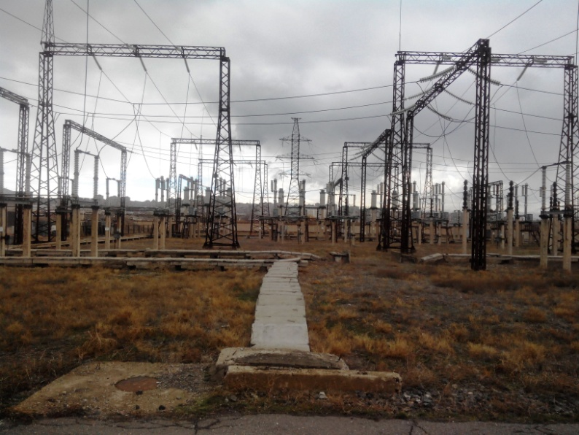

Final Report

April 2014

CONTENTS
1. BACKGROUND 3
2. PROJECT DESCRIPTION 3
3. LEGISLATION 5
4. PUBLIC CONSULTATIONS 6
5. POTENTIAL IMPACTS AND MITIGATION MEASURES 6
6. RESPONSIBILITIES AND INSTITUTIONAL ARRANGEMENTS 7
ENVIRONMENTAL MANAGEMENT PLAN 9
ENVIRONMENTAL MONITORING PLAN 15
7. MINUTES OF PUBLIC CONSULTATION………………………………………………………………………....20

BACKGROUND
Additional Financing for Electricity Supply Reliability Project (ESRP AF), requested by the Government of Armenia, intends to increase the reliability and capacity of the transmission network through rehabilitation/replacement of key transmission assets. To achieve this objective, the ESRP AF would include complete rehabilitation and expansion of Haghtanak substation of High Voltage Electric Networks CJSC (HVEN). The substation was commissioned in 1988 and has not been rehabilitated since then. The key equipment and supporting structures need replacement because of lack of maintenance parts and erosion of concrete foundations and steel supports. Poor equipment condition sometimes leads to unnecessary outages due to equipment failure. As part of the preparatory work for rehabilitation and expansion of Haghtanak substation, an Environmental Management Plan (EMP) is required.

PROJECT DESCRIPTION
Location and Site description
Haghtanak substation is located in the Western part of the capital city of Yerevan. Yerevan is situated in the north-eastern part of Ararat Valley, to the center-west of the Armenia. The upper part of the city is surrounded with mountains on three sides while it descends to the banks of the Hrazdan River at the south. It borders with Aragatsotn, Kotayk, Ararat and Armavir marzes of RA. The city's elevation ranges between 865 to 1390m above sea level.
The climate of Yerevan is a humid continental semi-arid climate, with hot and dry summers and cold and snowy winters. The average temperature in July is 25.8^{օ}C, and the absolute maximum temperature is 42^{օ}C. The average temperature in January is -3.6^{օ}C, and the absolute minimum temperature is -28^{օ}C. The average annual temperature is 11.9^{օ}C; average annual relative humidity is 61%; average annual precipitation is 291-353mm.
Being located in a developed area, there is no wildlife within the area of construction activities. The substation is constructed within the re-cultivated territory of a closed tuff quarry. The construction site has flat topography and is surrounded by small-scale vineyards to the south and south-east and by small production units to the west and south-west. The vineyards are owned by the residents of neighboring rural communities and are cultivated by them for personal use. An undeveloped land is located to the north of the substation. The closest residential area is about 300 m. There is a small water stream in 7 m distance from the southern fencing of the site.
The public road near the SS entrance will be used to access the site from the north. There are also access roads around SS fencing. Using of access roads will not restrict access to agricultural lands. All construction machinery and equipment will be parked inside the fencing area. The project implementation will not have any temporary or permanent impacts on neighboring production units.
The substation has: (a) two 220 kV overhead transmission lines (OTLs), (b) two 220 kV main transformers (MTRs); and (c) three 10 kV feeder bus sections. One of the MTRs is 220/(35)/10 kV 20 MVA transformer and the other is 220/10/(6) kV 63 MVA transformer.
The Substation occupies the fenced area of 2.6 ha with various` buildings having the following external dimensions (L×W×H):
- Control and dispatching building (including offices and battery room): 41.7×12.05×5m;
- 10 kV feeder bus sections and two associated buildings:
36.7×9.1×5m and 15.9×5.18×5m each; and
- Checkpoint: 6×3×4m.
The west side of the substation is currently used as decommissioned materials and equipment storage.
Project scope of work
The rehabilitation and expansion of the substation will involve the following:
- replacement of two 220 kV main transformers (MTRs);
- complete replacement of 220kV open switch-yard (OSY);
- construction of new 110kV OSY with four bays for overhead transmission lines (OTLs);
- demolition of existing and construction of new control and dispatching building;
- replacement of Alternating Current and Direct Current (AC/DC) systems, including distribution system, chargers, invertors, and batteries;
- installation of SCADA system and replacement of protection relay equipment;
- replacement of 10 kV cubicles and the associated building;
- reconstruction of grounding system;
- reconstruction of oil spill collection system;
- construction and reconstruction of roads and walkways;
- rebuilding of cable trenches;
- installation of fire alarm and fire localization system;
- construction of external water drainage and reconstruction of sewerage system; and
- restoration of outdoor lighting.

All of these activities will take place in the area of an already existing substation (as shown in Figure 1) and all impacts will be confined to the existing substation yard.
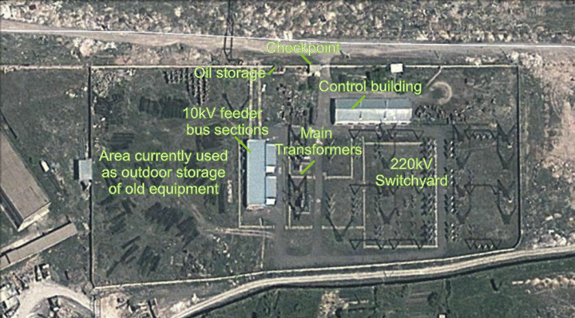
Figure 1: Site Plan

LEGISLATION
The following Armenian legislation defines a legal framework applicable to project activities:
Law on Atmospheric Air Protection of RoA (1994)
The purpose of Law on Atmospheric Air Protection is to define main principles of the RoA, directed to provision of purity of atmospheric air and improvement of air quality, prevention and mitigation of the chemical, physical, biological and other impacts on air quality and regulation of public relation.
According to this law, contractor shall undertake demolition and construction activities as well as transportation and temporary storage of wastes the way to minimize dust and other emissions to the air.
Law on Waste of RoA (2004)
The law provides the legal and economic basis for collection, transportation, disposal, treatment, re-use of wastes as well as prevention of negative impacts of waste on natural resources, human life and health. The law defines the roles and responsibilities of the state authorized bodies as well as of waste generator organizations in waste management operations.
According to this law, the waste generated by the demolition, construction, dismantling and installation activities should be recycled as appropriate, or disposed of in designated locations.
Law on Environmental Impact Assessment of RoA (1995)
The law defines type of activities which are subject to environmental impact assessment and ecological expertise.
According to this law, works planned at Haghtanak substation are not subject to the ecological expertise.
Law on Urban Development of RoA (1998)
According to this law, works planned at Haghtanak substation require obtaining of the construction permit.

PUBLIC CONSULTATIONS
The neighboring communities of Haghtanak substation are considered to be the affected parties during the construction and operational phases. EMP will be disclosed on the High Voltage Electric Networks CJSC website. Brief information on the planned works and contact information for addressing questions and grievance will be placed at the work site and/or in its immediate surroundings/municipality.

POTENTIAL IMPACTS AND MITIGATION MEASURES
The EMP covers environmental and social impacts that may arise from the project implementation and provides mitigation measures to cover typical impacts from upgrading equipment and installing new equipment at substations, including workers’ health and safety, earthworks, and solid and hazardous waste management. Environmental Management Program containing management and monitoring plans by project phase and activity is provided in Annex 1.
Waste management is the most challenging task of the environmental mitigation plan developed for the project. The main types of wastes expected at the construction phase are: (i) non-hazardous - demolition debris; other types of non-hazardous construction waste; excess material from excavation; obsolete equipment; and (ii) hazardous - lead batteries and battery acids; used transformer oils; used tires, filters, and oils of construction machinery and vehicles.
Non-hazardous - demolition debris and other as well as excess material from excavation will be disposed to the formally designated locations. Permission for disposal from the Yerevan Municipality shall be obtained by Construction Contractor prior to disposal.
Obsolete equipment will be stored at Haghtanak SS site before being sold or possible reuse by HVEN. A separated outdoor area in west side of the SS plot will be used as decommissioned equipment storage.
The maintenance of construction machinery and vehicles will be performed at specialized service centers, which also accept used tires, filters, and oils.
Transformer oils at Haghtanak SS were assessed by the Waste Research Center SNCO of the Ministry of Nature Protection of RoA in 2010 using DEXSIL L2000 DX analyser. According to assessment results, the transformer oils at Haghtanak SS do not contain PCBs. Since at present there is no local licensed recycling facility, the used oils will be transported 3 km north-east to Shahumyan-2 SS of HVEN and stored there in appropriate oil storage before recycling by a licensed contractor. Used oils will be transported in closed and sealed containers or tanks properly covered and immobilized by secure attachment to transportation trucks. Trucks will carry signage warning of hazardous cargo.
Since the disposal of decommissioned lead batteries and battery acid in a landfill is prohibited, while at present there is no local licensed recycling/neutralization facility in the country, the acid containing batteries must be transported 3.5 km north-east to Main Branch of HVEN and appropriately stored in warehouse building after removal of acid until such kind of facilities will be established. Batteries should be protected against short circuit and secured from movement during transportation in an enclosed vehicle. The storage conditions will include locked and ventilated room with non-permeable floor material and the shelves for placement of batteries. Acid will be stored in proper tanks having secondary containment. The trained HVEN staff will prepare the batteries and acid for storage. Proper personal protection gear will be used by personnel when handling acid.
The EMP establishes a critical link between the management and mitigation measures specified in this report and the proper implementation and management of the measures during the construction and operation phases of the project. It provides details on the measures responsibilities to mitigate these impacts; the costs of mitigation; and, the ways in which implementation and effectiveness of the measures will be monitored and supervised.

RESPONSIBILITIES AND INSTITUTIONAL ARRANGEMENTS
HVEN is responsible for the implementation of the EMP. The environmental management plan table, extracted from this EMP, will be included into the tender package and will be incorporated into the contract for the provision of works, so that contractor is aware of the mitigation measures to be applied, can properly cost them and include into the bill of quantities, and is obligated to adhere to the EMP alike any other terms of the contract.

Responsibilities of Construction Contractor
HVEN shall obtain Construction Permit for the designed works. If any additional licenses, permits, consents required (e.g. waste disposal etc.) construction company shall obtain such license, permits, and consents within its capacity.

Monitoring of EMP implementation
HVEN carries overall responsibility for the implementation of EMP and for organizing environmental monitoring of works. Environmental monitoring of works shall be undertaken according to the Environmental Monitoring Plan presented in this report and the outcomes of monitoring shall be documented in monthly environmental supervision reports.

ANNEX 1: ENVIRONMENTAL MANAGEMENT PROGRAM

ENVIRONMENTAL MANAGEMENT PLAN
Activity | Potential Impact | Mitigation Measure | Indicator of Mitigation | Cost of Mitigation | Responsibility for Mitigation
CONSTRUCTION PHASE
- Labor safety | Traumatism and accidents at work site | - Provision of construction workers with uniforms and PPE;  - Strict compliance with the rules of construction equipment operation and usage of PPE. | - Construction workers found wearing uniforms and adequate protective gear during inspections;  - No violations of equipment operation and use instructions registered during inspections. | No specific extra cost: common responsibility of works contractor | Construction Contractor
- Demolition and construction | Air pollution with dust and emissions | - Keeping demolition debris in controlled area and spraying with water mist to reduce debris dust;  - Suppression of dust during pneumatic drilling/wall destruction by ongoing water spraying and/or installing dust screen enclosures at site;  - Keeping the surrounding environment (sidewalks, roads) free of debris to minimize dust;  - Prohibiting open burning of construction / waste material at the site;  - Keeping construction vehicles and machinery in adequate technical condition excluding excessive emissions;  - No idling of construction vehicles at sites. | - No demolition debris found in uncontrolled area and unsprayed with water;  - No pneumatic drilling/wall destruction activity without suppression of dust by ongoing waster spraying and/or installing dust screen enclosures at site;  - Surrounding environment (sidewalks, roads) found free of debris during inspections;  - No open burning of construction / waste material found at the site during inspections;  - During inspections, construction vehicles and machinery found operating without excessive emissions;  - No complaints from nearby residents. | No specific extra cost: common responsibility of works contractor | Construction Contractor
 | Generation of noise | - Respecting working hours;  - Closing the engine covers of generators, air compressors and other powered mechanical equipment during operations, and placing of equipment as far away from residential areas as possible;  - Fitting noise mufflers to mobile plant and equipment;  - Preventative maintenance of equipment to minimize noise;  - Switching off unnecessary or idle equipment. | - No construction equipment found operational out of working hours;  - Construction equipment found in decent technical condition during inspections;  - No switched on unnecessary or idle equipment found during inspections;  - No complaints from nearby residents. | No specific extra cost: common responsibility of works contractor | Construction Contractor
- Provision of construction materials | Delivery of substandard materials which may cause risks to the safety of structure and to health of people | Purchase of construction materials from the registered providers | Delivery of standard quality construction materials carrying relevant certificates of origin | None | Construction Contractor
- Transportation of construction materials and waste  Movement of construction machinery | - Pollution due to poor technical condition of vehicles and movement of uncovered truckloads;  - Nuisance to local residents from noise and dust. | - Adequate technical condition of vehicles and machinery;  - Confinement and protection of truck loads with lining;  - Respect of the established hours and routes of transportation. | - Vehicles and machinery found in decent technical condition during inspections;  - No uncovered truck loads found during inspections;  - No activity ongoing out of working hours which may be disturbing for nearby population;  - No complaints from nearby residents. | No specific extra cost: common responsibility of works contractor | Construction Contractor
- Operation of construction equipment on site | - Pollution of environment with emissions and leakages;  - Nuisance for nearby population. | - Adequate technical condition of construction equipment;  - No excessive exhaust;  - No fuel and lubricant leakage;  - Observation of working hours. | - Vehicles and machinery found in decent technical condition during inspections;  - No heavy vehicles and machinery found operational out of the established hours;  - No complaints from nearby population. | No specific extra cost: common responsibility of works contractor | Construction Contractor
- Maintenance of construction equipment | - Pollution of ground water and soil with oil products due to operation of equipment;  - Damage in case of fire. | - Washing of cars and construction equipment outside the construction site or on maximum distance from natural streams;  - Refueling or lubrication of construction equipment at predetermined filling stations/service centers. | - No direct entry of runoff from car-wash to water bodies;  - No spillages of fuel and lubricants found on the ground within and nearby the construction site;  - Presence of basic fire extinguishing means on site. | No specific extra cost: common responsibility of works contractor | Construction Contractor
- Earth works | - Loss of vegetation due to ground piling and minimization of pollution of surface water body with particles. | - Topsoil removal and temporary stockpiling for re-cultivation of the land;  - Temporary storage of excavated soil at determined places;  - Backfilling of the excavated ground as needed and disposal of the excess mass to the places, approved in writing. | - Excess material disposed at the agreed upon safe permanent storage sites with no threat of erosion and no blocking of waterways;  - No remnants of excess material at the construction site upon completion of works; | Contractor has to include the cost of transportation of excess material to the sites of final disposal into the bill of quantities. | Construction Contractor
- Generation of non-hazardous construction waste | - Pollution of soil, surface water and ground water;  - Accidents at construction site due to scattered fragments of construction materials and debris;  - Deterioration of esthetic appearance of construction site and its surroundings. | - Temporary storage of construction waste in especially allocated areas within the fenced area of SS;  - Written agreement on the disposal of excess material and construction waste obtained from Municipality of Yerevan;  - Timely disposal of wastes to the formally designated locations. | - Construction waste found at the work site piled up in designated locations;  - No excessive amount of construction waste stored on site. | Contractor shall include cost of waste transportation/disposal into the bill of quantities. | Yerevan Municipality  Construction Contractor
- Generation of non-hazardous liquid wastes | - Pollution of surface and ground water;  - Deterioration of sanitary conditions at work site. | Arrangement and maintenance of toilets in compliance with sanitation norms at the construction site. | Toilets provided at the construction site and found in good sanitary condition | No specific extra cost: common responsibility of works contractor | Construction Contractor
- Generation of waste from the removal of used transformer oils and obsolete equipment | - Pollution of soil, surface water and ground water;  - Accidents at construction site due to scattered decommissioned; materials and equipment;  - Deterioration of esthetic appearance of construction site and its surroundings. | - Temporary storage of decommissioned equipment on the site of Haghtanak SS in especially designated locations.  - Safe transportation of transformer oils to Shahumyan-2 SS;  - Safe storage of transformer oils at Shahumyan-2 SS. | - Decommissioned equipment found at Haghtanak SS site collected in designated locations;  - Replaced transformer oils found in proper storage at Shahaumyan SS. | To be included in the SSs’ operation and maintenance budget | Construction Contractor  HVEN
- Generation of toxic waste from replacement of batteries | - Pollution of soil, surface water and ground water due to leakage or spillage of acid from old equipment;  - Health hazards to construction workers and other people which may enter the construction site;  - Health hazards to workers and other people which may enter waste storing site. | - Strict separation of toxic waste (used batteries, battery acid, etc.) from other types of waste generated at the substation;  - Preparation of toxic waste for storage through placement in containers and full labelling (details of composition, properties and handling information);  - Preparation of premises for storage of toxic waste (provision of non-permeable flooring, shelves, ventilation systems, security systems, etc.);  - Placement of toxic waste for storage. | - Hazardous waste found at the work site separated from other waste;  - Hazardous waste found at the central branch of HVEN stored in safe containers labeled with details of composition, properties and handling information. | To be included in the SS’s operation and maintenance budget | Construction Contractor  HVEN
- Construction site re-cultivation and landscaping | Loss of aesthetical value of the landscape due to rehabilitation/expansion of the SS | - Dismantlement of construction base (if any) and temporary access roads to the site (if any) and harmonization of the areas with the landscape;  - Final cleaning of the construction site and permanent access roads and landscaping-greening of the area. | - No remnants of a work camp left behind after demobilization of contractor;  - Temporary access roads harmonized with landscape and enabling conditions provided for natural regeneration of vegetation;  - Construction site landscaped and greened. | Included in  project costs | Construction Contractor
- Traffic and Pedestrian Safety | Direct or indirect hazards to public traffic and pedestrians by construction  activities | - Signposting, warning signs, barriers and traffic diversions;  - Traffic management system and staff training, especially for site access and near-site heavy traffic. Provision of safe passages and crossings for pedestrians where construction traffic interferes;  - Adjustment of working hours to local traffic patterns, e.g. avoiding major transport activities during rush hours;  - Active traffic management by trained and visible staff at the site, if required for safe and convenient passage for the public. | - Properly secured construction site;  - Clearly visible site and the public warned of all potential hazards;  - Regulated construction related traffic. | Included in  project costs | Construction Contractor
OPERATION PHASE
- Generation of hazardous waste (oily rags, oil contaminated sand) | - Health hazards to SS staff;  - Pollution of soil, surface and ground water in SS area and its surroundings. | - Separation of hazardous waste from other types of waste generated at substation;  - Presence of appropriately sealed and protected storage area for hazardous substances;  - Arrangements in place with especially licensed entities for regular out-transporting and recycling/disposal of hazardous waste in compliance with the national legislation and the best national practice. | Good sanitary conditions in and around SS | To be included in the SS’s operation and maintenance budget | HVEN
- Operation and maintenance of SS equipment | Pollution of soil, surface and ground water in substation area and its surroundings | - Availability of spill kits on-site for the clean-up of spills and leaks of oil;  - Preventing leakage and spillage of oil during operation and maintenance;  - Timely cleaning any oil leakages and accidental spillages. | Good sanitary conditions in and around SS | To be included in the SS’s operation and maintenance budget | HVEN
- Emergency preparedness | Disruption of the Substation operation causing nuisance to the consumers | Presence of fire alarm and fire localization system, and emergency back-up systems for power supply | Smooth operation of the Substation | To be included in the Substation operation and maintenance budget | HVEN

ENVIRONMENTAL MONITORING PLAN
Activity | What  (Is the parameter to be monitored?) | Where  (Is the parameter to be monitored?) | How  (Is the parameter to be monitored?) | When  (Define the frequency / or continuous?) | Why  (Is the parameter being monitored?) | Who  (Is responsible for monitoring?)
CONSTRUCTION PHASE
- Provision of construction materials | Purchase of construction materials from the registered providers | In the provider’s office or warehouse | Verification of labels of the materials and/or certificates if any | During conclusion of supply contracts | Ensure reliability of construction materials and their safety for human health | HVEN
- Transportation of construction materials and waste  Movement of construction machinery | - Technical condition of vehicles and machinery;  - Confinement and protection of truck loads with lining;  - Respect of the established hours and routes of transportation. | - Construction site;  - Routes of transportation of construction materials and wastes. | Inspection of roads adjacent to the SS in the direction of the movement route | Selective inspections during work hours | - Limit pollution of soil and air from emissions;  - Limit nuisance to local communities from noise and vibration;  - Minimize traffic disruption. | HVEN  Traffic Police
- Dust | Air condition on-site | Construction site and access road | Visual inspection | Recurrent | Reduce risks for the staff and neighboring communities | HVEN
- Noise | - Observance of working hours  - Technical condition of vehicles and machinery  - Noise levels (in case of complaints) | Construction site | - Visual inspection;  - instrumental measurement of noise levels (in case of complaints) | - Recurrent  - Within 2 weeks following a complaint | Reduce nuisance for staff and neighboring communities | HVEN
- Maintenance of construction equipment | - Washing of cars and construction equipment outside the construction site or on maximum distance from natural streams;  - Refueling or lubrication of construction equipment at the predetermined filling stations/service centers. | Construction site | Inspection of activities | Selective inspections during work hours | - Avoid pollution of water and soil with oil products due to operation of equipment;  - Timely localize fire and decrease possible damage. | HVEN
- Earth works | - Topsoil removal and temporary stockpiling for re-cultivation of the land;  - Temporary storage of excavated soil at determined places;  - Backfilling of the excavated ground as needed and disposal of the excess mass to the places, approved in writing. | Construction site | Inspection of activities | During earth works | - Limit loss of vegetation due to ground piling and minimization of pollution of surface water reservoirs with particles  - Limit pollution with contaminated soil of surface and ground waters | HVEN
- Generation of non-hazardous construction waste | - Temporary storage of construction waste in especially allocated areas within the fenced area of SS;  - Timely disposal of wastes to the formally designated locations. | Construction site;  Waste disposal site | Inspection of activities | Periodically during construction and upon its completion | - Prevent pollution of soil, surface water and ground water;  - Avoid accidents at the SS site due to scattered fragments of construction materials and debris;  - Retain esthetic appearance of the sites area and its surroundings. | HVEN  Yerevan Municipality
- Production of liquid wastes | - Arrangement and maintenance of toilets in compliance with sanitation norms at the construction site | Construction site | Inspection of activities | Total period of construction | - Reduce pollution of surface and ground waters. | Construction Contractor
- Generation of waste from the removal of obsolete equipment | - Temporary storage of decommissioned equipment in especially designated location of Haghtanak SS. | Land plot of Haghtanak SS | Inspection of activities | Periodically during construction and upon its completion | - Prevent pollution of soil, surface water and ground water;  - Avoid accidents at the construction site due to scattered decommissioned materials and equipment;  - Retain esthetic appearance of the SS area and its surroundings. | HVEN
- Generation of waste from replacement of transformer oils | - Transportation of oil to Shahumyan-2 SS  - Storage conditions of oils at Shahumyan-2 SS | - Transportation route from Haghtanak SS to Shahumyan-2 SS;  - Shahumyan-2 SS. | Visual inspection | - During transportation of oils;  - Periodically during storage of oils | Avoid pollution of soil and water | HVEN
- Generation of toxic waste from replacement of batteries | - Strict separation of toxic waste (used batteries, battery acid, etc.) from other types of waste generated at the SS;  - Preparation of toxic waste for on-site storage through placement in containers and full labeling (details of composition, properties and handling information);  - Preparation of premises for on-site storage of toxic waste (provision of non-permeable flooring, shelves, ventilation systems, security systems, etc.);  - Safe placement of toxic waste for storage. | - Transportation route from Haghtanak SS to the main branch of HVEN;  - Premises of the main branch of HVEN. | Visual inspection | - During transportation of toxic waste;  - Periodically during storage of toxic waste. | Avoid pollution of soil and water | HVEN  Ministry of Nature Protection
- Construction site re-cultivation and landscaping | - Dismantlement of construction base (if any) and temporary access roads to the site (if any) and harmonization of the areas with the landscape;  - Final cleaning of the construction site and permanent access roads and landscaping-greening of the area. | Construction site, access roads | Inspection of activities | Final period of construction | Reduce loss of aesthetical value of the landscape due to rehabilitation of the SS | HVEN
- Workers’ health and safety | - Construction workers wearing uniforms and PPE;  - Strict compliance with the rules of construction equipment operation and usage of PPE. | Construction site | Inspection of activities | Total period of works | Reduce probability of traumas and accidents to constructors | HVEN
OPERATION PHASE
- Hazardous waste management (oily rags, oil contaminated sand) | - Separation of hazardous waste from other types of waste generated at substation  - Presence of appropriately sealed and protected storage area for hazardous substances;  - Arrangements in place with especially licensed entities for regular out-transporting and disposal of hazardous waste in compliance with the national legislation and the best national practice. | Premises of SS | - Inspection of SS  - Checking presence and validity of waste removal and disposal agreement with a licensed entity. | Total period of operation of the SS | - Maintenance of good sanitary conditions at SS;  - Limitation of soil, surface and ground water pollution. | Ministry of Nature Protection
- Operation and maintenance of SS equipment | - Availability of spill kits on-site for the clean-up of spills and leaks of oil;  - Preventing leakage and spillage of oil during operation and maintenance;  - Timely cleaning any oil leakages and accidental spillages. | SS area | Inspection of SS premises | Total period of operation of the facility | - Prevention of health hazards to staff and other people which may enter the site;  - Avoid pollution of water and soil with oil products due to maintenance and operation of equipment;  - Timely localize and decrease expected damage in case of fire. | Ministry of Nature Protection  Ministry of Energy and Natural Resources
- Electric and Magnetic Field | Electric and Magnetic Field intensity | In the area of operation and at the fence | Electro meter and Gauss meter | Six monthly | Reduce risks for the staff and neighboring communities | HVEN  Ministry of Health
- Emergency preparedness | Presence of fire alarm and fire localization system, and emergency back-up systems for power supply | SS area | Periodic check-ups | Total period of operation of the facility | - Reduce risks for the staff and neighboring communities;  - Avoid disruption of SS’s operation. | Ministry of Energy and Natural Resources  Ministry of Emergency Situations

- MINUTES OF PUBLIC CONSULTATION

Environmental Management Plans and
Resettlement Policy Framework for the rehabilitation of Haghtanak, Charentsavan-3 and Vanadzor-1 substations
Introduction
The Environmental Management Plans (EMPs) and the Resettlement Policy Framework (RPF) for rehabilitation of Haghtanak, Charentsavan-3 and Vanadzor-1 substations - both in English and Armenian languages - were published to solicit public feedback. The timeframe of March 21, 2014 to April 1, 2014 was allowed for ascertaining concerns and obtaining comments/responses from concerned persons via regular mail (full address of HVEN was provided), email and corporate telephone number, which was available from 9 AM to 6 PM on business days.
Materials and Methods
The English and Armenian versions of the EMPs and RPF were posted on the web sites of the Ministry of Energy and Natural Resources of Armenia (http://www.minenergy.am/en/en/investment-projects/high-voltage-network) and High Voltage Electric Networks CJSC (http://hven.am/event-s_34_2.html).
Hard copies of EMPs and RPF were also submitted to the following state authorities:
- Malatia-Sebastia Administrative District of the Yerevan city – Mr. A. Alexsanyan, Head;
- Charentsavan city Municipality – Mr. H. Shahgaldyan, Mayor; and
- Vanadzor city Municipality – Mr. S. Darbinyan, Mayor.
Brief information on rehabilitation works, locations (web site addresses and municipality/administrative district) of disclosed EMPs and RPF documents, and HVEN’s contact information (including full address, email, telephone number, and contact person’s name) were placed at each substation’s entrance/fencing to allow people to express any questions or concerns regarding the documents.
The electronic copies of the EMPs and RPF were also submitted to the following non-governmental organizations:
- Acopian Center for the Environment, American University of Armenia – Mr. A. Amirkhanian, Director;
- “Association of Energy Service delivery Enterprises of Armenia” Union of Legal Entities for the Development of Energy Sector of Armenia – Mr. M. Martirosyan, President;
- Transparency International Armenia – Ms. S. Ayvazyan, President;
- “Energy Saving Alliance” Armenian Branch – Ms. A. Pasoyan, Director; and
- Pure Lori NGO – Mr. V. Buniatyan, President.
Conclusion
Over the public consultation period no concerns, questions, or comments have been received on the EMPs and RPF from any individual or a legal entity. Therefore, these documents are considered final in their present iteration.

PHOTO DOCUMENTATION
Notifications placed at Haghtanak substation
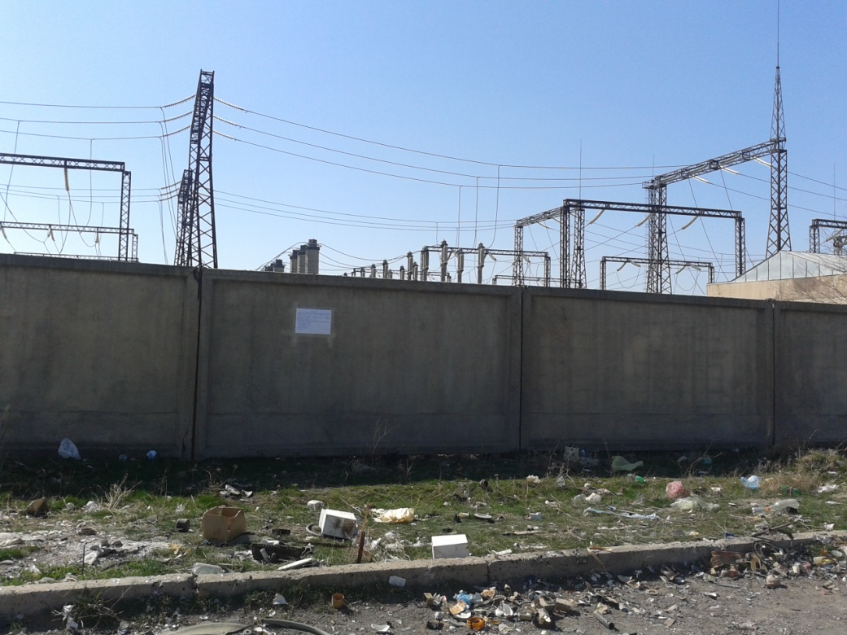

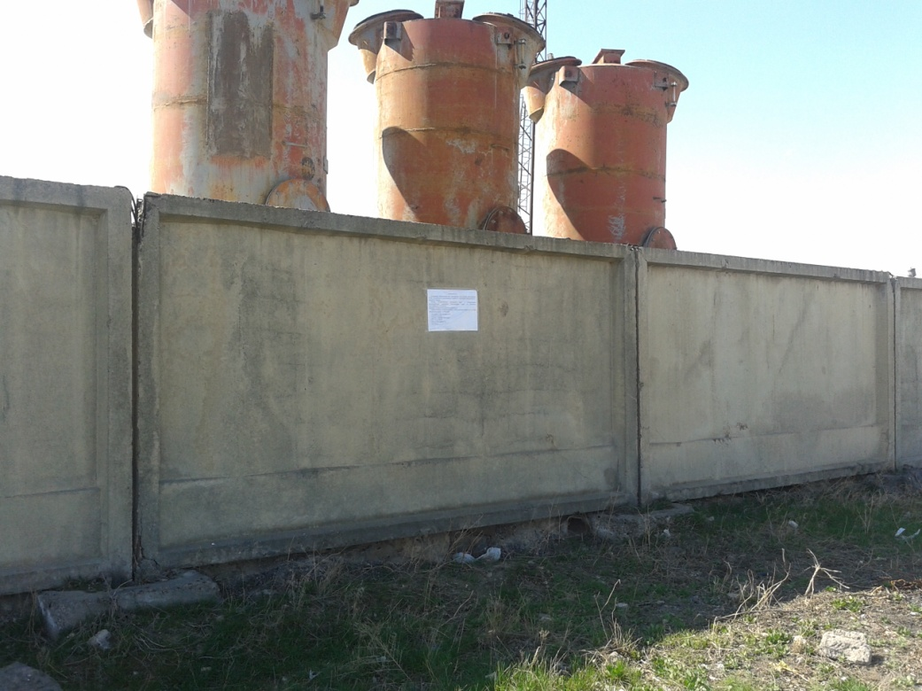

Notifications placed at Charentsavan-3 substation
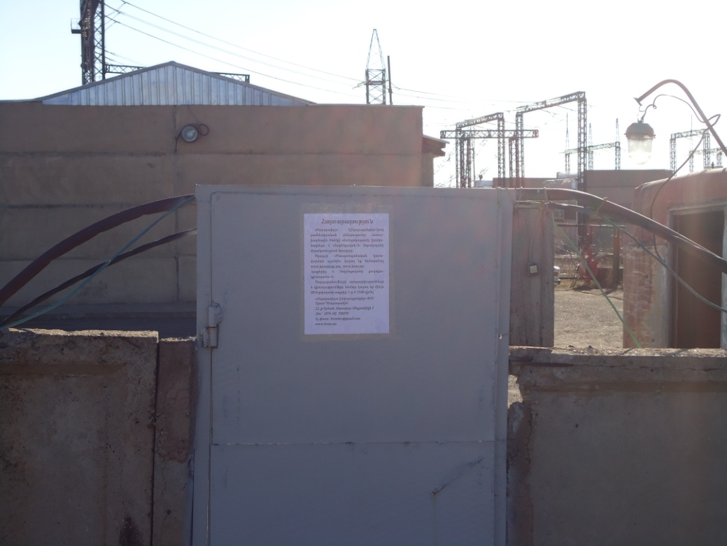

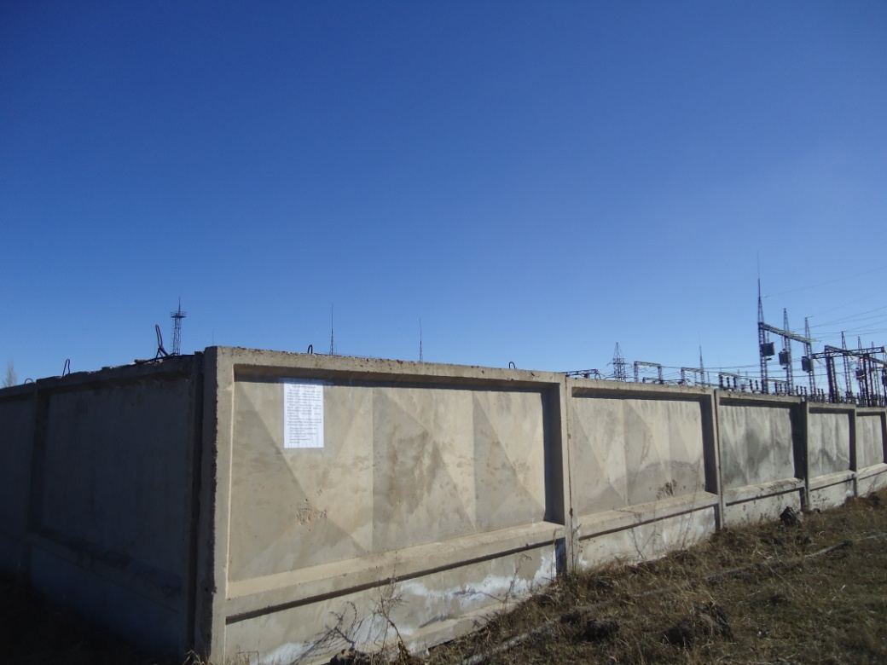

Notification placed at Vanadzor-1 substation
